**Physics Internal Assessment**

Measuring the speed of sound in air through resonance in an air column

**Student Name:** Arsham Eghdamian

**Supervisor:** Dr. Schultz

**Center Name:** EF Academy

**Year:** 2015-2016

**Candidate Number:** 006047-0153

Introduction:

The aim of this paper is to measure the speed of sound in air through using an open-end tube In this lab we measure the speed of sound using the first harmonic motion and the third harmonic motion of waves in an air column I decide to carry out this experiment as I was interested in to explore the characteristics of standing waves that we learnt in this course in this lab we can also understand a practical use of standing waves and resonance which is to measure the speed of sound. In this lab we measure the wavelength of the resonant wave in the column air of different wavelengths. The temperature is (17 degree). One end of the columns is sealed by water, this is so we can easily move the column in water and change the length of the column. When a tuning fork with a specific frequency produces a noise, we find several lengths of the column, which resonate with that specific frequency (the peak noise is the resonance frequency). We only need one length, which is the first harmonic length. Using the relationship, which there is between wavelength length and frequency we can find the speed of light.

Method

For this lab we need a tube, 6 tuning forks with different frequencies (the frequencies are mentioned in table 1.2, and water. First of all fill in the container with water and then put the tube into the water no part of the column air should be out of water at first, produce the sound of the tuning fork by striking it and place it near above the open end of the tube, slowly pull out the tube out of water and get a second person to mark the spot at the edge of water and tube which produces the highest resonant sound at that point. After you did this for 5 other frequencies and recorder the lengths for each do the experiment all over again but this time skip the first resonant sound and look for the second sound which corresponds to the 3rd harmonic motion.

Apparatus

* Tube(Air Column)

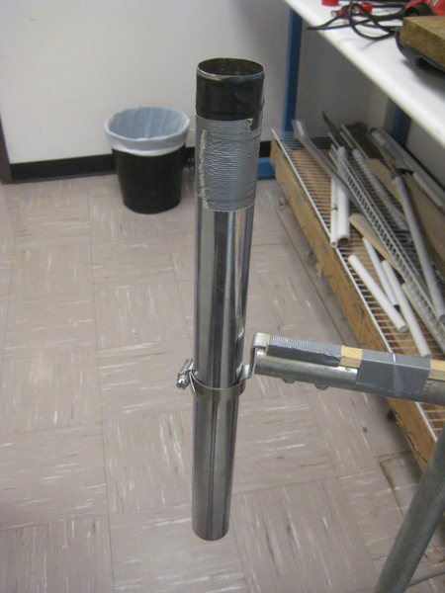

* tuning fork

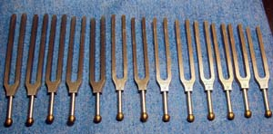

* Ruler
* Water and a container

Results:

The following table shows the length of the air column after 6 different frequencies are tested.

|  |  |  |  |  |  |
| --- | --- | --- | --- | --- | --- |
| Trial | Frequency(Hz) | 1/f | Length (m) | Uncertainty/m |  |
| 1 | 480 | 2.1E-03 | 0.179 | 0.012 |  |
| 2 | 512 | 1.95E-03 | 0.157 | 0.012 |  |
| 3 | 320 | 3.14E-03 | 0.268 | 0.012 |  |
| 4 | 340 | 2.92E-03 | 0.237 | 0.012 |  |
| 5 | 425 | 2.34E-03 | 0.188 | 0.012 |  |
| 6 | 256 | 3.91E-03 | 0.316 | 0.012 |  |

(1)

In this lab we measure the length of the air column with ruler, by peaking the peak of resonant sound and marking the spot and measuring the length of the tube by meter. Therefore the uncertainty involved in measuring the length is analogue and it will be $a/{√6}$ in which *a* is the smallest unit which can be measured although the smallest unit which can be measured in here is 1 millimeter but we took *a* to be 3 mm because of the uncertainty in the highest peak of the resonant sound:

E.g. Uncertainty= ${0.03}/{√6}=0.012m$

As the frequency does not have any uncertainty (is produced by tuning fork and no error is given by the tool or the provider). So the velocity which is 4 times the slope of the graph will have the same uncertainty.

Using the tuning forks. We generate sounds above the tube, then move the

tube until the sound reaches its maximum volume due to resonance.

Record the length of the tube at which the volume is at peak.

Trying different frequencies and using the formulas below:

v = fλ, L= λ/4, 3λ/4, 5λ /4

1.1

$$λ=vT→λ=v/f→4L=\frac{v}{f}→v=4*82.23=328.9m/s$$

In order to find the uncertainty of a slope we use the method of least squares and we find the uncertainty of the weighted fit line which its slope has been figured out by:

$$m=\frac{1}{∆}\sum_{i}{\frac{xiyi}{{δyi}^{2}} }$$

$$∆=\sum_{i}{\frac{x_{i}^{2}}{{δyi}^{2}} }$$

$$δm=\sqrt{\frac{1}{∆}}$$

$→∆=$ 0.315162667 $→$ $δm=1.78ms^{-1}$

$$→v=328.9±1.78 ms^{-1}$$

|  |  |  |  |  |
| --- | --- | --- | --- | --- |
| Trial | frequency | 1/f | Length of 3rd harmonic | Uncertainty/m |
| 1 | 425 | 2.34E-03 | 0.571790485 | 0.012 |
| 2 | 480 | 2.1E-03 | 0.5271875 | 0.012 |
| 3 | 512 | 1.95E-03 | 0.474863281 | 0.012 |

1.2

We could not carry this out on the other frequencies because it would require a longer tube , ours was 60 cm.

1.3

In the third harmonic motion L= 3λ/4, there fore based on $λ=v/f$ we have $4/3L=v/f→L=0.75v/f→0.75v=246.9→v=329.2 m.s^{-1}$

Based on what we explained before the uncertainty in the measured velocity will be 1.78 $m.s^{-1}$ (least square method)

Conclusion

In this lab we measured the speed of sound through the characteristics of wave in a one open end air column and we used the first harmonic waves and the third harmonic wave to measure the speed of sound by comparing the results we see that they are relatively close to each other we can also use the t test to ensure that our measurements are confident.

$$t^{'}=\frac{\left|A-B\right|}{\sqrt{δA^{2}-δB^{2}}}$$

$$→t^{'}=\frac{329.2-328.9}{\sqrt{2*{1.78}^{2}}}=0.119→t^{'}<1$$

This tells use that the measured values of the speed sound are confidently physically the same thing. And the speed of sound measured:

$$v=\frac{329.2+328.2}{2}=328.7 m.s^{-1}$$

Limitation and improvement:

We know that the speed of sound is 340 m at 20 degree Celsius but the experiment was carried out in room of temperature of almost 16 Celsius, this has had some impact on our measured speed we need to carry out the experiment in an environment of 20 degree Celsius.

If the tuning fork is struck hard the frequency of the sound might change slightly,( just like musical instruments when strings are pulled harder the frequency changes) so the tuning fork must be struck softly and moderately to improve the results.

The most limitation error is the end effects, which makes the antinode of the wave to be out of the tube depending on the diameter of our air column. This makes our effective length longer than what we measured.

$$L_{effective}=L_{measured}+4/5×radius$$

The radius of our air column is 0.75 cm:

${∆v≈4}/5×radius*∆f*4→$ $\frac{4}{5}×0.75×{10}^{-2}×\left(512-256\right)×4=6.15 m.s^{-1}$

Therefore our answer for velocity is in fact 328.7+ 6.15 = 334.8 which is in fact closer to the theoretical value of 340 ms^-1.

**Bibliography**:

“Rijke Tube." *Rijke Tube*. N.p., n.d. Web. 04 Mar. 2016

“http://gofurther.utsi.edu/Research/RijkeTube.htm”

“01/02, and Tube -. 1. *STANDING WAVES IN AN AIR COLUMN* (n.d.): n. pag. Web.”

http://www.physics.rutgers.edu/~jackph/2005s/PS07.pdf