Solidity
(important notes and highlights)
When we deploy a contract, an instance is made:
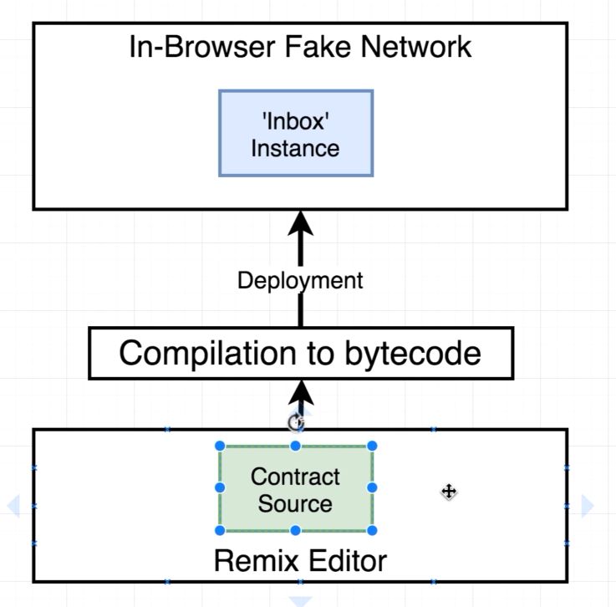
And remember deployed contracts are there in the network forever.
First example contract:
pragma solidity >=0.8.2 <0.9.0; //this defines the compiler version

contract test1{
string public message;

constructor(string memory initMessage){
message = initMessage;
}

function setter(string memory newMessage) public {
message = newMessage;
}

function getter() public view returns (string memory) {
return message;
}
}

We deployed and used the setter and getter; deployment is 1 Tx and using the setter is 1 Tx. Getter() is public view.
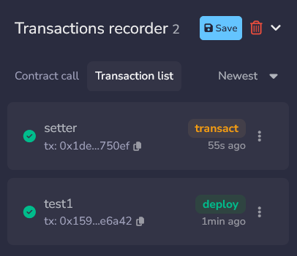
Now, if you make a change to your code the previously deployed contracts will stay. I told you! They will stay forever and you can interact with them with their old functioning and logic.
Txs that deploy a contract are like this:
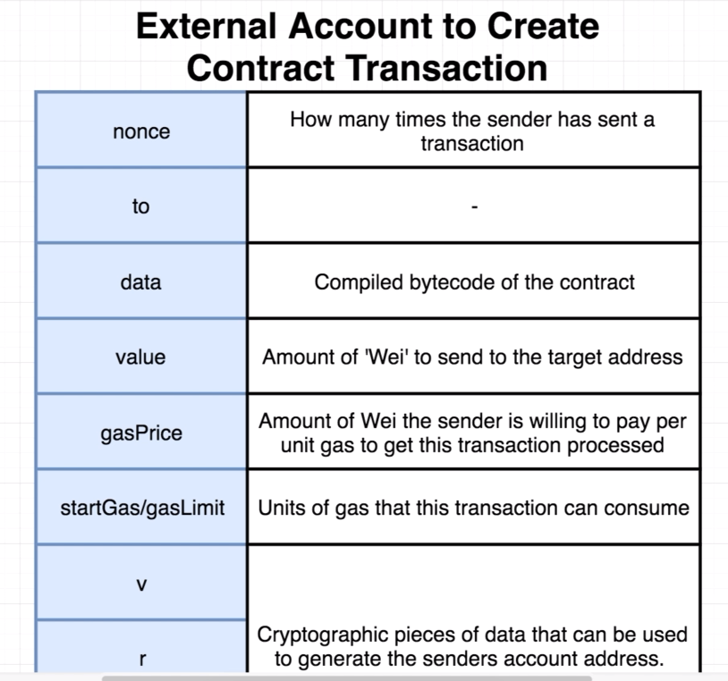
As you can see the Bytecode is the open-source contract code! There is no signature or anything saying who wrote this code! You just deploy it.
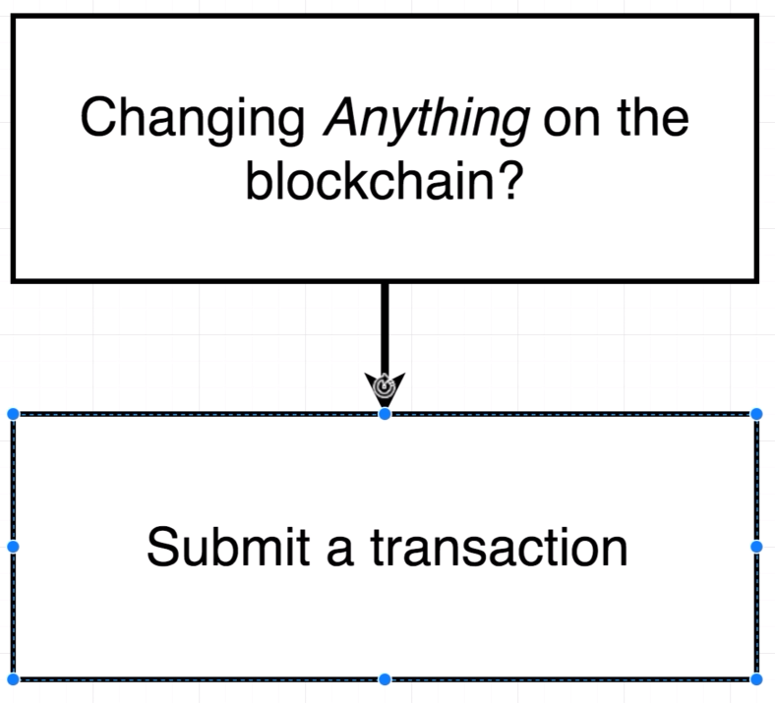
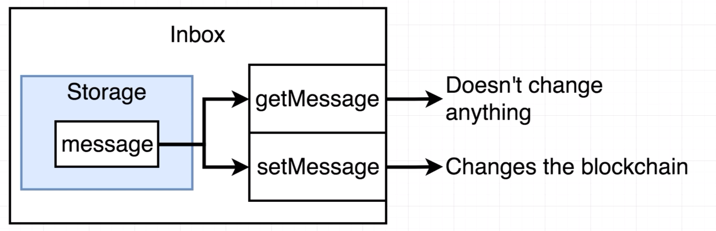
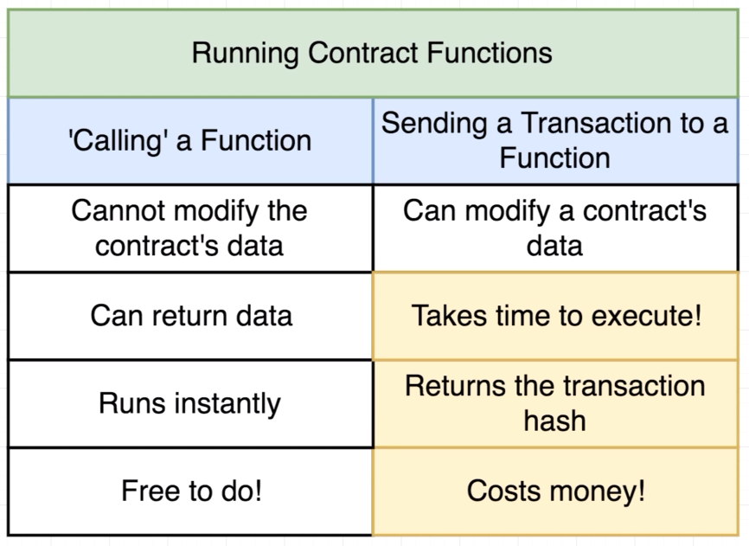
Important point: Tx take time, unlike the toy local networks that works instantly. Watch this Gottcha!
Look at these functions:
function doMath(uint a, uint b) private pure returns (uint) {
uint c = a * b;
return c;
}
function UseDoMath(uint d) public pure returns(uint){
uint a = 8;
uint b = 16;
uint c = doMath(a,b);
uint e = d * c;
return e;
}
They don’t deal with the storage so they are pure and we “Call” them we don’t “Transact” them.
It's always advisable to be explicit when specifying the length of the data type. Uint256 is an example.
Bytes are a collection of characters written in hexadecimal representation.
bytes1 minBytes = "I am a fixed size byte array of 1 byte";
bytes32 maxBytes = "I am a fixed size byte array of 32 bytes";
bytes dynamicBytes = "I am a dynamic array, so you can manipulate my size";

Every variable in Solidity comes with a default value. Uninitialized uint256 for example, defaults to 0 (zero) and an uninitialized boolean defaults to false.
Different visibilities: You see everything on BlockChain is public you can’t hide this. You are just restricting its access.
- 🌎 public: accessible from both inside the contract and from external contracts. It actually creates a getter function!
- 🏠 private: accessible only within the current contract. It does not hide a value but only restricts its access.
- 🌲 external: used only for functions. (can be used only by this.function())
- 🏠🏠 internal: accessible by the current contract and any contracts derived from it.
If a visibility specifier is not given, it defaults to internal.
View -> when only reading from the blockchain storage i.e. reading the state.
Pure -> not doing anything with the storage at all.
While calling view or pure functions doesn’t typically require gas, they do require it when called by another function that modifies the state or storage through a transaction (e.g. calling the function retrieve inside the function storage). This cost is called execution cost and it will add up to the transaction cost.
Arrays are zero-indexed: the first element is at position zero
Structs:
struct Person {
uint256 my_favorite_number;
string name;
}
Person public my_friend = Person(7, 'Pat');
Arrays:
Person[] public list_of_people; // this is a dynamic array
Person[3] public another_list_of_three_people; // this is a static array

Calldata and Memory
In Solidity, calldata and memory are temporary storage locations for variables during function execution. calldata is read-only, used for function inputs that can't be modified. In contrast, memory allows for read-write access, letting variables be changed within the function. To modify calldata variables, they must first be loaded into memory.

