HTML Assignments

1. Make page with a table having first row as table header and rest of rows as table body with the output as below:  
   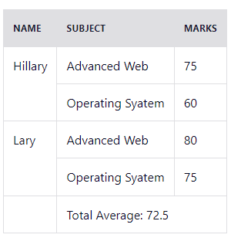
2. Make a form look like below with the follow features:
   1. Only one item can be selected from Level
   2. Major is a select element with the option to select more than 1.
   3. Postal/Zip code can be only number
   4. Only 1 country can be selected.
   5. Email should be a valid email.
   6. Multiple can be selected from ‘Preferred method of contact’  
        
      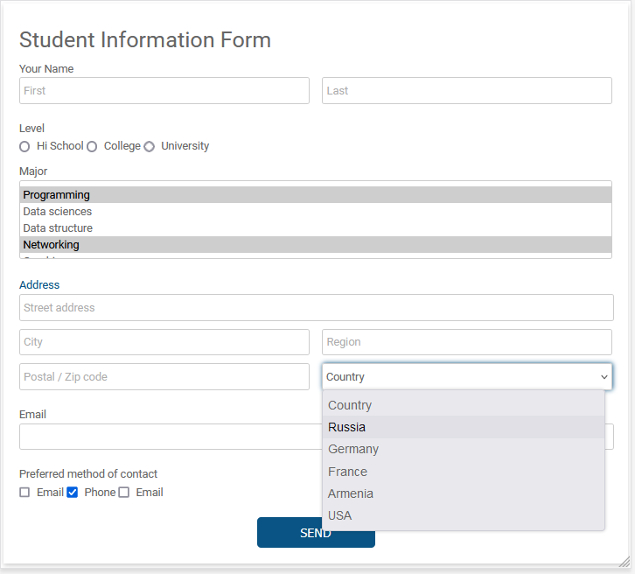
3. Make a page having images, links, frames, form, listing and paragraphs. The page can be like the image below.  
   Note: You can use any images, menu names and text.  
   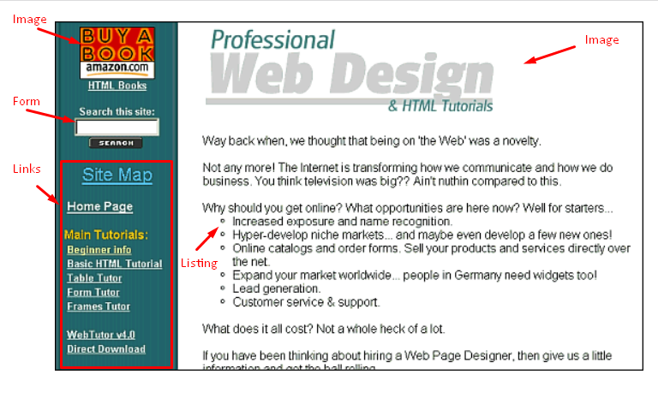

CSS Assignments

1. Make page with table with the following features and look like the image below:
   1. The table should have 2 headers.
   2. The styling (background color and text color) of 1st header should be as in the image.
   3. The styling (background color and text color) of 2nd header should be as in the image.
   4. The 1st column of the table body should be in different text and background color as in the image.
   5. The text of 1st column should be left align.
   6. The text of other column in the table body should look like in the image, center align and with different text and background color.
   7. There should be hover effect on the rows of table body only, not on the table header and also the hover effect of first column should be different from the other columns.  
      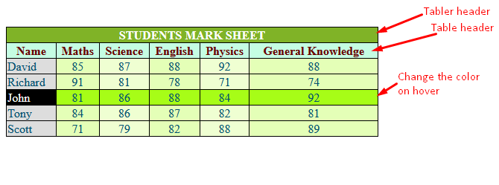
2. Make a page with image and a div, the div is covering some portion of image and it has some opacity to make the image visible. The div shall have h1 text then h3 text and then h2. The final page should be look like the image below. The h3 should be italic.   
     
   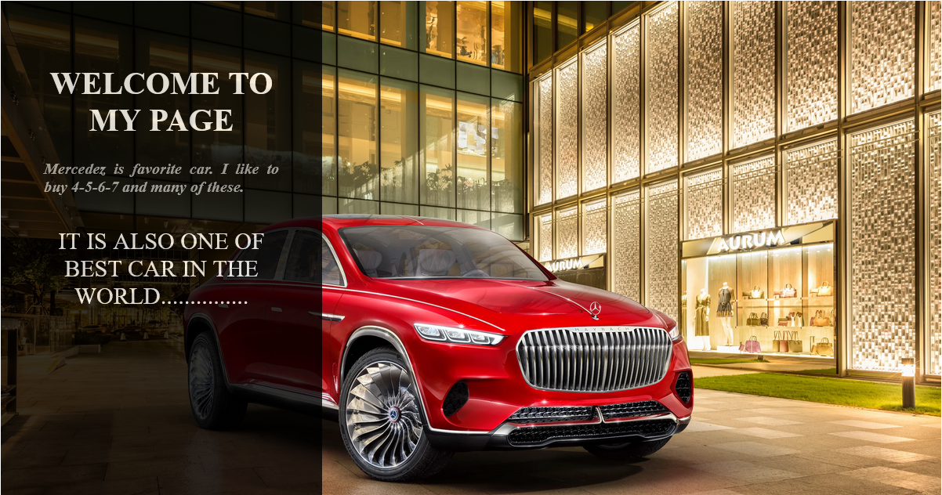
3. Make a page with top navigation bar have image, menu and sub-menu. The navigation bar should have shadow like in the image. Under the navigation there are 9 boxes of same size but different background colors. Then there should be another box with a form over the 9 boxes like in the image. There should be 90% of the box with form.  
     
   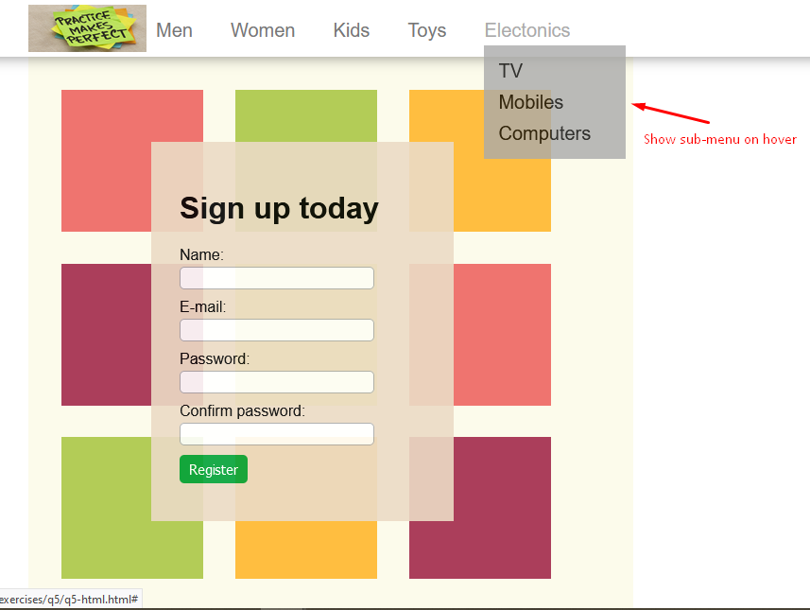

Final Assignment

Make a page having navigation bar with logo, menu with sub-menu (show sub-menu on click of down arrow) and a progress bar. The page should have a Search box, buttons, listing with buttons and icons. There should be a form over the listing just like in the image below. The form will show up when click on the invite candidate button and hide when click on the cancel or save button or anywhere in the page behind the form (you can take help from any other person regarding JS code to show and hide the form). There should be full overlay on the page when show the form and that overlay disappear when hide the form. There should be a help center icon at the right bottom just like in the image.  
  
