Anzahl Tickets:-
SELECT COUNT(*) AS ticket_count
FROM otrs_restore.ticket;
Ant:- ticket_count = 43,153

Anzahl Artikel (Nachrichten):-
SELECT COUNT(*) AS article_count
FROM otrs_restore.article;
Ant:- article_count = 283,028

Wie viele Tickets tatsächlich Artikel enthalten:-
SELECT COUNT(DISTINCT ticket_id)
FROM otrs_restore.article;
Ant:-
jedes Ticket hat mindestens einen Artikel
es gibt keine offensichtlichen leeren Tickets
im Mittel hat jedes Ticket etwa 6.56 Artikel

DESCRIBE otrs_restore.article;
Ant:-
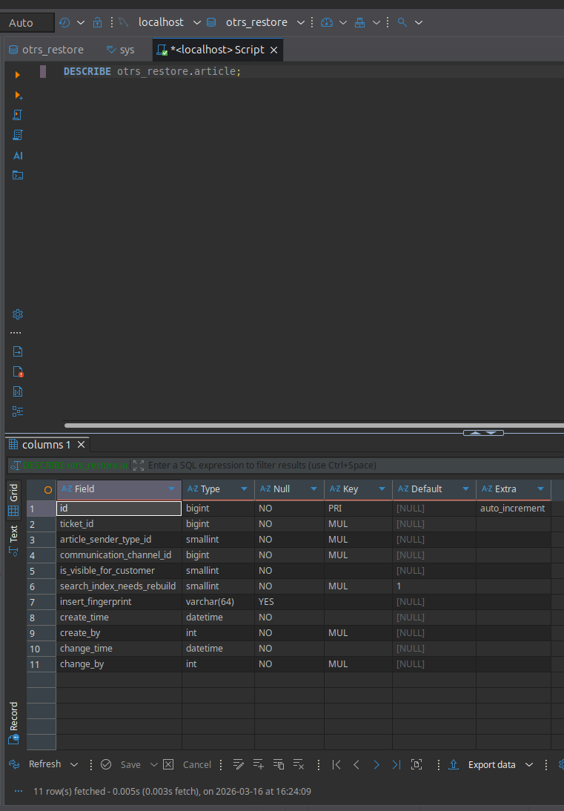

ticket
│
└── article
│
├── article_data_mime (header)
│ └── subject
│ └── from
│
└── article_data_mime_plain
└── body

SELECT
a.ticket_id,
adm.a_subject,
adm.a_from,
admp.body,
a.create_time
FROM otrs_restore.article a
LEFT JOIN otrs_restore.article_data_mime adm
ON a.id = adm.article_id
LEFT JOIN otrs_restore.article_data_mime_plain admp
ON a.id = admp.article_id
ORDER BY a.ticket_id, a.create_time;

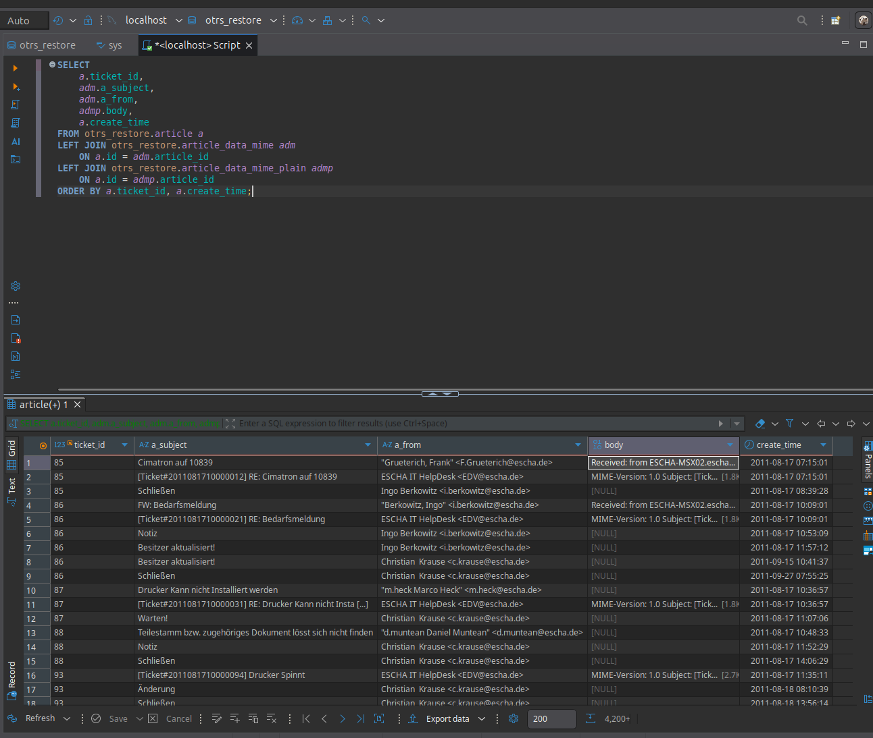

SELECT
u.first_name,
u.last_name,
u.login,
COUNT(*) AS closed_tickets
FROM otrs_restore.ticket_history th
JOIN otrs_restore.users u
ON th.create_by = u.id
WHERE LOWER(th.name) LIKE '%close%'
GROUP BY u.id, u.first_name, u.last_name, u.login
ORDER BY closed_tickets DESC
LIMIT 20;
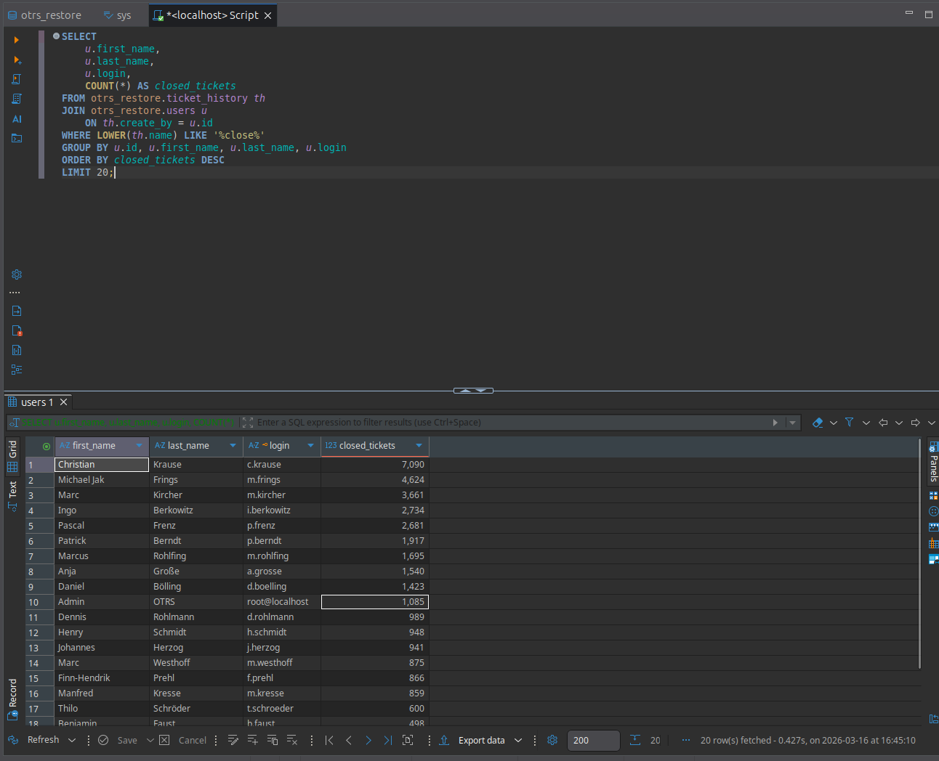

x11vnc -display :0 -auth guess -forever -loop -noxdamage -repeat -rfbauth ~/.vnc/passwd -rfbport 5900 -shared &

