**Set – I**

Q1. Design web Application using Spring [40 Marks]

Design a webpage to display links

Sale bike

Buy bike

If Sale bike selected, then accept the details of seller who wants to sell hisbike.

Bike name can be populated with values such as Activa,Jupitor, Bajaj scooter

And colors with Red,Black,Green,Silver

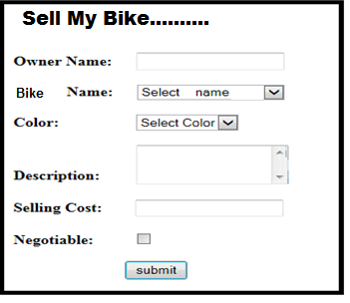

When clicking on submit button, store details in a table saleorder

if Buy Bike selected then accept Bike name from user e.gActiva, Bajaj Scooter

Display all bikes of selected type available for sell . (display in table format)

**Set – II**

Q2. Write aWeb application using spring to accept following details. [40 Marks]

Display web page to display 2 links

Apply leave

Show leave details

If user click apply link, then use following form to accept leave details

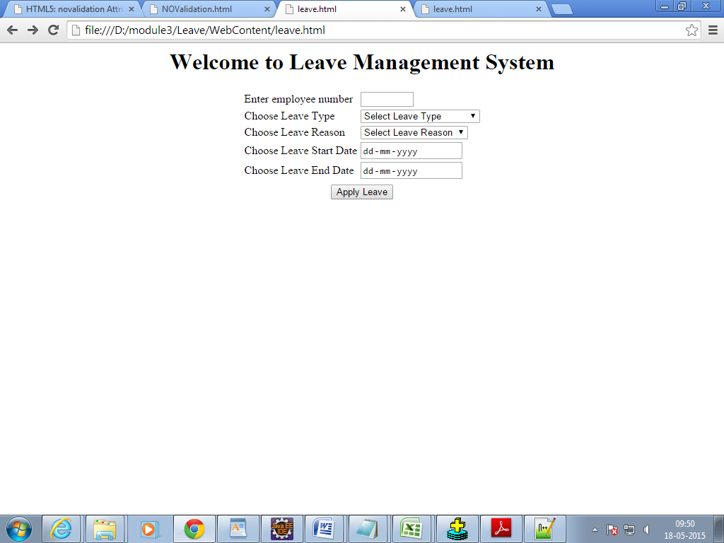

Values for leave reason control should be :

Select Leave Reason

Personal Leave

Sick Leave

Out of Station

**. Create another table empleave to store empno and leavebalance, leave_used**

**Also create Leavedetails table to store data from form**

When clicking on Apply Leave button, store details in a table Leavedetails

Once employee submit leave application then required changes should happen in empleave table

If user selects Show leave details then accept employee number from user and display leave balance and leave_usedfor the employee.

**Set – III**

Write a web application to do the following [40 Marks]

Display apage with 2 links

Add referral

View Referal

If user selects add referral then display following form and accept details from user.

1. Current Location should be Gurgaon,Mumbai, Pune,Chennai.

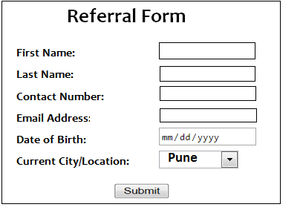

When user clicks submit button then add record in the table referaltab

When user select view referral, then accept city from user. Display all user from the city.

**Set - IV**

Write a web application using spring [40 Marks]

Write web page to display following links

Register user

View User

If user selects Register user then accept details in following form

**Create a registration page as shown below.**

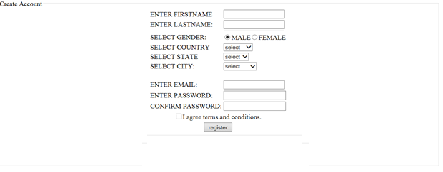

After clicking on register button store data in table registertab

When user clicks view user then accept city from user and display all registered users from the city.