**Resume Writing**

Meaning:

Resume, (English) to restart

**Resume’ (French) – to summarise**

**CV-(Latin) -The story of your life**

**Font Type:**

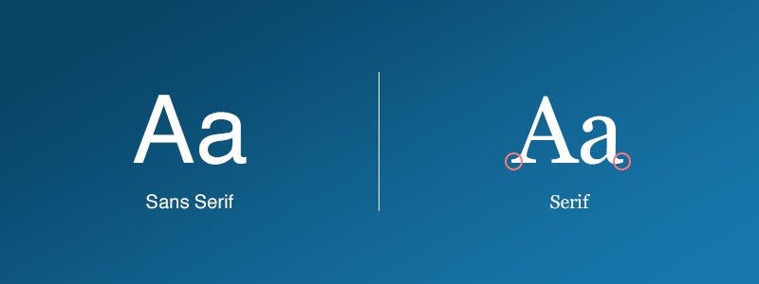

1. **Seriff-** Times New Roman

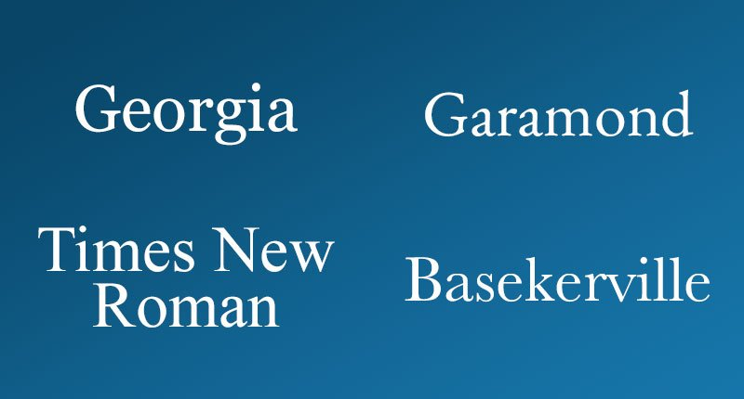 Georgia



1. Sans-seriff- Verdana, Helvetica, Arial

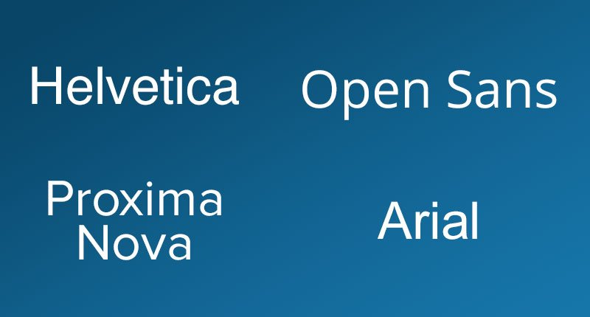



**Contact details**

**A.**

**Hardik Pandya (NOT: HARDIK PANDYA) (14-16/Bold)**

102, ABC Society, Pune-20

98567 23456

[hardik.pandya@gmail.com](mailto:hardik.pandya@gmail.com) (line spacing-1.5/1.15 withing the block)

**B.**

**Hardik Pandya**

102, ABC Society, Pune-20

98567 23456

hardik.pandya@gmail.com

**C.**

**Hardik Pandya**

102, ABC Society, Pune-20

98567 23456

hardik.pandya@gmail.com

**Objective:**

To obtain a position of a __________ which involves the skill set of _____________ .

(18-20 words / 1.5 lines)

**Skills/Strengths:**

* C++
* Java
* Python

**OR**

* Organised
* Focused
* Punctual
* A strong team leader
* Demonstrated excellent ability to communicate effectively
* Have negation skills with key vendors supplying…

**Professional Experience/ Internship:**

**1. Organization:** XYZ Ltd., Pune

**From**: January 2021 to December 2021

**Designation:** Team Lead

* Presented…
* Reported…
* Compiled…
* Assessed…
* Led a team…

**2.**

**Examples of Action Words:**

|  |  |  |  |  |
| --- | --- | --- | --- | --- |
| **Designed** | **Supervised** | **Created** | **Standardised** | **Built** |
| **Tested** | **Studied** | **Earned** | **Saved** | **computed** |
| **Designed** | **Remodeled** | **Planned** | **Streamlined** | **Projected** |
| **Gained** | **Programmed** | **Sold** | **Upgraded** | **Maximised** |

**Educational Qualifications: / Education:**

* Pursuing a PG Diploma in DAC at ACTS-CDAC, Pune
* Completed BE in IT with **85**% from XYZ University in 2021
* 12 class

**Projects:**

**1. Title: Object Detection (March 2021)**

**Summary:** (Not more than 3 /4 lines) include-technology used, procedure, what you did, what were the challenges, what was the outcome

**Note:** The project was published as a research paper**.\***

**2. Title: ___________________**

**Trainings / Certifications:**

**Awards/Achievements/Extracurricular Activities:**

* Published a research paper titled “___________________” in an international magazine “____________” in 2021* (ISBN:…..)
* Presented a research paper titled “_______________” at a national conference held in New Delhi in 2021

**Hobbies:** Reading non-fiction, Writing/Reading technical blogs, making vlogs, Trekking, Cycling, Playing Tennis, Running half marathons

**(Minimum 1/Maximum 2)**

**Languages known:** German (A1 Level) English, Marathi, Hindi

**Don’t add the following on the resume’**

Declaration

Family background

Date of birth

Height , complexion

Caste, Religion

Photographs

Passport number

Adhar number