***Software Engineering Module Test***

**Questions: 30**

**Marks: 60**

**Duration: 60min**

**1. Which of the following statement is correct?**

1. Requirement engineering is the process of discovering the services with the customer
2. The requirement specification acts as the basis for a contract between the client and the software developer.
3. Requirement verification is the process that checks whether the requirements are accurate and complete.
4. Requirement analysis is not an important task that is within Requirement engineering process.

**2. Which of the following is true with regard to the spiral model of software development?**

1. It is an evolutionary model that includes an explicit risk analysis phase.
2. Spiral model is not an incremental software development model.
3. It is applicable for projects with clear and stable requirements.
4. It is not suitable for a project such as developing a nuclear power plant control system.

**3. What are the two most important software quality attributes the system should have?**

* 1. Functionality
  2. Usability
  3. Performance
  4. Scheduling

**4. Following are levels of testing**

1. Unit Testing, System Level Testing, Acceptance Testing
2. Unit Testing, Integration Testing, User Acceptance Testing, Regression Testing
3. Resting, Unit Testing, Acceptance Testing
4. Integration Testing, Regression Testing, User Acceptance Testing

**5. Which of the following is NOT a white box technique?**

a. Statement testing

b. Path testing

c. Data flow testing

d. State transition testing

**6. Testing performed by a human, without using any third party tools is …………..**

a. Automation Testing

b. Functional Testing

c. Manual Testing

d. Documentation Testing

**7. QA identifies weakness in process and improves them.**

a. True

b. False

c. Not sure

d. Can’t say

**8. The** **cost of fixing a fault:**

1. is not important
2. increases the later a fault is found
3. decreases the later a fault is found
4. can never be determined

**9. Enhancement, upgrades, and bug fixes are done during the ----- step in SDLC.**

1. Maintenance and evaluation
2. Problem or opportunity identification
3. Design
4. Development and documentation

**10. To test a function, the programmer has to write a _________, which calls the function to be tested and passes it test data, and a ----------------which will be called for testing.**

a. Stub

1. Driver
   1. Proxy
   2. None of the above

**11. Incorrect form of Logic coverage is:**

1. Statement Coverage
2. Pole Coverage
3. Condition Coverage
4. Path Coverage

**12. The ------ determines whether the project should go forward.**

1. Feasibility assessment
2. Opportunity identification
3. System evaluation
4. Program specification

**13. Program validates a numeric field as follows:**

Values less than 10 are rejected, values between 10 and 21 are accepted,

Values greater than or equal to 22 are rejected

**Which of the following covers the MOST boundary values?**

1. 9,10,11,22
2. 9,10,21,22
3. 10,11,21,22
4. 10,11,20,21

**14. List out SDLC Models which can be used for the fixed requirements:**

**15. Which of each of the following is not an activity of the project planning process?**

1. Draw up project schedule
2. Establish project constraints
3. Review project progress
4. Define project milestones and deliverables
5. Product reviews

**16. State True/False**

* Unit Testing Focuses on Functional Testing

**17. Testing is often referred to as a destructive process where each test phase usually corresponds to different stages of the software development process. Which of the following do not match?**

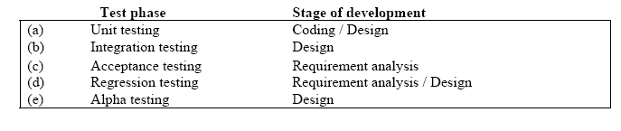

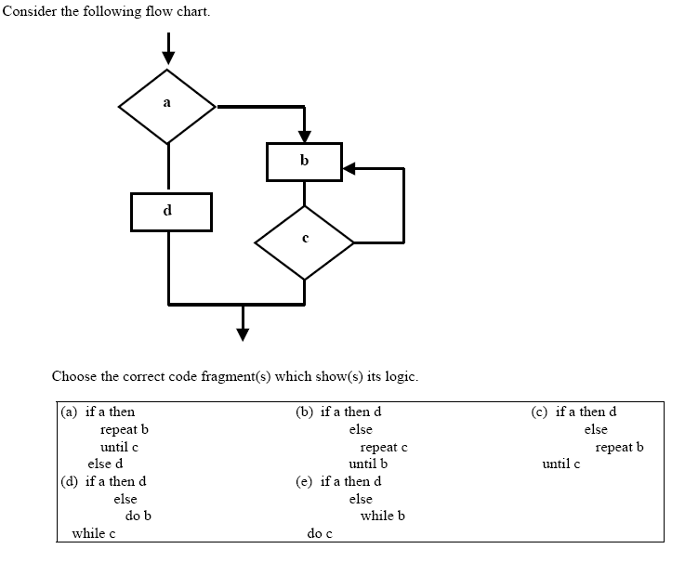

**18. Plz refer above question**

19. CMMI Stands for.......

1. Capable Maturity Model Integrity
2. Capability Maturity Method Integration
3. Capability Maths Model Integration
4. Capability Maturity Model Integration

**20. What are the fundamental software engineering activities?**

1. Software ageing
2. Software development,
3. Hardware preparation
4. Software reengineering

**21. What are the best software engineering techniques and methods?**

1. SDLC and Process Models
2. Reengineering Software
3. Setting Policies and Standards
4. Team development

**22. Validation is to check**

1. whether we are building the product right
2. whether we are building the right product
3. the methodology of software development
4. none of above

**Read the following scenario and answer questions (23) – (26).**

EBiz is a recently established organization in the business of buying and selling used computers. It has been in operation for 5 years and looks forward to improve its business process by automating some parts of its existing manual process, in the quest of gaining competitive advantage over its rivals. The EBiz management has decided to go online for transactions and plans to develop a web portal to display its stock of computers. With the new system, buyers can request a catalogue of the stock whereas sellers can post details of their computers online. Ebiz will notify successful tenderers in due course.

**23. Which of the following would be correct statements, given the information above?**

1. The linear sequential model is the most suitable process model to automate the core business process of Ebiz.
2. Rapid application development would be suitable to develop the system.
3. Evolutionary prototyping would be suitable to develop the interfaces with customer

feedback.

1. Spiral model would be the most suitable process model to develop the system.
2. Formal systems development is not suitable as the process model for this project.

**24. What are the two most important software quality attributes the system should have?**

1. Reliability
2. Robustness
3. Correctness
4. Usability
5. Safety

**25. Which of the following is a / are functional requirement(s) of the Ebiz system?**

1. Buyers need to request a catalogue of the stock.
2. The interfaces should be customizable so that a wide variety of users could use the system effectively.
3. Sellers need to post details of their computers to the system.
4. Ebiz needs to notify successful tenderers.
5. Time taken to download images in the catalogue should not irritate users.

**26. Consider the following Data Flow Diagrams (DFDs).**

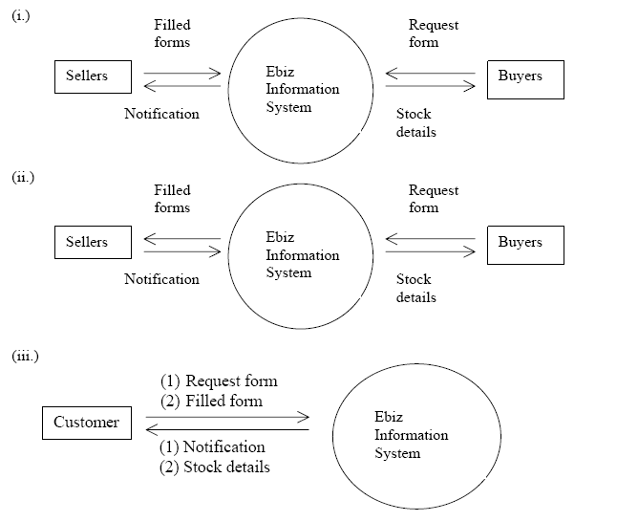

**Which of the following are correct DFDs for the Ebiz system?**

1. (i) only
2. (ii) only
3. (iii) only
4. (i) and (ii) only
5. All

**27. Find the activity which is not part of version management**

1. controlled change
2. storage management
3. coding standard
4. SDLC processes

**28. State True/False**

Agile Methodology gives flexibility for frequent Change in Requirements

**29. What is TDD?**

1. Testing Driver Development
2. Test Driver Development
3. Test Driven Development
4. Test Development for Driver

**30. Which of the following is a part of Risk Management?**

1. Risk Identification and Risk Analysis
2. Process Response Planning
3. Project Monitoring and Control
4. Reverse Engineering