Project' DetailsThis project aims to design and develop a backend administrative portal for the Learner’s Academy using Java EE technologies. I developed it as a  
project of phase 2 for the Become a back-end expert course. The goal of this project is to apply servlet, jsp and JDBC concepts.  
Product Backlog:1. Create database and tables.  
2. Connect the database to the project.  
3. Create models classes.  
4. Create a database utility class to retrieve data.  
5. Create login page.  
6. Create JSP files for all pages of the project.  
7. Create a servlet to get requests and send responses to the JSP files.  
8. Add cookies.  
9. Create a CSS file to format the contents.  
10. Debug and Test the project.  
Technologies and tools Used• Servlet: to do the business logic and works a controller for the project.  
• JSP: to handle the presentation view.  
• SQL: to create and manage the database.  
• JDBC: to make operations on the database for the project.  
• CSS: to format the contents.  
• phpMyAdmin: to administrate and manage the database manually.  
• Eclipse: to write and run the code.  
• Tomcat: to run and deploy servlet application.  
Flowcharts of The Application

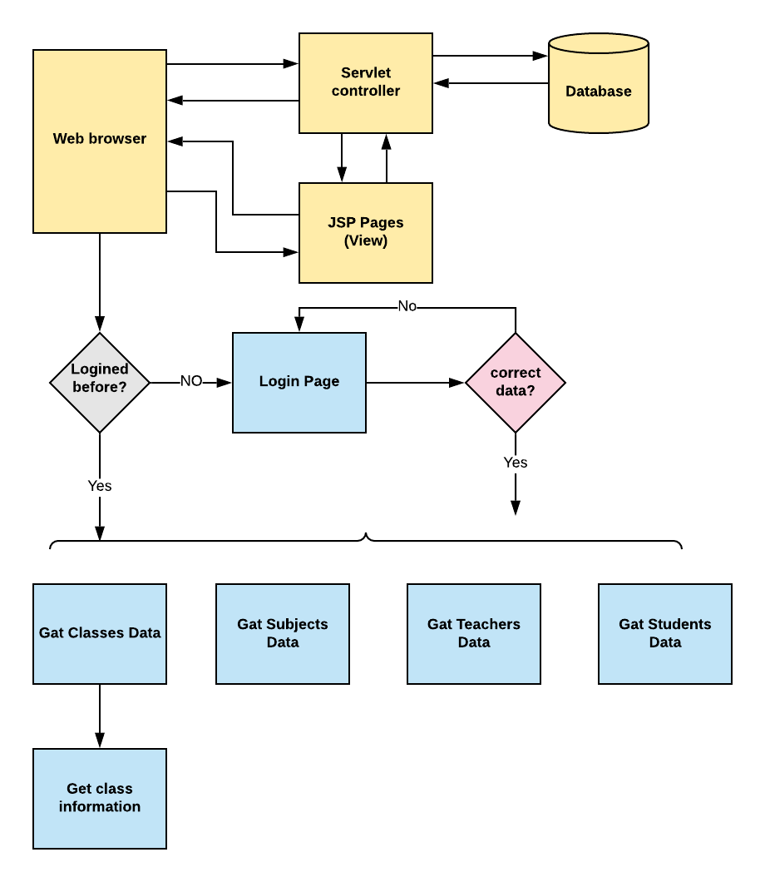  
Core concepts used in the project.• Object-Oriented: used to create and model objects for users and their credentials.  
• Databases: used to store and retrieve data.  
• Data Sources: used to define a set of properties required to identify and access the database.  
• Collections: used some collections such arraylist to store collection of data.  
• Exception Handling: used to catch problems that arises in the code especially in I/O blocks.  
• Cookies: to store log-in data on the client browser.  
How to run the program• clone project  
• Import the “database\database.sql” file to your database administration tool.  
• Go to “\src\main\webapp\META-INF\context.xml” file and open it.  
• Edit the database’ properties such as username, password and driverClassName to be suit to your database administration tool.  
• Now run program on a server.  
• To login you must enter admin for both username and password.  
  
Screenshots:  
