**FLOOD MONITORING AND EARLY WARNING SYSTEM**

**Abstract:**

Now-a-days floods are among the most common and devastating natural disasters, leading to loss of life, damage to infrastructure, and disruption of livelihoods. To mitigate the impact of floods, a robust Flood Monitoring and Early Warning System (FMEWS) is essential. This system integrates various technologies such as remote sensing, IoT (Internet of Things) sensors, and data analytics to monitor water levels, rainfall, and weather patterns in flood-prone areas. Real-time data collection and analysis enable the system to provide accurate and timely flood alerts to authorities and residents, facilitating prompt evacuation and disaster management efforts. Additionally, FMEWS(Flood Monitoring and Early Warning System) can be integrated with communication channels to disseminate warnings to the public via text messages, mobile applications, and sirens. By providing early warning and crucial information, the Flood Monitoring and Early Warning System significantly contributes to minimizing the impact of floods and enhancing community resilience to such natural disasters.

**INTRODUCTION:**

Floods are recurrent natural disasters that pose a significant threat to communities worldwide, causing widespread devastation and loss of life. The unpredictability of these events underscores the critical need for effective flood monitoring and early warning systems (FMEWS) to mitigate their impact. Such systems play a pivotal role in providing crucial data on water levels, weather patterns, and other relevant parameters, enabling authorities to make informed decisions and communities to take necessary precautions.

This paper provides a comprehensive analysis of the various components and functionalities of flood monitoring and early warning systems, highlighting their importance in disaster preparedness and risk reduction. By examining the integration of cutting-edge technologies and the implementation of robust communication strategies, this study aims to underscore the critical role of FMEWS in safeguarding vulnerable communities and enhancing their resilience against the detrimental impacts of flooding.

**Working Principle:**

The Flood Monitoring and Early Warning System (FMEWS) operates based on a multifaceted approach that integrates various technologies and data sources to effectively monitor and predict potential flood events. The primary components and working principles of FMEWS include:

**Data Collection:**

The system collects real-time data from multiple sources, including IoT sensors, weather stations, satellite imagery, and hydrological monitoring devices. These data sources provide information on rainfall intensity, water levels in rivers and streams, soil moisture content, and other relevant parameters.

**Data Analysis:**

Advanced data analytics and modeling techniques are applied to the collected data to assess flood risks, predict potential flood scenarios, and identify vulnerable areas prone to inundation. Machine learning algorithms and hydrological models help in generating accurate forecasts and early warnings based on historical data and current environmental conditions.

**Early Warning Generation:**

Once the data analysis identifies an imminent flood risk, the system generates early warnings that include precise information about the potential impact, expected flood extent, and recommended actions for residents and authorities. These warnings are disseminated through various communication channels to ensure timely and effective response measures.

**Communication and Dissemination:**

FMEWS utilizes a range of communication channels, such as SMS alerts, mobile applications, sirens, and local media, to disseminate timely warnings and flood-related information to the public and relevant stakeholders. This ensures that communities receive actionable guidance and can implement necessary evacuation and preparedness measures.

**Response and Mitigation:**

The early warnings enable local authorities and communities to initiate prompt response and mitigation measures, including evacuations, deployment of emergency services, and implementation of temporary flood protection measures. Community engagement and awareness campaigns play a crucial role in fostering a proactive approach to flood preparedness and resilience-building.

**ARCHITECTURE OF THE PROPOSED SYSTEM:**

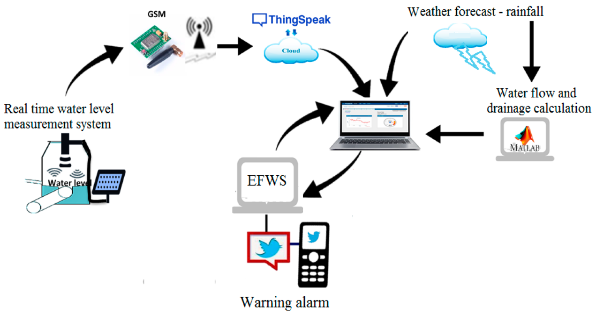

**HARDWARE REQUIREMENTS:**

* Water level sensors
* Rainfall Gauges
* Weather Stations
* Remote Sensing Devices
* Communication Systems
* Data Processing and Storage Equipments
* Power Supply and Backup System
* Networking infrastructure

**SOFTYWARE REQUIREMENTS:**

* Data Analytics
* Visualization
* Communication

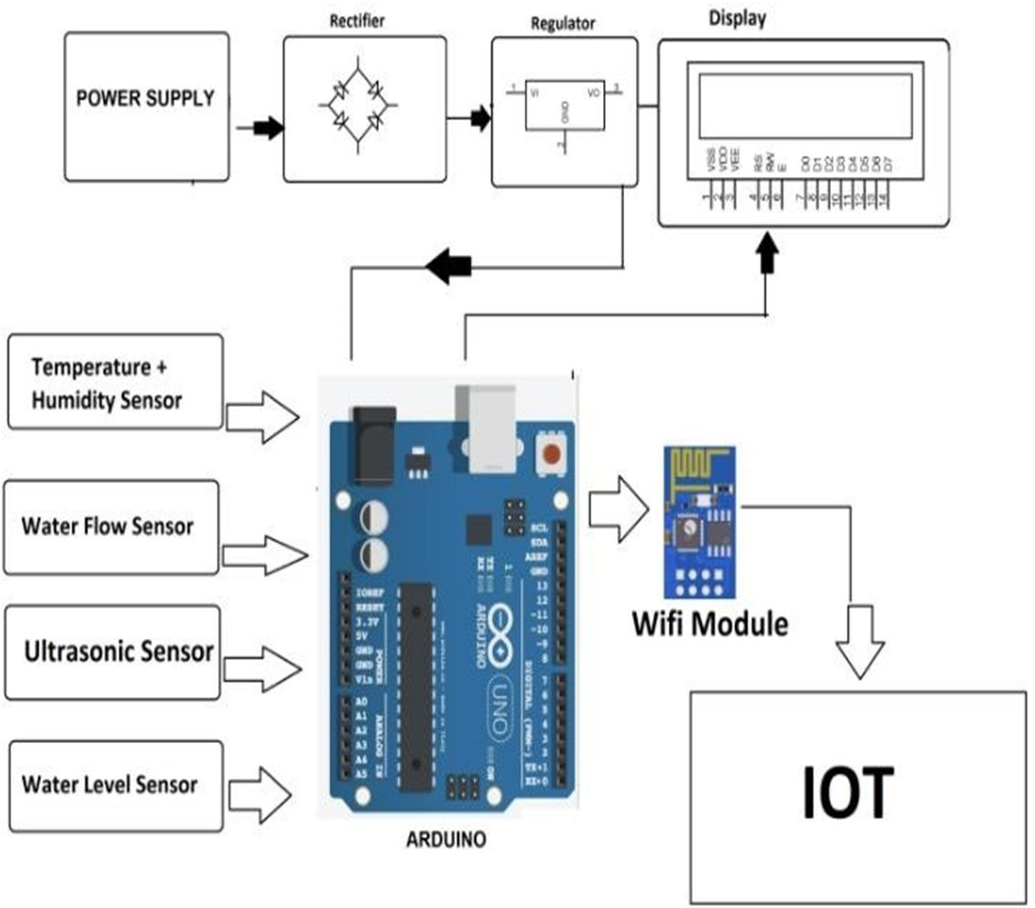**BLOCK DIAGRAM :**

**FLOW CHART:**

System sends alert to every local at every minute

Ultra sonic sensor receives sonic pulse reflected from water level

Liquid level?

Indicator turns red

Water level cautious level

Indicator turns green

System sends alert to locals that request alerts

Indicator turns yellow

System sends to every locals for every five minutes.

Alarm sounded

Water level at dangerous level

Water level at safe level

Ultrasonic sensor and sends sonic pulse reflected from water in a place that require observation

]

**CODING:**

import random

import time

# Simulated river level monitoring function

def monitor_river_level():

return random.uniform(0, 10) # Simulate river level between 0 and 10 meters

# Function to issue a flood warning

def issue_flood_warning(severity):

print(f"Flood warning - Severity: {severity}")

# Threshold values for flood warnings (adjust as needed)

threshold_low = 2.0 # Low flood risk

threshold_medium = 5.0 # Moderate flood risk

threshold_high = 7.5 # High flood risk

while True:

# Monitor the river level

current_river_level = monitor_river_level()

# Check if river level exceeds the thresholds

if current_river_level >= threshold_high:

issue_flood_warning("High")

elif current_river_level >= threshold_medium:

issue_flood_warning("Moderate")

elif current_river_level >= threshold_low:

issue_flood_warning("Low")

# Pause for a set interval (simulating real-time monitoring)

time.sleep(60) # Wait for 60 seconds before the next reading.

**WORKING MODEL:**

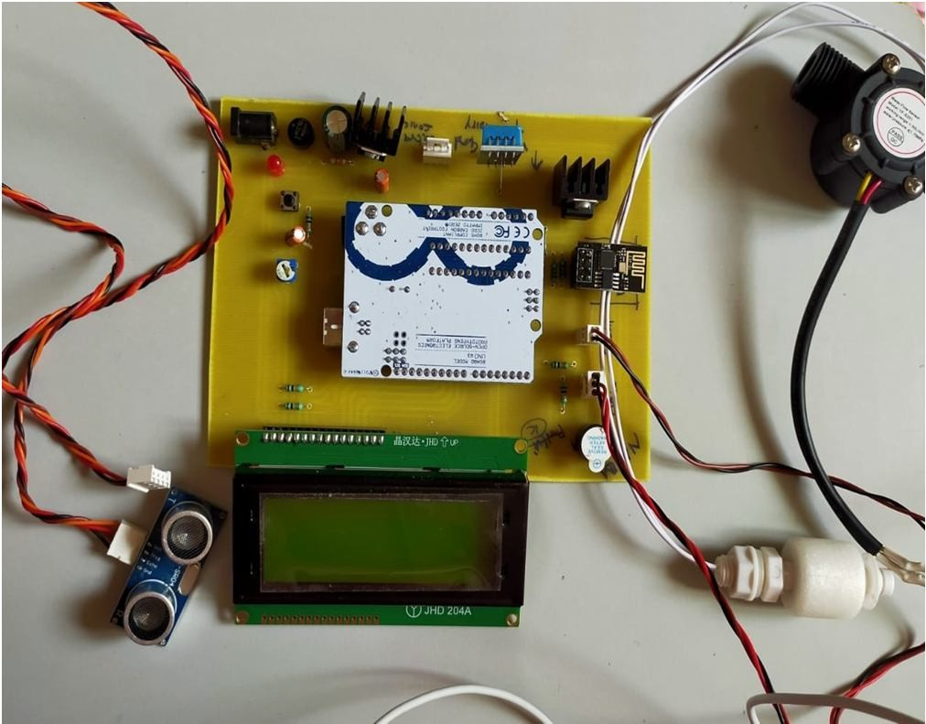

**CONCLUSION:**

In now-a-days scenarios, the development and implementation of Flood Monitoring and Early Warning Systems (FMEWS) play a pivotal role in enhancing community resilience and reducing the devastating impacts of flooding events. By integrating advanced technologies, data-driven analysis, and effective communication strategies, FMEWS enable timely and accurate flood forecasting, early warnings, and proactive disaster response measures.

Through the utilization of a combination of hardware components such as sensors, data collection devices, and communication tools, along with software systems for data analysis, modeling, and communication, FMEWS can effectively monitor, assess, and predict flood risks. This comprehensive approach empowers authorities and communities to make informed decisions, initiate timely evacuations, and implement effective flood mitigation measures to safeguard lives and minimize property damage.

The successful implementation of FMEWS requires collaborative efforts between various stakeholders, including government agencies, research institutions, and local communities. Community engagement and awareness campaigns are essential for ensuring that residents are well-informed and prepared to respond to flood warnings and evacuation alerts.

As climate change continues to exacerbate the frequency and intensity of extreme weather events, the importance of robust FMEWS cannot be overstated. By fostering a culture of preparedness, leveraging technological advancements, and promoting interdisciplinary collaboration, FMEWS can significantly contribute to building more resilient communities and sustainable disaster risk reduction strategies in flood-prone regions worldwide.