C++ Hybrid Inheritance Block Diagram

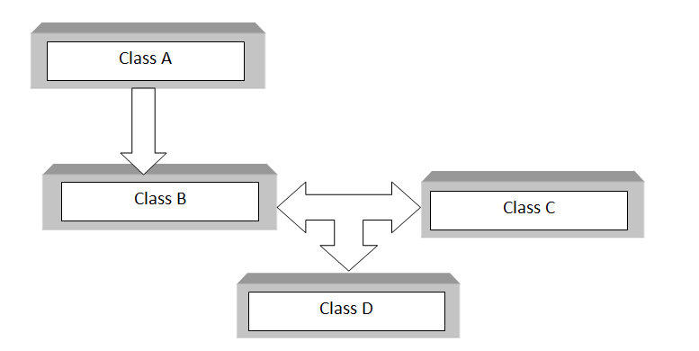

C++ Hybrid Inheritance Syntax

class A

{

.........

};

class B : public A

{

..........

} ;

class C

{

...........

};

class D : public B, public C

{

...........

};

As shown in block diagram class B is derived from class A which is single inheritance and then Class D is inherited from B and class C which is multiple inheritance. So single inheritance and multiple inheritance jointly results in **hybrid inheritance**.

class A

{

public:

int x;

};

class B : public A

{

public:

B() //constructor to initialize x in base class A

{

x = 10;

}

};

class C

{

public:

int y;

C() //constructor to initialize y

{

y = 4;

}

};

class D : public B, public C //D is derived from class B and class C

{

public:

void sum()

{

cout << "Sum= " << x + y;

}

};

int main()

{

D obj1; //object of derived class D

obj1.sum();

return 0;

} //end of program

**Output**

Sum= 14