## ASSESSMENT

**INDEX**

**Chapter – 1**

Introduction

**Chapter – 2**

Overall Description

**Chapter – 3**

Feasibility Study

**Chapter – 4**

Project matrix in 20 Days

**Chapter – 5**

Output Screens

**Introduction**

**Purpose :-** A service station is originally a full service filling station with a repair garage on-site. So this software is very helpful to manage the service station work in very easy way. The working in the organization will be well planned and organized. The data will be stored properly in data stores, which will help in retrieval of information as well as its storage. The level of accuracy in the proposed system will be higher. All operation would be done correctly and it ensures that whatever information is coming from the center is accurate. The reliability of the proposed system will be high due to the above stated reasons. The reason for the increased reliability of the system is that now there would be proper storage of information. In the proposed system utmost care would be that no information is repeated anywhere, in storage or otherwise. This would assure economic use of storage space and consistency in the data stored.

**Overall Description**

**1. Planned approach towards working: -** The working in the organization will be well planned and organized. The data will be stored properly in data stores, which will help in retrieval of information as well as its storage.

**2. Accuracy: -** The level of accuracy in the proposed system will be higher. All operation would be done correctly and it ensures that whatever information is coming from the center is accurate.

**3. Reliability: -** The reliability of the proposed system will be high due to the above stated reasons. The reason for the increased reliability of the system is that now there would be proper storage of information.

**4. No Redundancy: -** In the proposed system utmost care would be that no information is repeated anywhere, in storage or otherwise. This would assure economic use of storage space and consistency in the data stored.

**5. Immediate retrieval of information: -** The main objective of proposed system is to provide for a quick and efficient retrieval of information. Any type of information would be available whenever the user requires.

**6. Immediate storage of information: -** In manual system there are many problems to store the largest amount of information.

**7. Easy to Operate: -** The system should be easy to operate and should be such that it can be developed within a short period of time and fit in the limited budget of the user.

**Hardware/Software Requirements**

**System Specifications Minimum Hardware Requirements:-**

* I3 Processor
* 8 GB Ram
* Hard disk 1000 GB
* Microsoft Compatible 101 or more Key Board Software Requirements: -

**Operating System** :

* Windows 7 , 10
* Programming language: .NET
* Web-Technology: ASP.NET 4.7
* Front-End: ASP.NET MVC
* Back-End: SQL SERVER
* Web Server: IIS

**Feasibility Study**

Feasibility study is conducted once the problem is clearly understood. Feasibility study is a high level capsule version of the entire system analysis and design process. The objective is to determine quickly at a minimum expense how to solve a problem. The purpose of feasibility is not to solve the problem but to determine if the problem is worth solving. The system has been tested for feasibility in the following points.

3.1. Technical Feasibility

3.2. Economical Feasibility

3.3. Operational Feasibility.

**Project Time Divination (20 Days)**

|  |  |
| --- | --- |
| Feasibility Study | 4st July to 12th July |
| **Requirement Gathering** | 12thJulyto 14th July |
| **Designing** | 15th july to 18th july |
| **Coding** | 19th july to 20th july |
| **Testing and Implementation** | 21st july to 23rd july |

**Output Screens**

**1. Register Page: -** This is Register page in which You can register new user

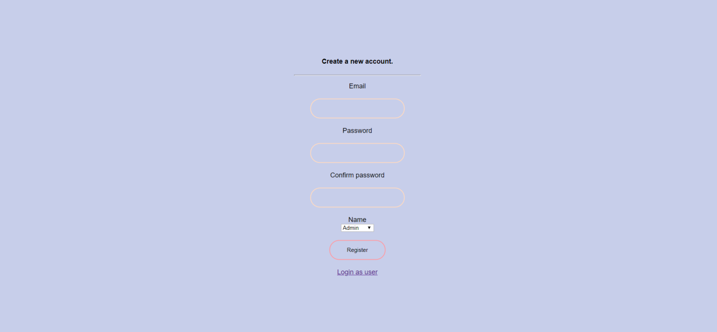

**2. Login Page: -** This is Login page of our website. In this page I can login as a Admin and As a Manager.

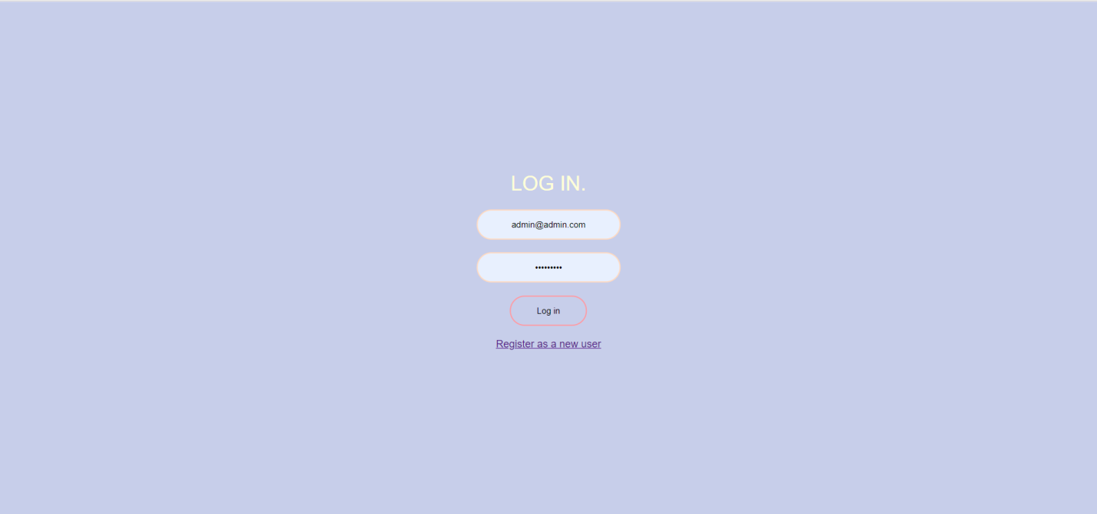

**3. Admin Login**: When admin logins then he can access the all modules of website. Which are shown in the picture.

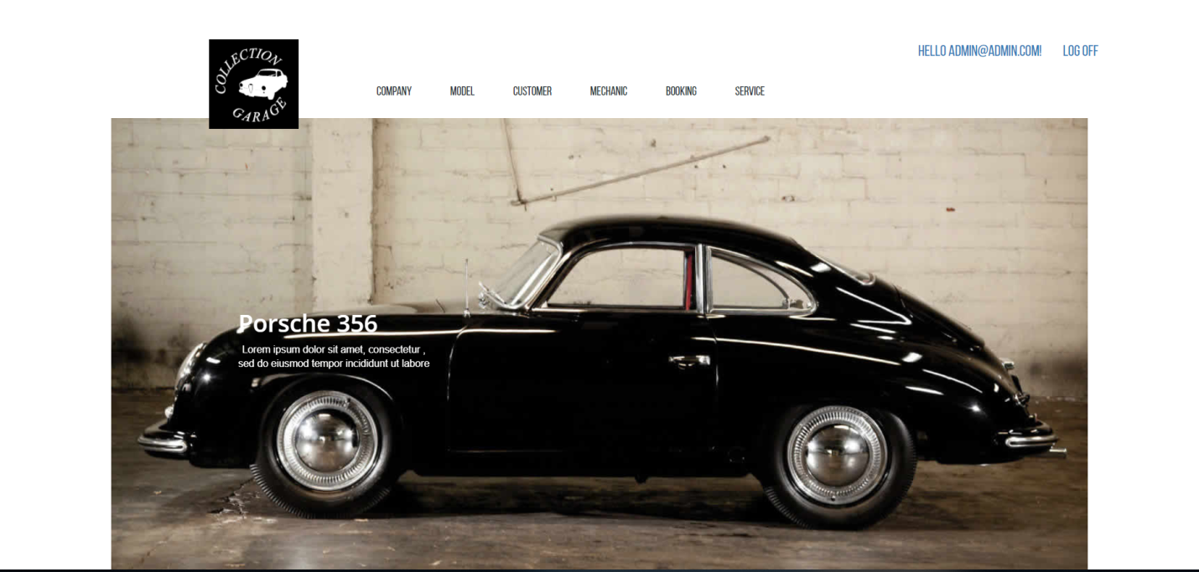

**4. Company: -**  Here I can show the companys in my website. And clicking on the create new link I can create the companys. Edit and delete company are also available here.

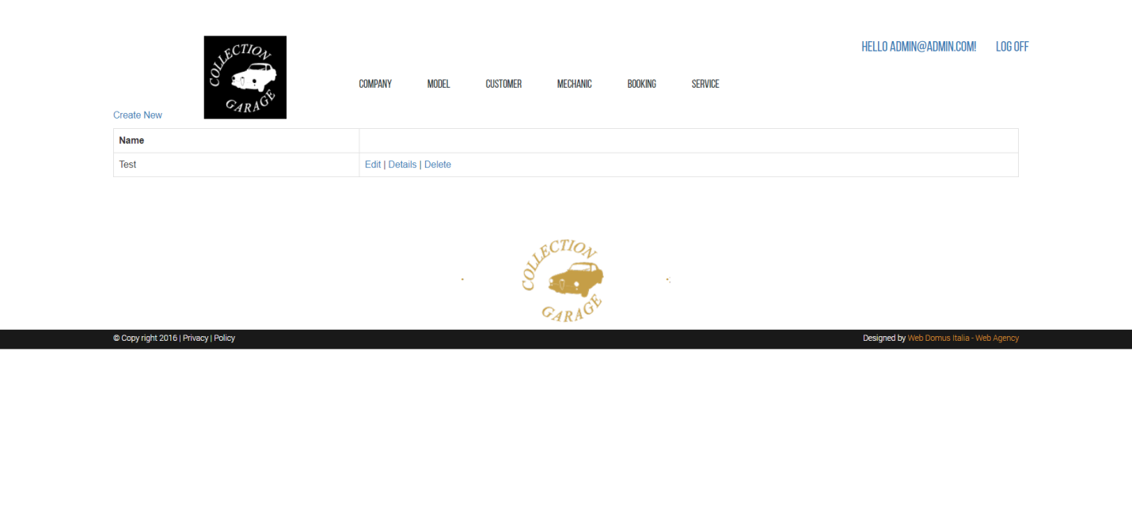

**5. Model: -**  Here I can show the model in my website. And clicking on the create new link I can create the model. Edit and delete model are also available here.

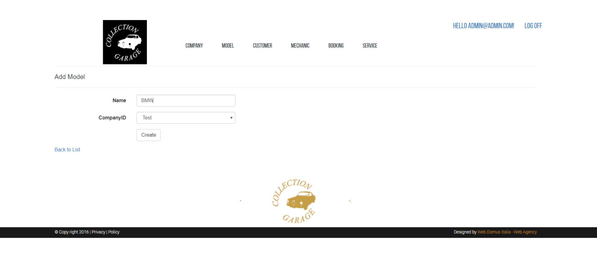

**6. Customer: -**  Here I can show the customer in my website. And clicking on the create new link I can create the customer. Edit and delete customer are also available here.

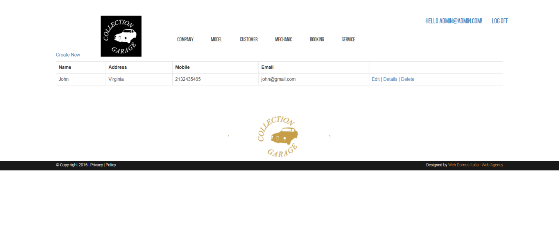

**7. Mechanic: -**  Here I can show the mechanic in my website. And clicking on the create new link I can create the mechanic. Edit and delete mechanic are also available here.

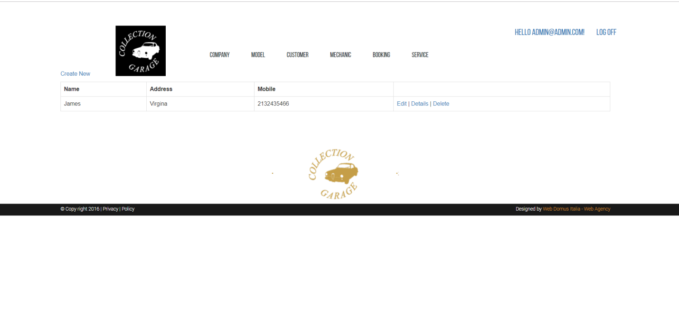

**7. Booking: -**  Here I can show the booking in my website. And clicking on the create new link I can create the booking. Edit and delete booking are also available here.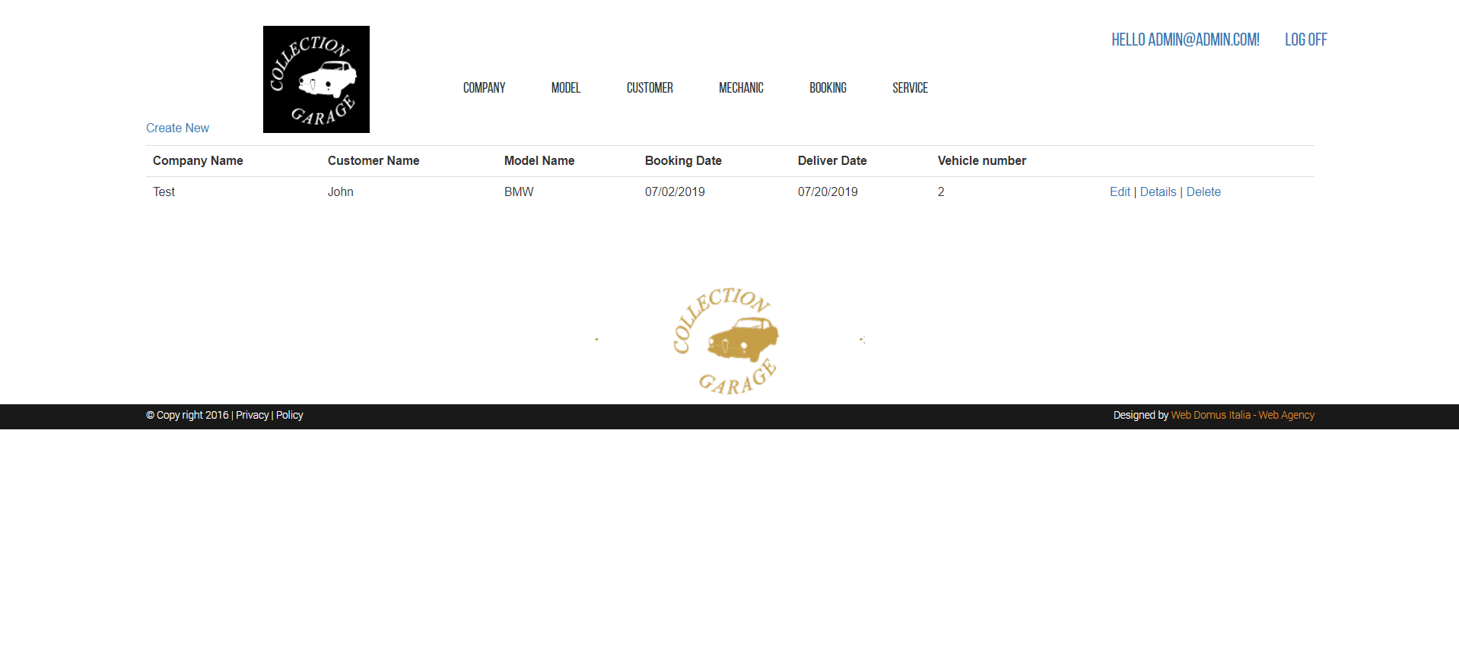

**7. Service: -**  Here I can show the service in my website. And clicking on the create new link I can create the service. Edit and delete service are also available here.

