# Table content

1. **Introduction**
2. **Wireframes**
3. **Mock-ups**
4. **Testing**

# Introduction

This project is about the Google Map Services application created by the group of 5 people. The application works in three Option on the main screen. First option is the Map where we can see the map location interface and Second option is the Locate Me where we can see our current location And, the last is Quit Option Which Helps to Quit the Application. At top of the Main page of application shows the Earth Image.

## 

## Mock ups

**Main Page**

At the starting of the Application an Earth Image and Also,There are four option in Front page .

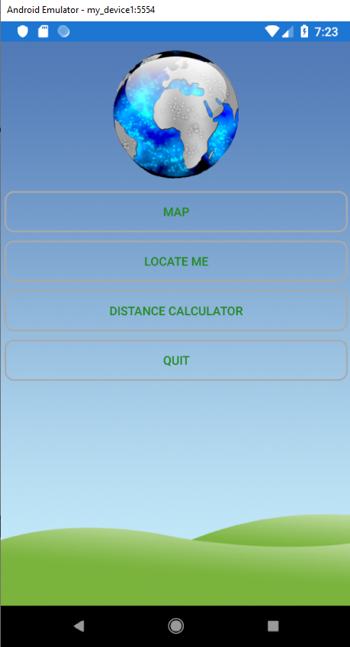

**Map Option**

**There is Map option Where we can see the Map and also we can see our current location.**

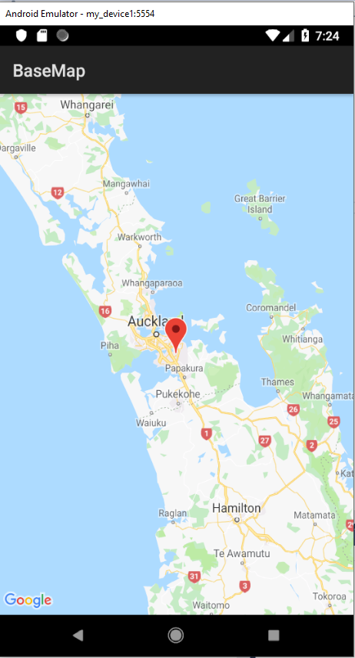

**Locate Me Option**

**We can see the Live Location by inserting in coding latitude and longitude.**

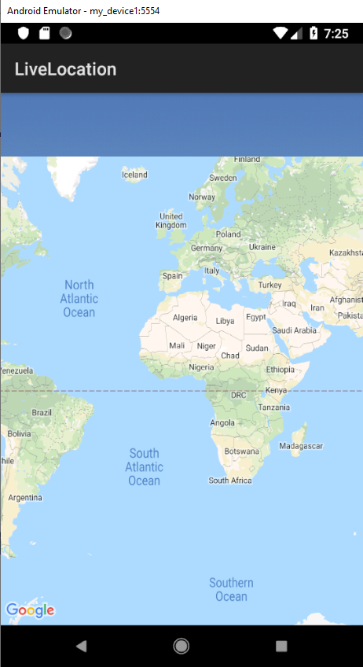

**Calculator Option**

**We can Calculate the distance between Two location in this option .**

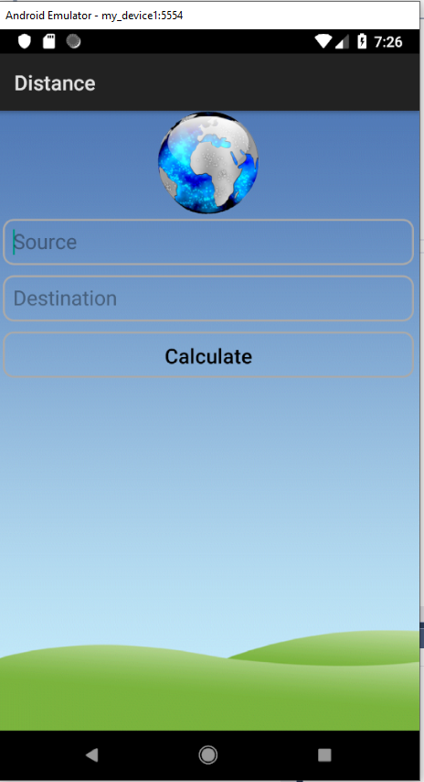

**Quit Option**

**The last option is quit where we can quit the application.**

## TESTING: -

|  |  |  |  |  |  |
| --- | --- | --- | --- | --- | --- |
| Step NO | Test Step | Input Data | Expected Result | Actual Result | Test Step Result |
| 1 | Map option shows the Map |  | Map shows | As Expected | Pass |
| 2 | Click on live location to see the current location |  | Shows your live location | As Expected | Pass |
| 3 | Distance Calculator | Add Cities for Calculating the Distance | Shows the distance between two cities | As Expected | Pass |
| 4 | Click Quit option |  | Quit the Application. | As Expected | Pass |