***On my honor, I pledge that I have not violated the provisions of the NJIT Student Honor Code***

STUDENT TEAM No__**2**__

Name Signature

…Arsh Bhamla………… ___**ARSH BHAMLA~~___~~**_ …Pranay KC………….. _**_PRANAY RAJ KC_____** ..Shreedhar Rajendran. **__Shreedhar Rajendran—**

..Christopher Karkenny. __**Christopher Karkenny**_

Experiment performed on date _04/ 25 / 2025__

Report submitted on date _________

Returned for corrections on date _________ Grade ______

Returned after corrections on date _________ Grade ______

**Introduction**

In this lab, we will be measuring the input impedance of an oscilloscope and understanding how a scope probe helps ensure accurate high frequency measurements. The oscilloscope's input impedance is made up of a resistive component and a capacitive component along with the capacitance of the connecting cable and these form a frequency-dependent load that can change how the circuit under test behaves which can cause errors in measurements because the current through the capacitive load depends on the frequency. We will use a scope probe being a 10:1 attenuator that includes a resistor and an adjustable capacitor to compensate for the oscilloscope's impedance which minimizes its effect on the circuit and ensures consistent signal attenuation at different frequencies. We will measure the oscilloscope’s internal resistance and capacitance, learn how the scope probe works, and use circuit simulation.

**Procedure**

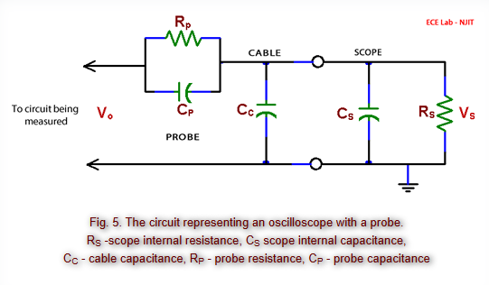

*Figure shown taken from* [*lab manual*](https://ecelabs.njit.edu/ece294/lab10.php)

**4.1 Measurement Of The Internal Impedance Of An Oscilloscope**

We will determine the oscilloscope's internal resistance by connecting a DC voltage source directly to the oscilloscope input and record the voltage reading and then use a resistance substitution box in series with the source and oscilloscope, gradually increasing resistance until the voltage displayed drops to half its original value which will have the resistance at this point approximating Rs. We will then find impedance with an AC signal by replacing the DC source with a sinewave generator and connect a fixed resistor in series with the generator and oscilloscope input to measure the voltage at frequencies like 10 kHz and 50 kHz to observe how the capacitive load affects impedance. We will then use a capacitance meter to measure the coaxial cable's capacitance by calculating its capacitance per unit length by dividing total capacitance by cable length, and document these values to evaluate the cable's impact on overall impedance and measurement accuracy.

**4.2 Scope Probe**

We will adjust the probe and connect it to the oscilloscope’s calibration terminal and fine-tune the probe’s adjustable capacitor until the displayed waveform is a clean square to make sure RpCp= Rs(Cs + Cc) for proper compensation and then construct a 2:1 resistive voltage divider with two equal resistors and verify their ratio and then measure input/output voltages using a sinewave (1 V amplitude) at frequencies like 10 kHz and 100 kHz with and without the probe and observe consistent attenuation with the probe unaffected by capacitance.

**4.3 Circuit Simulation**

We will use a simulation software such as LTspice or Multisim to model the oscilloscope probe circuit depicted in Fig. 5, incorporating the measured values for Rs,Cs, and Cc. For a 10:1 probe we will set Rp= 9Rs and Cp= (Cs + Cc)/9 as per standard probe design and simulate the circuit with the probe section (Rp || Cp) and cable Cc, and scope ((Rs || Cs)) connected in series between the input voltage (Vo) and oscilloscope voltage (Vs). For Cp we will input a 1 V amplitude and 1 kHz square wave to observe how adjusting Cp affects the waveform at Vs, starting with the ideal Cp value for proper compensation and then tweaking Cp slightly to see distortions like overshooting or rounding. We will then simulate the 2:1 voltage divider from Experiment 4.2 using the same resistor values and frequencies first without the probe by connecting the divider to the scope impedance and then with the probe and cable to assess how the probe minimizes capacitive effects by comparing simulated attenuation values with those observed in the lab.

**Data and Calculations**

**4.1 Measurement Of The Internal Impedance Of An Oscilloscope**

A)

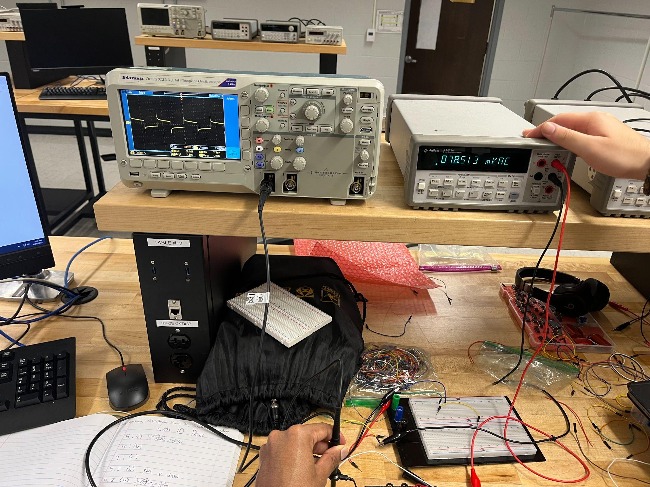

B)

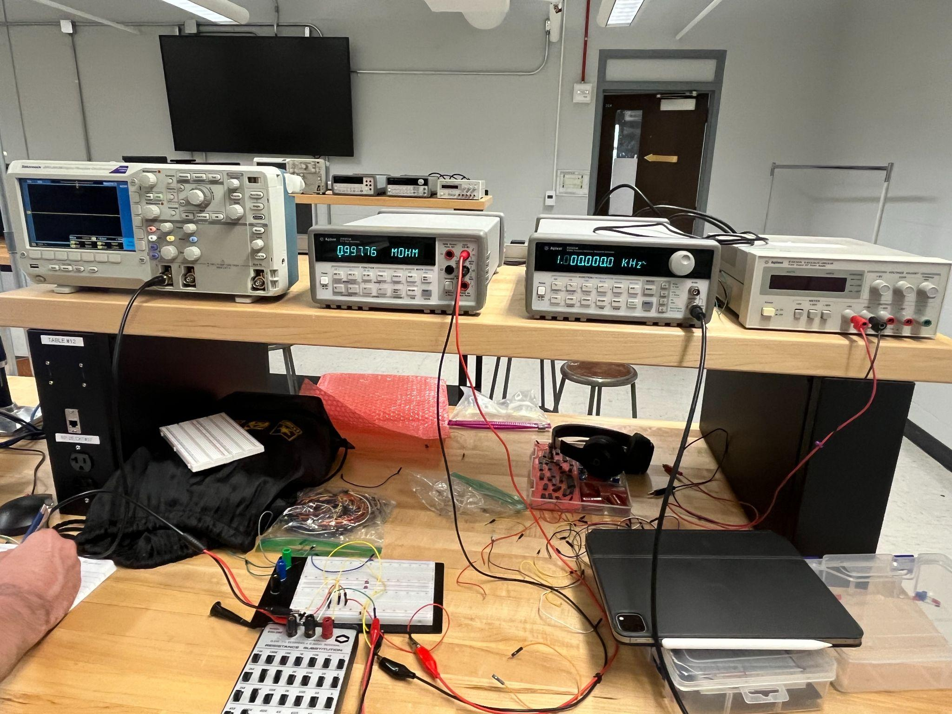

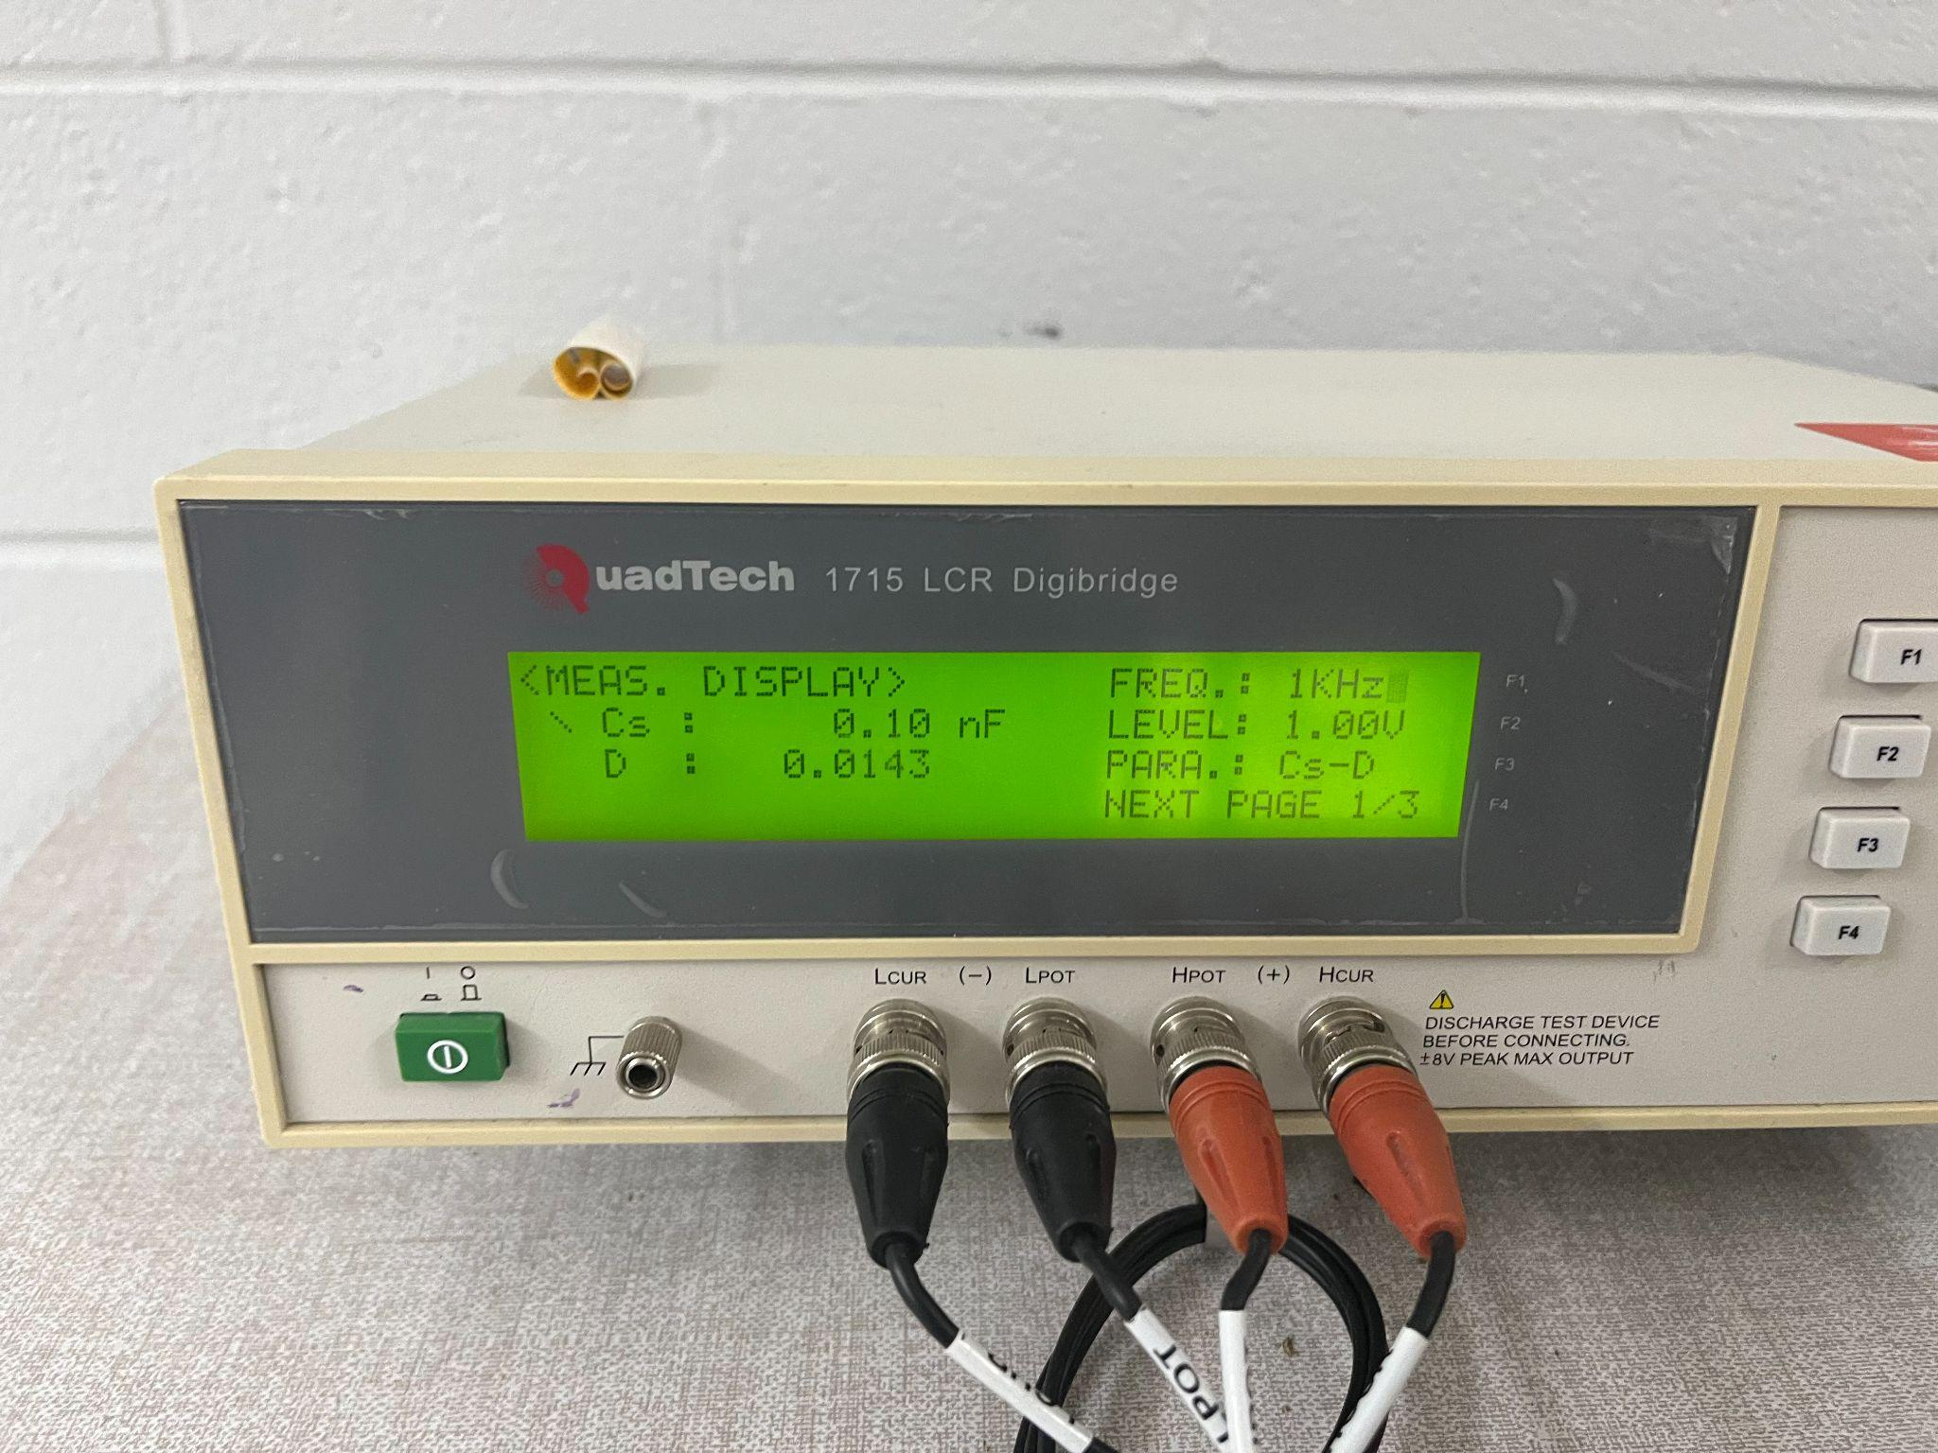

**4.2 Scope Probe**

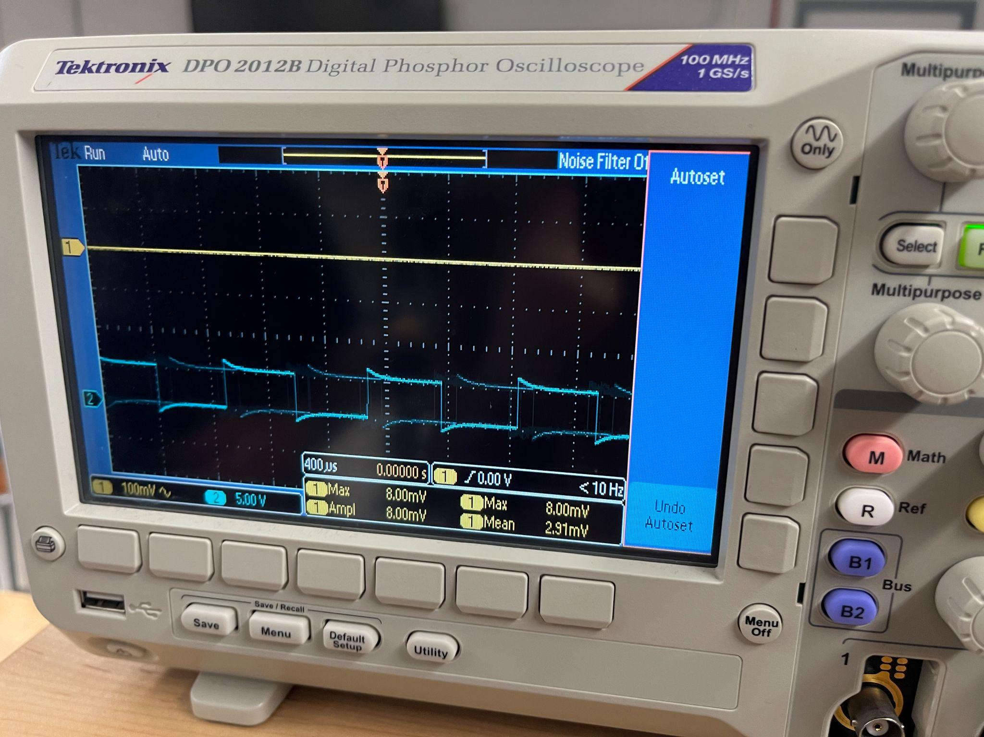

B)

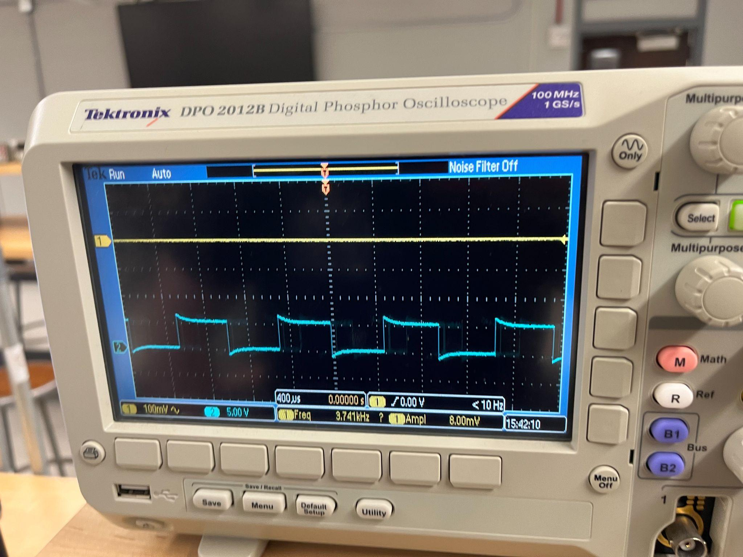

**Discussion**

In this lab, we learned about the oscilloscope's internal characteristics by figuring out its input resistance and capacitance through both DC and AC measurements. For Experiment 4.1, we used the DC method to calculate Rs by finding the external resistance that cut the measured voltage in half, giving us Rs=1 Mohm and we moved to the AC measurements where we used a sinewave signal and an external resistor to study how the oscilloscope’s input impedance changed with frequency by applying the voltage divider formula and subtracting the cable capacitance we had measured earlier, we were able to isolate the oscilloscope’s internal capacitance. Rs and Cs define the input impedance of the scope, with Cs having a bigger influence at higher frequencies because of its capacitive reactance. In Experiment 4.2, we tested how the scope probe affects measurements by comparing voltage divider setups with and without it and found without the probe, the attenuation changed with frequency because of the scope’s capacitive loading, but with the probe, the attenuation stayed steady. Even though the probe reduces the signal by a factor of 10, this trade-off improves consistency across a wide frequency range which makes it super useful for accurate high-frequency measurements.

**Conclusions**

This lab was a great way to understand the oscilloscope’s input impedance and how important the scope probe is for reliable electronic measurements and by figuring out Rs and Cs experimentally we got a clearer picture of how these properties affect the scope’s performance, especially at higher frequencies as even though the scope probe reduces the signal, it’s really important because it counters the oscilloscope’s capacitive effects, making sure the results are consistent at different frequencies. These experiments, along with the calculations we did, showed how crucial it is to manage instrument impedance for accurate measurements which is why this lab showed why scope probes and impedance management matter so much in real-world applications.