***On my honor, I pledge that I have not violated the provisions of the NJIT Student Honor Code***

STUDENT TEAM No__**2**__

Name Signature

…Arsh Bhamla………… ___**ARSH BHAMLA~~___~~**_ …Pranay KC………….. _**_PRANAY RAJ KC_____** ..Shreedhar Rajendran. **__Shreedhar Rajendran—**

..Christopher Karkenny. __**Christopher Karkenny**_

Experiment performed on date _04/ 11 / 2025__

Report submitted on date ___04/25/2025______

Returned for corrections on date _________ Grade ______

Returned after corrections on date _________ Grade ______

**Introduction**

In this lab we will be looking into the basics of alternating current by working with a series RLC circuit which is powered by an AC voltage source and includes a capacitor, an inductor, and a resistor all connected in a loop. We will be seeing how capacitors and inductors resist current in AC systems and resonance which happens when impedance hits its lowest point at a certain frequency. The main goals are to see how reactance affects the voltage drops across the resistor, capacitor, and inductor, and to improve at using a digital oscilloscope to measure amplitude and phase differences. We’ll be using a digital voltmeter and an oscilloscope to gather accurate data to confirm Kirchhoff’s voltage law, especially since AC voltages involve both magnitude and phase. This lab will help us connect the theory of AC circuits to real world skills and will give us a deeper understanding of how AC systems work.

**Procedure**

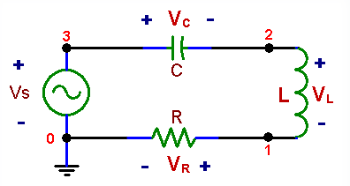

*Figure shown taken from* [*lab manual*](https://ecelabs.njit.edu/ece294/lab9.php)

**3.1 Set Frequency**

We will start by setting the waveform generator to produce an AC signal at roughly 1 kHz and then switch to a digital voltmeter to AC voltage mode and use it to measure the RMS voltages across different parts of the circuit such as the voltage across the resistor between nodes 0 and 1, the inductor between nodes 1 and 2, the capacitor between nodes 2 and 3, and the AC voltage source between nodes 0 and 3. We will make sure the total voltage drops in a closed loop should equal the source voltage.

**3.2 Compare Voltages**

We will set up a digital oscilloscope to compare the source voltage and the voltage across the resistor which reflects the circuit's current. We will connect one probe to nodes 0 and 1 to measure VR and another to nodes 0 and 3 to measure Vs and keep the waveform generator set to around 1 kHz and observe the sinusoidal waveforms for Vs and VR. We will then change the generator frequency up to around 5 kHz and take new measurements for the amplitudes and phase difference between Vs and VR and see how any changes to the measurements showing how frequency impacts the phase relationship between the source voltage and current.

**3.3 Measure Phase**

We will measure the phase difference between the voltage across the inductor and the current, using VR as a stand-in for current. We will set up the digital oscilloscope with two probes: one connected to nodes 0 and 1 to measure VR, and the other to nodes 0 and 2 to measure the voltage across both the resistor and inductor. We will then subtract the VR signal from the VRL signal, which will give you the voltage across the inductor, since VRL = VR + VL and find the phase difference by measuring the time delay between matching points on the waveforms, like peaks or zero crossings which will show the effect of inductive reactance on the voltage-current relationship in the circuit.

**Data and Calculations**

**3.1 Set Frequency**

VC= 0.7084 V

VL= 0.6538 V

VR= 0.705 V

VS= 0.7083 V

**3.2 Compare Voltages**

VS phase = -178.6°

VR phase = -178.3°

(VR Vs VS)

Left phase = resistor phase, same as VS

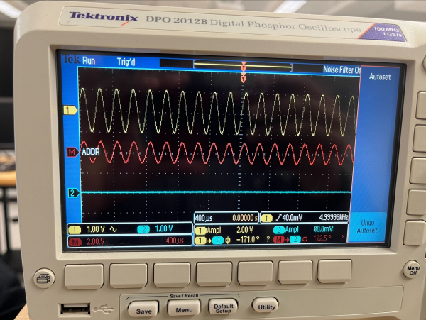

**3.3 Measure Phase**

Inductor: [78.53°]

Resistor: [-955.5°]

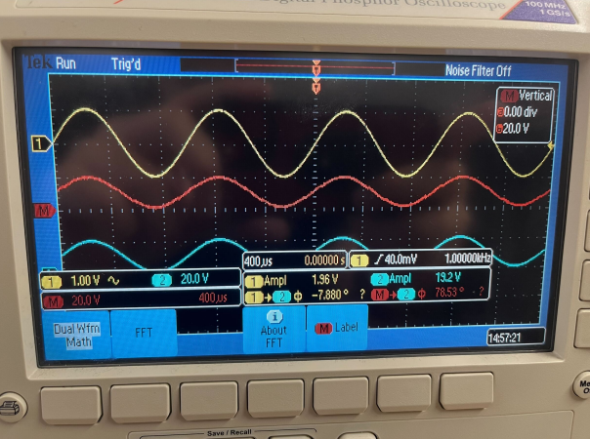

*VResistor (9.7k)*

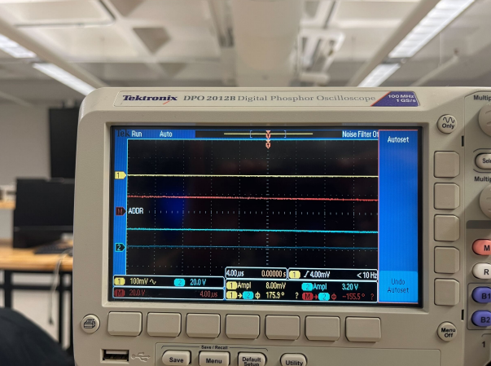

**Discussion**

In this lab experiment, we looked at the behavior of a series RLC circuit powered by an AC source. The main focus was on measuring voltage amplitudes and phase relationships across different components at various frequencies as in section 3.1 we used a digital voltmeter to measure the voltages across the resistor, inductor, capacitor, and the source and at first, the sum of the voltage magnitudes didn’t match Vs but we realized that KVL in AC circuits requires a vector sum, which considers both amplitude and phase, rather than just adding the magnitudes. This idea was supported by the measurements in sections 3.2 and 3.3, where we used a digital oscilloscope to measure phase differences, like between Vs and VR, and between VL and VR. When comparing our experimental results to theoretical calculations, the measured amplitudes and phase shifts lined up well, proving our methods were accurate. For section 3.3, we also observed that the phase difference between VL and VR matched the theoretical prediction that the voltage across an inductor leads the current by 90 degrees which showed that the results confirmed that KVL applies to AC circuits as long as phase is taken into account.

**Conclusions**

This lab gave us a hands-on look at the dynamics of a series RLC circuit under AC excitation and helped us better understand key concepts like reactance, phase shifts, and Kirchhoff’s voltage law in AC systems. We used a DVM to measure voltages and an oscilloscope to track phase differences at different frequencies and were able to confirm theoretical predictions which included validating that KVL holds in AC circuits when phase relationships are factored in. There is a close match between our data for the both amplitude and phase measurements and our theoretical calculations proved that our approach was accurate and the principles of AC circuits are reliable. This lab also improved our ability to use lab tools like oscilloscopes and DVMs, setting us up for future work in the field.