# Wireframe

# [Flight Fare Prediction](https://github.com/ganeshss0/flight-fare-prediction)

Revision Number: 1.0

Last Date of Revision: 20/07/2024

[**Arshdeep Singh**](https://github.com/arshdeep-singh-0/flight-fare-prediction)

**Contents**

|  |  |
| --- | --- |
| Abstract | 3 |
| Web Interface | 4 |
| User Input | 4 |
| Result Page | 5 |

* **Abstract**

The recent international things had a large impact on the aviation sector because of several reasons. This documentation is all about the user interface wireframe; here the home page of our flight fare prediction project is explained.

**1. Web Interface**

Our web page is one single interface where both input from the user and the prediction is displayed.

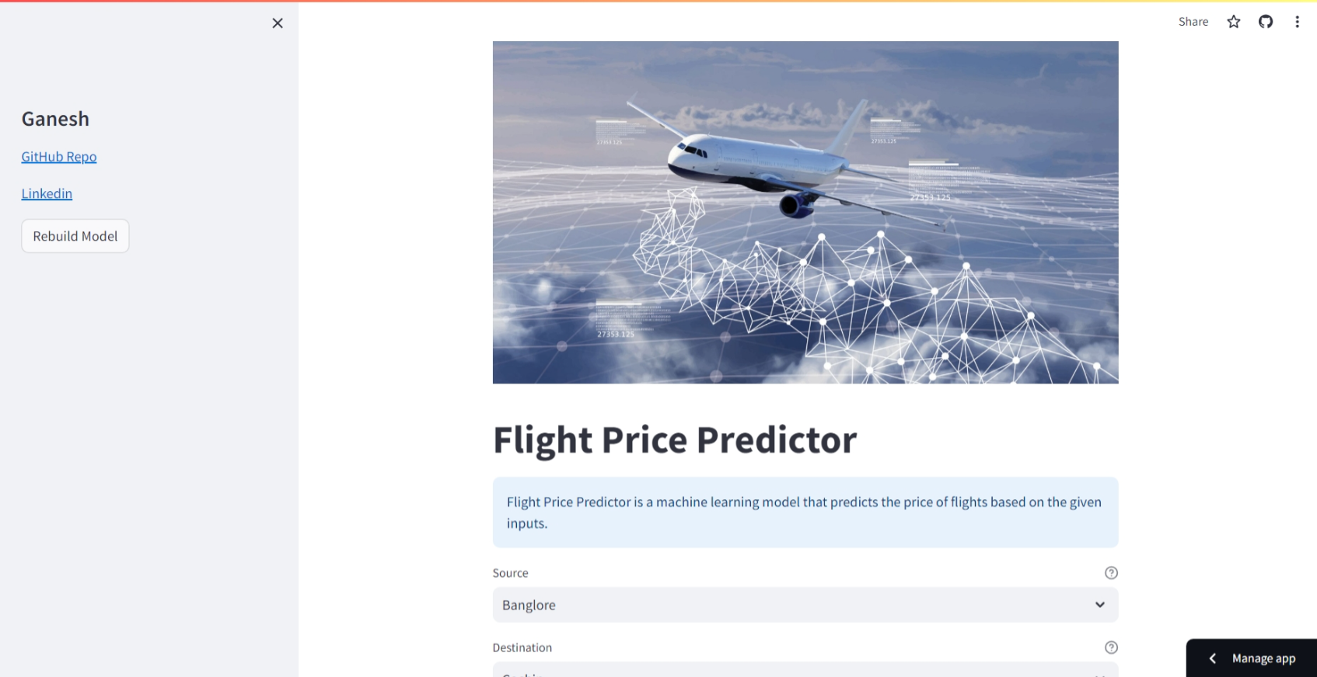

**2. User Input**

Whenever the user hits our URL, they first see the user input page here they must provide the information like:

* Every user input has its own dropdown where the user can select their input.
* After providing the required input and pressing the submit button, the page refreshes and displays the output

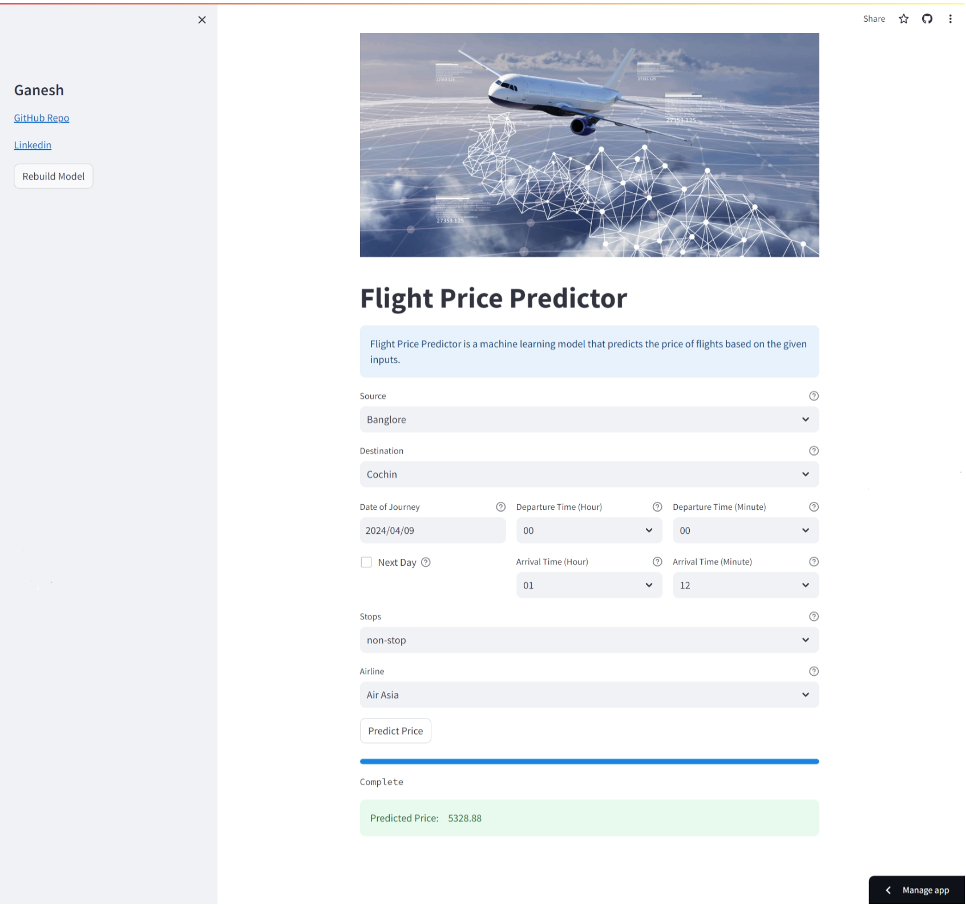

**3. Result Page**

After the user hits the submit button the page gets refreshed, and the results are being displayed in the highlighted area in the above frame.

The user can refill all the inputs in same page and get the results in the same way.