This project aims to provide a short critique of different Data Visualizations that can be found below. It aims towards providing an understanding of what differentiates a good visualization from a bad one.

**Visualisation 1:**

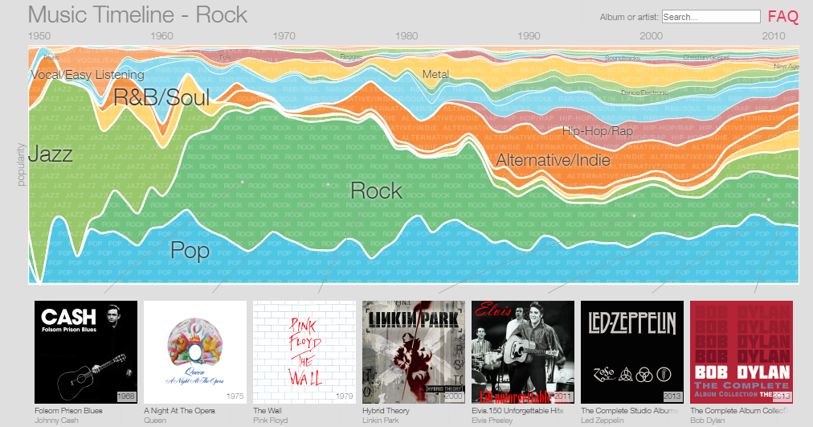

**Source:** [http://research.google.com/bigpicture/music/#](http://research.google.com/bigpicture/music/)

The above graph represents the Music Timeline from Google, which depicts the popularity of different music genres over the years ranging from 1950 to 2010. Since the visualization is highly interactive, further analysis of it gives information regarding which albums and artists were popular in a given year.

The intended audience of this visualization are the people who love music and the ones in the music industry who could do formal analysis and direct music based on its popularity among masses in a given year.

As can be seen from graph, the major data that has been visually encoded is the popularity of different musical genres over the years from 1950-2010. Each stripe has been encoded with a different colour to represent each genre. The thickness of the stripe represents the change in the popularity of music released in each genre over the years. The graph has been designed in an interactive manner with the following features:

1. When one hovers over any of the genres, it shows various albums of different artists just below the graph.
2. On clicking any of the genres, the individual graph for that genre gets opened. That graph is further subdivided into various subcategories to represent sub-genres with a different shading of the same base colour as that of the genre. For example, on clicking the Rock genre which is depicted through Green colour, the new graph pops up which represents sub-genres like Classic Rock, Progressive rock, ‘80s Rock, etc. with different shades of green. The thickness of each of these sub-genres also represents their popularity over the years.
3. Again on hovering on any of these sub-genres, one can see the list of corresponding albums displayed below the graph. On clicking on any of those albums from the list below, Google opens up information about the artist of that album and his various compositions based on different years in Google Play Music.
4. On clicking on any of the sub-genres, a new graph pops up showing the popularity of different artists from that sub-genre over the years. Again, the thickness of the graph represents the popularity of different artists over the years.
5. When one hovers over any of the artists’ name, the corresponding graph gets highlighted. On clicking on any of the artists’ name, a brief introduction of that artist and list of his/her most popular albums in different years gets displayed just below the graph.
6. When one clicks on any of the albums, one is redirected to Google Play store and has an option of buying that album.

In my view, the Music Timeline by Google is good at providing layers of information through each successive graph. All of the encoding principles like different colour coding and appropriate label description appear to have been followed. The graph is not only visually appealing but also data heavy. Although exact numerical values have not been used to represent the popularity of artists, the approximate visualization provided enough qualitative information to form a good formal analysis.

**Visualisation 2:**

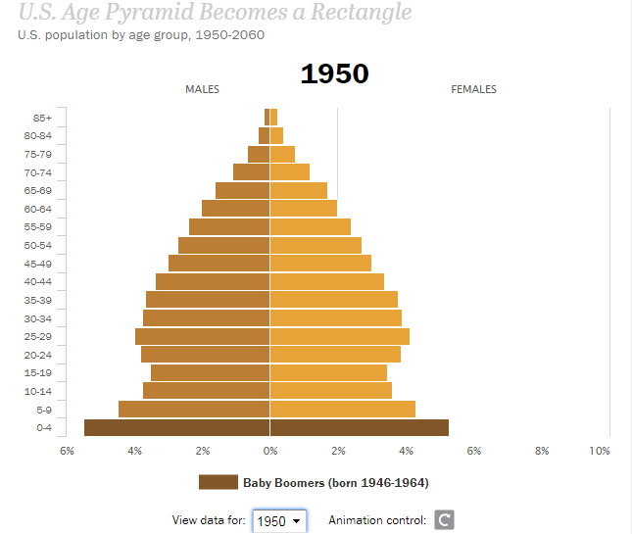

**Source:** <http://www.pewresearch.org/next-america/#Two-Dramas-in-Slow-Motion>

The above graph represents the U.S. Age pyramid which explains the challenges that America may face in future as a result of demographic transformations.

The intended audience of this visualization is the general public and the concerned political and economic organizations. The graphic intends to aware the general public so that they can prepare their next generation who will be made to work longer to finance the retirement of older people. It also warns various organizations to lay down appropriate policies in order to deal with the stress that will be generated on families and politics.

The major data that has been visually encoded are ages divided in fixed length groups of five years and the percentage of males and females in those age groups for different years varying from 1950 to 2060. Visualization in the form of bar graph has been used to represent the percentage of males and females (quantitative data) in each age group. The data can be interpreted in two ways. First is visualizing the data on a yearly basis where we can get quantitative values (percentage) of male and female in each age group. Second is visualizing the data in the form of animation where we can get a formal population analysis according to age groups over the years. The graph takes the form of a pyramid which turns into a rectangle close to the year 2060. This change in the shape represents very important information. The number of Americans above the age 85 will be same as those under the age of 5 by 2060. This implies that there will be lower birth-rates and longer life expectancy. This also means that people in the working age group will be in smaller proportion and will have to bear the burden of supporting the finances of retirement of old age people. This acts as a warning message for various political and economic organizations to prepare themselves and people to face such demographic challenges in near future.

In my opinion, the data visualization has been successful in conveying the message. It does not seem to violate any encoding principles. All the information is quantitative and different colour coding has been used for males, females and the baby boomers which make it clear to read the data. The additional feature of animation helps in quick population analysis for various age groups over the years. Although the graph is not using too much data, the simplicity of it works well to convey demographic transformation and challenges ahead.

**Visualisation 3:**

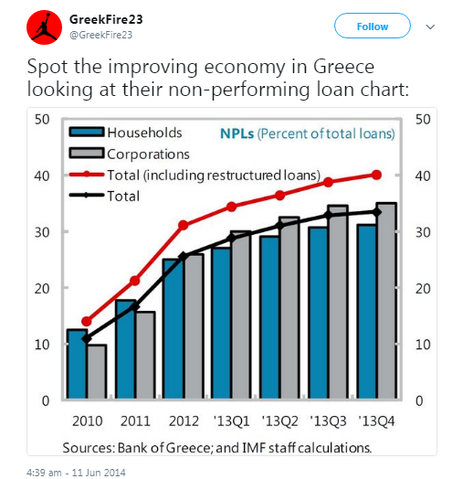

**Source**: <https://twitter.com/GreekFire23/status/476690146306568194>

The above graph represents the economic condition of Greece from 2010 to 2013 based on the percentage of its NPLs (Non-Performing Loans) out of total loans taken by it.

The intended audience of this visualization is the general public to whom it is trying to convey the information that the Greece economy improved from 2010 to 2013.

The two major data depicted in the graph are different years from 2010-2013 and quarters for year 2013; and the total percentage of loans. The data visualization chart that has been used is vertical bar graph to depict percentage of NPLs for both Households and Corporations. Different colour coding has been used to depict the information for both. Two line graphs with different colour codes each for Total Loans and Total Loans including Restructured loans have been plotted on the same bar graph to represent the general economic trend over 4 years.

In my opinion, although the visualization is trying to represent that the economy of Greece improved over 2010-2013 based on the analysis of NPLs, the graph is highly ambiguous and data seems to be misleading. It appears that the NPLs slowed down by the end of 2013 from the graph but in actual it does not appear to be the case. The visualization comes with various flaws as follows:

1. The independent variable axis depicting the years is non-uniform. It might appear that diving the year 2013 into quarters will give additional information, but in reality it is distorting the data. If we combine the quarters into year, the NPLs line will appear to rise instead of slow down which would mean the Greece economy worsened rather than improved, contrary to the message conveyed.
2. There is an assumption made that the line graph represents the percentage of NPLs out of total loans and hence the conclusion has been reached. But from the visualization, the assumption itself appears doubtful. The thing which is evident is that the individual bars represent total percentage loans. The line graph in that case should represent NPLs but the label on the graph depicts that to be Total loans which create confusion at first glance.
3. It also appears that if the total Household and Corporation loans have been represented through separate bar graphs, then why aren’t there two line graphs to represent percentage of NPLs out of total loans for each of them. This clearly creates confusion about how the calculation of NPLs has been performed. Has the percentage been taken out of total household loans or total corporation loans or total of both the loans remains unanswered. If some calculation formula had been provided, it would have cleared the confusion.

In my opinion, this graph stands as an example of bad visualization and also is highly misleading for a layman. If the above mentioned flaws had been addressed, the visualization would have represented a better picture of Greece economy.