Lab 1 - Getting Started with RISC-V (Assembly Language) in VS Code

Name: Arsheel Abbas | Student ID: aa11163

Task 3:

Code:
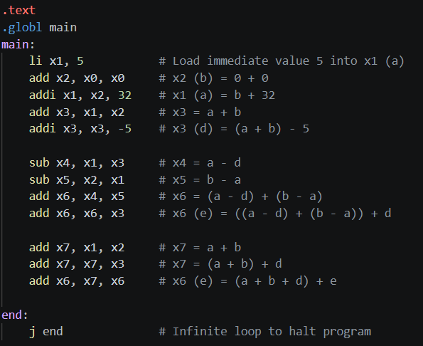

Results:
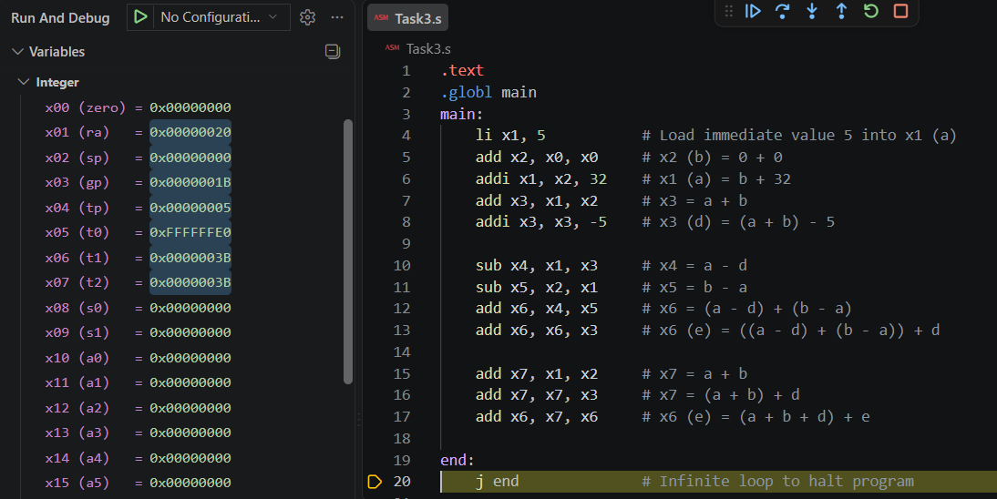

Task 4a:
- Store x10 as unsigned integer at address 0x100.
sw x10, 0x100(x0)

- Store x11 as unsigned integer at address 0x1F0.
sw x11, 0x1F0(x0)

- Load an unsigned short integer (two bytes) from address 0x100 in x12.
lhu x12, 0x100(x0)

- Load a short integer from address 0x1F0 in register x13.
lh x13, 0x1F0(x0)

- Load a singed character from address 0x1F0 in register x14.
lb x14, 0x1F0(x0)

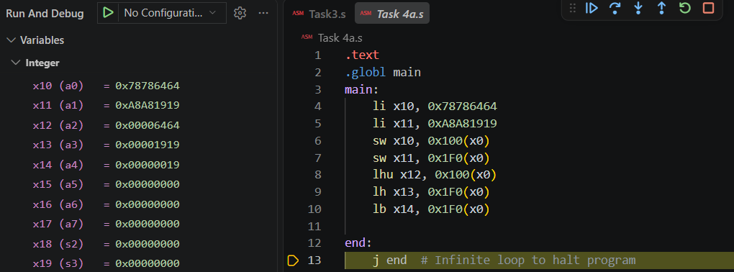

Task 4b:

Code:
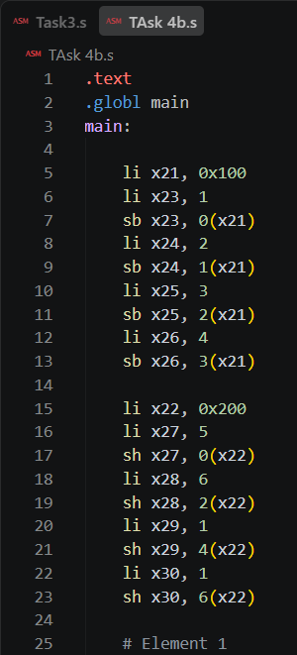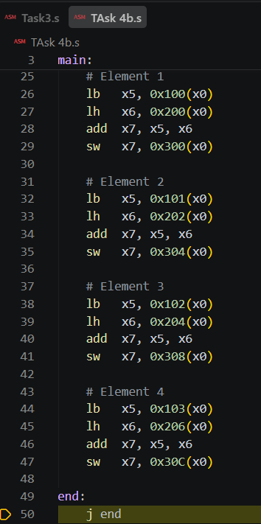

Results:
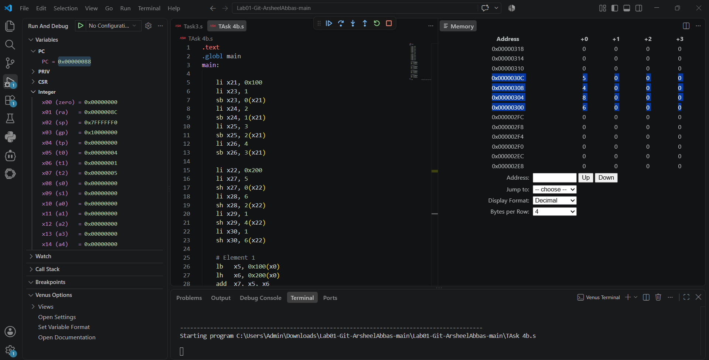

Assessment Rubric
Lab 1: Getting Started with RISC-V (Assembly Language) n VS Code

Name | Student ID: | Section:

Points Distribution:

 | Task No. | LR 2 (Code) | LR 5 (Results)
In-Lab | Task 1 | - | /15
 | Task 2 | - | /15
 | Task 3 | /10 | /5
 | Task 4a | /10 | /5
 | Task 4b | /10 | /10
Total Points: 100 |  | /30 | /50
CLO Mapped |  | CLO 2

Affective Domain Rubric |  | Points | CLO Mapped
AR7 | Report Submission & Git Upload | /10 & /10 | CLO 2

CLO | Total Points | Points Obtained
2 | 100
Total | 100

