Lab 2 - Implementing Decision Instructions in RISC V Assembly Language

Name: Arsheel Abbas | Student ID: aa11163

Task 1:

Code:
Task A:
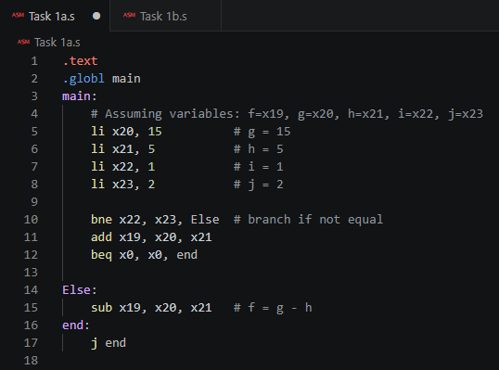
Task B:
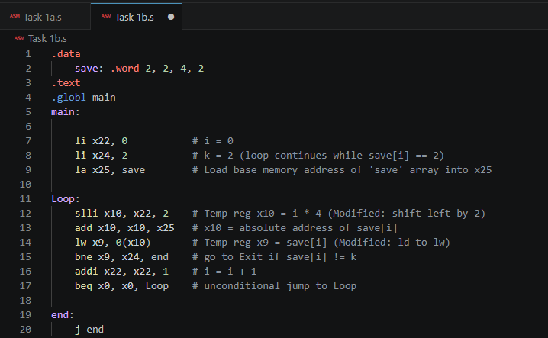
Results:
Task A:
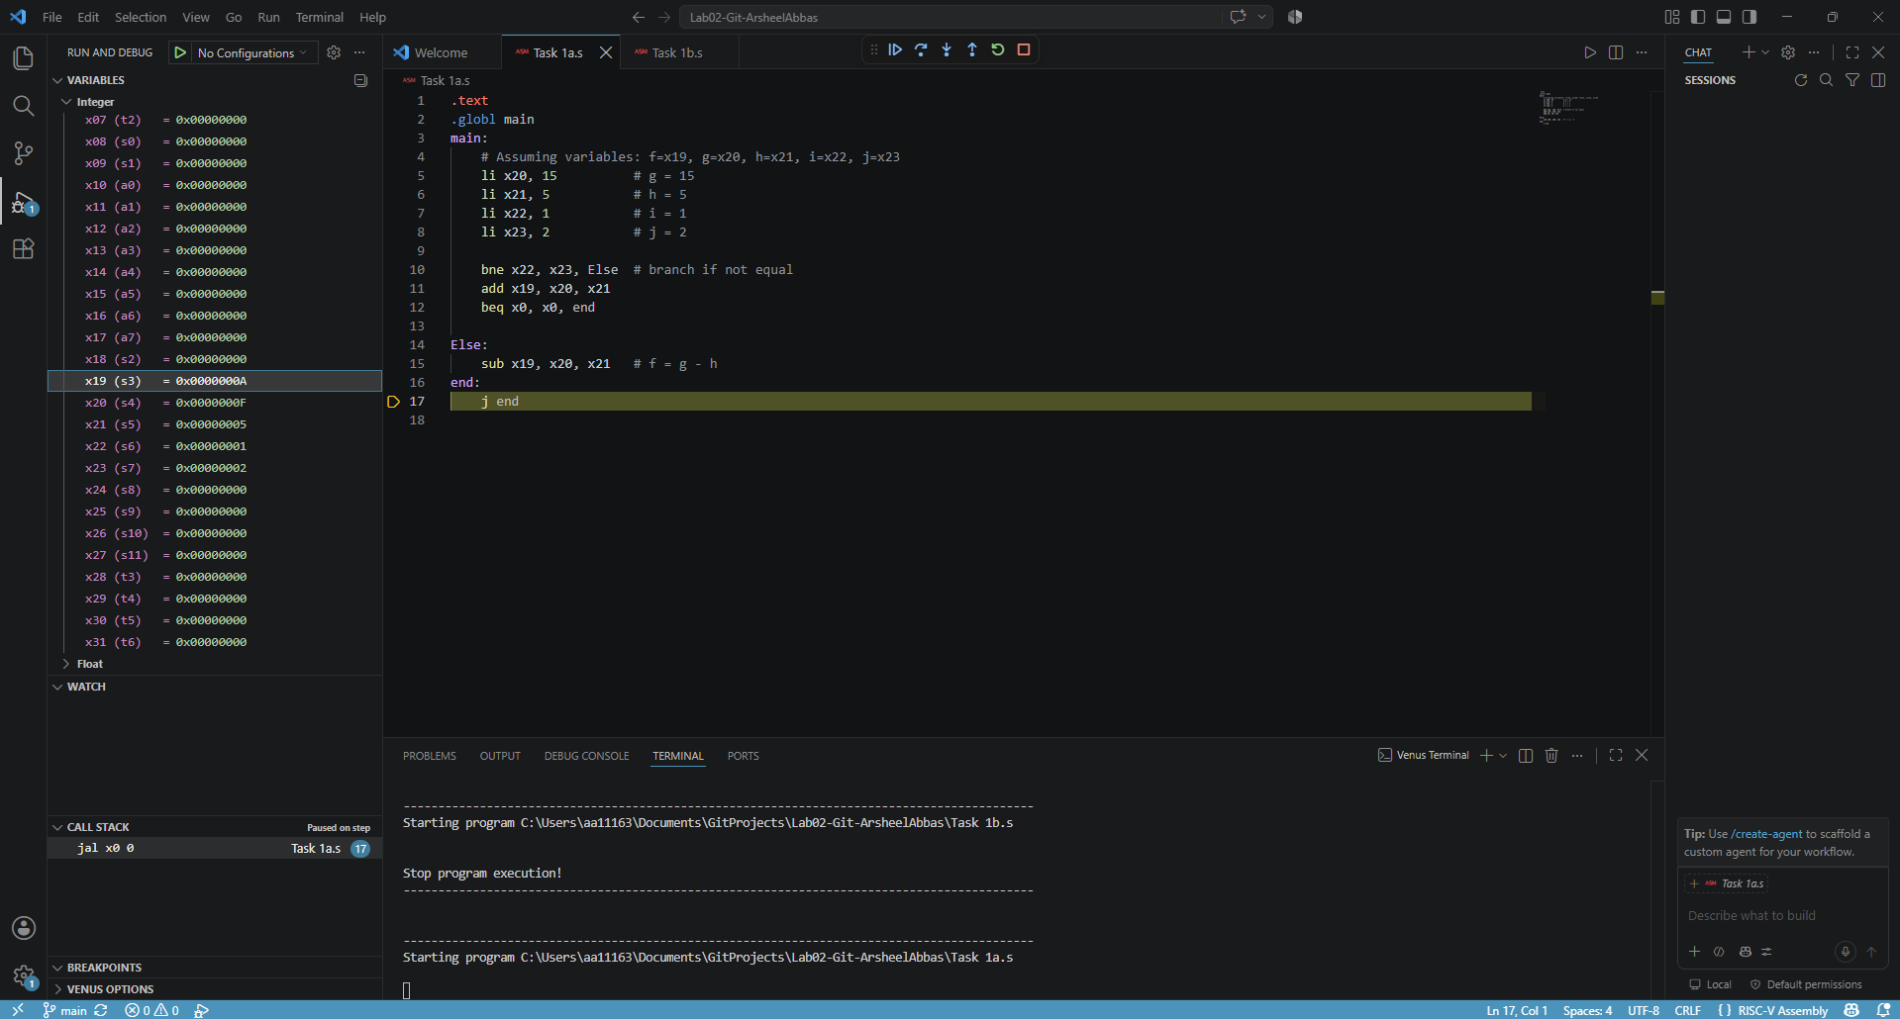
Task B:
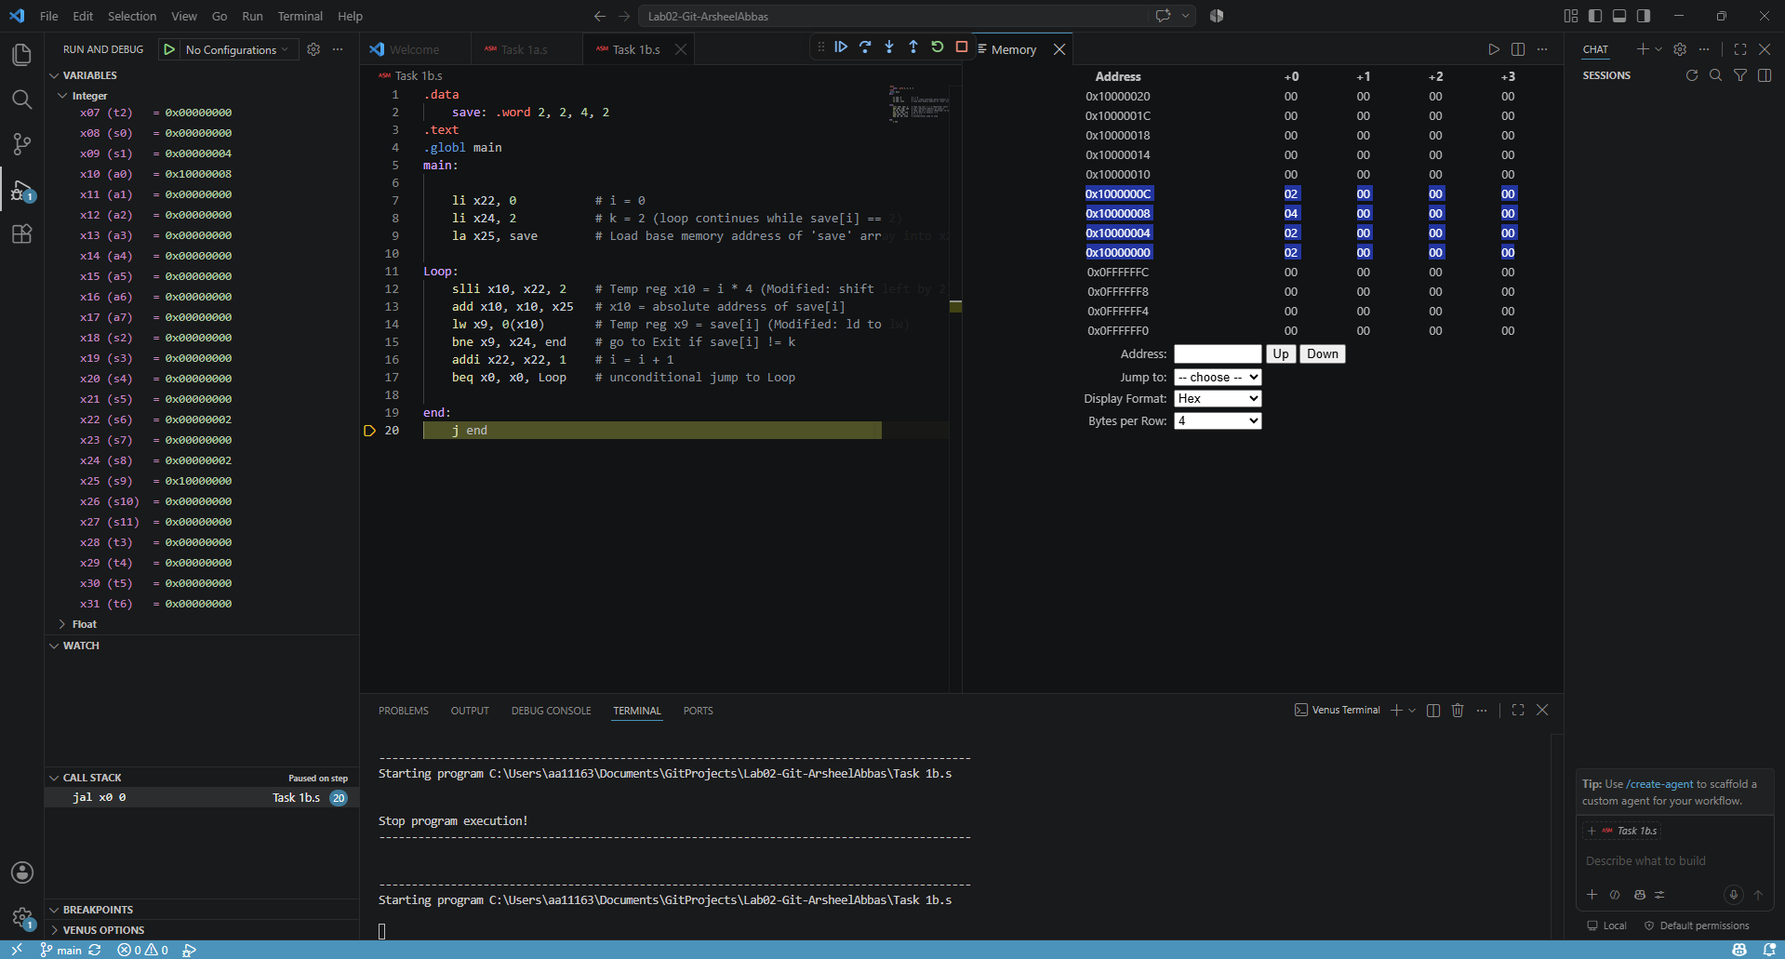

B-type field order: imm[12] | imm[10:5] | rs2 | rs1 | funct3 | imm[4:1] | imm[11] | opcode

bne x22,x23,Else (+12)

imm[12]=0 | imm[10:5]=000000 | rs2(x23)=10111 | rs1(x22)=10110 | funct3=001 | imm[4:1]=0110 | imm[11]=0 | opcode=1100011

beq x0,x0,end (+8)

imm[12]=0 | imm[10:5]=000000 | rs2(x0)=00000 | rs1(x0)=00000 | funct3=000 | imm[4:1]=0100 | imm[11]=0 | opcode=1100011

bne x9,x24,Else (+12)

imm[12]=0 | imm[10:5]=000000 | rs2(x24)=11000 | rs1(x9)=01001 | funct3=001 | imm[4:1]=0110 | imm[11]=0 | opcode=1100011

beq x0,x0,Loop (-20)

imm[12]=1 | imm[10:5]=111111 | rs2(x0)=00000 | rs1(x0)=00000 | funct3=000 | imm[4:1]=0110 | imm[11]=1 | opcode=1100011

Task 2:
Code:
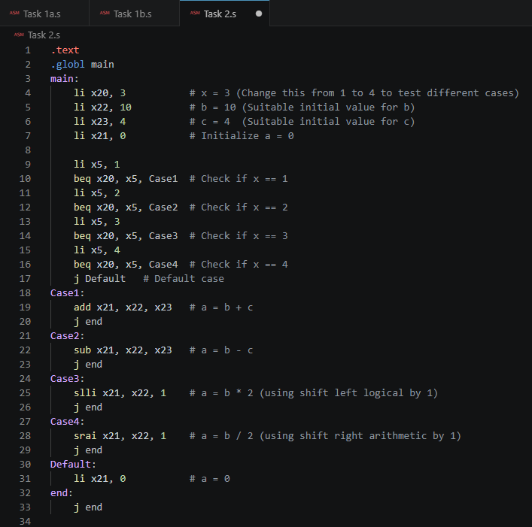

Results:
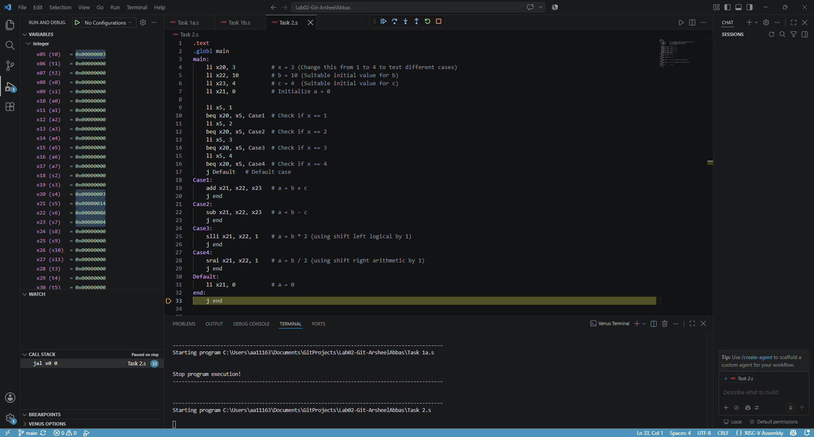

Task 3:
Code:
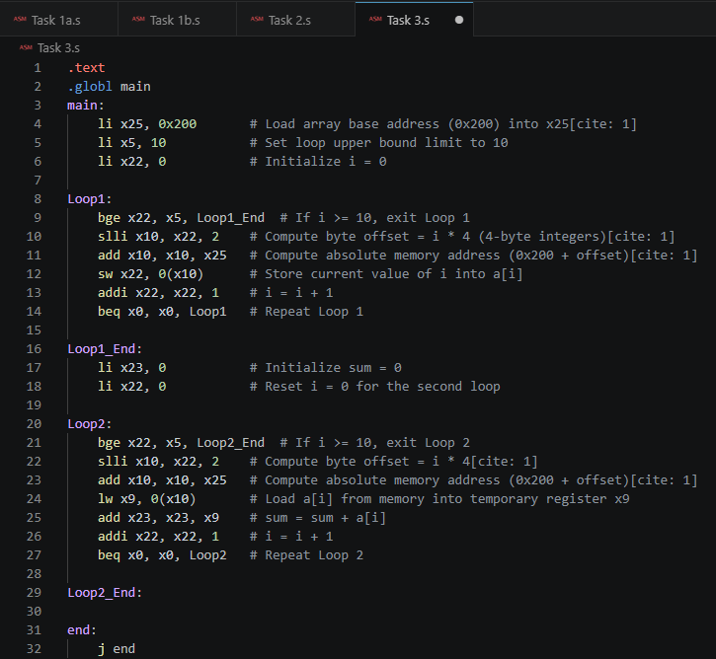

Results:
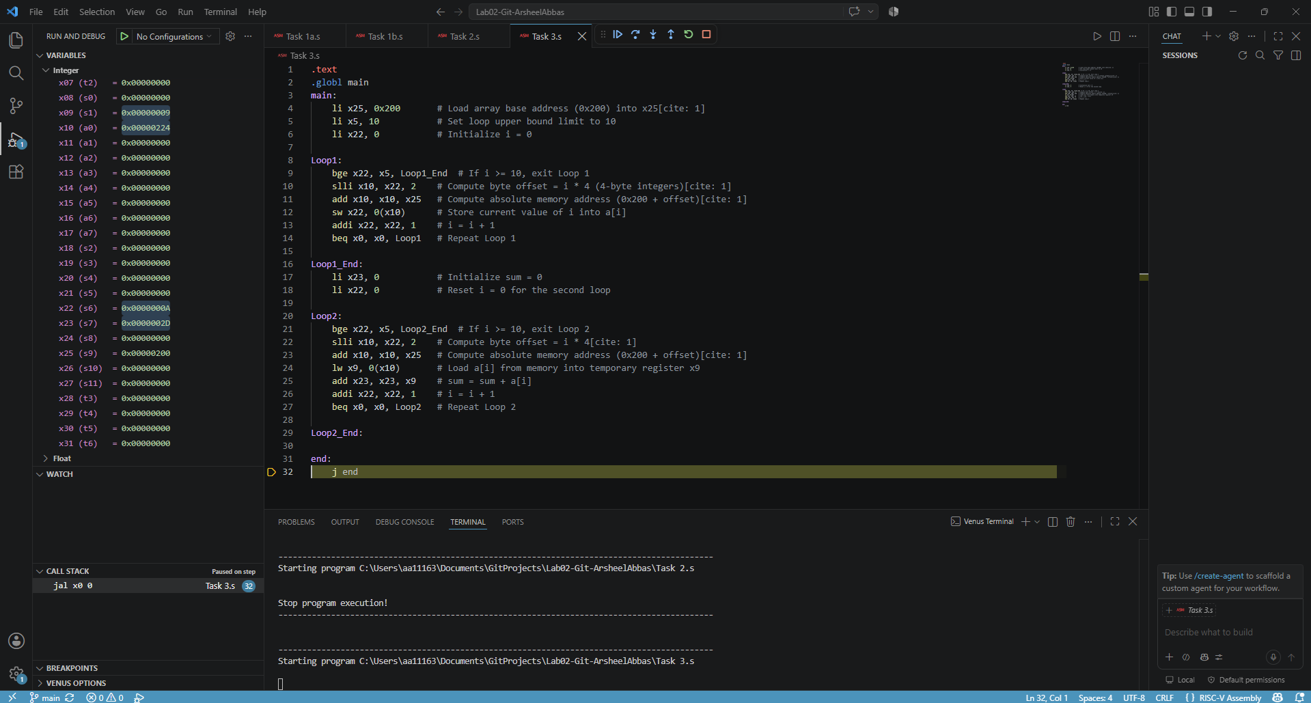
Task 4:
Code:
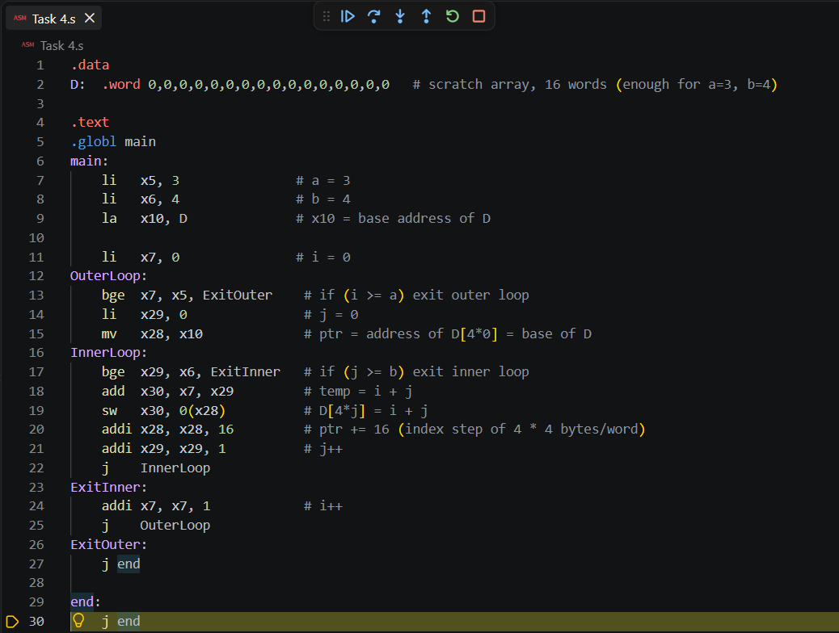

Results:
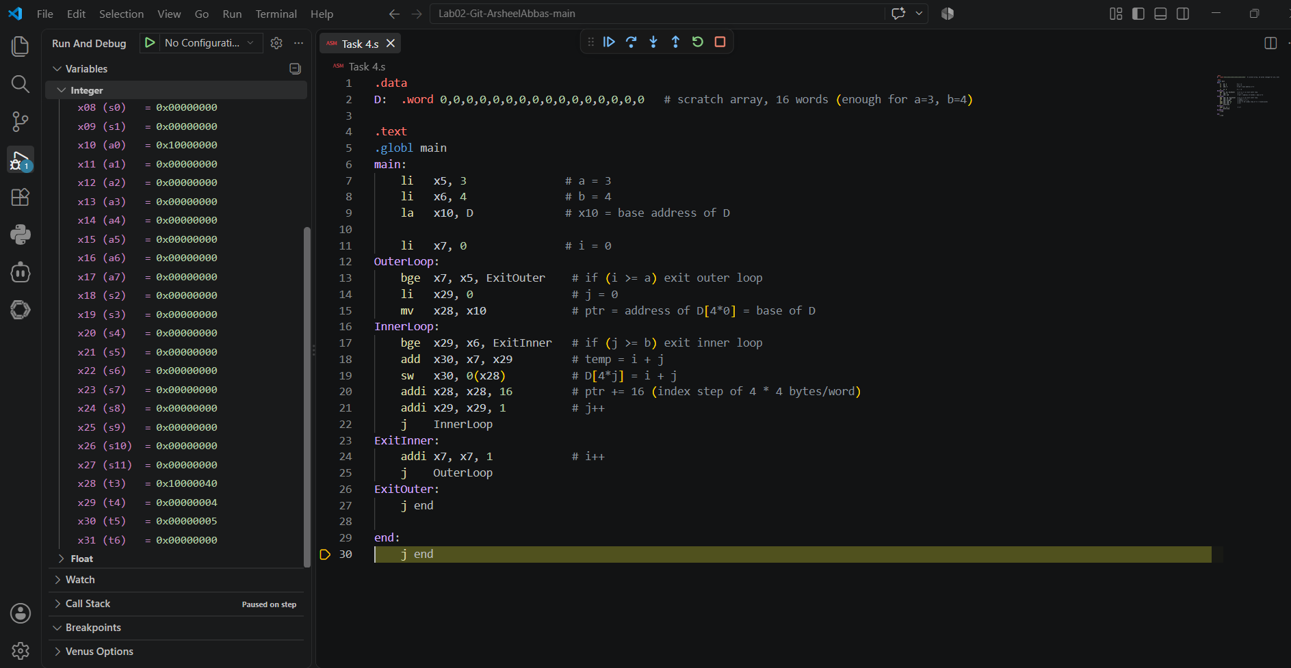

Assessment Rubric
Lab 2 - Implementing Decision Instructions in RISC V Assembly Language

Name: Arsheel Abbas | Student ID: aa11163 | Section: T2

Points Distribution:

 | Task No. | LR 2 (Code) | LR 5 (Results)
In-Lab | Task 1 | - | /5
 | Task 2 | /10 | /10
 | Task 3 | /15 | /10
 | Task 4 | /20 | /10
Total Points: 100 |  | /45 | /35
CLO Mapped |  | CLO 2

Affective Domain Rubric |  | Points | CLO Mapped
AR7 | Report Submission & Git Upload | /10 & /10 | CLO 2

CLO | Total Points | Points Obtained
2 | 100
Total | 100

