Lab 10 – Worksheet

Name: Arsheel Abbas, Hatim Shabbir | ID: aa11163,  hs11045 | Section: T2

Note: Assumptions and logics should be explained separately in tasks after the task results.

Task 1
FSM of assembly implementation of FSM designed in Lab 05

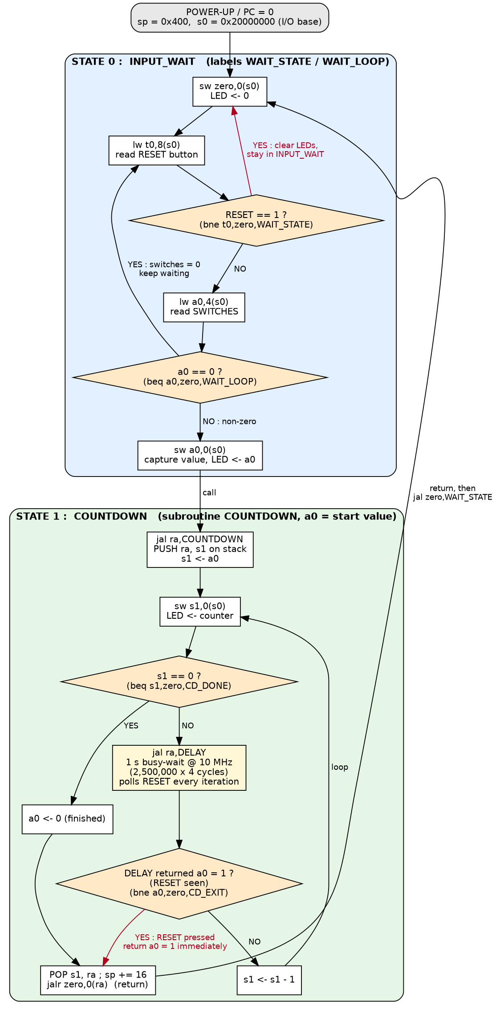
Figure 1: Control-flow diagram of the assembly implementation of the Lab 5 FSM (states, branch conditions and reset behaviour).
Assumptions and logic
• Two FSM states, as in Lab 5: INPUT_WAIT (S0) and COUNTDOWN (S1). The state is encoded by where the program counter is (labels WAIT_STATE/WAIT_LOOP versus COUNTDOWN/CD_LOOP); the state variables are held in registers: s1 = counter, a0 = captured value / return status, s0 = base address of the I/O.
• Memory map used for address decoding: RAM 0x0000_0000-0x0000_03FF (stack), LED 0x2000_0000 (R/W), SWITCH 0x2000_0004 (R), RESET button 0x2000_0008 (R, bit 0 = 1 while pressed). The values can be changed to match the Lab 7/8 map by editing addressDecoder.v and the offsets in the assembly.
• S0 -> S0: LEDs are written with 0 and the RESET button is read (branch RESET == 1 -> clear LEDs and stay). If RESET = 0 the switches are read; switches == 0 -> branch back to WAIT_LOOP.
• S0 -> S1: switches != 0 -> the value is captured in a0, written to the LEDs, and COUNTDOWN(a0) is called with jal.
• S1: the LEDs show the counter; counter == 0 -> return; otherwise DELAY (1 s) is called, and the counter is decremented. Switch input is never read in S1, so it is ignored.
• Reset: DELAY polls the RESET button on every loop iteration (4 clock cycles = 0.4 us at 10 MHz). If it is pressed, DELAY returns a0 = 1, COUNTDOWN pops its stack frame and returns immediately, and the main loop jumps to WAIT_STATE, which clears the LEDs. While the button is held the FSM stays in INPUT_WAIT with the LEDs off.
• S1 -> S0 on completion: when the counter reaches 0 the subroutine returns a0 = 0 and the main program jumps back to WAIT_STATE.

Task 2

Complete assembly source file implementing the FSM.
Complete assembly source file (program.s):
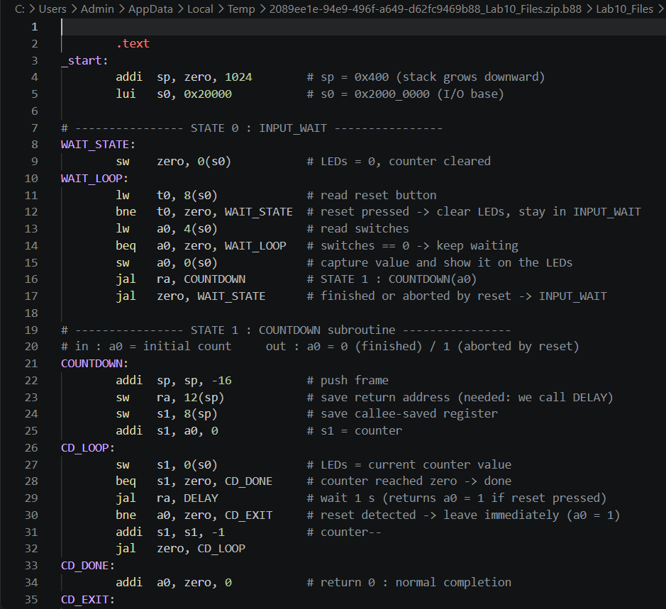
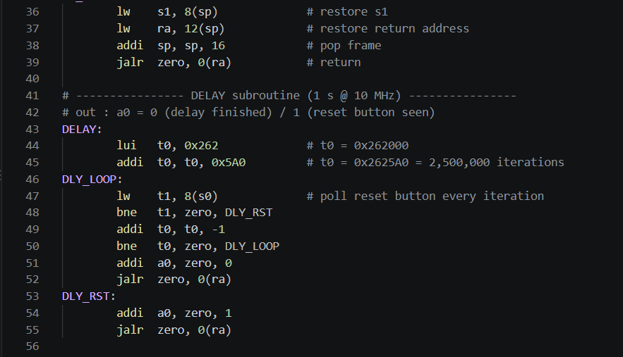

Assumptions and logic
• Processor clock f_clk = 10 MHz (the 100 MHz board clock is divided by 10), single-cycle RV32I core, so every instruction takes 1 cycle.
• Delay: the loop lw / bne / addi / bne executes 4 instructions per iteration. 2,500,000 iterations x 4 cycles = 10,000,000 cycles = 10,000,000 / 10,000,000 Hz = 1 second per count. The constant is built with lui t0,0x262 (0x262000) + addi t0,t0,0x5A0 (1440) = 0x2625A0 = 2,500,000.
• Subroutine convention: argument and return value in a0; COUNTDOWN is a non-leaf routine (it calls DELAY), therefore it must save ra on the stack. It also uses the callee-saved register s1, which is saved/restored too. s0 (I/O base) is global and never modified; DELAY only uses temporaries t0/t1.
• Stack usage (stack grows downward, sp initialised to 0x400): on entry addi sp,sp,-16 ; sw ra,12(sp) ; sw s1,8(sp). On exit lw s1,8(sp) ; lw ra,12(sp) ; addi sp,sp,16 ; jalr zero,0(ra). Both exits (normal completion and reset abort) go through the same CD_EXIT label, so sp is always balanced (sp = 0x400 again after every call).
• Reset detection returns execution to the input-waiting state immediately: worst-case latency = 2 synchroniser cycles + one DELAY iteration + return sequence (about 15 CPU cycles = 1.5 us).
• Expected result (verified by an instruction-level execution of the exact machine code): switches = 5 gives LED sequence 0, 5, 4, 3, 2, 1, 0 with 1 s per step (10,000,01x cycles per step); changing the switches during the countdown has no effect; pressing btnC clears the LEDs within 1.5 us.

Task 3

Design module code of instruction memory module containing memory initialized with assembly instructions:

Verilog design module (instructionMemory.v), memory initialised with the machine code of the Task 2 program (35 instructions = 140 bytes, little-endian):
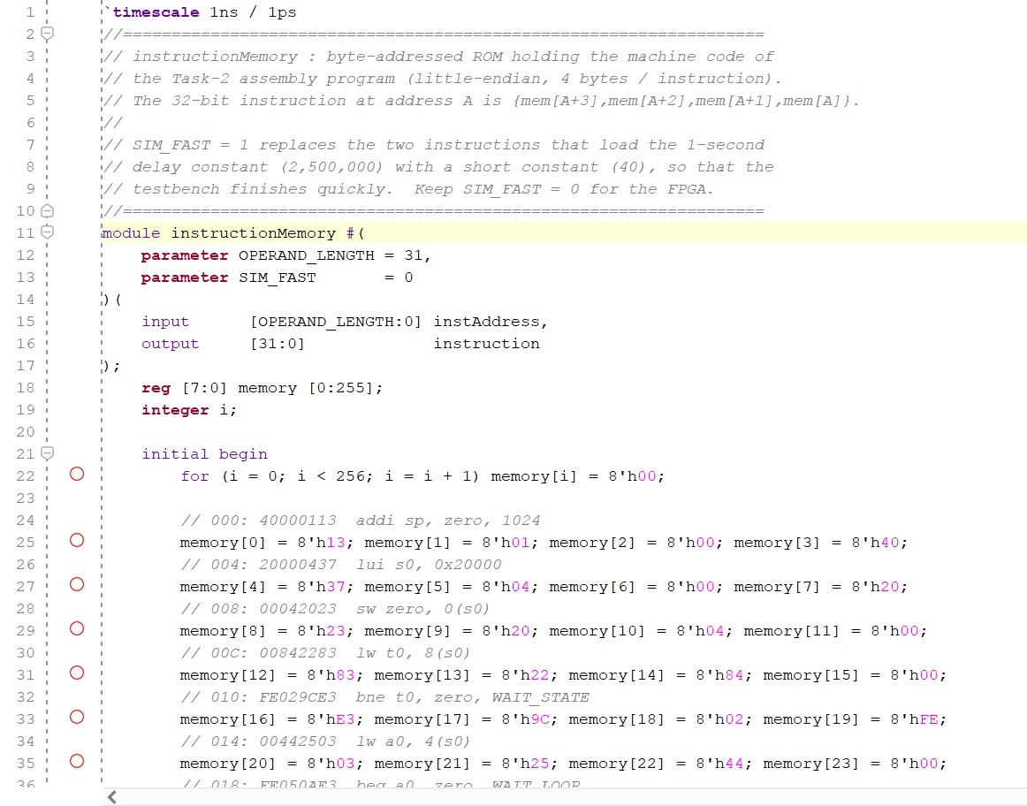
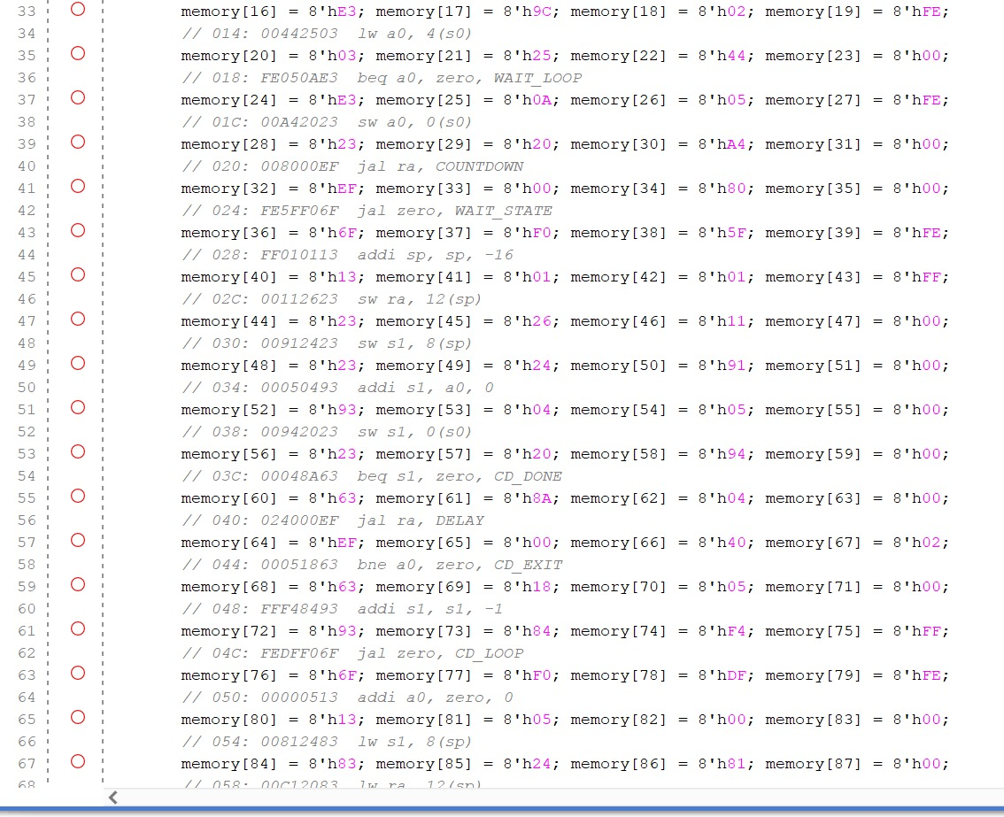
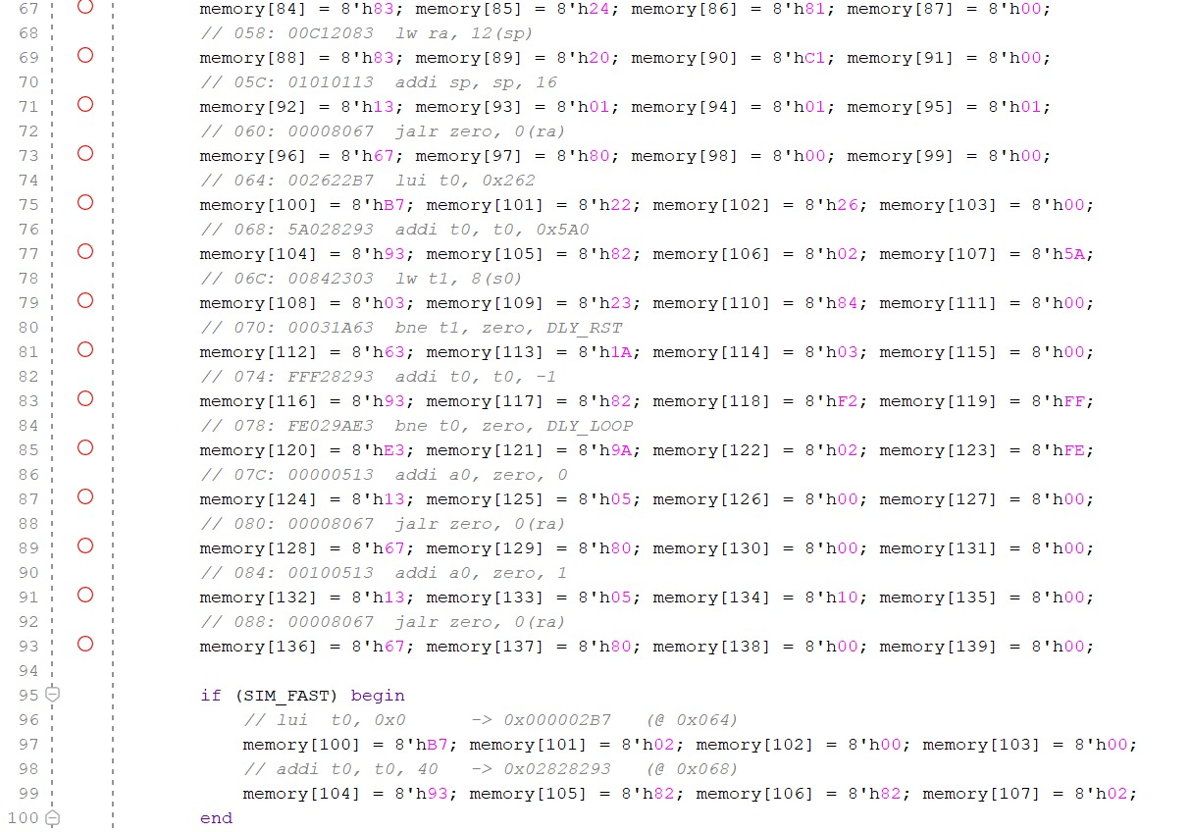

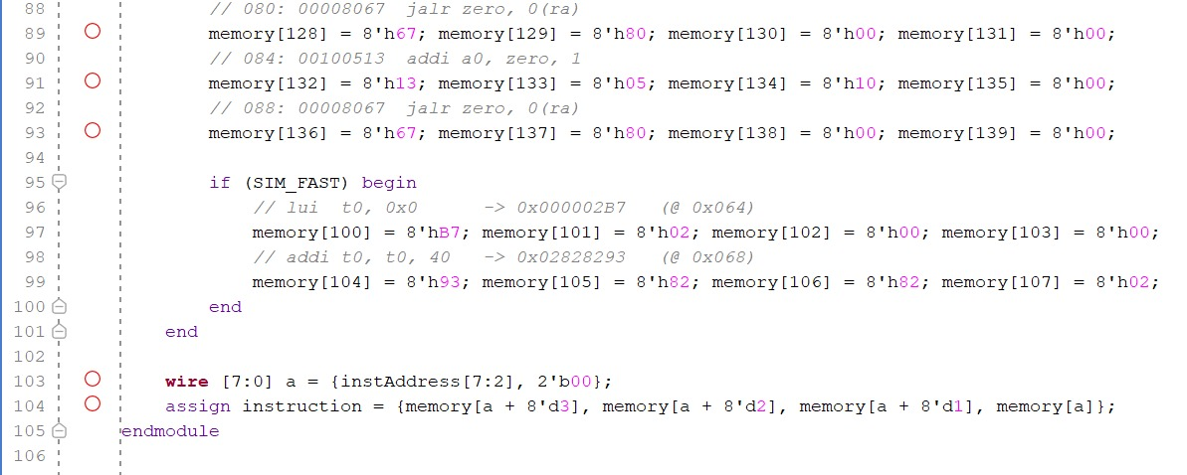Assumptions and logic
• Byte-addressable ROM reg [7:0] memory [0:255] as given in the lab reference. The instruction at address A is {memory[A+3], memory[A+2], memory[A+1], memory[A]} (RISC-V is little-endian); the two least-significant address bits are ignored because the PC is word aligned.
• The machine code was produced by assembling program.s (e.g. 40000113 = addi sp,zero,1024; 20000437 = lui s0,0x20000; 00008067 = jalr zero,0(ra)). The same image is supplied as the memory initialisation file program.mem (one byte per line) and program_words.hex (one 32-bit word per line with the assembly).
• Verification of instruction sequencing: PC = 0x000 -> 0x004 -> 0x008 (WAIT_STATE) -> ... -> jal ra,COUNTDOWN (0x020) -> COUNTDOWN at 0x028 -> jal ra,DELAY (0x040) -> DELAY at 0x064 -> jalr returns to 0x044. In tb_lab10_top.v the parameter SIM_FAST=1 replaces the 2 instructions at 0x064/0x068 so a countdown step takes about 17 us instead of 1 s; for the FPGA SIM_FAST must stay 0.

Lab 10: State-Based Control Flow Using RISC-V Assembly

Points Distribution
Task No. | LR2  Code | LR 5  Results | LR11  Design | AR7
Task 1 | - | - | /20 | /20
Task 2 | /20 | /20 |  | /20
Task 3 | /20 | - |  | /20
Total Points | /80 |  |  | /20
CLO Mapped | CLO 1
For description of different levels of the mapped rubrics, please refer the provided Lab Evaluation Assessment Rubrics and Affective Domain Assessment Rubrics.
# | Assessment Elements | Level 1: Unsatisfactory  Points 0-1 | Level 2: Developing  Points 2 | Level 3:Good  Points 3 | Level 4:Exemplary  Points 4
LR2 | Program/Code/ Simulation Model/ Network Model | Program/code/simulation model/network model does not implement the required functionality and has several errors. The student is not able to utilize even the basic tools of the software. | Program/code/simulation model/network model has some errors and does not produce completely accurate results. Student has limited command on the basic tools of the software. | Program/code/simulation model/network model gives correct output but not efficiently implemented or implemented by computationally complex routine. | Program/code/simulation /network model is efficiently implemented and gives correct output. Student has full command on the basic tools of the software.
LR5 | Results & Plots | Figures/ graphs / tables are not developed or are poorly constructed with erroneous results. Titles, captions, units are not mentioned. Data is presented in an obscure manner. | Figures, graphs and tables are drawn but contain errors. Titles, captions, units are not accurate. Data presentation is not too clear. | All figures, graphs, tables are correctly drawn but contain minor errors or some of the details are missing. | Figures / graphs / tables are correctly drawn and appropriate titles/captions and proper units are mentioned. Data presentation is systematic.
AR9 | Report | All the in-lab tasks are not included in report and / or the report is submitted too late. | Most of the tasks are included in report but are not well explained. All the necessary figures / plots are not included. Report is submitted after due date. | Good summary of most the in-lab tasks is included in report. The work is supported by figures and plots with explanations. The report is submitted timely. | Detailed summary of the in-lab tasks is provided. All tasks are included and explained well. Data is presented clearly including all the necessary figures, plots and tables.

