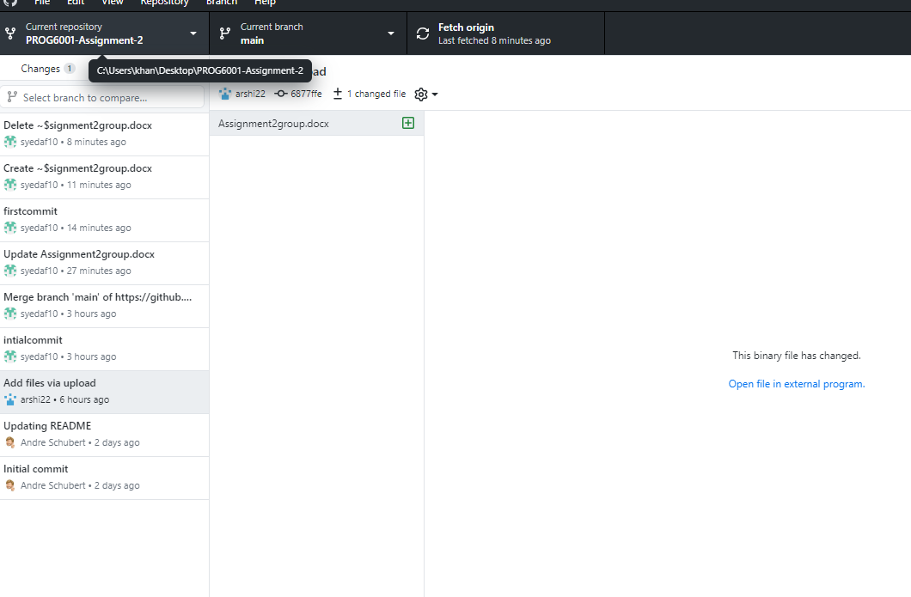

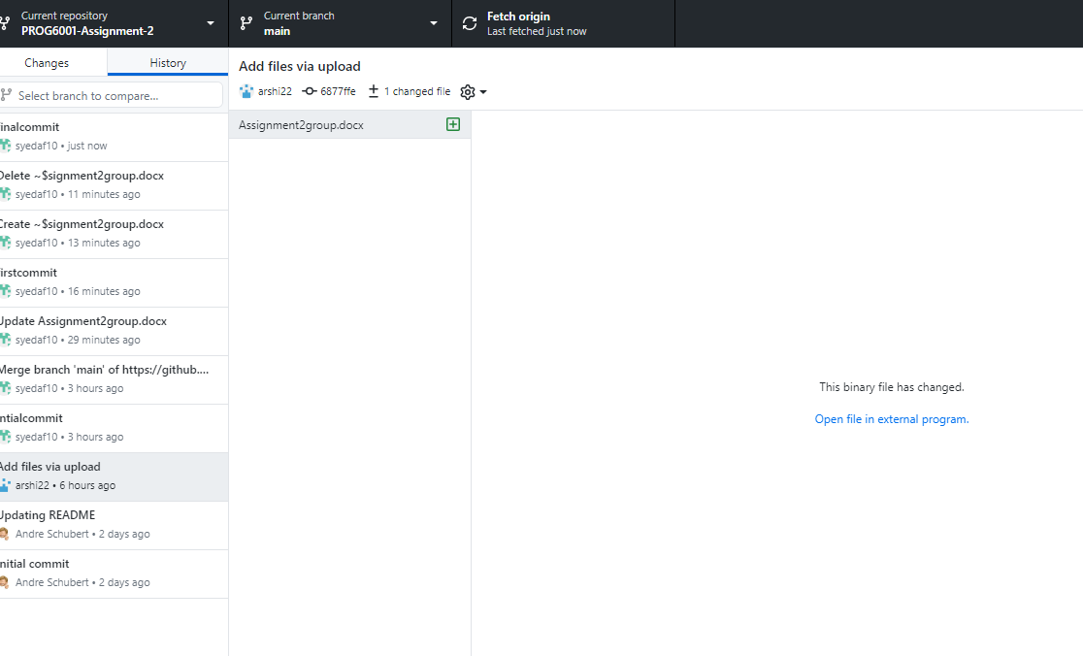

**Table of Contents**

Overview of the Agile mindset 3

Characteristic of Agile Process 3

Agile mindset vs Waterfall Process 3

Scrum process and the Waterfall methodology 4

Guidelines for Choosing Scrum or XP according to types of Project 4

Agile Method Candidate for adoption 4

Summary 4

References 5

# Overview of the Agile mindset

This is how advocates simply approach a project. Some of these are teamwork, strength, the ability to grow and learn, pride and importance, the ability to consider all options, and the ability to work together. Traditional methods, such as waterfall development, which takes between reasonable billing and final approval, are irrelevant to the customer. Then, when the final framework is delivered to the client, it fails to meet the client's standards in many ways (Ashraf, 2017). As a result, agile development measures have been developed to overcome environmental management challenges. It is important for customers to remember to generate leads. The main goal of an agile development process is to improve operational efficiency by encouraging customer collaboration and successful testing. Programming and hierarchical programming are combined using Extreme Programming (XP), the most famous agile programming technique. As these trends change from day to day, so does the management of the program.

## Characteristic of Agile Process

In cooperation with American partners, it was determined that the most important feature of the development plan is to reduce the length of development. Time becomes one of the nine characteristics of the fast cycle to show its importance (Paruch, Stray, & Blindheim, 2020):

1. Modality - an important part of any critical cycle. It divides the cycle into exercises. The product development process shows many ways to implement the product concept.
2. Iterative - Lean programming practice believes in making mistakes before everything is perfect. So, they expect a short cycle. A series of activities are performed in each period.
3. Repetition is the best way to organize products because you are short on time. Each weight can be limited to time (usually a month and a half) and adjusted accordingly.
4. Modesty - Agile cycles offer a new way to measure time constraints in a development program. Tracking conflicting events that cannot be done in a fast-paced environment puts pressure on productivity (Ashraf, 2017). This causes congestion and is not good.
5. Adaptive - During the crisis, new threats appear, which will require some previous actions. The flash changes the circuit to compensate for these new possibilities.
6. The agile cycle does not try to develop the entire system at once. Bring up. At the same time, it divides the non-core building into parts that can be built in the same way, but at different times and prices.
7. Consolidation - Consolidation means that we have enough to deal with any threat that needs to be addressed. Therefore, the system is close to the reality that we are looking for in all important factors.

# Agile mindset vs Waterfall Process

Agile is a management team strategy that involves breaking down sales into small tasks and continuously monitoring and planning for change. The word "water" can refer to a steady flow of water or a stream. A cascade model is a model developed through the stages of collection, analysis, design, improvement, testing, preparation and validation (Fagarasan et al., 2021). The concept of creating a tree slide template follows a similar pattern. This is a method that reduces the risk that the plant is complete and has a working process. The project process should be broken down into several steps as separate efforts, and each step should be done once in the SDLC according to the Waterfall definition. However, the agile process can be seen as a collection of activities that only focus on different levels of work, customer feedback, and assurance meetings (Miler and Gaida, 2019).

# Scrum process and the Waterfall methodology

Scrum is less robust than XP because they use different management systems. This makes it easy for large enterprises to adopt and can be very useful for small businesses. It starts with the owner talking to partners and customers (Mora et al., 2021). The owner of the item can add a collection. Manufacturing is a well-designed cycle that includes all the expected functions. Sprints usually last from two weeks to several weeks. In the sprint configuration, there is a sprint that contains the description required for the current sprint. Here, partners hold small meetings every day to plan their development (Ashraf and Aftab, 2017). All progress and sprint goals are monitored by the scrum pro. After the competition, the scrum team welcomes the owners and partners to the competition, where they evaluate the results together. Scrum helps customers deliver the best possible user experience.

# Guidelines for Choosing Scrum or XP according to types of Project

Smart-tech Auto Services (SAS) is a startup that allows customers to order hardware and software to tag IoT devices. To achieve this, the organization should adopt the XP process, but it is important that scrum is suitable for the job. The following factors support the choice of methods for all types of work: The success of an independent company is determined by its presentation and skills. Small business owners look to indoor practices to help them organize their workplace and make it more efficient and effective. Scrum makes them happen. Everyone contributes to this project and I am very happy with the project. Scrum helps employees work together and helps achieve this goal by allowing greater communication between employees and partners. XP is full of different things, all of which are difficult to access. XP also has important features that the audience doesn't see. The boats are divided into tasks and teams that finish in the competition. By completing this task, you can see the gander in action (Mora et al., 2021). The following is true due to common usage. Cooperatives spend a lot of time and money preparing XP. Before getting XP, the company had to prepare all development team members, including only the project manager, to follow scrum.

# Agile Method Candidate for adoption

Scrum is the best project management method for projects that need to change over time. Scrum is a change that may be appropriate in this situation. Customers need to change quickly after looking at different models, which makes change scrum important for web development and building flexible applications (Scrum: An Agile Process Reengineering in Software Engineering, 2020). Likewise, agile is ineffective for organizations that don't get the changes they need. If your job requires you to build chunks or parts every day, Scrum is not the right choice for you. Therefore, scrum is not suitable for all projects that cannot be planned in advance. In this case, Kanban is the best project management method.

# Summary

Agile processes are generally more responsive to changing customer needs. Compared to other skills, such as Kanban, beautiful stone, XP and scrum, customers get a lot of benefits from XP and scrum. But looking at XP from the inside has a lot of cost, time and reliability issues, to name a few. Considering this, Scrum is the most suitable process for both clients. Scrum is designed for highly ambiguous tasks, but not for highly ambiguous tasks.

# References

Ashraf, S. (2017). IScrum: An Improved Scrum Process Model. *International Journal of Modern Education and Computer Science*, 9(8), pp.16–24. doi:https://doi.org/10.5815/ijmecs.2017.08.03.

Fagarasan, C., Popa, O., Pisla, A. and Cristea, C. (2021). Agile, waterfall and iterative approach in information technology projects. *IOP Conference Series: Materials Science and Engineering*, [online] 1169(1), p.012025. doi:https://doi.org/10.1088/1757-899x/1169/1/012025.

Miler, J. and Gaida, P. (2019). On the Agile Mindset of an Effective Team – An Industrial Opinion Survey. *Proceedings of the 2019 Federated Conference on Computer Science and Information Systems*. doi:https://doi.org/10.15439/2019f198.

Mora, M., Adelakun, O., Galvan-Cruz, S. and Wang, F. (2021). Impacts of IDEF0-Based Models on the Usefulness, Learning, and Value Metrics of Scrum and XP Project Management Guides. *Engineering Management Journal*, pp.1–17. doi:https://doi.org/10.1080/10429247.2021.1958631.

Scrum: An Agile Process Reengineering in Software Engineering. (2020). *International Journal of Innovative Technology and Exploring Engineering*, 9(3), pp.840–848. doi:https://doi.org/10.35940/ijitee.c8545.019320.