**MIRZA ARSHI ABBAS**

 **MIRZA ARSHI ABBAS**  Bangalore, Karnataka

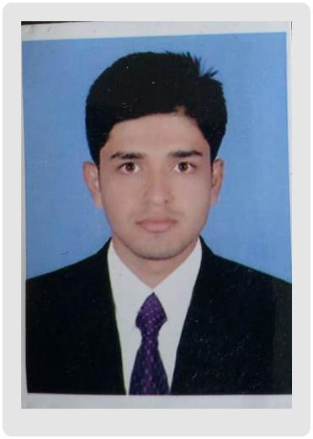

 +91-8867848450

 arshiabbas50@gmail.com

mirza arshi abbas



**TRAINING & CERTIFICATIONS**



1) Software Testing Coursenity/ACCPL, 2019.

2) Android studio and IOS

3) CCNA

 **SKILLS**



Networking, Switching, Routing, Telnet, Subnetting, LAN, WAN.

System, Unit, Load, Regression, Acceptance testing.

Defect & Bug Discovery

Tracking, Logging and Reporting.

Issue Identification.

Test cases and plans.

 **LANGUAGES**





English





Hindi





Kannada



Urdu

**Experienced**



**PROFILE**  **ABOUT ME**

* A detail oriented, hard working professional with exceptional programming skills possesses MCA degree in Computer.
* Proficient in maintaining the existing program with implementation of new techniques.
* Looking for challenging duties in an expert environment that makes use of my analytical, problem-solving abilities, expertise & specialized information, for the mutual development of my career and the business.
* Skilled in programming languages and using them for software developing and testing.
* An ability to learn new technologies quickly.
* Proficient in monitoring and troubleshooting the Network/Link in case of any breakdown.
* Maintained networking equipment & systems including routers & switches to ensure proper performance.

|  |  |  |  |  |  |  |  |  |
| --- | --- | --- | --- | --- | --- | --- | --- | --- |
| **EDUCATION** |  |  |  |  | | | |  |
|  |  |  |  | | | |  |
| **High School** | |  |  |  | | |  |
| Noble School | |  |  | Completed | | |  |
| CBSE – Marks 6.6 [CGPA], Division I | | | | May 2010 | | | |  |
| Chickbalapur, Karnataka | | | |  | | | |  |
| **PCMB, Intermediate** | |  |  |  | | | |  |
| Noble College | |  |  | Completed | | | |  |
| KSEEB – Marks 5.9 [CGPA], Division II | | | | May 2012 | | | |  |
| Chickbalapur, Karnataka | | | |  | | | |  |
| **COMPUTER SCIENCES, Bachelor of Computer Applications** | | | | | | |  |
| AIIS | |  |  | Graduated | | | |  |
| BANGALORE UNIVERSITY – Marks 6.21 [CGPA], Division I | | | | Jun 2015 | | | |  |
| BANGALORE, Karnataka | | | |  | | | |  |
| **COMPUTER SCIENCES, Master of Computer Applications** | | | |  | | | |  |
| AIIS | |  | Post Graduate | | | | |  |
| BANGALORE UNIVERSITY – Marks 7.11 [CGPA], Division II | | | | | Nov 2018 |  | |
| BANGALORE, Karnataka | | | | |  | | |  |
| **ENGINEERING/TECHNOLOGY** | | |  | |  | | |  |
|  | |  | | |  |
| **Languages –** JavaScript, C, C++ | | | | |  |  | |
| **Web Components –** CSS, HTML, PHP | | | | |  |  | |
| **Database –** MySql, Oracle | | | | |  |  | |
| **Networking –** Addressing, Routing & Switching protocols | | | | |  |  | |
| **Ethernet addresses –** Unicast, Multicast & Broadcast. | | | | |  |  | |
| **Routing protocols –** EIGRP, OSPF, BGP | | | | |  |  | |

 **PERSONAL INFORMATION**



**Birthday**

March 29, 1995

**Gender**

Male

**Marital Status**

Single

**Father's Name**

Mr. MIRZA ALHAJ HUSSAIN

**Nationality**

India

**Passport**

R3960966, Expires 08/30/27

|  |  |  |
| --- | --- | --- |
| **PROJECTS** |  |  |
|  |  |
| **Project** | **Blood BAnk Management** |  |
|  | **System** |  |
| Period: | February 2018 - June 2018 |  |
| Technologies: | PHP, MySQL |  |
| Team Size: | 2 |  |



Help Line is an voluntary and non-governmental organization. It maintains Online library of blood donors in India. Sometimes Doctors and Blood bank project have to face the difficulty in finding the blood group Donors at right time. Help Line has attempted to provide the answer by taking upon itself the task of collecting Blood bank project nationwide for the cause and care of people in need.

At any point of time the people who are in need can reach the donors through our search facility. By mobilizing people and organization who desire to make a difference in the lives of people in need. On the basis of humanity, Everyone is welcome to register as a blood donor.

**Professional Experience (Oct-2018 to Feb-2020)**

**Junior QA Tester,**

Perform system, unit, acceptance, regression, load and functional/performance testing on applications using manual testing methods. Validate, verify, communicate and resolve software issues through careful, thoroughly documented testing to maximize return on investment (ROI) for IT initiatives.

With full system development lifecycle experience, developing and implementing test plans, test cases and test processes fueling swift corrective actions, significant cost savings and fault-free audits.

**Contributions:**

**Identified, documented and reported bugs,** errors, interoperability flaws and other issues within proprietary software applications.

**Demonstrated methodical, detail-oriented and thorough approach** to all assignments while adhering to compressed timelines. Complete all assignments on or ahead of schedule.

**Skills Summary**

* SQA Testing & Methodologies
* Test Plans, Cases & Processes
* Functional Requirements
* Regression & Negative Testing
* UI &CompatabilityTesting
* Performance, Load &Stress Testing



**DECLARATION**



I, MIRZA ARSHI ABBAS, hereby declare that the information contained here in is true and correct to the best of my knowledge and belief.



Bangalore, Karnataka

__/__/2020

**MIRZA ARSHI ABBAS**