LAB:09
Arshia Jadoon
Bse-2023-014

Task 1: GitHub CLI, Codespace Setup and Authentication
task1_gh_install.png
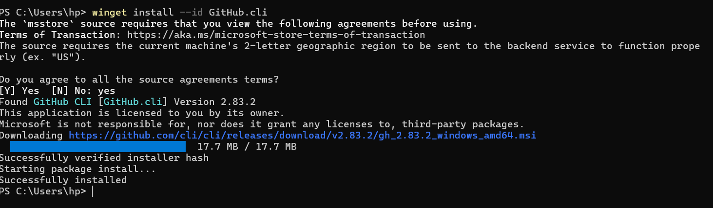
task1_gh_auth_login.png
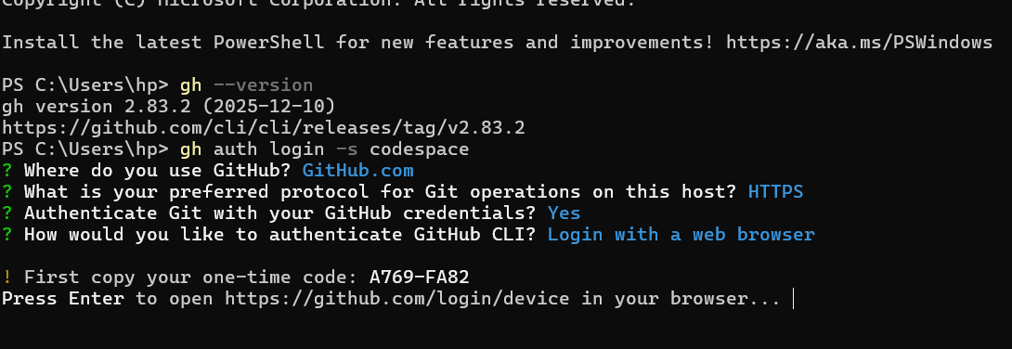
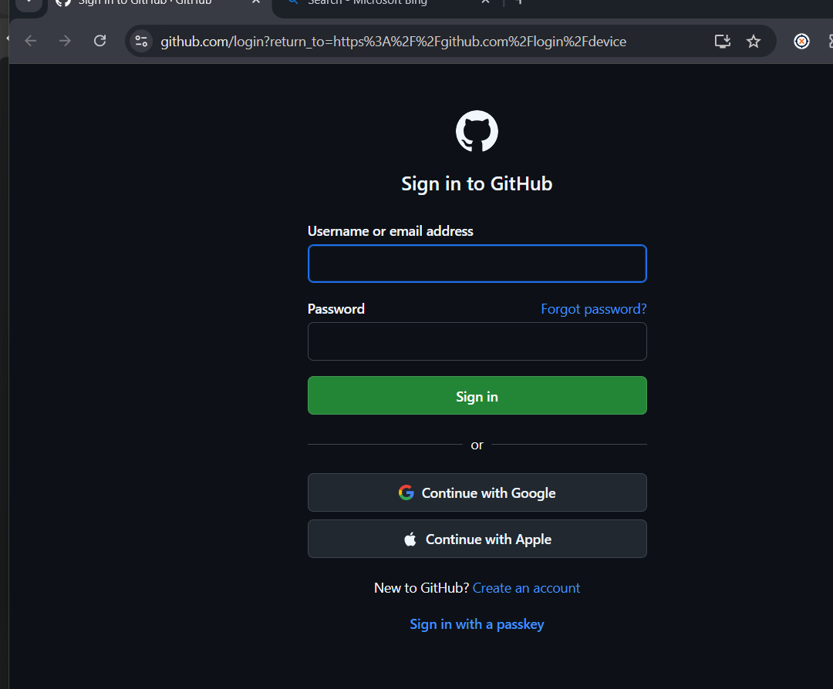
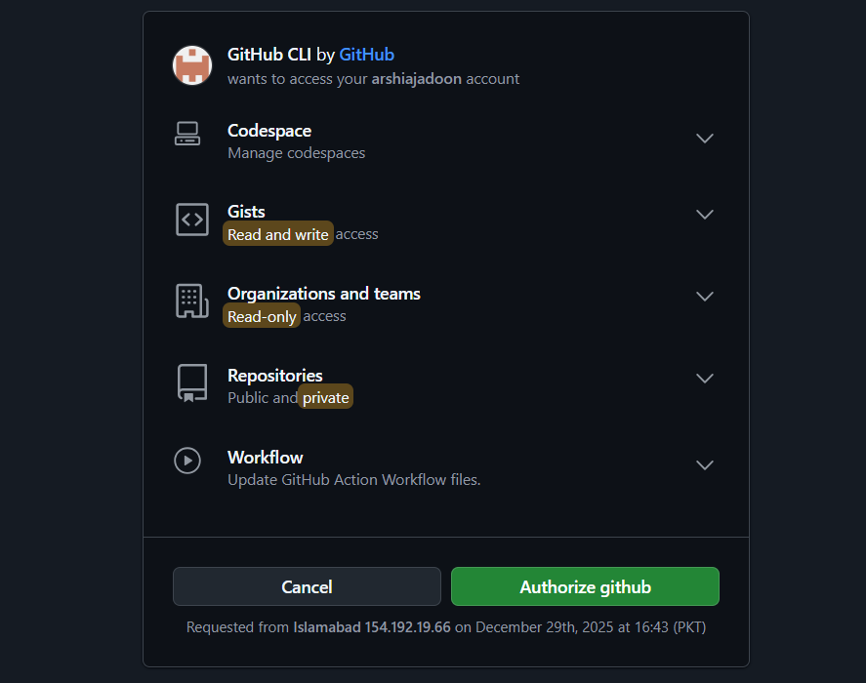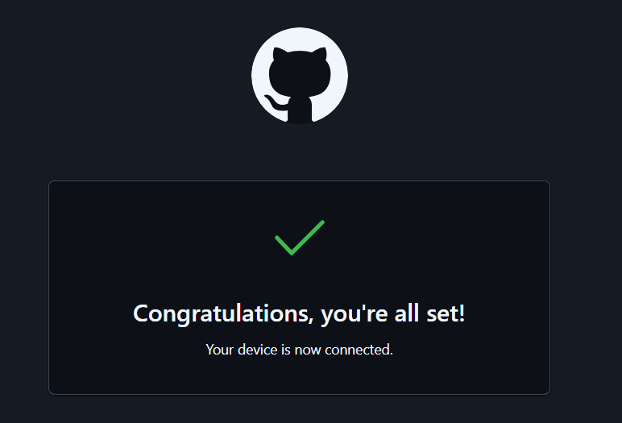
task1_codespace_list.png
task1_codespace_ssh_connected.png
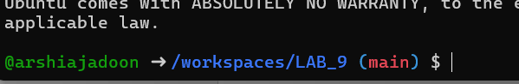
Task 2: Install AWS CLI Inside Codespace
task2_aws_install_and_version.png
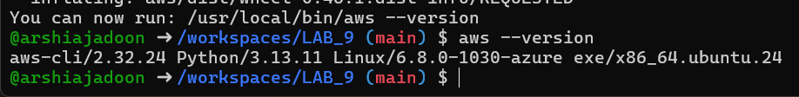
task2_aws_configure_and_files.png
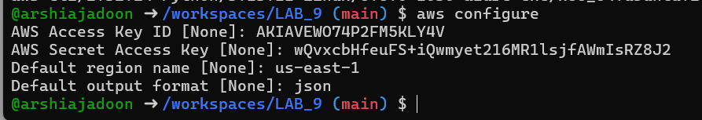
task2_aws_configure_and_files.png
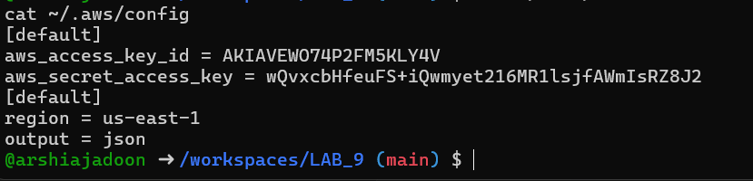
task2_aws_get_caller_identity.png
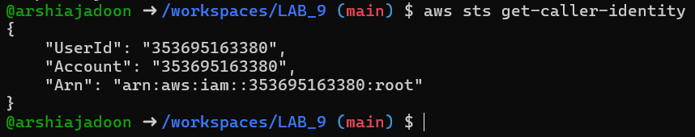
Task 3: Create Security Group and Add Ingress Rules
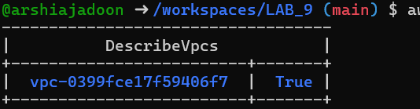
task3_describe_sg_before_ingress.png
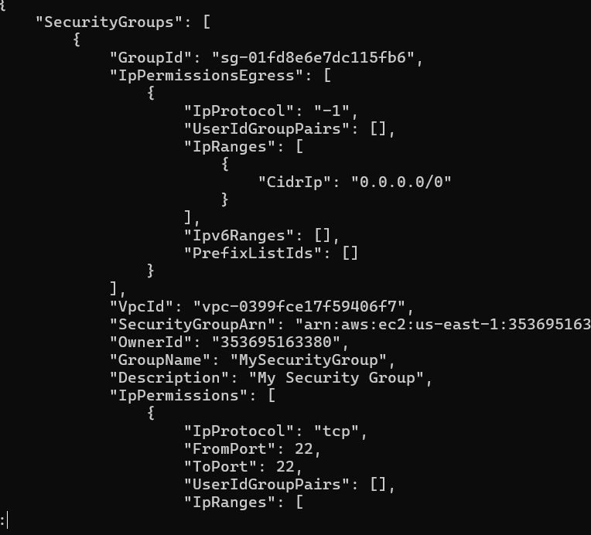
task3_codespace_public_ip.png
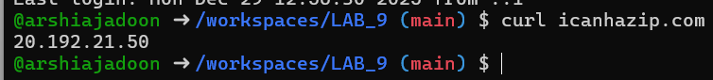
task3_authorize_ssh_and_describe.png
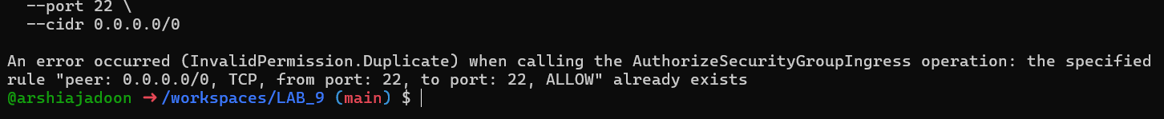
task3_authorize_ssh_and_describe.png
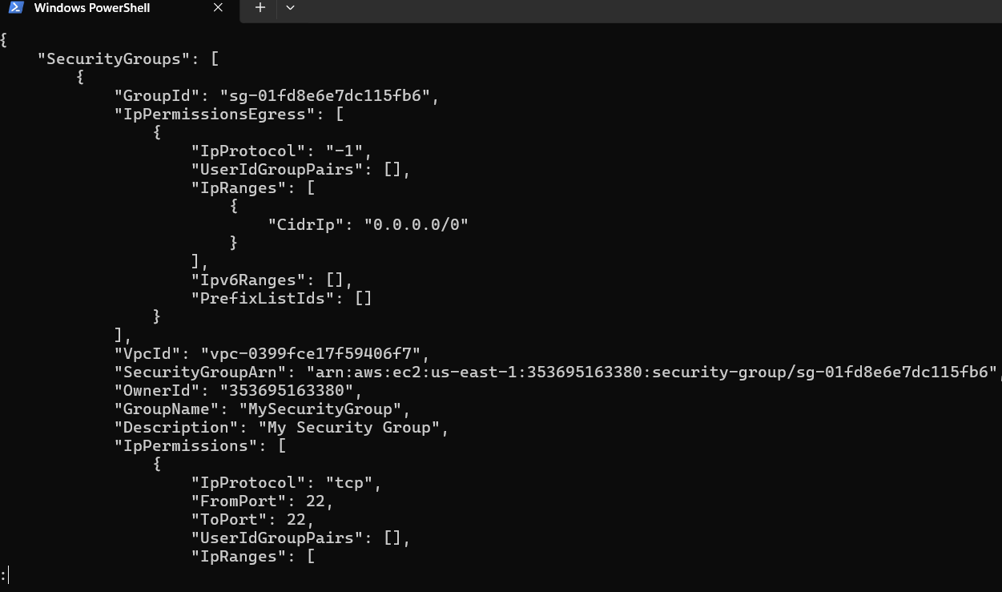
task3_authorize_http_and_describe.png
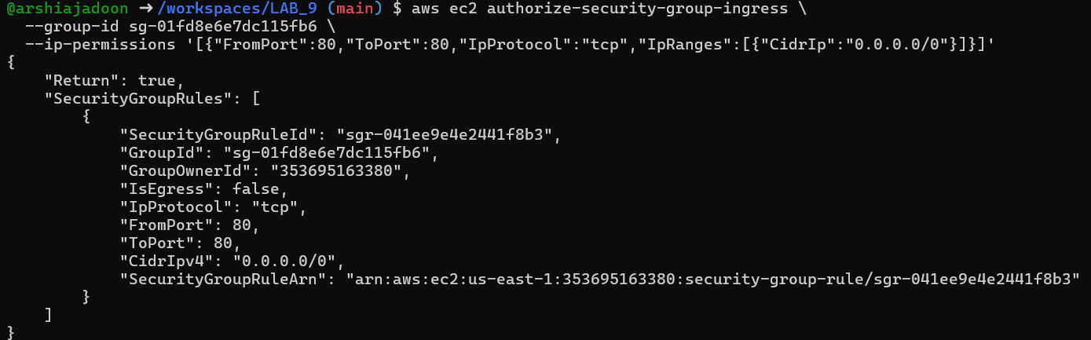
task3_describe_sg_final.png
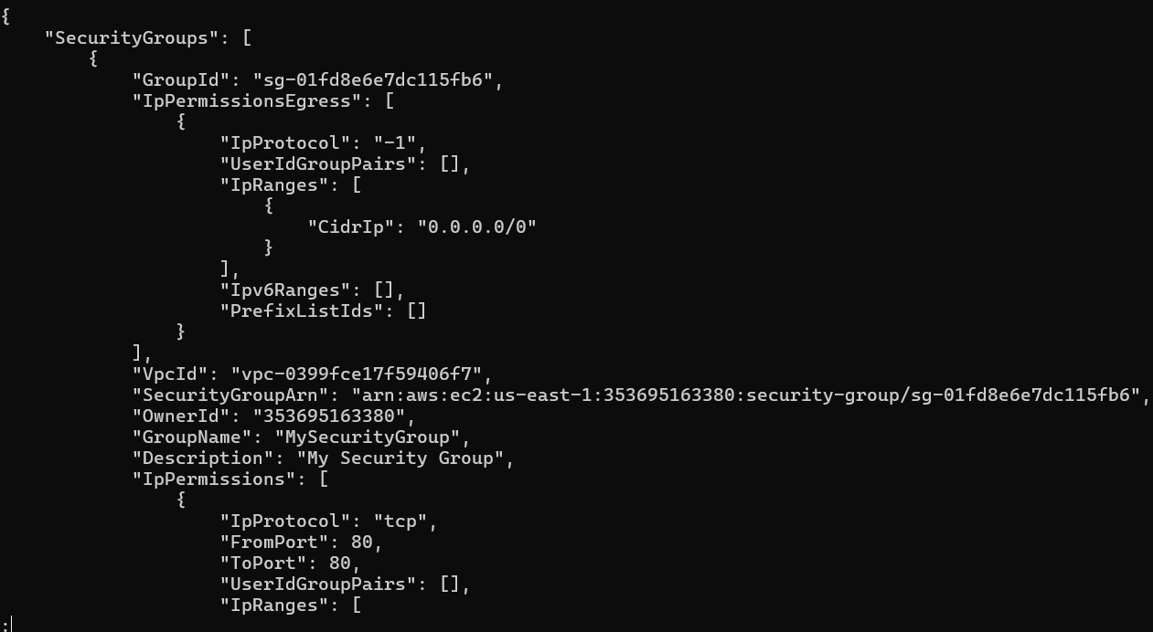
task4_create_keypair_output.png
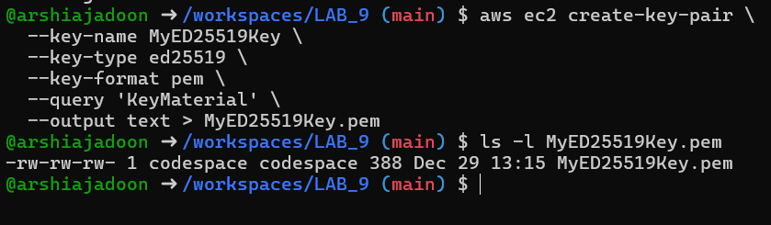
task4_describe_keypairs.png
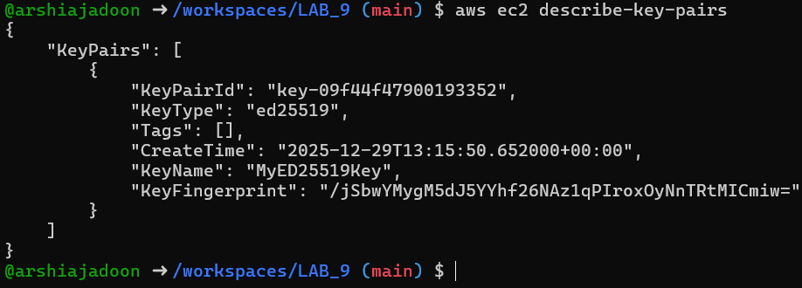
Subnet ID:
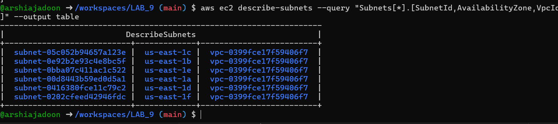
Finding ami id:
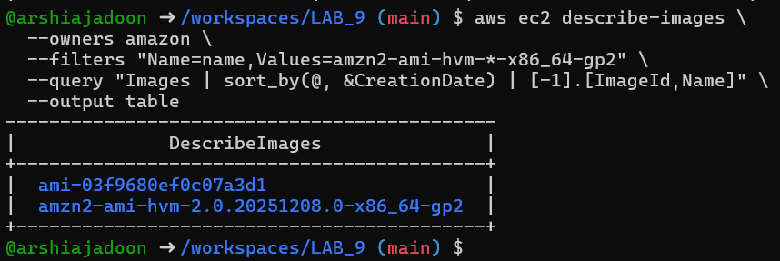
Instance id:
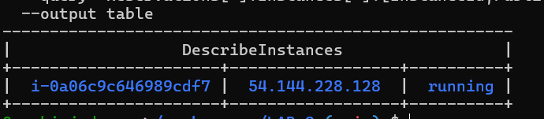
task4_ssh_permission_error_and_fix.png
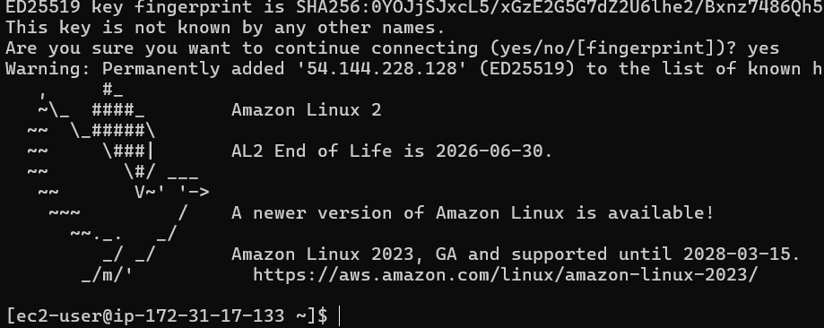
task4_stop_start_terminate_commands.png
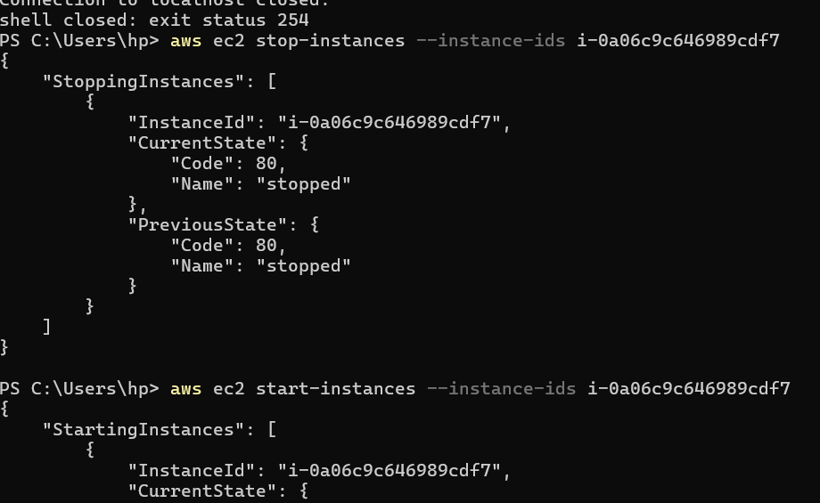
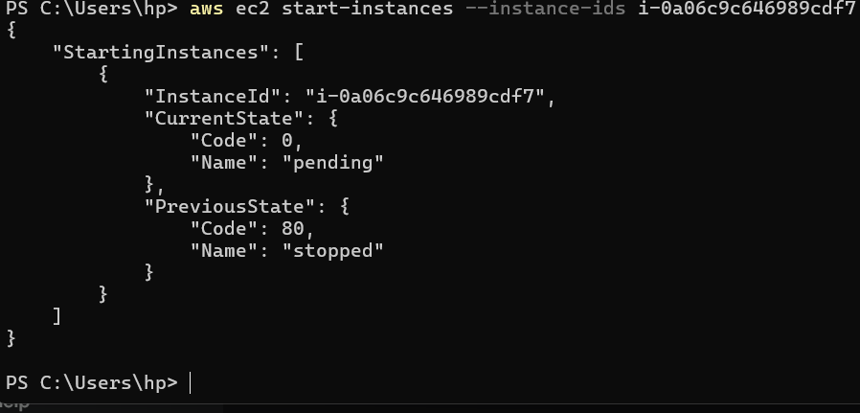
task5_describe_security_groups.png
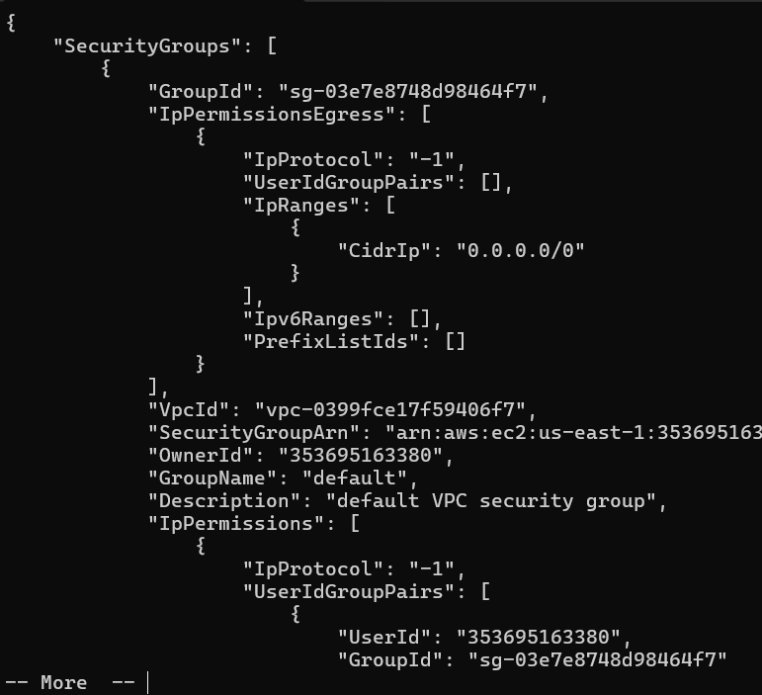
task5_describe_vpcs.png
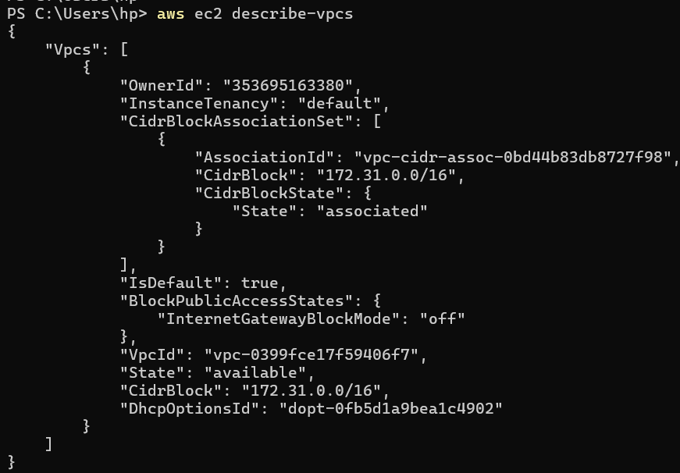
task5_describe_subnets.png
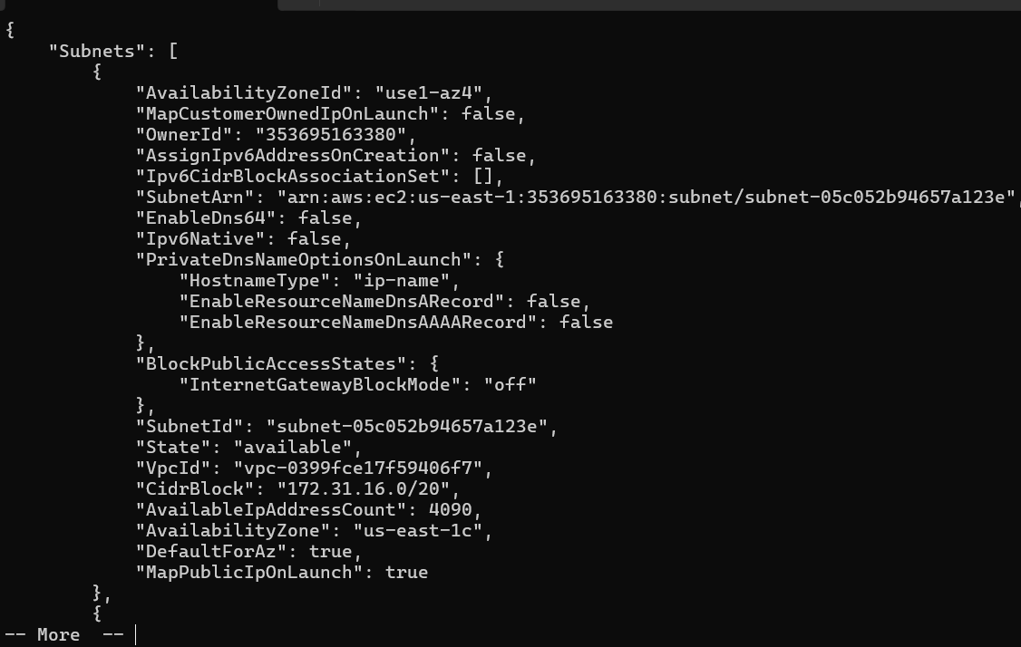
task5_describe_instances.png
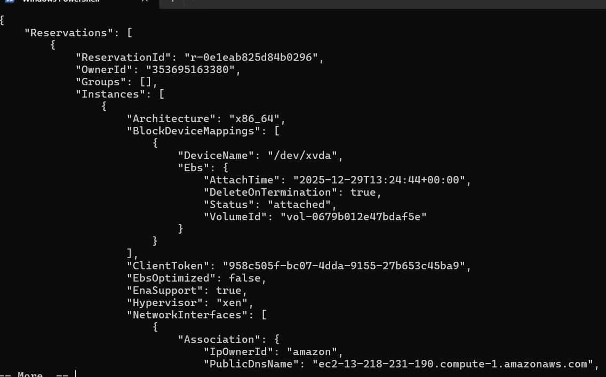
task5_describe_regions.png
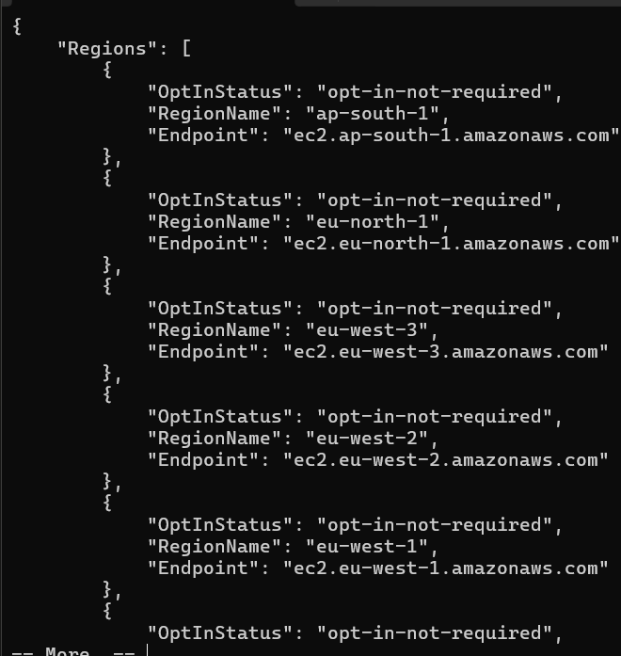
ask5_describe_availability_zones.png
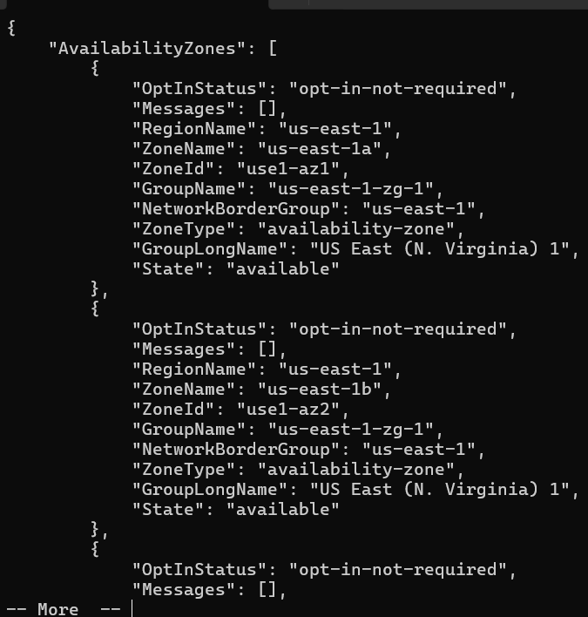
task6_create_group_and_user.png
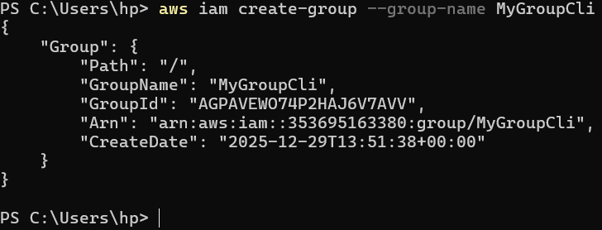
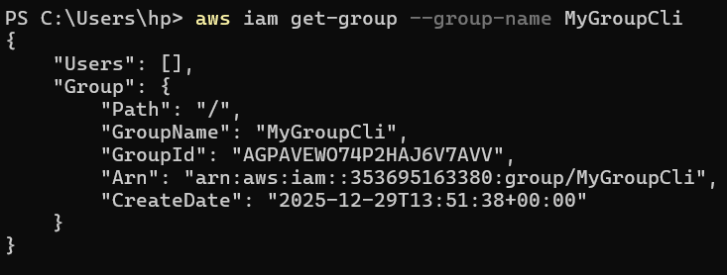
task6_create_group_and_user.png
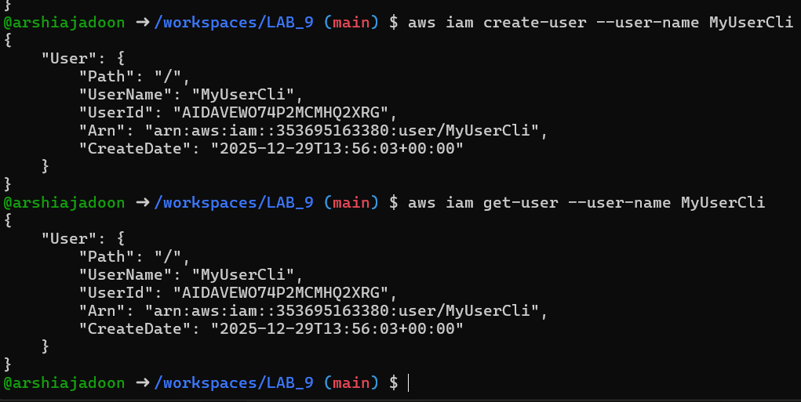
task6_add_user_to_group_and_verify.png
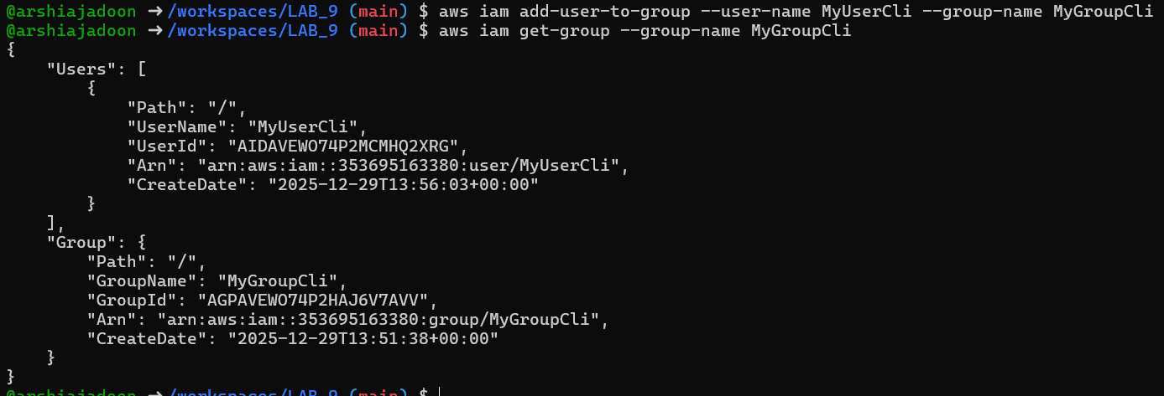
task6_policy_list_and_attach.png
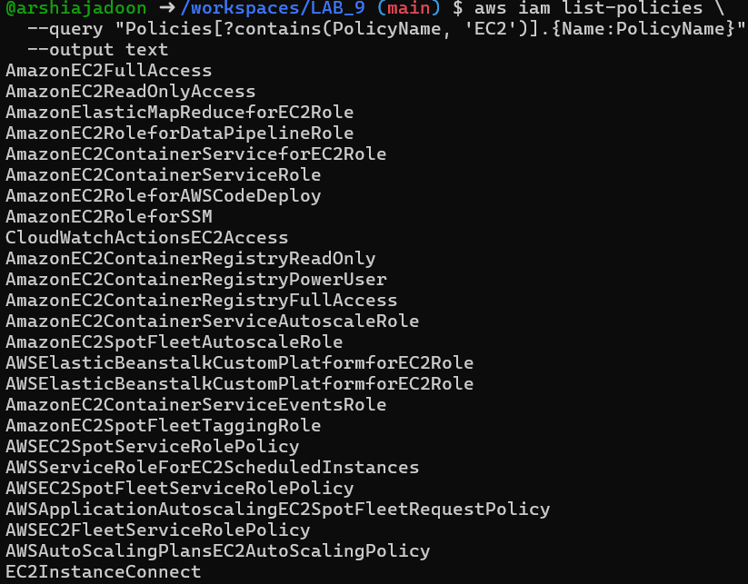
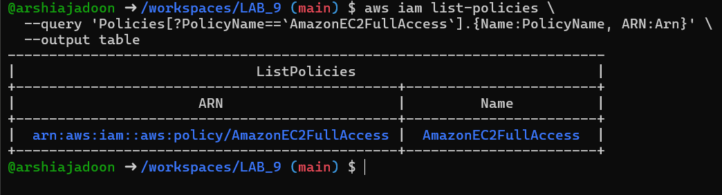
task6_policy_list_and_attach.png
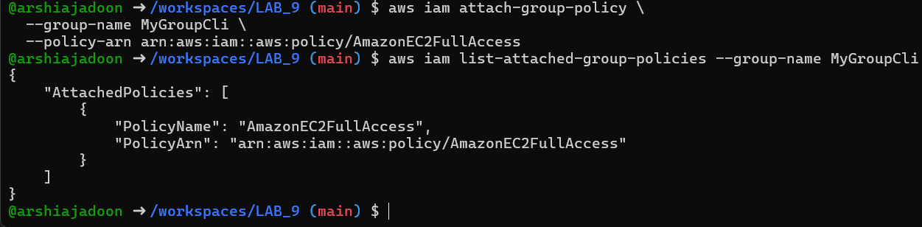
task6_create_login_profile_and_signin.png
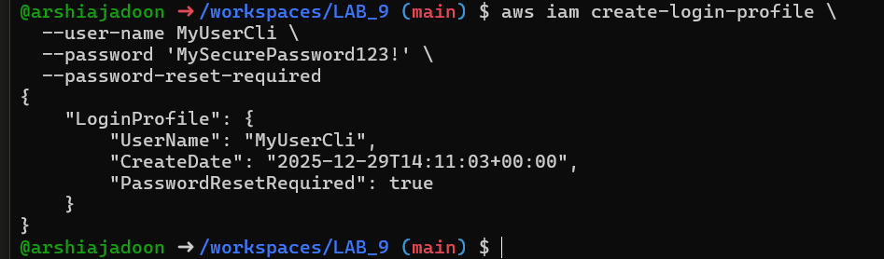
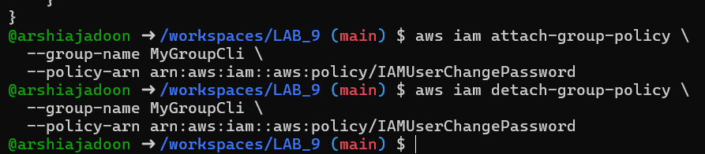
task6_create_access_key_output.png
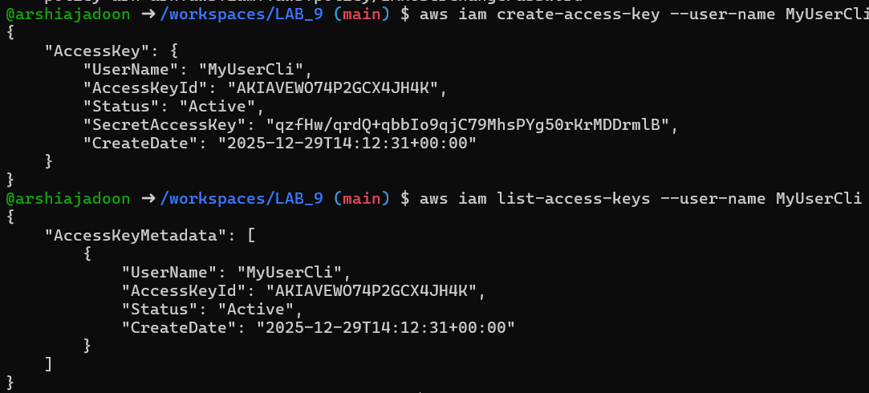
task6_env_exports_and_get_user_error.png
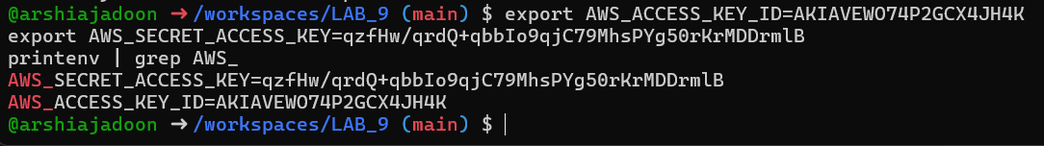
task6_after_logout_and_get_user_success.png
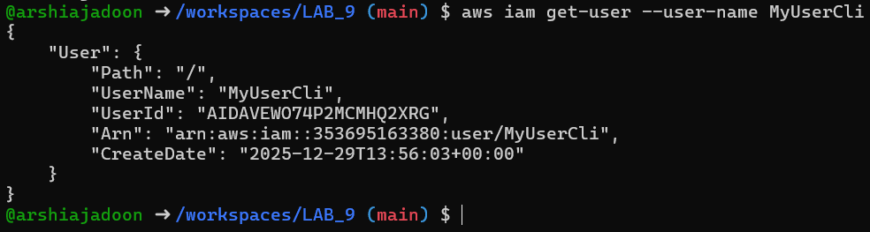
task7_filter_by_tag_public_ip.png
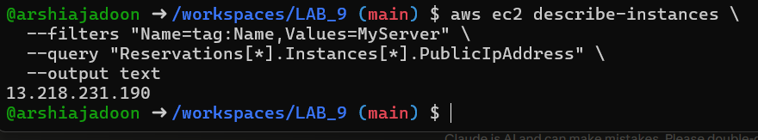
task7_filter_by_instance_type.png
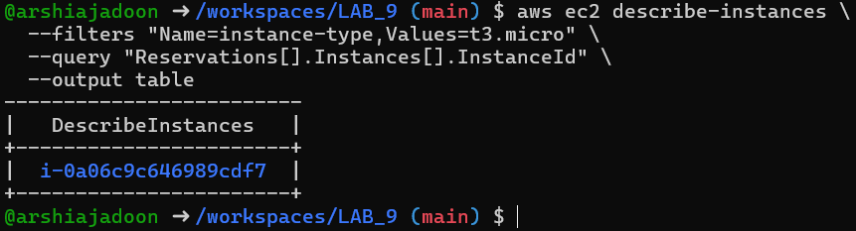
task7_filter_by_subnet.png
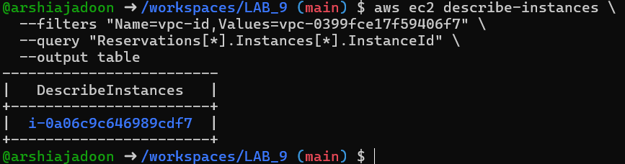
task7_filter_by_vpc.png
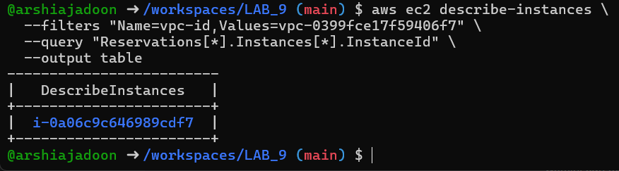
Task 8: Query Outputs for Reporting
task8_query_table_instances_name_ip.png
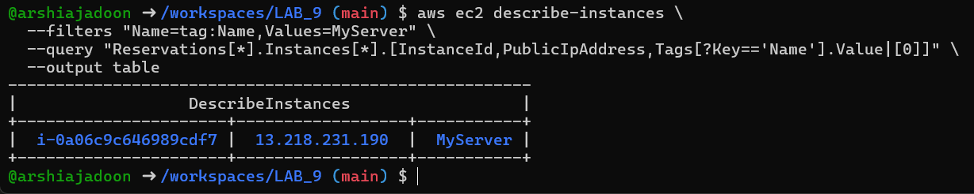
task8_query_table_instance_state.png
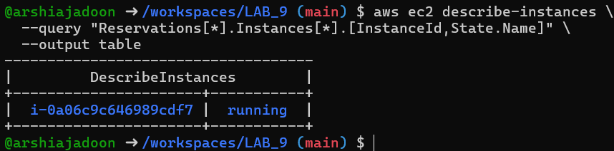
task8_query_table_instance_type_az.png
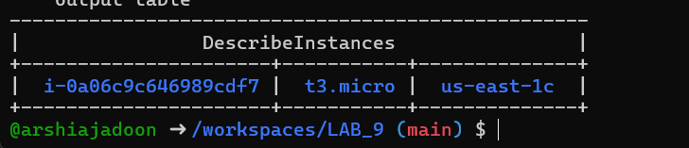
Cleanup: Remove All Resources
cleanup_terminate_instance.png
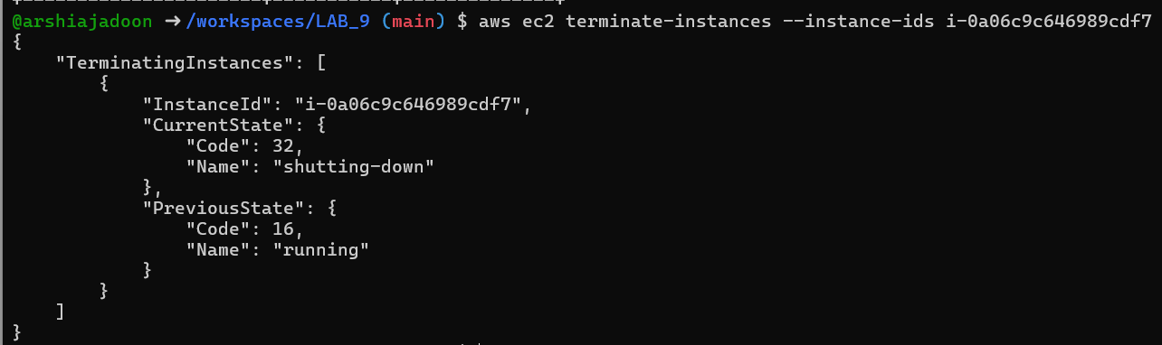
cleanup_delete_volumes_snapshots.png
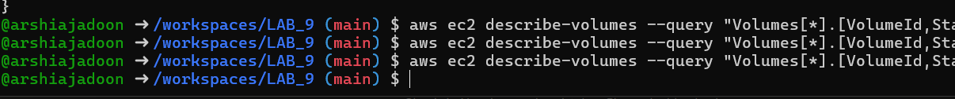
cleanup_delete_security_group_and_keypair.png
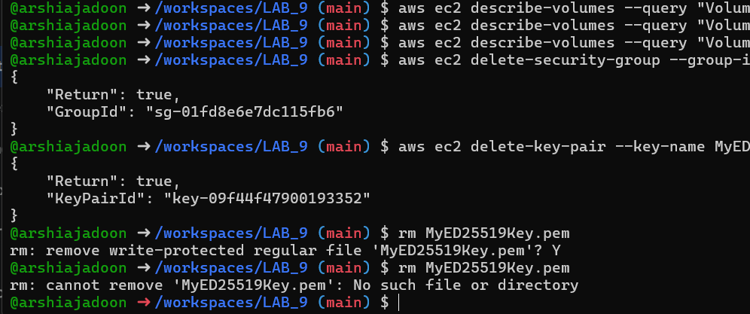
cleanup_iam_users_deleted.png
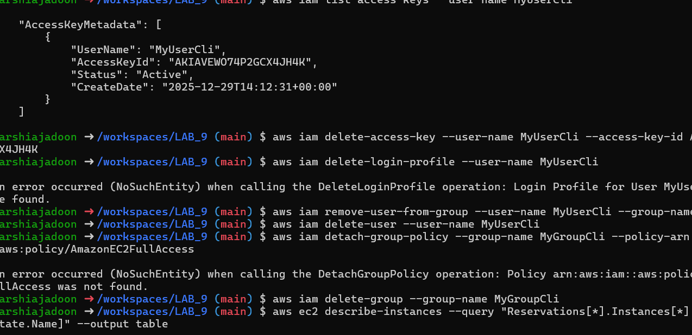
cleanup_summary.png#
