SimpleML Neural Network Library
  - A Complete Guide to Building Neural Networks from Scratch in C++
By: Arshian Ali
Technical Documentation
January 2026
Table of Contents
Executive Summary 2
1. Introduction 2
1.1 Purpose 2
1.2 Scope 2
2. Understanding Neural Networks 3
2.1 What is a Neural Network? 3
2.2 The Training Process 4
3. The Tensor Class 4
3.1 Overview 4
3.2 Core Implementation 4
3.3 Key Operations 4
4. Activation Functions 5
4.1 ReLU (Rectified Linear Unit) 5
4.2 Sigmoid 5
4.3 Comparison of Activation Functions 6
5. Loss Functions 7
5.1 Mean Squared Error (MSE) 7
5.2 Binary Cross-Entropy (BCE) 7
5.3 Cross-Entropy 7
6. Neural Network Layers 7
6.1 Dense (Fully Connected) Layer 7
6.2 Weight Initialization 8
6.3 Sequential Container 8
7. Optimizers 8
7.1 Stochastic Gradient Descent (SGD) 8
7.2 Adam Optimizer 8
8. Complete Training Example 9
8.1 The XOR Problem 9
8.2 Implementation 9
8.3 Results 10
9. Project Structure 10
10. Building and Running 11
10.1 Prerequisites 11
10.2 Build Instructions 11
11. Future Enhancements 11

Executive Summary
This document provides a comprehensive guide to the SimpleML Neural Network Library, a from-scratch implementation of deep learning fundamentals in C++. The library enables building, training, and deploying neural networks for machine learning applications.
Key Features:
- Multi-dimensional Tensor operations with gradient support
- Activation functions: ReLU, Sigmoid, Tanh, Softmax
- Loss functions: MSE, Binary Cross-Entropy, Cross-Entropy
- Fully connected layers with Xavier initialization
- Optimizers: SGD with momentum and Adam
- Sequential model container for easy network construction

1. Introduction

1.1 Purpose
This library implements a minimal but complete neural network framework, designed to:
- Provide educational insight into how neural networks function internally
- Offer a lightweight alternative to large frameworks for simple tasks
- Serve as a foundation for understanding deep learning concepts

1.2 Scope
The library covers the essential components needed to:
- Store and manipulate multi-dimensional numerical data
- Build neural network architectures
- Train models using backpropagation
- Optimize network weights using gradient descent methods

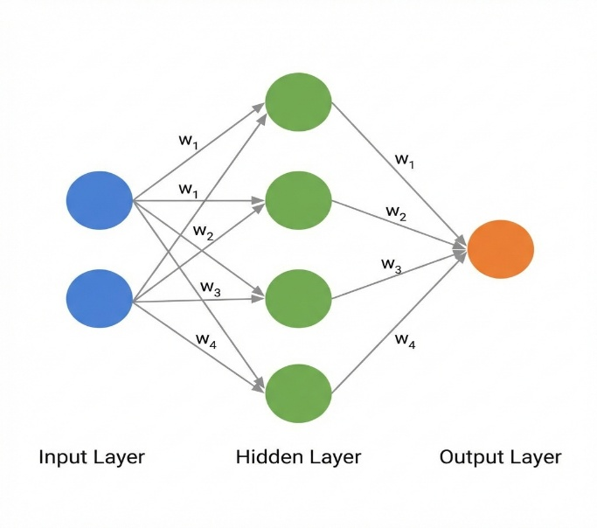
2. Understanding Neural Networks

2.1 What is a Neural Network?
A neural network is a computational model inspired by biological neural systems. It consists of interconnected layers of artificial neurons that process information.

Neural Network Architecture
Core Components:
Component | Description
Neurons | Basic computational units that receive inputs and produce outputs
Layers | Groups of neurons organized in sequence
Weights | Learnable parameters connecting neurons between layers
Biases | Additional learnable parameters added to neuron outputs
Activations | Non-linear functions that introduce complexity

2.2 The Training Process
Training a neural network involves four key steps repeated iteratively:
- Forward Pass: Input data flows through the network, producing predictions
- Loss Computation: Measure how incorrect the predictions are
- Backward Pass: Calculate gradients using the chain rule (backpropagation)
- Weight Update: Adjust weights to reduce the loss

3. The Tensor Class

3.1 Overview
A tensor is a multi-dimensional array that serves as the fundamental data structure for all computations in neural networks.
Tensor Dimensions:
Dimensions | Name | Example
0D | Scalar | 5.0
1D | Vector | [1, 2, 3]
2D | Matrix | [[1,2], [3,4]]
ND | Tensor | Higher-dimensional arrays

3.2 Core Implementation
class Tensor {
private:
std::vector<size_t> shape_; // Dimensions
std::vector<float> data_; // Flattened data (row-major)
std::vector<float> grad_; // Gradients for backpropagation
bool requires_grad_; // Flag for gradient computation
};

3.3 Key Operations

Matrix Multiplication
Matrix multiplication is the cornerstone operation of neural networks:
// For matrices A (M×K) and B (K×N), result C is (M×N)
// C[i][j] = Σ(A[i][k] × B[k][j]) for all k
Tensor matmul(const Tensor &other) const;

Other Operations
- add(), subtract(), multiply() - Element-wise operations
- transpose() - Matrix transposition
- scalar_multiply(), scalar_add() - Scalar operations
- sum(), mean() - Reduction operations

4. Activation Functions
Activation functions introduce non-linearity, enabling networks to learn complex patterns.

4.1 ReLU (Rectified Linear Unit)
The most widely used activation function due to its simplicity and effectiveness.
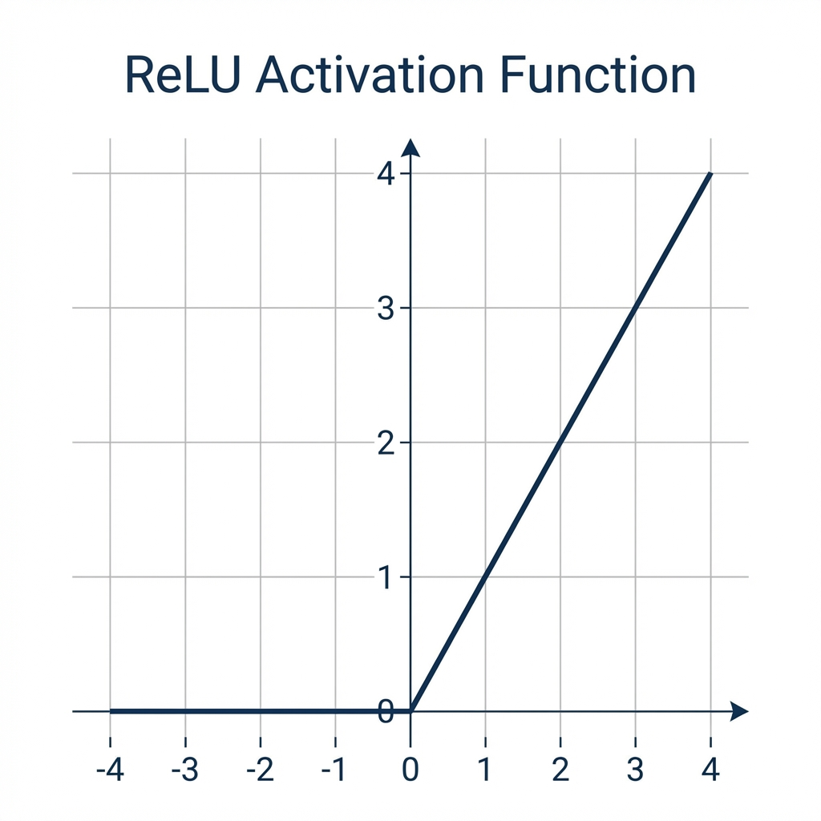
ReLU Activation Function
Mathematical Definition:
$$ReLU(x)=max(0,x)$$
Derivative:
$$\frac{d}{dx}ReLU(x)=\left\{\begin{matrix}1 & \text{if }x>0 \\ 0 & \text{otherwise}\end{matrix}\right.$$

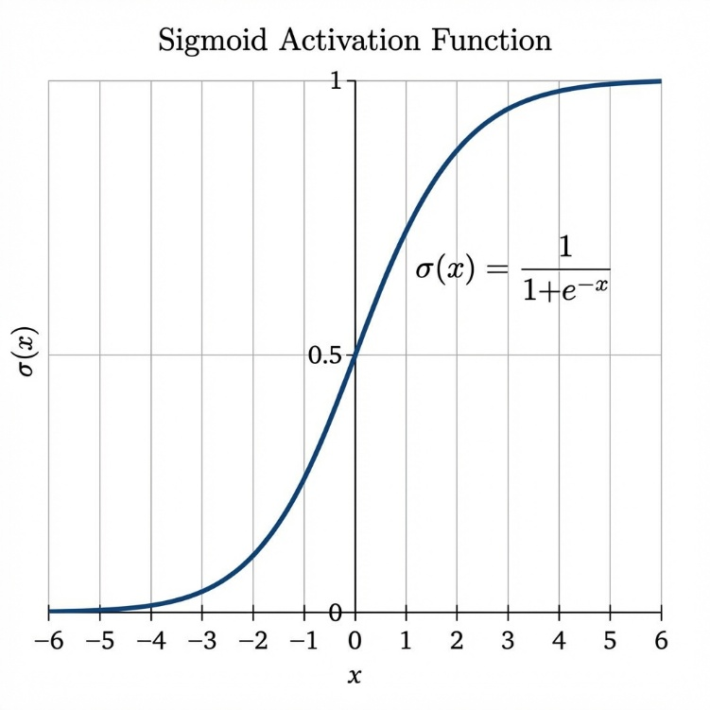
4.2 Sigmoid
Squashes input values to the range (0, 1), making it ideal for probability outputs.

Sigmoid Activation Function
Mathematical Definition:
$$σ(x)=\frac{1}{1+e^{-x}}$$
Derivative:
$$\frac{d}{dx}σ\left(x\right)=σ\left(x\right)⋅\left(1-σ\left(x\right)\right)$$

4.3 Comparison of Activation Functions
Function | Range | Use Case | Pros | Cons
ReLU | [0, ∞) | Hidden layers | Fast, reduces vanishing gradient | Dead neurons
Sigmoid | (0, 1) | Binary output | Smooth probability | Vanishing gradient
Tanh | (-1, 1) | Hidden layers | Zero-centered | Vanishing gradient
Softmax | (0, 1) | Multi-class output | Probability distribution | Computationally expensive

5. Loss Functions
Loss functions quantify how well the network’s predictions match the expected outputs.

5.1 Mean Squared Error (MSE)
Best suited for regression tasks where outputs are continuous values.
$$MSE=\frac{1}{n}\sum_{i=1}^{n}{(}prediction_{i}-target_{i})^{2}$$

5.2 Binary Cross-Entropy (BCE)
Optimal for binary classification problems.
$$BCE=-\frac{1}{n}\sum_{i=1}^{n}{[}t_{i}⋅log(p_{i})+(1-t_{i})⋅log(1-p_{i})]$$

5.3 Cross-Entropy
Designed for multi-class classification with softmax output.
$$CE=-\sum_{i=1}^{n}{t}arget_{i}⋅log(softmax(prediction_{i}))$$

6. Neural Network Layers

6.1 Dense (Fully Connected) Layer
In a dense layer, every input neuron connects to every output neuron.

Forward Pass
$$output=input×weights+bias$$

Backward Pass (Gradient Computation)
$$\frac{∂Loss}{∂weights}=input^{T}×\frac{∂Loss}{∂output}$$
∂Loss∂bias=batch​∂Loss∂output
$$\frac{∂Loss}{∂input}=\frac{∂Loss}{∂output}×weights^{T}$$

6.2 Weight Initialization
Proper initialization prevents vanishing/exploding gradients. We use Xavier/Glorot initialization:
$$W∼Uniform\left(-\sqrt{\frac{6}{n_{in}+n_{out}}},\sqrt{\frac{6}{n_{in}+n_{out}}}\right)$$

6.3 Sequential Container
The Sequential class provides a convenient way to stack layers:
Sequential model;
model.add(std::make_shared<Dense>(2, 8, Activation::ReLU));
model.add(std::make_shared<Dense>(8, 1, Activation::Sigmoid));
Tensor output = model.forward(input);
model.backward(loss_gradient);

7. Optimizers
Optimizers update network weights based on computed gradients.

7.1 Stochastic Gradient Descent (SGD)
The foundational optimization algorithm:
$$W_{new}=W_{old}-η⋅∇Loss$$
Where η is the learning rate.

SGD with Momentum
Accelerates convergence and helps escape local minima:
$$v_{t}=γ⋅v_{t-1}+η⋅∇Loss$$
$$W_{new}=W_{old}-v_{t}$$

7.2 Adam Optimizer
Combines momentum with adaptive learning rates:
$$m_{t}=β_{1}⋅m_{t-1}+(1-β_{1})⋅g_{t}$$
$$v_{t}=β_{2}⋅v_{t-1}+(1-β_{2})⋅g_{t}^{2}$$
$${\hat{m}}_{t}=\frac{m_{t}}{1-β_{1}^{t}}, {\hat{v}}_{t}=\frac{v_{t}}{1-β_{2}^{t}}$$
$$W_{new}=W_{old}-η⋅\frac{{\hat{m}}_{t}}{\sqrt{{\hat{v}}_{t}}+ϵ}$$
Default Hyperparameters:
Parameter | Value | Description
η (lr) | 0.001 | Learning rate
β₁ | 0.9 | First moment decay
β₂ | 0.999 | Second moment decay
ε | 1e-8 | Numerical stability

8. Complete Training Example
Input A | Input B | XOR Output
0 | 0 | 0
0 | 1 | 1
1 | 0 | 1
1 | 1 | 0

8.1 The XOR Problem
XOR is a classic problem that demonstrates the need for non-linearity:
A single-layer network cannot solve XOR, but a two-layer network with non-linear activation can.

8.2 Implementation
#include "Dense.h"
#include "Loss.h"
#include "Optimizer.h"
#include "Sequential.h"
int main() {
// Training data
Tensor X({4, 2}, {0, 0, 0, 1, 1, 0, 1, 1});
Tensor Y({4, 1}, {0, 1, 1, 0});
// Model: 2 → 8 → 1
Sequential model;
model.add(std::make_shared<Dense>(2, 8, Activation::ReLU));
model.add(std::make_shared<Dense>(8, 1, Activation::Sigmoid));
// Training configuration
Loss::BCELoss loss_fn;
Adam optimizer(0.1f);
// Training loop
for (int epoch = 0; epoch < 1000; ++epoch) {
Tensor pred = model.forward(X);
float loss = loss_fn.forward(pred, Y);
model.zero_grad();
model.backward(loss_fn.backward());
auto p = model.parameters();
auto g = model.gradients();
optimizer.step(p, g);
}
return 0;
}

8.3 Results
After training, the network correctly classifies all XOR inputs:
Input | Prediction | Expected | Status
[0, 0] | 0.0005 | 0 | ✓
[0, 1] | 0.9995 | 1 | ✓
[1, 0] | 0.9995 | 1 | ✓
[1, 1] | 0.0001 | 0 | ✓

9. Project Structure
SimpleML/
├── include/
│ ├── Tensor.h # Multi-dimensional array operations
│ ├── Activations.h # ReLU, Sigmoid, Tanh, Softmax
│ ├── Loss.h # MSE, BCE, CrossEntropy
│ ├── Layer.h # Abstract base layer class
│ ├── Dense.h # Fully connected layer
│ ├── Sequential.h # Model container
│ └── Optimizer.h # SGD, Adam optimizers
├── src/
│ └── core/
│ └── Tensor.cpp # Tensor implementation
├── examples/
│ └── main.cpp # XOR training demonstration
├── images/ # Documentation images
└── CMakeLists.txt # Build configuration

10. Building and Running

10.1 Prerequisites
- CMake 3.10 or higher
- C++17 compatible compiler

10.2 Build Instructions
# Configure the project
cmake -B build -S .
# Compile
cmake --build build
# Run the example
./build/ml_example.exe

11. Future Enhancements
The following features are recommended for future development:
- Convolutional Layers - For image processing applications
- Recurrent Layers (LSTM, GRU) - For sequential data
- Dropout Regularization - To prevent overfitting
- Batch Normalization - For faster and more stable training
- GPU Acceleration - Using CUDA or OpenCL
- Model Serialization - Save and load trained models
- Additional Optimizers - RMSprop, Adagrad, AdamW

This document provides the technical foundation for understanding and utilizing the SimpleML Neural Network Library. For questions or contributions, please refer to the project repository.

