Enforce least-privilege access through identity-aware, application-specific access policies using Zscaler Private Access (ZPA)

College Name: Akshaya College of Arts and Science

College Code: brubw

TEAM MEMBERS: 4

Team Leader Name: ARSHIGA M

Email:23csarshiga@acascbe.edu.in

Team Member 1: ABARNA S

Email: 23csAabarna@acascbe.edu.in

Team Member 2: ABDUL RAHMAN M

Email: 23csabdul@acascbe.edu.in

Team Member 3: AKASH M

Email: 23csakash@acascbe.edu.in

INTRODUCTION:

In the modern digital era, organizations rely heavily on cloud-based applications, remote access, and distributed work environments. As a result, securing sensitive data and critical applications has become more challenging than ever before. Traditional security models that provide broad network access are no longer sufficient, as they increase the risk of unauthorized access, insider threats, and cyberattacks. To address these challenges, organizations are increasingly adopting advanced security principles and technologies such as least-privilege access and Zero Trust architecture.

The principle of least-privilege access is a fundamental concept in cybersecurity. It ensures that users, applications, and systems are granted only the minimum level of access necessary to perform their specific tasks. By limiting access rights, organizations can significantly reduce the risk of accidental or intentional misuse of sensitive information. This approach not only enhances security but also improves system stability and compliance with data protection regulations.

To effectively implement least-privilege access in complex IT environments, identity-aware and application-specific access policies are used. Identity-aware access means that access decisions are based on the user’s identity, role, device, and context rather than just their network location. Application-specific policies ensure that users can access only the particular applications they are authorized to use, instead of granting full access to the entire network. This granular level of control helps prevent lateral movement within the network, which is a common technique used by attackers.

A leading solution that enables this approach is through its service known as Zscaler Private Access (ZPA). ZPA is a cloud-based Zero Trust Network Access (ZTNA) solution that replaces traditional VPNs by providing secure, direct connections between users and applications. Unlike VPNs, which expose the entire network, ZPA ensures that applications remain invisible to unauthorized users. It verifies each access request in real-time and allows access only after proper authentication and policy checks.

By using ZPA, organizations can enforce least-privilege access in a more efficient and scalable manner. It dynamically applies security policies based on user identity and context, ensuring that access is continuously monitored and controlled. This not only enhances protection against cyber threats but also improves user experience by providing seamless and secure connectivity.

In conclusion, enforcing least-privilege access through identity-aware and application-specific access policies using Zscaler Private Access (ZPA) represents a modern and effective approach to cybersecurity. It aligns with the Zero Trust model, minimizes security risks, and provides a robust framework for protecting organizational resources in an increasingly complex digital landscape.

ABSTRACT:

In today’s rapidly evolving digital landscape, ensuring secure access to organizational resources has become a major concern. Traditional security approaches that rely on perimeter-based defenses are no longer effective in protecting against modern cyber threats. This has led to the adoption of advanced security models such as Zero Trust, which emphasizes strict verification and controlled access.

This project focuses on enforcing the principle of least-privilege access through identity-aware and application-specific access policies using Zscaler Private Access (ZPA). The least-privilege model ensures that users are granted only the minimum level of access required to perform their tasks, thereby reducing the risk of unauthorized access and data breaches. Identity-aware access control further strengthens security by considering user identity, role, and context before granting access.

Zscaler Private Access (ZPA), a cloud-based Zero Trust Network Access solution, enables secure and direct connectivity between users and applications without exposing the network. It replaces traditional VPNs by providing application-level access instead of network-level access. This approach prevents lateral movement within the network and enhances overall security.

The implementation of least-privilege access using ZPA not only improves data protection but also offers scalability, flexibility, and better user experience. This study highlights how modern security solutions can effectively safeguard digital resources while supporting the dynamic needs of organizations

Use Case Scenarios

Scenario 1: Secure Remote Employee Access
A company allows its employees to work from home. Instead of giving full network access through VPN, the organization uses Zscaler Private Access (ZPA) to allow employees to access only specific applications like email or internal portals based on their role and identity.

Output:
Employees can securely access only the required applications without exposing the entire network. Unauthorized access is prevented, and overall security is improved.

Scenario 2: Third-Party Vendor Access Control
An external vendor is hired to maintain a specific software application. The organization provides access only to that particular application using ZPA, without allowing access to other internal systems.

Output:
The vendor can perform their tasks efficiently while sensitive company data and other applications remain protected from unauthorized access.

Scenario 3: Protection of Sensitive Applications
Critical systems like HR and finance applications contain confidential data. Using ZPA, only authorized employees with proper identity verification can access these applications.

Output:
Sensitive data is protected, and only authorized users can access critical applications, reducing the risk of data breaches.

Scenario 4: Multi-Device / BYOD Environment
Employees use personal devices such as mobiles and laptops to access company resources. ZPA verifies both user identity and device security before granting access.

Output:
Access is allowed only from trusted devices, ensuring secure usage even in flexible work environments.

Scenario 5: Preventing Lateral Movement in Cyber Attacks
An attacker gains access to one user account. However, due to ZPA’s application-specific access control, the attacker cannot move across the network to other systems.

Output:
The attack is contained, preventing further damage and protecting the organization’s overall network security.

Stage – 1

Title:

Enforce least-privilege access through identity-aware, application-specific access policies using Zscaler Private Access (ZPA).

Overview:
In today’s highly connected digital world, organizations face increasing security challenges due to remote work, cloud adoption, and evolving cyber threats. Traditional security models that rely on perimeter-based defenses are no longer sufficient, as they often provide broad network access, making systems vulnerable to unauthorized access and attacks. To overcome these limitations, modern security approaches such as the Zero Trust model and least-privilege access have become essential.

The concept of least-privilege access ensures that users, applications, and devices are granted only the minimum level of access required to perform their tasks. This reduces the risk of accidental misuse, insider threats, and external attacks. Instead of providing full network access, organizations focus on restricting access to specific resources, thereby minimizing exposure to sensitive data.

To implement this effectively, identity-aware and application-specific access policies are used. Identity-aware access control verifies the user’s identity, role, and context before granting access. It may also consider additional factors such as device security, location, and authentication status. Application-specific access ensures that users can connect only to the applications they are authorized to use, rather than the entire network. This granular control significantly improves security and prevents unauthorized activities.

A key technology that supports this approach is through its solution Zscaler Private Access (ZPA). ZPA is a cloud-based Zero Trust Network Access (ZTNA) platform that enables secure, direct connections between users and applications. It eliminates the need for traditional VPNs by ensuring that applications are never exposed to the public internet. Instead, access is provided dynamically after verifying user identity and enforcing predefined policies.

ZPA continuously monitors and evaluates access requests in real time, ensuring that security is maintained at all times. It also prevents lateral movement within the network by isolating applications and restricting access paths. This makes it significantly harder for attackers to move across systems even if one point is compromised.

Overall, enforcing least-privilege access using ZPA provides a secure, scalable, and efficient way to protect organizational resources. It aligns with modern cybersecurity practices, enhances user experience, and ensures that access control is both flexible and robust. This approach is essential for organizations aiming to safeguard their data and applications in an increasingly complex and dynamic environment.
List of Vulnerabilities:

S. No. |  | Vulnerability Name | CWE ID
1 |  | Stored Cross-Site Scripting (XSS) | CWE-79
2 |  | Broken Access Control | CWE-285
3 |  | SQL Injection | CWE-89
4 |  | Broken Authentication | CWE-285
5 |  | Insecure Direct Object Reference (IDOR) | CWE-639
6 |  | Security Misconfiguration | CWE-732
7 |  | Cross-Site Request Forgery (CSRF) | CWE-352
8 |  | Cleartext Transmission of Sensitive Information | CWE-319
9 |  | Clickjacking | CWE-1021
10 |  | Password Auto-Completion Enabled | CWE-310
11 |  | DOM-Based Cross-Site Scripting | CWE-79
12 |  | jQuery Version Vulnerability (XSS) | CWE-79
13 | Information Exposure (HTTP Header - Internal IP Disclosure) |  | CWE-200
14 |  | Information Exposure (SSL Issues) | CWE-200
15 |  | Information Exposure (HTTP Issues) | CWE-200

Vulnerability Report
1. Vulnerability Name: Stored Cross-Site Scripting (XSS)
CWE ID: CWE-79
OWASP Category: A03:2021 – Injection
Description
Stored Cross-Site Scripting (XSS) occurs when malicious scripts are permanently stored within a web application, such as in a database, message board, or input field. When other users access the affected page, the malicious script is executed in their browser without their knowledge.
Business Impact
This vulnerability can have serious consequences for the organization. Attackers can inject malicious scripts that are later executed by other users, especially those with higher privileges such as administrators. This can lead to unauthorized actions, session hijacking, data theft, or exposure of sensitive user information. Since the script is stored, it can affect multiple users over time, increasing the severity of the attack.
Vulnerable URL
http://testfire.net/
Vulnerable Parameter
http://testfire.net/search.jsp?query=%27%3E%3Cscript%3Ealert%28%27hacked%27%29%3C%2Fscript%3E
Steps to Reproduce
- Open the vulnerable web application URL in a browser.
- Navigate to the search functionality or input field.
- Enter a malicious script such as:
<script>alert('hacked')</script>
- Submit the input.
- If the application is vulnerable, the script will be stored and executed when the page is accessed again.

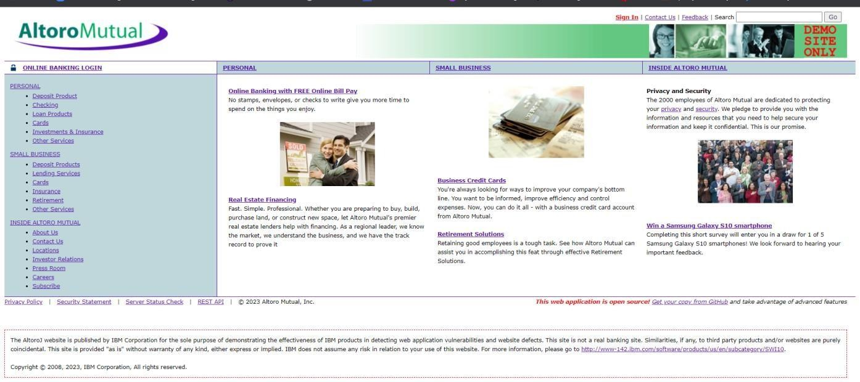

- In the search box we will input some code to perform the vulnerability.
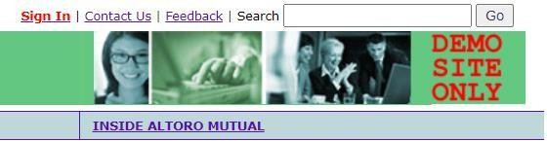

- The Script we will be inputting is '><script>alert('hacked')</script>

- This displays a harmless pop up alert box with the text saying ‘hacked’
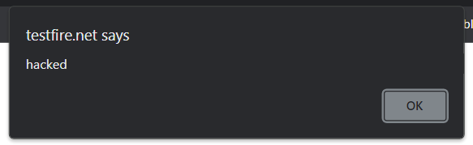

Recommendation:
- When interacting with databases, use parameterized statements or prepared statements to avoid SQL injection, which can be a vector for XSS.
- Sanitize and validate all user inputs and ensure that any data displayed on the web page is properly encoded. Use output encoding libraries or functions to prevent script injection.

- Vulnerability name: Broken access control CWE: 285
Description: When access control checks are not applied consistently - or not at all - users are able to access data or perform actions that they should not be allowed to perform. This can lead to a wide range of problems, including information exposures, denial of service, and arbitrary code execution.
Business Impact: wide-ranging business impact, including financial losses, reputation damage, legal consequences, operational disruption, and loss of customer trust. Addressing this vulnerability is crucial to protect the organization and its stakeholders from these potential negative effects.

Vulnerability path: http://testfire.net/

Vulnerability parameter: http://testfire.net/login.jsp
Steps to Reproduce:

  - Access the URL



  - Now we will try to sign in to this website with admin privileges
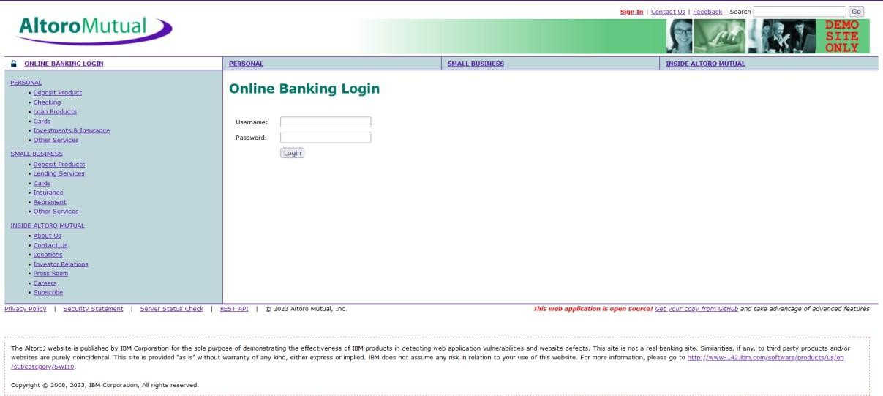
  - Also, we will be using burp suite to get requests from the website and know additional information.
We use ‘admin’ for the username and password.
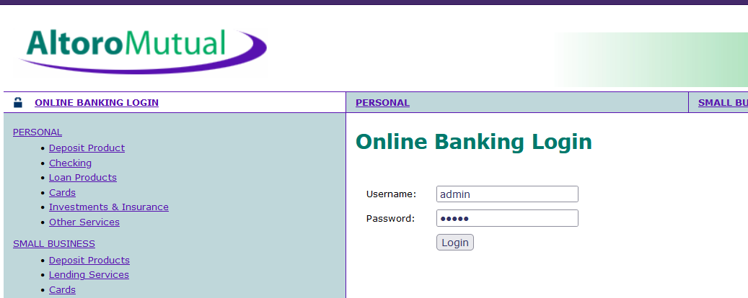

  - This request has been received in the burp suite with the username and password as well in clear text.

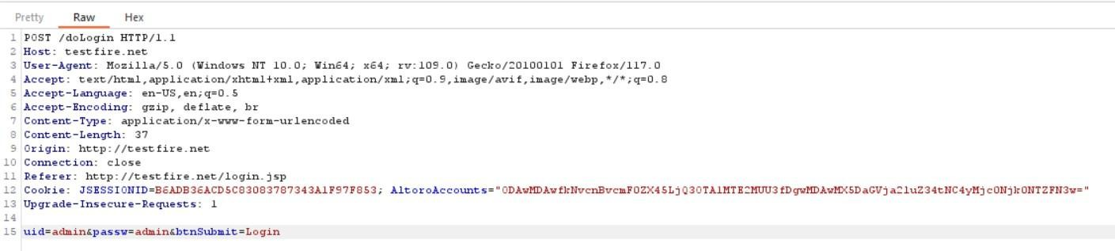
  - now we click on forward request in the burp suite and then we will be redirected to the admin user details.
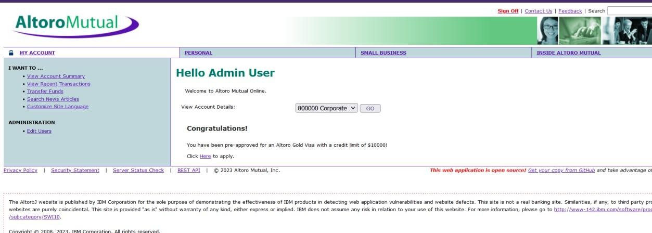

  - We can even edit the other users data and delete their login details as well.
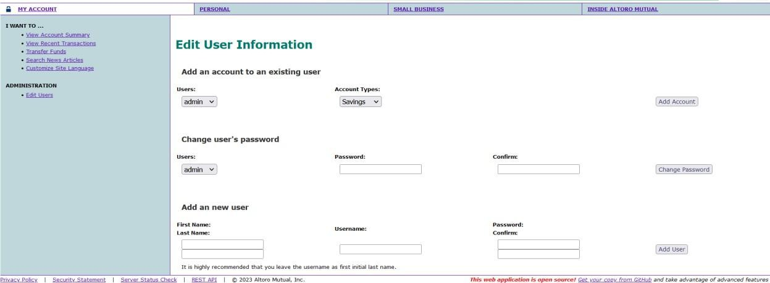

Recommendations:
- Ensure that the application has a robust authentication and authorization mechanism in place. Users should be authenticated before any sensitive actions are performed, and authorization checks should be conducted to verify that users have the necessary permissions for the requested operation.
- Ensure that session management is secure. Use strong session IDs, enforce session timeouts, and regenerate session tokens after login. Implement session fixation protection to prevent session hijacking.

- Vulnerability name: SQL injection CWE: 89
Description: The product constructs all or part of an SQL command using externally-influenced input from an upstream component, but it does not neutralize or incorrectly neutralizes special elements that could modify the intended SQL command when it is sent to a downstream component.

Business Impact: In summary, it is crucial to underscore that CWE-89, known as SQL Injection, can exert a profound and diverse business impact. This encompasses critical facets such as data breaches, financial setbacks, harm to reputation, legal ramifications, and operational turmoil. Hence, the imperative of preventing and remedying SQL injection vulnerabilities cannot be overstated, as it is indispensable for fortifying the security and continuity of an organization's applications and data.
Vulnerability path: http://testfire.net/

Vulnerability parameter: http://testfire.net/login.jsp
Steps to Reproduce:

  - Access the URL

  - Now we will try to sign in to this website with admin privileges but using SQL injection


  - Also, we will be using burp suite to get requests from the website and know additional information.

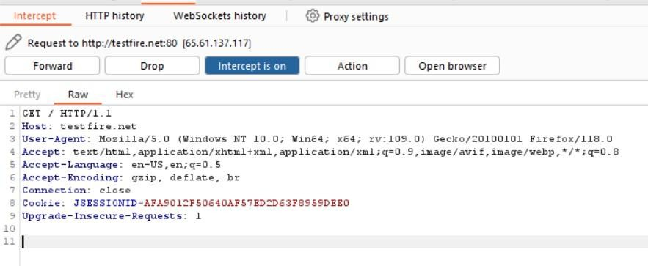
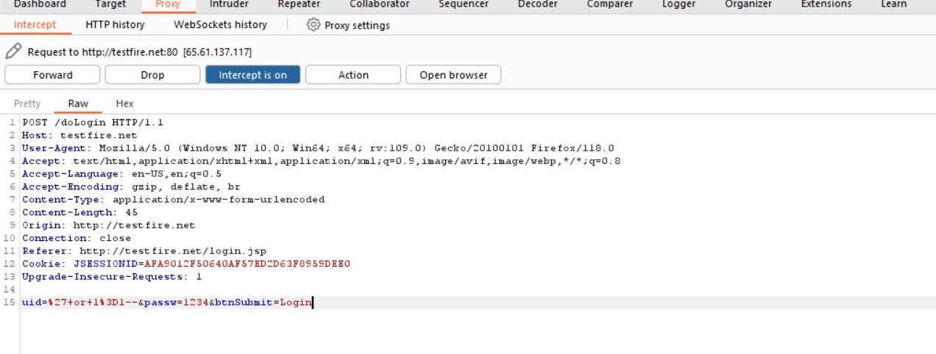

  - Click forward request multiple times to proceed to the login page.
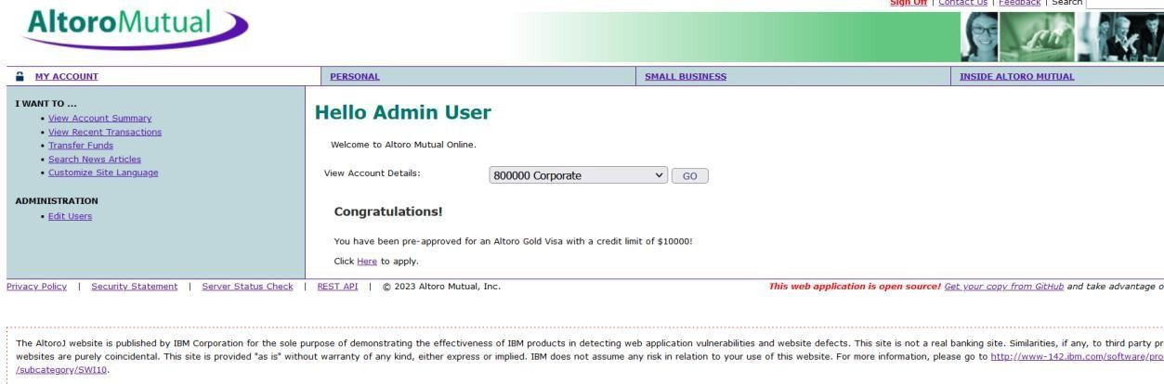

  - With this we can know that sql injection worked and we got the admin privileges.

Recommendations:
- If parameterized statements are not feasible, use proper input validation and escaping mechanisms to sanitize user inputs before they are used in SQL queries. This helps prevent malicious code injection.
- Utilize stored procedures for database operations. This can help separate SQL code from application code and reduce the risk of SQL injection.
- Implement strict input validation for all user inputs, ensuring that data adheres to the expected format and structure.

- Vulnerability name: Broken authentication CWE: 285

Description: The system's authorization functionality does not prevent one user from gaining access to another user's data or record by modifying the key value identifying the data.

Business Impact: To effectively mitigate the business impact of CWE-285, it is imperative that organizations place a strong emphasis on bolstering their authentication and session management practices. This should encompass the adoption of multi-factor authentication, the secure storage of credentials, meticulous session handling, and a commitment to conducting routine security assessments and testing. The rectification of these vulnerabilities stands as a critical imperative, safeguarding sensitive data, user identities, and the organization's overarching security stature and reputation.

Vulnerability path: http://testfire.net/

Vulnerability parameter: http://testfire.net/login.jsp

Steps to Reproduce:

  - Access the URL


  - Now we will try to login using some different approach.
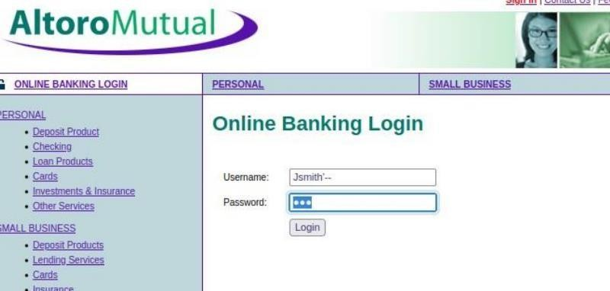
  - As we know which users are present in the database of this website by using the admin privileges. We can directly access a particular user by simply knowing their username; we will add some characters after his user name as a sql injection to simply bypass the password.

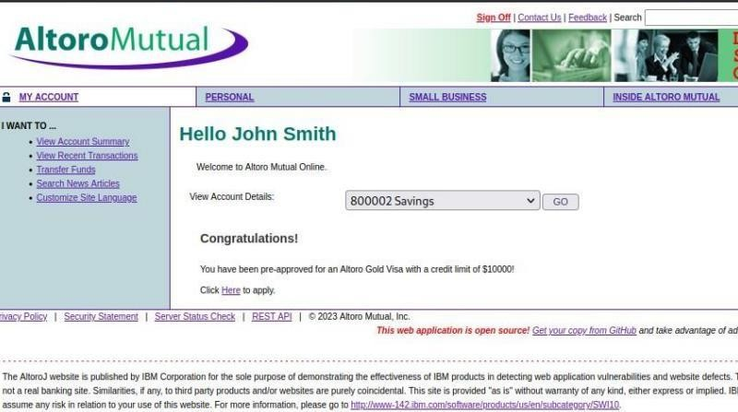
  - This leads us to the details of this person’s account.
Recommendations:
- Implement strong authentication mechanisms, such as multi-factor authentication (MFA) or two- factor authentication (2FA), to ensure that only authorized users can access the system.
- Implement proper authorization controls to ensure that users have the necessary permissions to access specific functions or data. Use role-based access control (RBAC) to manage user privileges effectively.
- Deploy intrusion detection and prevention systems (IDS/IPS) to monitor and block suspicious activities related to authentication and authorization.
- Vulnerability Name: Insecure Direct object Reference CWE: 639
OWASP Category: A01: Broken Access Control
Description:
Insecure Direct Object Reference (IDOR) is a vulnerability that arises when attackers can access or modify objects by manipulating identifiers used in a web application's URLs or parameters. It occurs due to missing access control checks, which fail to verify whether a user should be allowed to access specific data.
Business Impact:
To effectively mitigate the business impact of CWE-639, organizations must make it a top priority to fortify their access control and authorization mechanisms. This entails the implementation of robust security measures, the regular conduct of comprehensive security assessments, and the deployment of intrusion detection systems to promptly identify and counter unauthorized access attempts. These measures stand as absolutely critical in the defense of sensitive data, the overall security of systems, and the preservation of the organization's esteemed reputation.

Vulnerability Path: http://testfire.net

Vulnerability Parameter: http://testfire.net/bank/transfer.jsp

Steps to Reproduce:
- Go to the domain.
- Sign into the site.

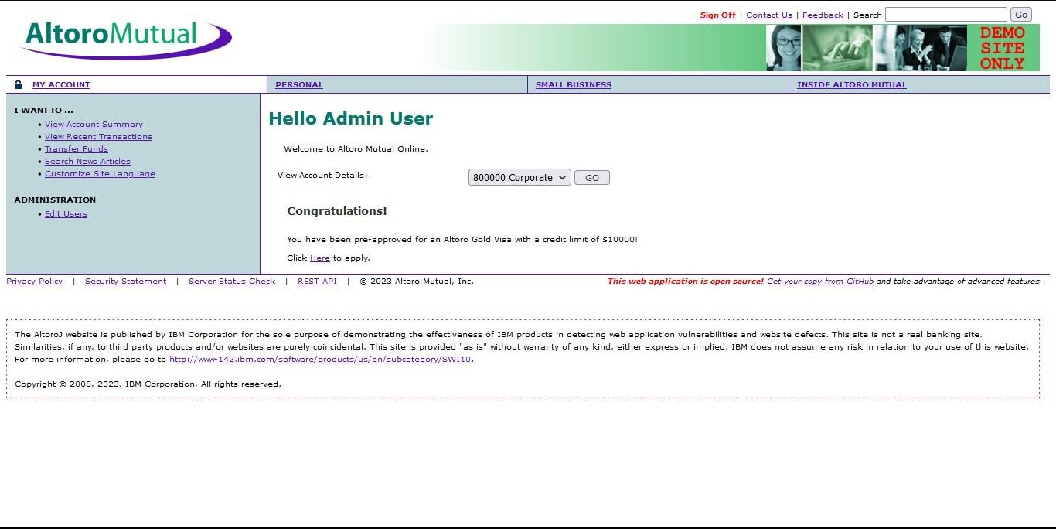
- Open “Transfer Money” on the left side and fill in the details. On the intercept and click transfer
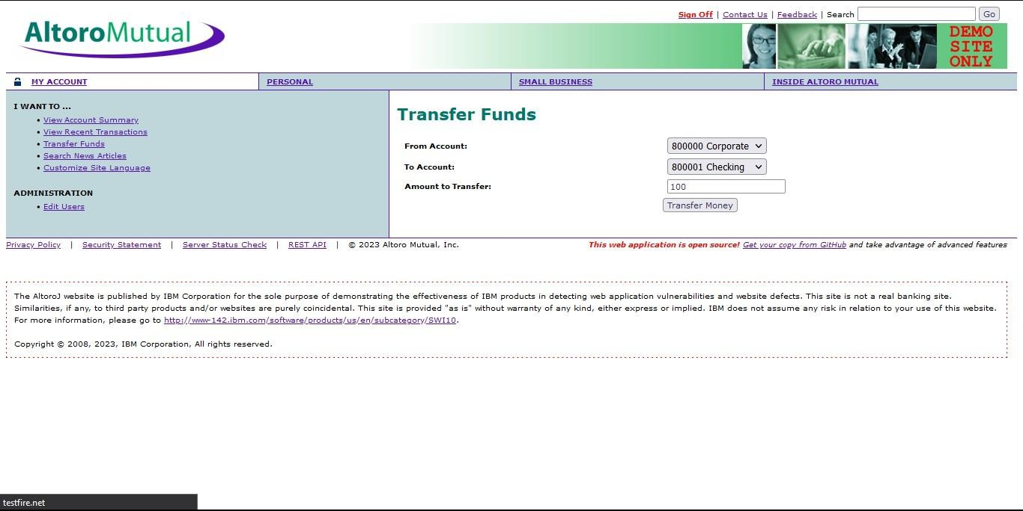
- Open burp and notice the change.
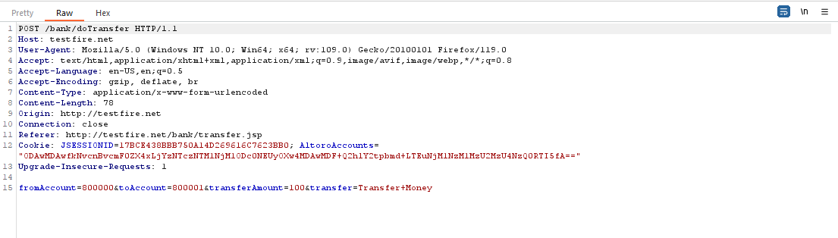
- In the 15th line change the amount from 100 to 1000 and click forward

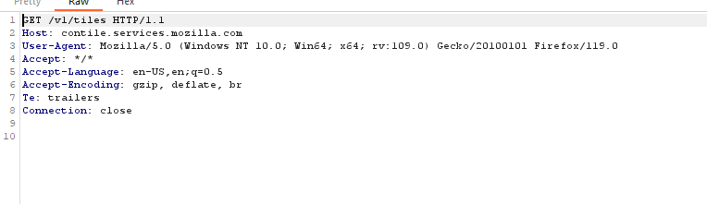
- Look at the site, we can notice the msg that shows the transfer of 1000.
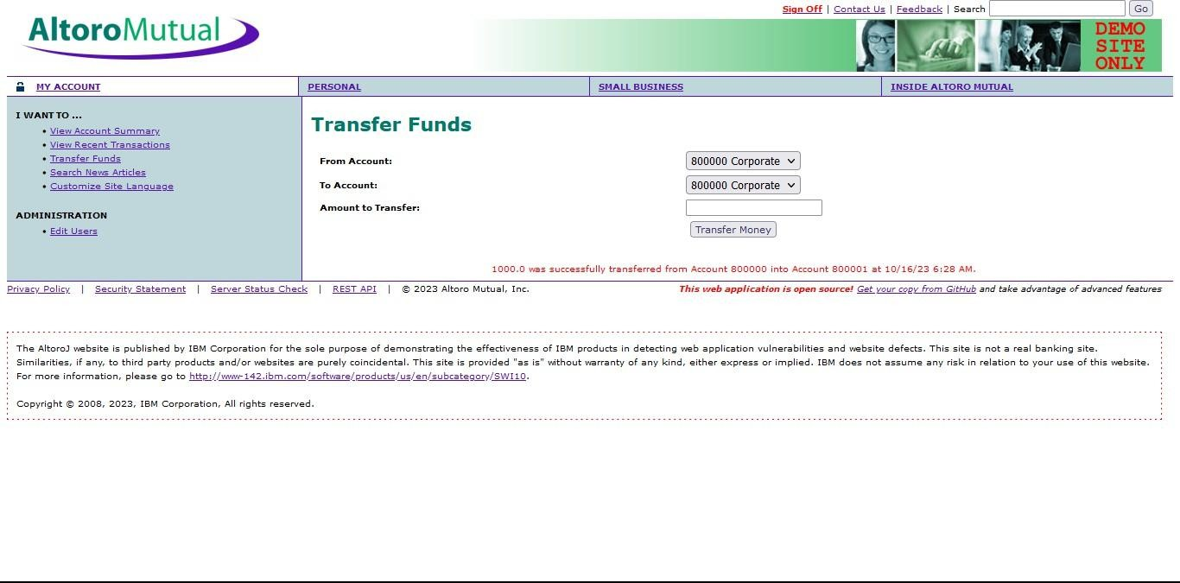

- Off the Intercept and open “View Recent Transactions”.
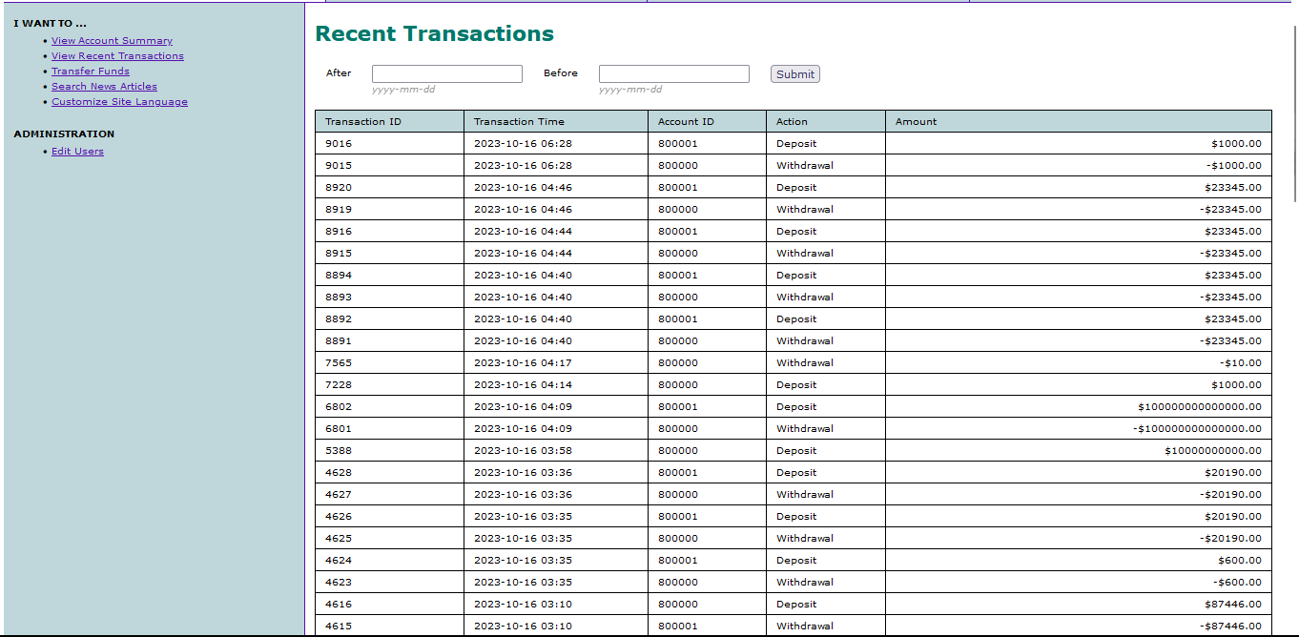

Recommendation:
  - Utilize parameterized queries or prepared statements when interacting with databases. This prevents user-controlled input from being executed as SQL code.
  - Implement a Content Security Policy to mitigate the risk of cross-site scripting (XSS) attacks, which can be used to execute unauthorized queries.
  - Implement account lockout mechanisms that temporarily suspend accounts after a specified number of unauthorized access attempts to prevent brute force attacks.

5. Vulnerability Name: Security Misconfiguration
CWE ID: CWE-732
Description
Security Misconfiguration occurs when security settings are not properly defined or maintained, allowing unauthorized users to access or modify sensitive resources. This can happen due to default configurations, improper permission settings, unnecessary services enabled, or lack of regular security updates.
Business Impact
This vulnerability can expose critical systems and sensitive data to unauthorized access. Improper configurations may allow attackers to exploit system weaknesses, leading to data breaches, system compromise, or service disruption. To reduce these risks, organizations should implement secure configuration practices, perform regular security audits, and continuously monitor systems to detect and fix misconfigurations. Proper configuration management helps in maintaining data confidentiality, system integrity, and organizational reputation.
Vulnerable URL
http://testfire.net/
Vulnerable Parameter
http://testfire.net/login.jsp
Steps to Reproduce
- Open the application URL in a web browser.
- Navigate to the login page.
- Observe the security configuration (such as exposed settings, default credentials, or unnecessary services).
- Identify any misconfigured settings that allow unauthorized access or information exposure.


  - We will be using the uniscan tool which is available in the kali.
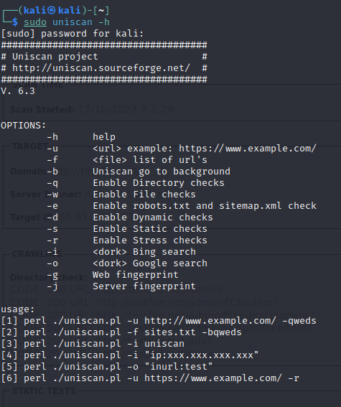

  - We will use this tool to scan for hidden directories that can be access due to poor security measures taken in this website.
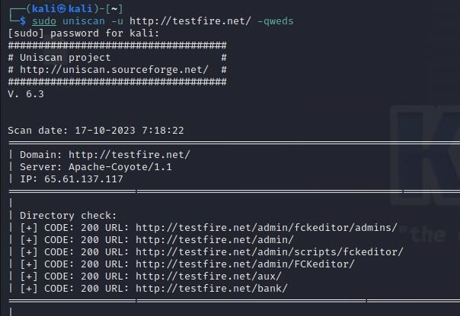

  - We found directories that can be accessed easily. Also all the files that are present in the website has also been found.
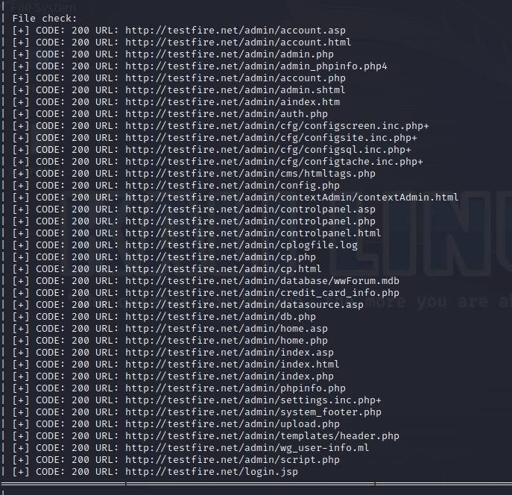

  - Let us go through one webpage to see the vulnerability

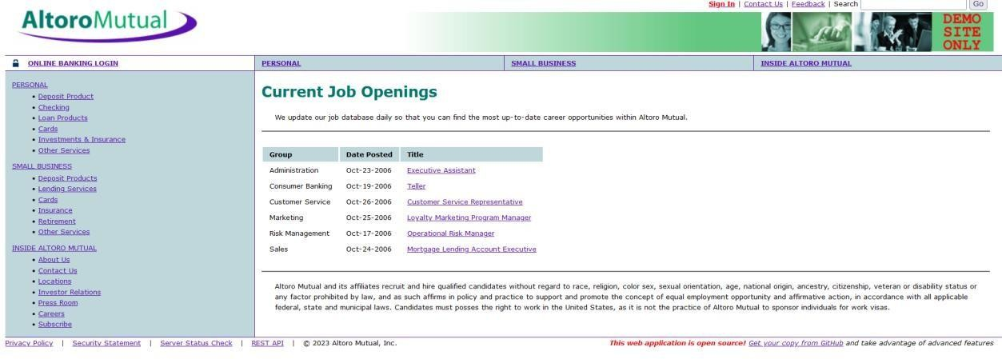

  - Here we can see the sensitive data of job applications which can help an attacker.

Recommendations:
- Implement a change management process to document and review all changes to system configurations. This helps prevent unauthorized or unintended alterations.
- Follow security guidelines provided by software and hardware vendors to ensure secure configurations.
- Regularly perform compliance checks against industry standards and regulations to ensure that configurations remain in compliance with security requirements.

5. Vulnerability Name: Cross-Site Request Forgery (CSRF)
CWE ID: CWE-352
OWASP Category: A08:2021 – Cross-Site Request Forgery

Description
Cross-Site Request Forgery (CSRF) is a vulnerability where an attacker tricks a logged-in user into performing unintended actions on a web application without their consent. This is usually done by sending malicious links or embedding requests in external websites. Since the user is already authenticated, the application processes the request as legitimate, even though it was initiated by the attacker.

Business Impact
CSRF attacks can lead to serious consequences depending on the user’s privileges. For regular users, it may result in unauthorized actions such as changing account details or initiating transactions. If an administrator is targeted, the attacker may gain control over the entire application. To minimize these risks, organizations must implement secure coding practices such as anti-CSRF tokens, conduct regular security testing, and promote safe browsing awareness among users. This helps in protecting sensitive data and maintaining user trust.

Vulnerable URL
http://testfire.net/

Vulnerable Parameter
http://testfire.net/bank/transfer.jsp

Steps to Reproduce
- Open the application in a web browser: https://testfire.net/
- Log in to the application with valid user credentials.
- Navigate to the fund transfer page.
- Intercept or observe the request being sent without CSRF protection.
- Attempt to replicate the request from another source (e.g., external page or tool).
- If the transaction is processed without verification, the application is vulnerable to CSRF.

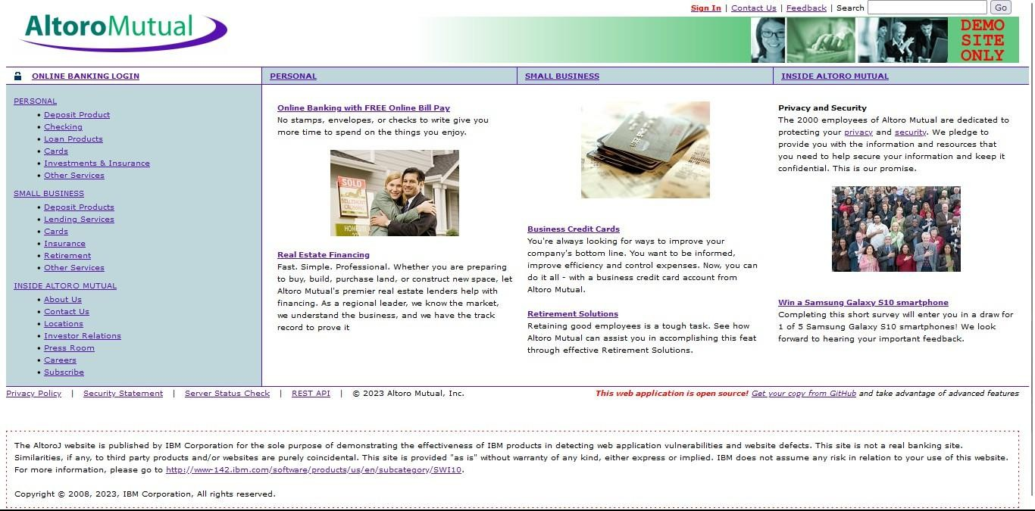
- Login to it using default credentials, and you will find two accounts.
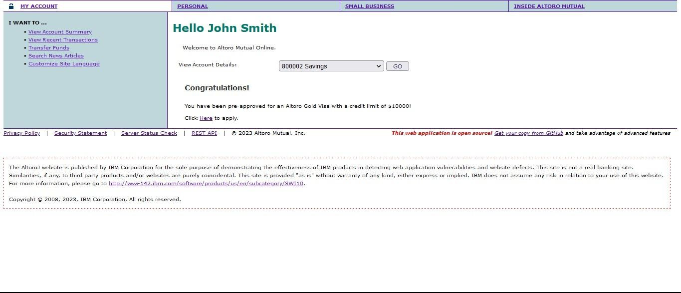

- Capture the request in any Intercepting proxy (Burp Suite, Charles Proxy etc.) while transferring the amount from one account to another as shown in the below picture.
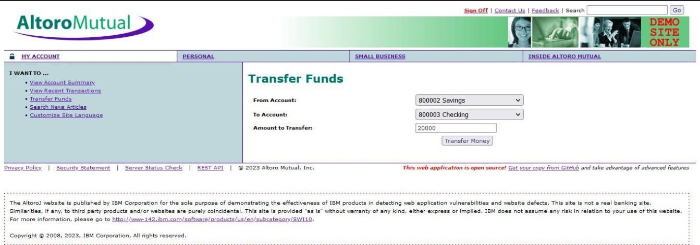

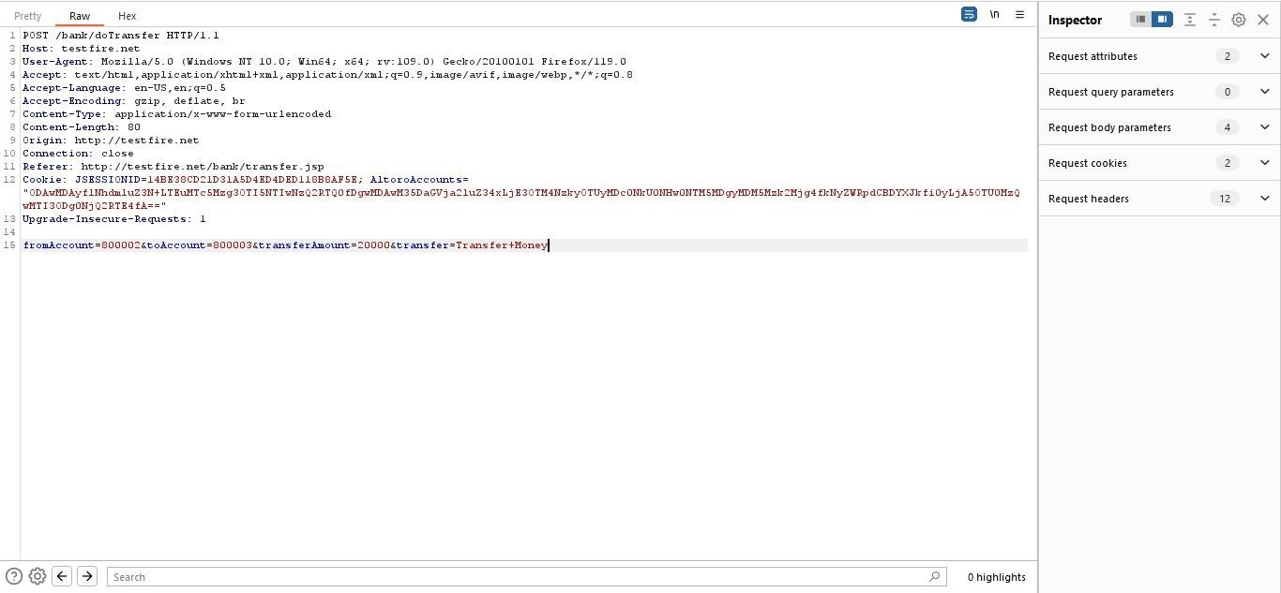

- Generate CSRF POC using Burp Suite Engagement tools (by modifying the account numbers accordingly)
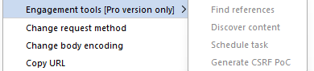
- As the victim is already logged-in to the site an attacker can send the crafted malicious form/URL to the user to his email/text/by any other means and trick the victim using his social engineering skills/techniques like below.
- User thinks, he could use a free $100 gift card! What could go wrong? You open the email and click the link/open the attachment.
- Once the user opens the form a transaction is automatically performed from his account without his knowledge as the user is already logged in.
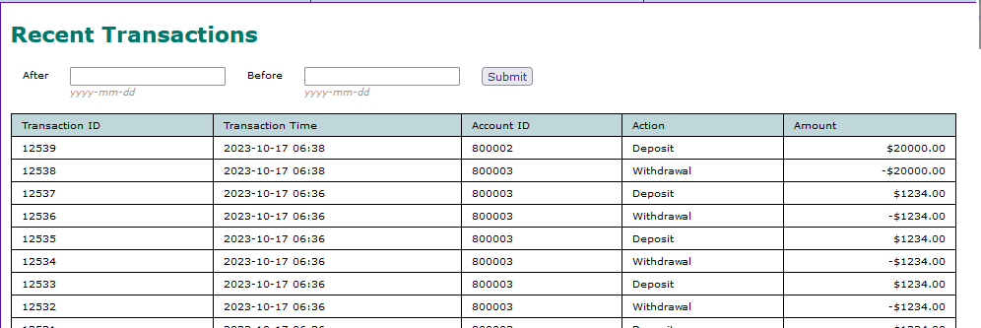

Recommendations:
- Implement Synchronizer Token Patterns to include unique, randomly generated tokens in each HTTP request and validate these tokens on the server side to verify the authenticity of the request.
- Utilize the SameSite attribute in cookies to restrict their usage to same-site requests only, preventing them from being sent along with cross-site requests and effectively mitigating CSRF attacks.

- Utilize framework-specific protections and security features to prevent CSRF attacks. Many modern web frameworks have built-in mechanisms and libraries for handling CSRF vulnerabilities effectively.
- Implement a Content Security Policy to restrict the sources from which various types of content can be loaded. By specifying the trusted sources of content, you can minimize the risk of malicious code execution and reduce the likelihood of successful CSRF attacks.
- Vulnerability name: Cleartext Transmission of Sensitive Information CWE: 319
Description: The product transmits sensitive or security-critical data in cleartext in a communication channel that can be sniffed by unauthorized actors. Many communication channels can be "sniffed" (monitored) by adversaries during data transmission. For example, in networking, packets can traverse many intermediary nodes from the source to the destination, whether across the internet, an internal network, the cloud, etc. Some actors might have privileged access to a network interface or any link along the channel, such as a router, but they might not be authorized to collect the underlying data. As a result, network traffic could be sniffed by adversaries, spilling security-critical data.
Business Impact: To effectively reduce the business consequences associated with CWE-319, organizations must prioritize the adoption of secure data transmission practices. This includes the utilization of encryption and robust, secure protocols. The routine conduct of security assessments and testing is pivotal in pinpointing and remedying vulnerabilities linked to data transmission. Furthermore, the education of users on secure data handling practices plays a vital role in proactively preventing data exposure incidents. These actions are of paramount importance in the protection of sensitive data and in preserving the trust of both customers and partners.

Vulnerability path: http://testfire.net/

Vulnerability parameter: http://testfire.net/login.jsp
Steps to reproduce:

  - Access the URL

  - Now we will try to sign in to this website with admin privileges



  - Also, we will be using burp suite to get requests from the website and know additional information.
  - We use ‘admin’ for the username and password.
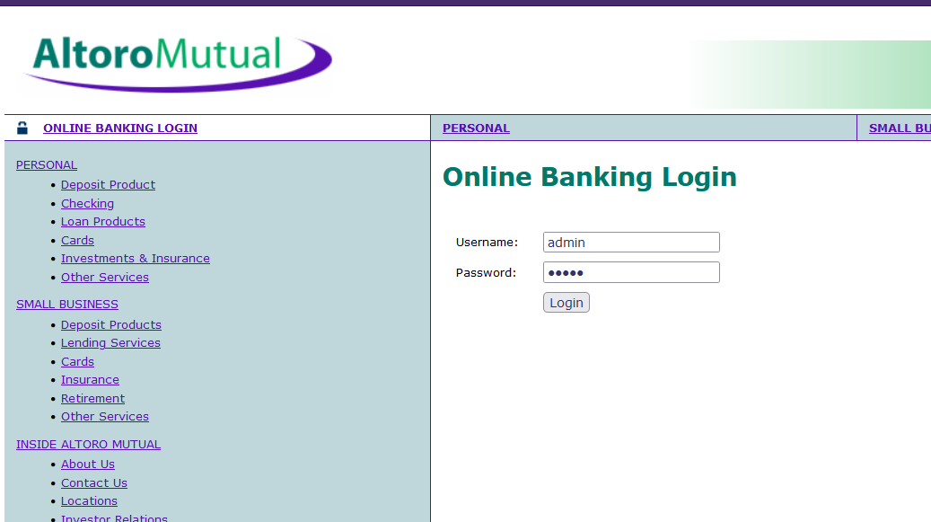
  - This request has been received in the burp suite with the username and password as well in clear text.


  - Now we click on forward request in the burp suite and then we will be redirected to the admin user details. Here in the burp suite, we can clearly see the login details in clear text. this is the clear indication of the vulnerability which can lead to data breach, monitored, and manipulated as well.

Recommendations:
- Educate users and employees on secure data handling practices, such as recognizing secure websites (look for "https") and avoiding insecure Wi-Fi networks.
- Employ data masking or redaction techniques to replace sensitive data with placeholders or cryptographic representations during transmission.
- Implement encryption for data in transit. Use secure encryption protocols such as TLS/SSL to protect sensitive information during transmission.

- Use secure communication protocols for transmitting data, such as HTTPS for web applications, and ensure that the selected protocols are kept up-to-date.

- Vulnerability name: Click Jacking CWE: 1021
Description: The web application does not restrict or incorrectly restricts frame objects or UI layers that belong to another application or domain, which can lead to user confusion about which interface the user is interacting with.
Business Impact: To effectively reduce the business consequences resulting from CWE-1021, organizations must prioritize the implementation of protective measures, such as frame-busting code. Simultaneously, educating users on safe browsing practices plays a crucial role in preventing clickjacking incidents. Additionally, routine security assessments and testing are pivotal for identifying and mitigating vulnerabilities associated with clickjacking. These actions are of paramount importance in upholding user trust, ensuring data protection, and safeguarding the organization's reputation.
Vulnerability path: http://testfire.net/

Vulnerability parameter: http://testfire.net/

Steps to reproduce:

  - Access the URL

  - Then take the URL and use it for the html code
  - we will be writing some html code to perform this vulnerability. we will be writing the code in vs code for better flexibility and functionality.
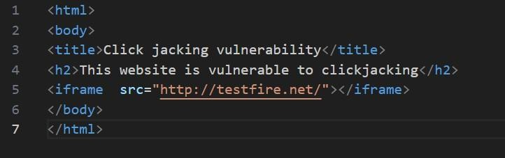

  - After the code has been written then we will be executing the code in the browser.

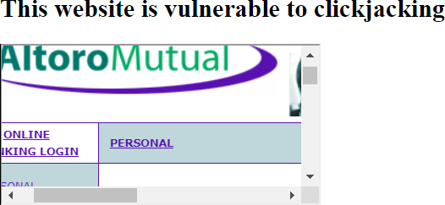

  - From this image we can see that the vulnerability has been found.

Recommendation:
  - Set the X-Frame-Options HTTP response header to deny or same-origin to control how your site can be framed. This is supported by most modern browsers.
  - Utilize frame-busting JavaScript code in web applications to prevent the embedding of your site within malicious iframes. This code can disrupt clickjacking attempts.
  - Implement a Content Security Policy to restrict which domains can embed your site in iframes. This can help prevent unauthorized framing.
  - Implement additional security controls to prevent UI redress attacks, such as clickjacking, within your web application.
- Vulnerability name: web server allows password auto-completion CWE: 310
Description:
Weaknesses in this category are related to the design and implementation of data confidentiality and integrity. Frequently these deal with the use of encoding techniques, encryption libraries, and hashing algorithms. The weaknesses in this category could lead to a degradation of the quality data if they are not addressed.
Business impact:
To effectively lessen the business consequences associated with CWE-310, organizations must prioritize the adoption of secure cryptographic practices. This entails ensuring proper password storage and robust encryption key management. Simultaneously, conducting routine security assessments and testing is pivotal in detecting and mitigating vulnerabilities related to cryptographic issues. Striving for compliance with pertinent data protection regulations and industry standards is equally essential. These actions are of paramount importance in the protection of sensitive data, the upholding of user trust, and the preservation of the organization's esteemed reputation.

Vulnerability path: http://testfire.net/

Vulnerability parameter: http://testfire.net/login.jsp

Steps to reproduce:

- Access the URL



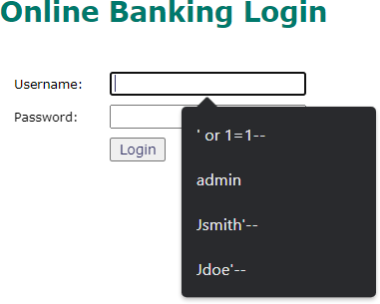
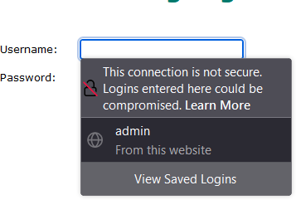

- From this image we can see the usernames and the passwords getting auto filled. This is a potential vulnerability as this can be a doorway for attackers.

Responsibilities:
- Implement secure password storage mechanisms, such as using strong and salted cryptographic hashing algorithms like bcrypt or scrypt.
- Implement robust encryption key management practices, including secure key storage, key rotation, and access controls.
- Utilize well-established and proven cryptographic libraries and algorithms for encryption and decryption.
- Use secure encryption protocols, like TLS/SSL, for data transmission over networks to protect data in transit.

- Vulnerability name: Cross-site scripting (DOM based XSS) CWE: 79
OWASP category: A03: Injections

Description: It occurs when a malicious script is injected directly into a vulnerable web application. Reflected XSS involves the reflection of a malicious script of a web application, onto a user's browser.
DOM-XSS: DOM stands for Document Object Model and is a programming interface for HTML and XML documents. It represents that programs can change the document structure, style and content. A webpage is a document and this document can be either displayed in the browser window or as the HTML Source.

Business Impact: The application stores dangerous data in a database, message forum, visitor log, or other trusted data store. Later, the dangerous data is subsequently read back into the application and included in dynamic content. From an attacker's perspective, the optimal place to inject malicious content is in an area displayed to many users or particularly interesting users. Interesting users typically have elevated privileges in the application or interact with sensitive data that is valuable to the attacker. If one of these users executes malicious content, the attacker may be able to perform privileged operations on behalf of the user or gain access to sensitive data belonging to the user.
Vulnerability path: https://vit.ac.in/

Vulnerability parameter: https://vit.ac.in/

Steps to Reproduce:

- Access the URL


- We will try to perform the DOM XSS attack which is displaying the source code of the webpage.
- Now we can access the source code of the webpage in two ways by clicking on the inspect option or by simply pressing Ctrl + U.

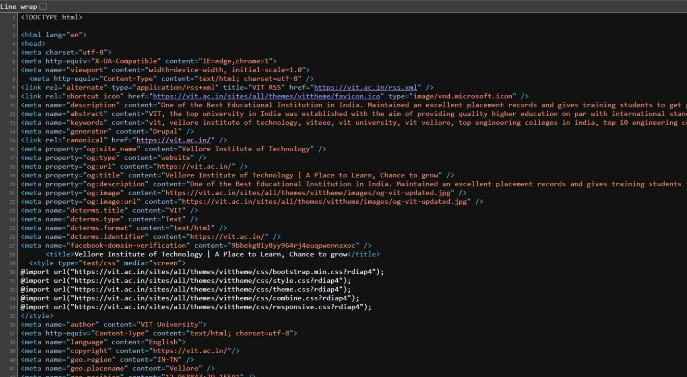

- Many programs can help to alter this source code to find vulnerable spots.

- So, getting access to the source code of the webpage can lead to potential vulnerabilities as attackers can abuse the loop holes, exploits, vulnerabilities in the code and act accordingly.
Recommendation:
- When interacting with databases, use parameterized statements or prepared statements to avoid SQL injection, which can be a vector for XSS.
- Sanitize and validate all user inputs and ensure that any data displayed on the web page is properly encoded. Use output encoding libraries or functions to prevent script injection.
- Avoid using DOM manipulation methods that can introduce vulnerabilities. Be cautious with inner HTML, document. Write, and other methods that can execute scripts.
- Consider using well-established JavaScript frameworks and libraries that include built-in security features to prevent DOM XSS.

- Vulnerability name: JQuery 1.2 < 3.5.0 Multiple XSS

CWE: 79

OWASP category: A03: Injections

Description: It occurs when a malicious script is injected directly into a vulnerable web application. Reflected XSS involves the reflection of a malicious script of a web application, onto a user's browser.
Stored XSS (Persistent XSS): In this type of attack, the malicious script is permanently stored on a server or in a database, often in user-generated content like comments or forum posts. When other users view the affected content, the script executes in their browsers, potentially compromising their data or sessions.

Reflected XSS: Reflected XSS occurs when the malicious script is embedded in a URL and immediately executed when a victim clicks on a manipulated link. The script is not stored on a server but is reflected off a web application, making it a one-time attack.

DOM-based XSS: DOM stands for Document Object Model and is a programming interface for HTML and XML documents. It represents that programs can change the document structure, style and content. A webpage is a document and this document can be either displayed in the browser window or as the HTML Source.

Business Impact: The application stores dangerous data in a database, message forum, visitor log, or other trusted data store. Later, the dangerous data is subsequently read back into the application and included in dynamic content. From an attacker's perspective, the optimal place to inject malicious content is in an area displayed to many users or particularly interesting users. Interesting users typically have elevated privileges in the application or interact with sensitive data that is valuable to the attacker. If one of these users executes malicious content, the attacker may be able to perform privileged operations on behalf of the user or gain access to sensitive data belonging to the user.
Vulnerability path: https://vit.ac.in/

Vulnerability parameter: https://vit.ac.in/sites/all/themes/vittheme/js/jquery-2.1.1.min.js?rdiap4

Steps to Reproduce:
- Access the URL


- Try to access the URL https://vit.ac.in/sites/all/themes/vittheme/js/jquery- . This will lead us to the webpage with jquery script in it.
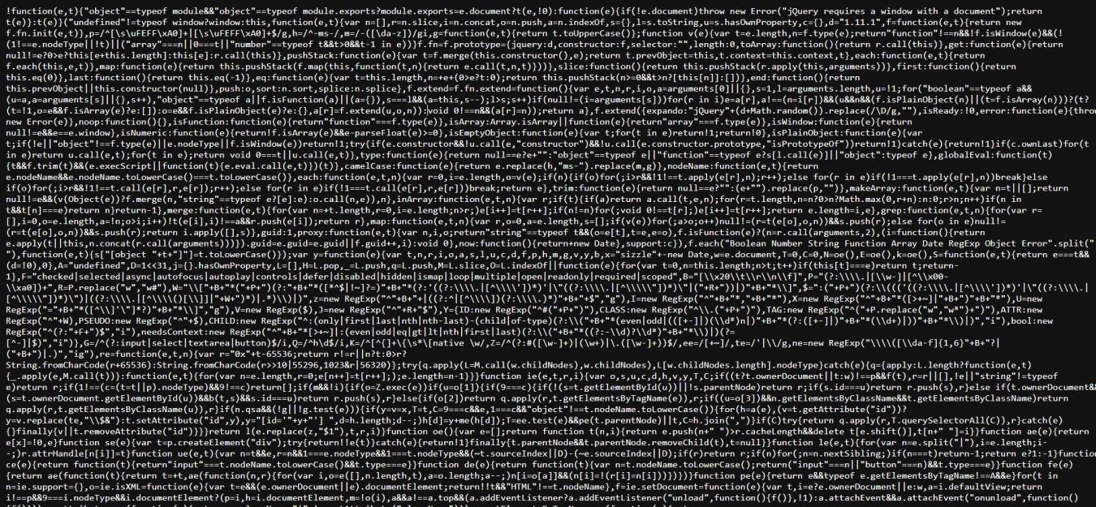

- We can also see the jquery version that has been used in the website
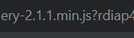

- We can access the source code of the jquery script that has been used in making the website, which can lead to multiple potential threats
Recommendation:
  - The most important recommendation is to update to the latest version of jQuery. Newer versions typically include security patches, bug fixes, and performance improvements.
  - Stay vigilant about jQuery updates and security announcements. Subscribe to relevant security mailing lists or forums to receive notifications about new releases.
  - A Content Security Policy (CSP) can help mitigate various types of client-side vulnerabilities, including Cross-Site Scripting (XSS). Consider implementing a CSP in your web application to restrict the sources from which scripts can be loaded.
  - If updating jQuery is not immediately possible, review your code for potential security issues. Ensure that you are escaping or sanitizing user inputs and that you are using safe coding practices to prevent XSS and other security vulnerabilities.

- Vulnerability name: Information Exposure (Web Server HTTP Header Internal IP Disclosure) CWE: 200
Description: The product exposes sensitive information to an actor that is not explicitly authorized to have access to that information.

Business Impact: To effectively reduce the business consequences associated with CWE-200, organizations must prioritize the implementation of robust data access controls, secure data handling practices, and privacy protection measures. Regular security assessments and testing are instrumental in detecting and rectifying vulnerabilities related to information exposure. Furthermore, strict adherence to data protection regulations and industry standards is indispensable. These actions are of paramount importance in the protection of sensitive data, the preservation of user trust, and the upholding of the organization's esteemed reputation.

Vulnerability path: https://vit.ac.in/ Vulnerability parameter: https://vit.ac.in/ Steps to Reproduce:
  - Access the URL


  - We will be using a tool to perform a scan on this website. (Nessus Scanner)

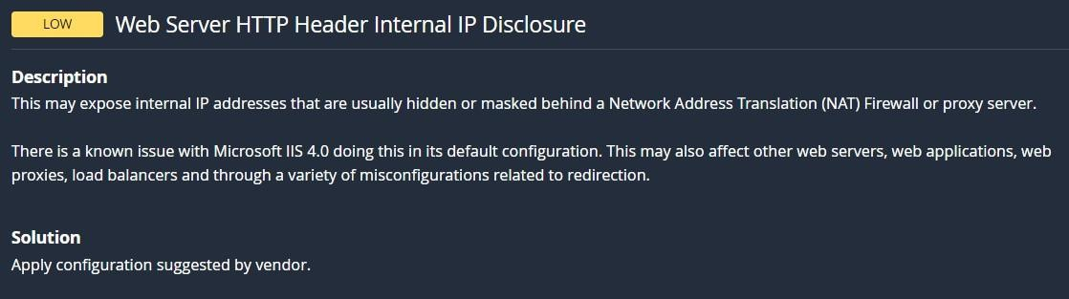

  - Through this tool we can see the vulnerability in the scan along with detailed information regarding that vulnerability.
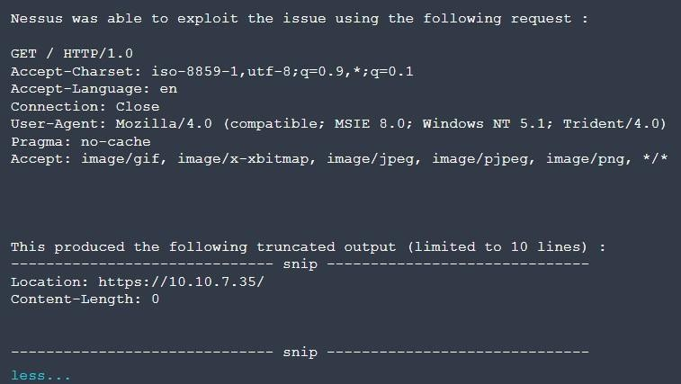

  - Now this image tells us the internal IP address of the target website, the attackers can easily exploit the website using the ip address.

Recommendation:
- Carefully review your web server's configuration files (e.g., Apache's httpd.conf, Nginx's nginx.conf) to identify anywhere internal IP addresses are inadvertently included in HTTP response headers.
- Remove or replace any internal IP addresses in the server configuration files with appropriate placeholders or public IP addresses.
- If you use proxy servers or load balancers, ensure that they are configured to hide internal IP addresses and only expose public IP addresses instances in HTTP headers.
- Review and configure HTTP response headers (e.g., Server, X-Powered-By) to limit the exposure of server and technology details, reducing the potential for disclosing internal IP addresses.

- Vulnerability name: Information Exposure (SSL (Multiple Issues)) CWE: 200
Description: The product exposes sensitive information to an actor that is not explicitly authorized to have access to that information.

Business Impact: To effectively reduce the business consequences arising from SSL issues, organizations must give utmost priority to establishing a secure SSL/TLS configuration, conducting frequent security assessments and testing. Adhering to data protection regulations and industry standards is imperative. These actions play a pivotal role in safeguarding sensitive data, upholding user trust, and safeguarding the organization's esteemed reputation.

Vulnerability path: https://vit.ac.in/

Vulnerability parameter: https://vit.ac.in/

Steps to Reproduce:


  - Access the URL

  - We will be using a tool to perform a scan on this website. (Nessus Scanner)
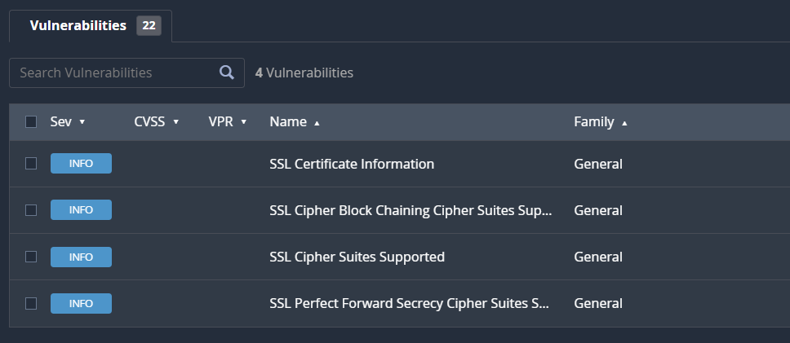

  - Through this tool we can see the vulnerability in the scan along with detailed information regarding that vulnerability.

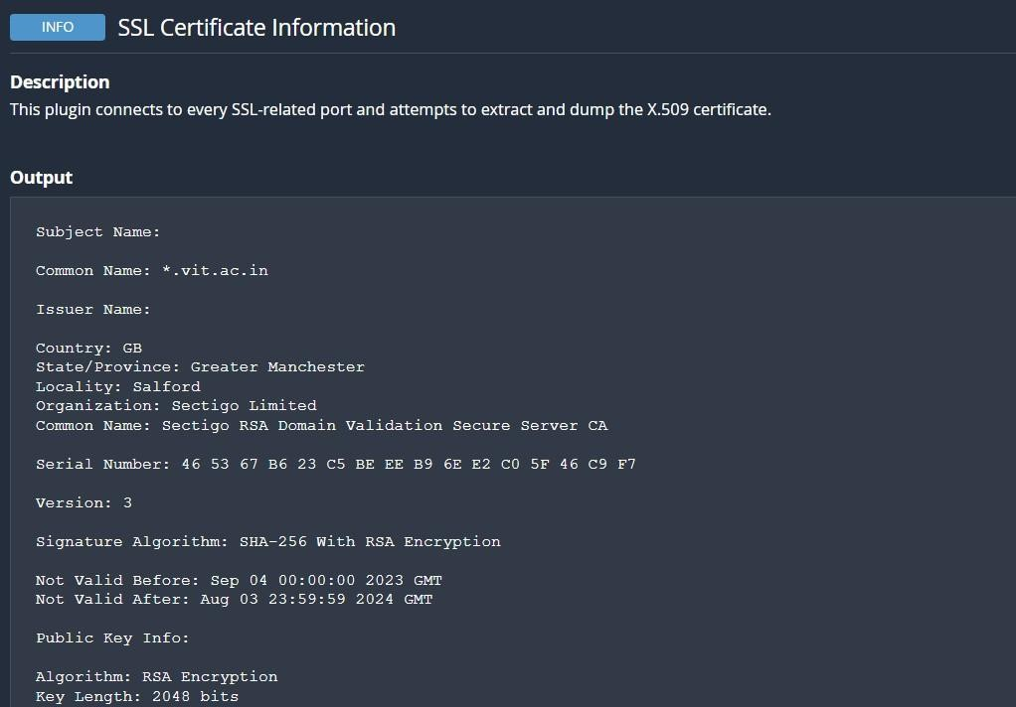

  - Now this image tells us the type of encryption used in the target website with the public key details as well.
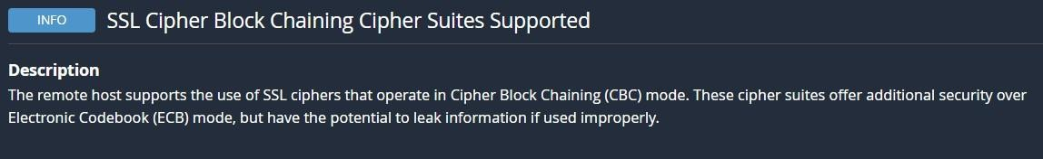
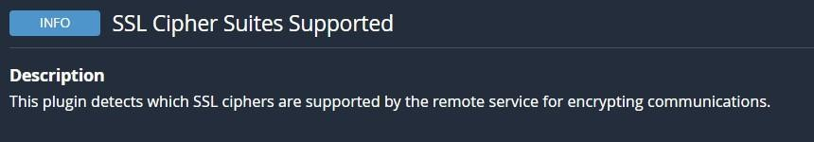
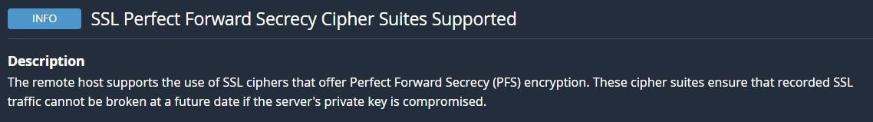

  - Through this we can understand what different types of encryptions are used in the website.

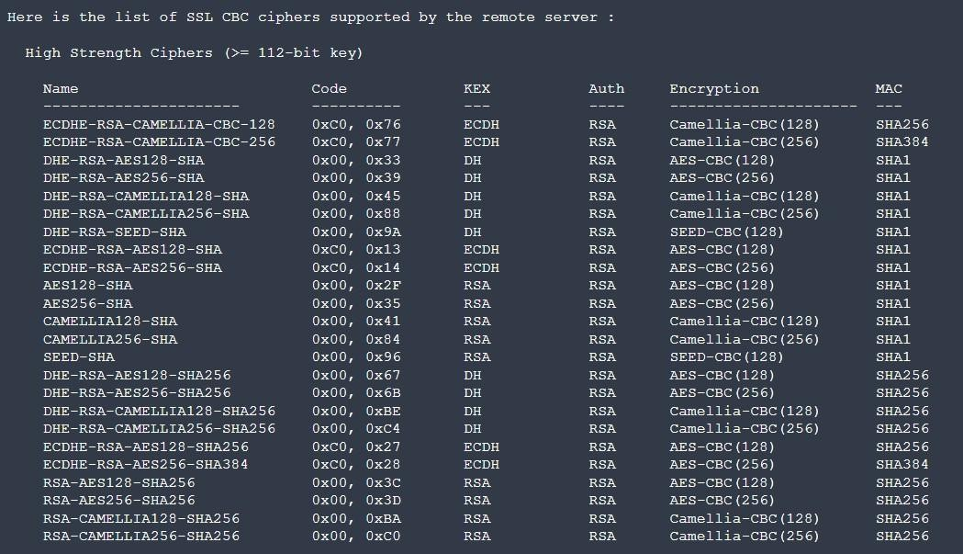

Recommendation:
    - Configure your web server to use the latest and strongest encryption protocols, such as TLS 1.2 or higher. Disable outdated and insecure protocols like SSLv3.
    - Implement Perfect Forward Secrecy to ensure that even if the private key is compromised, previously recorded encrypted traffic remains secure.
    - Safeguard your private keys by storing them securely and ensuring they are not accessible to unauthorized parties.

- Vulnerability name: Information Exposure (HTTP (Multiple Issues)) CWE: 200
Description: The product exposes sensitive information to an actor that is not explicitly authorized to have access to that information.
Business Impact: To effectively reduce the business repercussions of HTTP issues, organizations must place a strong emphasis on ongoing monitoring and enhancement of their web services. Consistent performance testing and security assessments, coupled with proactive maintenance, are indispensable to ensure a seamless and secure online presence. Furthermore, offering timely and helpful customer support and transparent communication when HTTP issues arise is instrumental in mitigating adverse effects on user trust and satisfaction.

Vulnerability path: https://vit.ac.in/

Vulnerability parameter: https://vit.ac.in/

Steps to Reproduce:

  - Access the URL


  - We will be using a tool to perform a scan on this website. (Nessus Scanner)
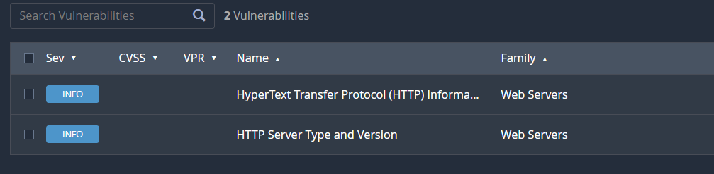
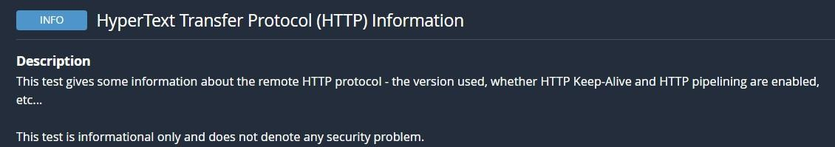
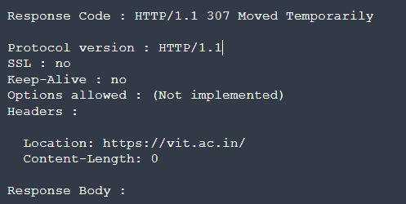

  - From the above image we can see the details of protocol version of the website and its status.
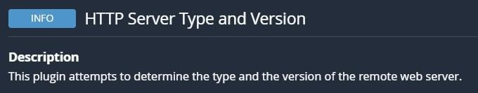
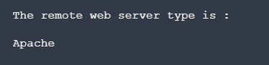

  - We can see the type of remote webserver here.
  - All this information can lead to multiple potential threats such as data breaches by hackers.
Recommendation:
    - Minimize the use of unnecessary redirects as they can increase page load times. Use 301 (permanent) redirects for consistent content.
    - Regularly check for broken links (404 errors) and fix them to ensure users find the content they are looking for.
    - Properly configure CORS to control which domains are allowed to make requests to your server.
    - Migrate your website from HTTP to HTTPS to ensure secure data transmission. This is essential for user trust and search engine ranking.
- Vulnerability name: OS Identification Failed CWE: 200
Description: OS identification failed refers to the inability of a system or software to accurately recognize the operating system running on a device or network. This issue can result from various factors such as misconfigurations, network issues, or compatibility problems. The failure to identify the OS correctly can lead to security vulnerabilities, hindered software updates, and potential operational disruptions. Resolving this issue promptly is crucial to ensure accurate security measures and the smooth functioning of the system or network.

Business Impact: It may lead to operational inefficiencies, potential security vulnerabilities, non-compliance with industry regulations, and a possible loss of customer trust. Such failures could result in downtime, compromised data security, regulatory penalties, and damage to the company's reputation, potentially leading to financial losses and decreased market competitiveness. Resolving this issue promptly is crucial to mitigate these risks and maintain the smooth functioning of the organization.

Vulnerability path: https://vit.ac.in/ Vulnerability parameter: https://vit.ac.in/ Steps to Reproduce:
  - Access the URL


  - We will be using a tool to perform a scan on this website. (Nessus Scanner)

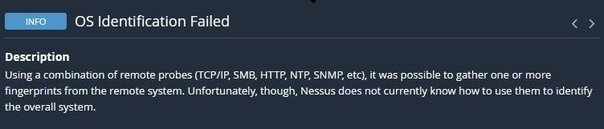
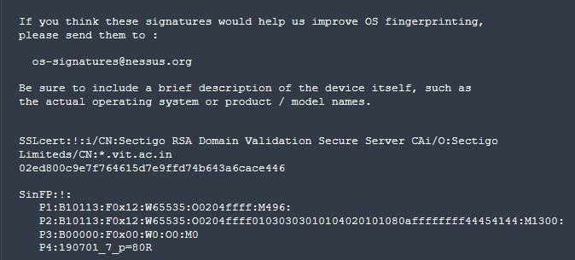

  - From the above image, we can see the details of SSL Certificate Information and SinFP Information.
  - If it is released without proper authorization, it can lead to serious consequences such as increased vulnerability to cyberattacks, potential data breaches, privacy violations, and legal repercussions.
  - All this information can lead to multiple potential threats such as data breaches by hackers.

Recommendations:
    - Employ robust data encryption methods for both data in transit and at rest.
    - Implement strict access controls and authentication protocols to limit unauthorized access.
    - Use secure communication channels, such as encrypted email and file transfer protocols.
    - Provide comprehensive training to employees on data security best practices.
    - Conduct regular security audits and assessments to identify and address vulnerabilities promptly.
    - Ensure compliance with relevant data protection regulations and have a well-defined incident response plan in place.

NESSUS SCAN REPORT:
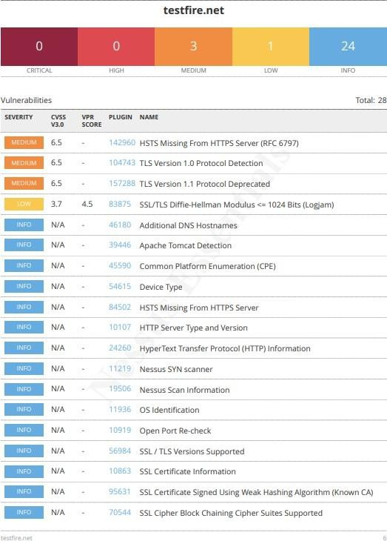
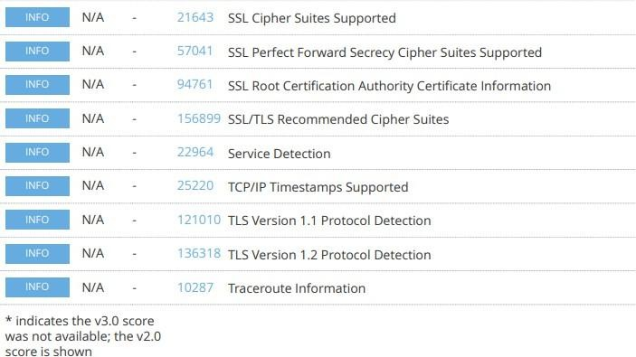

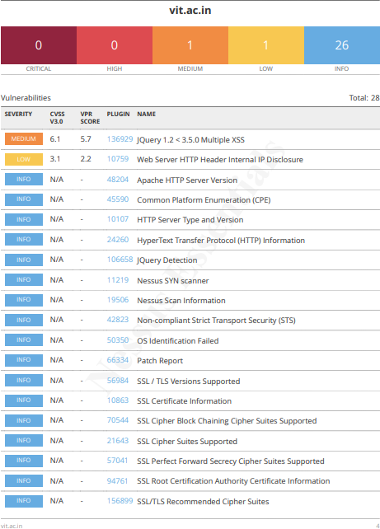
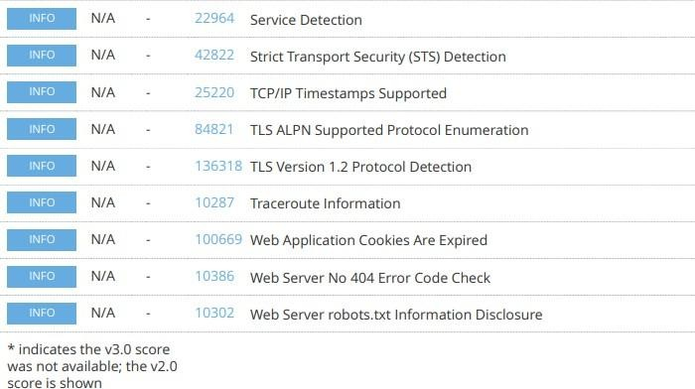

"With the Nessus scan report now at our disposal, we're equipped with critical data on the existing vulnerabilities and potential threats. This invaluable information will serve as a foundation for our project planning phase, as we chart the course to develop our AI-driven incident response platform with a well- informed strategy and timeline."

Stage – 2

Overview: -
An overview of a Nessus scan typically involves the following key steps and aspects:

- Preparation: Define Objectives: Determine the scope and objectives of the scan. What systems or networks do you want to assess, and what specific vulnerabilities are you looking for?

System Access: Ensure that you have the necessary permissions and access rights to scan the target systems or networks.
- Configuration: Set Up Scan Policy: Create a scan policy that defines the parameters of the scan, such as the types of vulnerabilities to check for, scanning frequency, and specific configurations.
Define Target Assets: Specify the IP addresses, hostnames, or network ranges of the systems you want to scan.
- Scanning: Initiate Scan: Start the Nessus scan using the configured policy and target assets. Nessus will systematically scan the target systems for vulnerabilities based on its plugins and policies.

- Vulnerability Identification: Nessus performs a comprehensive assessment, checking for vulnerabilities, misconfigurations, open ports, and other security issues. As the scan progresses, it categorizes vulnerabilities by severity, making it easier to prioritize remediation efforts.

- Reporting: Nessus generates detailed reports that list the vulnerabilities discovered during the scan. Reports typically include information about the severity of each vulnerability, recommended actions for remediation, and supporting evidence. These reports can be customized and exported in various formats, such as PDF, HTML, or CSV.

- Remediation: Review Findings: IT and security teams review the Nessus scan reports to prioritize and address the identified vulnerabilities.

Remediation Steps: Take corrective actions to fix or mitigate the vulnerabilities. This may involve applying patches, changing configurations, or implementing security measures.

- Follow-up: Regular Scanning: Conduct periodic Nessus scans to continuously monitor the security posture of the systems and networks. This helps identify new vulnerabilities and track progress in mitigating existing ones.
Integration: Integrate Nessus with other security tools or workflows to automate the vulnerability management process and streamline the response to new findings.

- Compliance Auditing (if applicable): If compliance checks are part of your scan policy, review compliance results and take actions to ensure systems meet the required standards and regulations.

- Documentation: Maintain records of scan results, remediation efforts, and compliance checks for audit and reporting purposes.

- User Training: Ensure that your IT and security teams are trained in using Nessus effectively and interpreting scan results.

Nessus scans are a critical component of proactive security, helping organizations identify and address vulnerabilities in their IT infrastructure to reduce the risk of security breaches and data compromises. The frequency and depth of scans can vary depending on an organization's security strategy and requirements.
Nessus is a popular vulnerability scanning tool used for identifying security weaknesses in computer systems and networks. It is widely utilized by security professionals and organizations to assess the security posture of

their systems and to proactively identify potential vulnerabilities that could be exploited by attackers. Here's what I understand about Nessus scans:
- Vulnerability Assessment: Nessus performs a vulnerability assessment by scanning target systems or networks to identify security issues, such as missing patches, misconfigurations, weak passwords, and other potential weaknesses that could be exploited by attackers.
- Network Scanning: Nessus can scan a wide range of network devices, including servers, routers, switches, firewalls, and more. It examines network services, open ports, and software running on target systems.
- Plugin Architecture: Nessus uses a plugin-based architecture, allowing it to check for a wide variety of vulnerabilities. These plugins are regularly updated to include the latest security checks and support for new vulnerabilities.

- Compliance Auditing: It can also be used to assess systems against various compliance standards and regulatory requirements, helping organizations ensure that their systems meet specific security standards, like PCI DSS or CIS benchmarks.
- Customization: Nessus scans can be customized to suit the specific needs of an organization. Users can define scan policies, select the target systems, and specify the types of vulnerabilities to scan for.
- Reporting: Nessus provides detailed reports that highlight vulnerabilities, their severity, and remediation recommendations. These reports are essential for IT and security teams to prioritize and address vulnerabilities.

- Scanning Frequency: Organizations often perform regular Nessus scans to continuously monitor and improve their security posture. This is crucial for staying ahead of evolving threats and vulnerabilities.
- Integration: Nessus can be integrated with other security tools and platforms, allowing organizations to automate the scanning process and streamline their vulnerability management.

- Licensing: Nessus offers both free and commercial versions. The free version is limited in its functionality, while the commercial version provides more features and support.
- User-Friendly Interface: Nessus offers an easy-to-use web-based interface, making it accessible to a wide range of users, from security experts to less experienced IT professionals.

It's important to note that Nessus is a valuable tool for identifying vulnerabilities, but it doesn't fix these vulnerabilities itself. It's up to the organization's IT and security teams to take the necessary steps to remediate the identified issues to enhance their security.

S. No | Vulnerability Name | Severity | Plugins
1. | Cross-site scripting (stored) | Low | Web application Scanner
2. | Broken Access Control | Medium | SSH weak HMAC Algorithms Supported
3. | SQL Injection | Medium | N/A
4. | Broken Authentication | Low | HSTS Missing from Server
5. | Insecure Direct Object Reference | Info | Service Detection
6. | Security Misconfiguration | Low | SSL cipher Block Chaining cipher  suites
7. | Cross-Site Request Forgery | Low | HTTP Form- Based Authentication Detected
8. | Cleartext Transmission of Sensitive Information | Medium | Cleartext Transmission of Sensitive Information over HTTP
9. | ClickJacking | Info | HTML Rendering Layer Vulnerability

10. | webserver allows password auto- completion | Low | SSL/TLS Diffie-Hellman Modulus<=1024 bits(Logjam)

Target Website: testfire.net Target IP Address: 54.83.41.36 Report:
- VULNERABILITY NAME: Cross site scripting (stored) SEVERITY: Low
PLUGIN: web application scanner PORT: N/A
DESCRIPTION: It occurs when a malicious script is injected directly into a vulnerable web application. Reflected XSS involves the reflection of a malicious script of a web application, onto a user's browser.

SOLUTION:
  - When interacting with databases, use parameterized statements or prepared statements to avoid SQL injection, which can be a vector for XSS.
  - Sanitize and validate all user inputs and ensure that any data displayed on the web page properly encoded. Use output encoding libraries or functions to prevent script injection.

BUSINESS IMPACT: The application stores dangerous data in a database, message forum, visitor log, or other trusted data store. Later, the dangerous data is subsequently read back into the application and included in dynamic content. From an attacker's perspective, the optimal place to inject malicious content is in an area that is displayed to either many users or particularly interesting users. Interesting users typically have elevated privileges in the application or interact with sensitive data that is valuable to the attacker. If one of these users executes malicious content, the attacker may be able to perform privileged operations on behalf of the user or gain access to sensitive data belonging to the user.

- VULNERABILITY NAME: Broken access control SEVERITY: medium
PLUGIN: SSH weak HMAC Algorithms supported PORT: N/A
DESCRIPTION: When access control checks are not applied consistently - or not at all - users are able to access data or perform actions that they should not be allowed to perform. This can lead to a wide range of problems, including information exposures, denial of service, and arbitrary code execution.

SOLUTION:

  - Ensure that the application has a robust authentication and authorization mechanism in place. Users should be authenticated before any sensitive actions are performed, and authorization checks should be conducted to verify that users have the necessary permissions for the requested operation.
  - Ensure that session management is secure. Use strong session IDs, enforce session timeouts, and regenerate session tokens after login. Implement session fixation protection to prevent session hijacking.

BUSINESS IMPACT: wide-ranging business impact, including financial losses, reputation damage, legal consequences, operational disruption, and loss of customer trust. Addressing this vulnerability is crucial to protect the organization and its stakeholders from these potential negative effects.

- VULNERABILITY NAME: SQL injection

SEVERITY: medium

PLUGIN: N/A (typically would be a security testing tool) PORT: port 80/443
DESCRIPTION: The product constructs all or part of an SQL command using externally influenced input from an upstream component, but it does not neutralize or incorrectly neutralizes special elements that could modify the intended SQL command when it is sent to a downstream component.

SOLUTION:
  - If parameterized statements are not feasible, use proper input validation and escaping mechanisms to sanitize user inputs before they are used in SQL queries. This helps prevent malicious code injection.
  - Utilize stored procedures for database operations. This can help separate SQL code from application code and reduce the risk of SQL injection.
  - Implement strict input validation for all user inputs, ensuring that data adheres to the expected format and structure.

BUSINESS IMPACT: In summary, it is crucial to underscore that CWE-89, known as SQL Injection, can exert a profound and diverse business impact. This encompasses critical facets such as data breaches, financial setbacks, harm to reputation, legal ramifications, and operational turmoil.
Hence, the imperative of preventing and remedying SQL injection vulnerabilities cannot be overstated, as it is indispensable for fortifying the security and continuity of an organization's applications and data.

- VULNERABILITY NAME: Broken authentication SEVERITY: Low
PLUGIN: HSTS Missing from HTTPS Server (plugin id:142960) PORT: port 443

DESCRIPTION: The system's authorization functionality does not prevent one user from gaining access to another user's data or record by modifying the key value identifying the data.

SOLUTION:
  - Implement strong authentication mechanisms, such as multi-factor authentication (MFA) or two-factor authentication (2FA), to ensure that only authorized users can access the system.
  - Implement proper authorization controls to ensure that users have the necessary permissions to access specific functions or data. Use role-based access control (RBAC) to manage user privileges effectively.
  - Deploy intrusion detection and prevention systems (IDS/IPS) to monitor and block suspicious activities related to authentication and authorization.

BUSINESS IMPACT: To effectively mitigate the business impact of CWE-285, it is imperative that organizations place a strong emphasis on bolstering their authentication and session management practices. This should encompass the adoption of multi-factor authentication, the secure storage of credentials, meticulous session handling, and a commitment to conducting routine security assessments and testing. The rectification of these vulnerabilities stands as a critical imperative, safeguarding sensitive data, user identities, and the organization's overarching security stature and reputation.

- VULNERABILITY NAME: Insecure Direct object Reference SEVERITY: Info
PLUGIN: Service Detection (plugin id:22964) PORT: port 80/443
DESCRIPTION: Insecure Direct Object Reference (IDOR) is a vulnerability that arises when attackers can access or modify objects by manipulating identifiers used in a web application's URLs or parameters. It occurs due to missing access control checks, which fail to verify whether a user should be allowed to access specific data.

SOLUTION:
  - Utilize parameterized queries or prepared statements when interacting with databases. This prevents user-controlled input from being executed as SQL code.
  - Implement a Content Security Policy to mitigate the risk of cross-site scripting (XSS) attacks, which can be used to execute unauthorized queries.
  - Implement account lockout mechanisms that temporarily suspend accounts after a specified number of unauthorized access attempts to prevent brute force attacks.

BUSINESS IMPACT: To effectively mitigate the business impact of CWE-639, organizations must make it a top priority to fortify their access control and authorization mechanisms. This entails the implementation of robust security measures, the regular conduct of comprehensive security assessments, and the deployment of intrusion detection systems to promptly identify and counter unauthorized access attempts. These measures stand as critical in the defence of sensitive data, the overall security of systems, and the preservation of the organization's esteemed reputation.

- VULNERABILITY NAME: Security Misconfiguration

SEVERITY: low

PLUGIN: SSL cipher Block chaining cipher suites PORT: port 443
DESCRIPTION: The product specifies permissions for a security-critical resource in a way that allows that resource to be read or modified by unintended actors.

SOLUTION:
  - Implement a change management process to document and review all changes to system configurations. This helps prevent unauthorized or unintended alterations.
  - Follow security guidelines provided by software and hardware vendors to ensure secure configurations.
  - Regularly perform compliance checks against industry standards and regulations to ensure that configurations remain in compliance with security requirements.

BUSINESS IMPACT: To effectively lessen the business consequences stemming from CWE-732, organizations must place a strong emphasis on bolstering their configuration management practices. This involves the establishment of secure default settings, the routine conduct of comprehensive security evaluations, and the deployment of intrusion detection systems to promptly detect and address misconfigurations and vulnerabilities. These actions are of paramount importance in safeguarding sensitive data, fortifying system security, and preserving the organization's esteemed reputation.

- VULNERABILITY NAME: Cross-Site Request Forgery SEVERITY: Low
PLUGIN: HTTP Form-Based Authentication Detected PORT: port 8080/443
DESCRIPTION: Cross-Site Request Forgery (CSRF) is an attack that forces an end user to execute unwanted actions on a web application in which they’re currently authenticated. With a little help of social engineering (such as sending a link via email or chat), an attacker may trick the users of a web application into executing actions of the attacker’s choosing. If the victim is a normal user, a successful CSRF attack can force the user to perform state changing requests like transferring funds, changing their email address, and so forth. If the victim is an administrative account, CSRF can compromise the entire web application.

SOLUTION:
  - Implement Synchronizer Token Patterns to include unique, randomly generated tokens in each HTTP request and validate these tokens on the server side to verify the authenticity of the request.
  - Utilize the Same Site attribute in cookies to restrict their usage to same-site requests only, preventing them from being sent along with cross-site requests and effectively mitigating CSRF attacks.

  - Utilize framework-specific protections and security features to prevent CSRF attacks. Many modern web frameworks have built-in mechanisms and libraries for handling CSRF vulnerabilities effectively.
  - Implement a Content Security Policy to restrict the sources from which various types of content can be loaded. By specifying the trusted sources of content, you can minimize the risk of malicious code execution and reduce the likelihood of successful CSRF attacks.

BUSINESS IMPACT: To effectively reduce the business repercussions of CWE-352, organizations must prioritize secure coding practices, including the incorporation of anti-CSRF tokens, while also conducting routine security assessments and testing to detect and rectify CSRF vulnerabilities.
Furthermore, educating users on secure browsing practices is pivotal in preventing CSRF attacks. These actions are of paramount importance in the protection of data and in upholding the trust of customers and partners.

- VULNERABILITY NAME: Cleartext Transmission of Sensitive Information SEVERITY: Medium
PLUGIN: Cleartext Transmission of Sensitive Information over HTTP PORT: port 443
DESCRIPTION: The product transmits sensitive or security-critical data in cleartext in a communication channel that can be sniffed by unauthorized actors. Many communication channels can be "sniffed" (monitored) by adversaries during data transmission. For example, in networking, packets can traverse many intermediary nodes from the source to the destination, whether across the internet, an internal network, the cloud, etc. Some actors might have privileged access to a network interface or any link along the channel, such as a router, but they might not be authorized to collect the underlying data. As a result, network traffic could be sniffed by adversaries, spilling security-critical data.

SOLUTION:
  - Educate users and employees on secure data handling practices, such as recognizing secure websites (look for "https") and avoiding insecure Wi-Fi networks.
  - Employ data masking or redaction techniques to replace sensitive data with placeholders or cryptographic representations during transmission.
  - Implement encryption for data in transit. Use secure encryption protocols such as TLS/SSL to protect sensitive information during transmission.
  - Use secure communication protocols for transmitting data, such as HTTPS for web applications, and ensure that the selected protocols are kept up to date.

BUSINESS IMPACT: To effectively reduce the business consequences associated with CWE-319, organizations must prioritize the adoption of secure data transmission practices. This includes the utilization of encryption and robust, secure protocols. The routine conduct of security assessments and testing is pivotal in pinpointing and remedying vulnerabilities linked to data transmission.
Furthermore, the education of users on secure data handling practices plays a vital role in proactively preventing data exposure incidents. These actions are of paramount importance in the protection of sensitive data and in preserving the trust of both customers and partners.

- VULNERABILITY NAME: Clickjacking

SEVERITY: Info

PLUGIN: HTML Rendering Layer Vulnerability PORT: port 80/443
DESCRIPTION: The web application does not restrict or incorrectly restricts frame objects or UI layers that belong to another application or domain, which can lead to user confusion about which interface the user is interacting with.

SOLUTION:
  - Set the X-Frame-Options HTTP response header to deny or same-origin to control how your site can be framed. This is supported by most modern browsers.
  - Utilize frame-busting JavaScript code in web applications to prevent the embedding of your
site within malicious frame’s. This code can disrupt clickjacking attempts.
  - Implement a Content Security Policy to restrict which domains can embed your site in iframes. This can help prevent unauthorized framing.
  - Implement additional security controls to prevent UI redress attacks, such as clickjacking, within your web application.

BUSINESS IMPACT: To effectively reduce the business consequences resulting from CWE-1021, organizations must prioritize the implementation of protective measures, such as frame-busting code. Simultaneously, educating users on safe browsing practices plays a crucial role in preventing clickjacking incidents. Additionally, routine security assessments and testing are pivotal for identifying and mitigating vulnerabilities associated with clickjacking. These actions are of paramount importance in upholding user trust, ensuring data protection, and safeguarding the organization's reputation.

- VULNERABILITY NAME: web server allows password auto-completion SEVERITY: Low
PLUGIN: SSL/TLS Diffie-Hellman Modulus <= 1024 Bits (Logjam) PORT: port 443
DESCRIPTION: Weaknesses in this category are related to the design and implementation of data confidentiality and integrity. Frequently these deal with the use of encoding techniques, encryption libraries, and hashing algorithms. The weaknesses in this category could lead to a degradation of the quality data if they are not addressed.

SOLUTION:
  - Implement secure password storage mechanisms, such as using strong and salted cryptographic hashing algorithms like crypt or script.
  - Implement robust encryption key management practices, including secure key storage, key rotation, and access controls.
  - Utilize well-established and proven cryptographic libraries and algorithms for encryption and decryption.

  - Use secure encryption protocols, like TLS/SSL, for data transmission over networks to protect data in transit

BUSINESS IMPACT: To effectively lessen the business consequences associated with CWE-310, organizations must prioritize the adoption of secure cryptographic practices. This entails ensuring proper password storage and robust encryption key management. Simultaneously, conducting routine security assessments and testing is pivotal in detecting and mitigating vulnerabilities related to cryptographic issues. Striving for compliance with pertinent data protection regulations and industry standards is equally essential. These actions are of paramount importance in the protection of sensitive data, the upholding of user trust, and the preservation of the organization's esteemed reputation.

S. NO | VULNERABILITY NAME | SEVERITY | PLUGINS
1. | Cross-site scripting (DOM based XSS) | Medium | Multiple XSS
2. | jQuery 1.3<3.5.0 Multiple XSS | Medium | CGI Abuse: XSS
3. | Information exposure (web server HTTP header internal IP disclosure) | Low | Webserver HTTP Header Internal IP Disclosure
4. | Information exposure (SSL (Multiple Issues)) | Info | SSL Certificate Information
5. | Information exposure (HTTP (Multiple Issues)) | Info | HTTP Information
6. | OS identification failed | Info | TCP/IP Remote Probing

TARGET WEBSITE: vit.ac.in TARGET IP ADDRESS: 122.184.65.22

Report:

- VULNERABILITY NAME: Cross-site scripting (DOM based XSS) SEVERITY: Medium
PLUGIN: Multiple XSS PORT: port 443
DESCRIPTION: It occurs when a malicious script is injected directly into a vulnerable web application. Reflected XSS involves the reflection of a malicious script of a web application, onto a user's browser. DOM-XSS: DOM stands for Document Object Model and is a programming interface for HTML and XML documents. It represents that programs can change the document structure, style and content. A webpage is a document, and this document can be either displayed in the browser window or as the HTML Source.

SOLUTION:
  - When interacting with databases, use parameterized statements or prepared statements to avoid SQL injection, which can be a vector for XSS.
  - Sanitize and validate all user inputs and ensure that any data displayed on the web page is properly encoded. Use output encoding libraries or functions to prevent script injection.
  - Avoid using DOM manipulation methods that can introduce vulnerabilities. Be cautious with inner HTML, document. Write, and other methods that can execute scripts.
  - Consider using well-established JavaScript frameworks and libraries that include built- in security features to prevent DOM XSS.

BUSINESS IMPACT: The application stores dangerous data in a database, message forum, visitor log, or other trusted data store. Later, the dangerous data is subsequently read back into the application and included in dynamic content. From an attacker's perspective, the optimal place to inject malicious content is in an area displayed to many users or particularly interesting users. Interesting users typically have elevated privileges in the application or interact with sensitive data that is valuable to the attacker. If one of these users executes malicious content, the attacker may be able to perform privileged operations on behalf of the user or gain access to sensitive data belonging to the user.

- VULNERABILITY NAME: jQuery 1.2 < 3.5.0 Multiple XSS

SEVERITY: Medium PLUGIN: CGI Abuse: XSS
PORT: port 443

DESCRIPTION: It occurs when a malicious script is injected directly into a vulnerable web application. Reflected XSS involves the reflection of a malicious script of a web application, onto a user's browser. Stored XSS (Persistent XSS): In this type of attack, the malicious script is permanently stored on a server or in a database, often in user-generated content like comments or forum posts. When other users view the affected content, the script executes in their browsers, potentially compromising their data or sessions. Reflected XSS: Reflected XSS occurs when the malicious script is embedded in a URL and immediately executed when a victim clicks on a manipulated link. The script is not stored on a server but is reflected off a web application, making it a one-time attack. DOM-based XSS: DOM stands for Document Object Model and is a programming interface for HTML and XML documents. It represents that programs can change the document structure, style and content. A webpage is a document, and this document can be either displayed in the browser window or as the HTML Source.

SOLUTION:
  - The most important recommendation is to update to the latest version of jQuery. Newer versions typically include security patches, bug fixes, and performance improvements.
  - Stay vigilant about jQuery updates and security announcements. Subscribe to relevant security mailing lists or forums to receive notifications about new releases.
  - A Content Security Policy (CSP) can help mitigate various types of client-side vulnerabilities, including Cross-Site Scripting (XSS). Consider implementing a CSP in your web application to restrict the sources from which scripts can be loaded.

  - If updating jQuery is not immediately possible, review your code for potential security issues. Ensure that you are escaping or sanitizing user inputs and that you are using safe coding practices to prevent XSS and other security vulnerabilities.
BUSINESS IMPACT: The application stores dangerous data in a database, message forum, visitor log, or other trusted data store. Later, the dangerous data is subsequently read back into the application and included in dynamic content. From an attacker's perspective, the optimal place to inject malicious content is in an area displayed to many users or particularly interesting users. Interesting users typically have elevated privileges in the application or interact with sensitive data that is valuable to the attacker. If one of these users executes malicious content, the attacker may be able to perform privileged operations on behalf of the user or gain access to sensitive data belonging to the user.

- VULNERABILITY NAME: Information Exposure (Web Server HTTP Header Internal IP Disclosure)

SEVERITY: Low

PLUGIN: Web Server HTTP Header Internal IP Disclosure PORT: port 80
DESCRIPTION: The product exposes sensitive information to an actor that is not explicitly authorized to have access to that information.

SOLUTION:
  - Carefully review your web server's configuration files (e.g., Apache's httpd.conf, Nginx's nginx.conf) to identify anywhere internal IP addresses are inadvertently included in HTTP response headers.
  - Remove or replace any internal IP addresses in the server configuration files with appropriate placeholders or public IP addresses.
  - If you use proxy servers or load balancers, ensure that they are configured to hide internal IP addresses and only expose public IP addresses instances in HTTP headers.
  - Review and configure HTTP response headers (e.g., Server, X-Powered-By) to limit the exposure of server and technology details, reducing the potential for disclosing internal IP addresses.

BUSINESS IMPACT: To effectively reduce the business consequences arising from SSL issues, organizations must give utmost priority to establishing a secure SSL/TLS configuration, conducting frequent security assessments and testing. Adhering to data protection regulations and industry standards is imperative. These actions play a pivotal role in safeguarding sensitive data, upholding user trust, and safeguarding the organization's esteemed reputation.

- VULNERABILITY NAME: Information Exposure (SSL (Multiple Issues) ) SEVERITY: Info
PLUGIN: SSL certificate Information PORT: port 443

DESCRIPTION: The product exposes sensitive information to an actor that is not explicitly authorized to have access to that information.
SOLUTION:
  - Configure your web server to use the latest and strongest encryption protocols, such as TLS 1.2 or higher. Disable outdated and insecure protocols like SSLv3.
  - Implement Perfect Forward Secrecy to ensure that even if the private key is compromised, previously recorded encrypted traffic remains secure.
  - Safeguard your private keys by storing them securely and ensuring they are not accessible to unauthorized parties.

BUSINESS IMPACT: To effectively reduce the business consequences arising from SSL issues, organizations must give utmost priority to establishing a secure SSL/TLS configuration, conducting frequent security assessments and testing. Adhering to data protection regulations and industry standards is imperative. These actions play a pivotal role in safeguarding sensitive data, upholding user trust, and safeguarding the organization's esteemed reputation.

- VULNERABILITY NAME: Information Exposure (HTTP (Multiple Issues)) SEVERITY: Info
PLUGIN: HTTP information PORT: port 80 /443
DESCRIPTION: The product exposes sensitive information to an actor that is not explicitly authorized to have access to that information

SOLUTION:
  - Minimize the use of unnecessary redirects as they can increase page load times. Use 301 (permanent) redirects for consistent content.
  - Regularly check for broken links (404 errors) and fix them to ensure users find the content they are looking for.
  - Properly configure CORS to control which domains are allowed to make requests to your server.
  - Migrate your website from HTTP to HTTPS to ensure secure data transmission. This is essential for user trust and search engine ranking.

BUSINESS IMPACT: To effectively reduce the business repercussions of HTTP issues, organizations must place a strong emphasis on ongoing monitoring and enhancement of their web services. Consistent performance testing and security assessments, coupled with proactive maintenance, are indispensable to ensure a seamless and secure online presence. Furthermore, offering timely and helpful customer support and transparent communication when HTTP issues arise is instrumental in mitigating adverse effects on user trust and satisfaction.

- VULNERABILITY NAME: OS Identification Failed SEVERITY: Info

PLUGIN: TCP/IP remote probing PORT: N/A
DESCRIPTION: OS identification failed refers to the inability of a system or software to accurately recognize the operating system running on a device or network. This issue can result from various factors such as misconfigurations, network issues, or compatibility problems. The failure to identify the OS correctly can lead to security vulnerabilities, hindered software updates, and potential operational disruptions. Resolving this issue promptly is crucial to ensure accurate security measures and the smooth functioning of the system or network.

SOLUTION:
  - Minimize the use of unnecessary redirects as they can increase page load times. Use 301 (permanent) redirects for consistent content.
  - Regularly check for broken links (404 errors) and fix them to ensure users find the content they are looking for.
  - Properly configure CORS to control which domains are allowed to make requests to your server.
  - Migrate your website from HTTP to HTTPS to ensure secure data transmission. This is essential for user trust and search engine ranking.

BUSINESS IMPACT: It may lead to operational inefficiencies, potential security vulnerabilities, non-compliance with industry regulations, and a possible loss of customer trust. Such failures could result in downtime, compromised data security, regulatory penalties, and damage to the company's reputation, potentially leading to financial losses and decreased market competitiveness. Resolving this issue promptly is crucial to mitigate these risks and maintain the smooth functioning of the organization.

Stage – 3

Title:
Enforce least-privilege access through identity-aware, application-specific access policies using Zscaler Private Access (ZPA).

Zero Trust Network Access (ZTNA)
Zero Trust Network Access (ZTNA) is a cybersecurity framework that shifts access control from a network-centric model to an identity-centric model. The foundational principle of ZTNA is "never trust, always verify," meaning that no user or device is trusted by default, regardless of whether they are connecting from inside or outside the corporate network. Unlike traditional remote access solutions that grant users broad access to the entire network, ZTNA creates a secure, application-specific tunnel between the user and the resources they are authorized to access. This ensures that the application remains invisible to unauthorized users and the broader internet, effectively shrinking the attack surface and eliminating the risk of lateral movement across the network.
Zscaler Private Access (ZPA)
Zscaler Private Access (ZPA) is a cloud-delivered ZTNA solution that provides identity- and context- based access to private applications without granting network-level access. ZPA operates on a "service- initiated" model, where users connect to the Zscaler cloud, and the cloud brokers a secure connection to the specific application via ZPA App Connectors deployed in the data center or cloud environment. Because ZPA never places the user on the corporate network, internal IP addresses and network infrastructure are completely hidden. Access policies are dynamically enforced based on user identity, group membership, device posture, and location, ensuring that each user sees only the applications they are explicitly permitted to use.
Principle of Least Privilege
The principle of least privilege (PoLP) is a security concept in which a user, device, or process is granted only the minimum levels of access—or permissions—necessary to perform its function. In the context of network security, this means moving away from "fat" network access (where authenticated users can reach large segments of the network) to "thin," application-specific access. By enforcing least privilege through ZPA, organizations ensure that even if a user's credentials are compromised, the attacker cannot pivot to other systems because the network itself is invisible and inaccessible. This principle is foundational to reducing insider threats and limiting blast radius during a security incident.
Identity-Aware Access
Identity-aware access is a security model that bases access decisions on who the user is, rather than where they are connecting from. ZPA integrates directly with existing identity providers (IdPs) such as Microsoft Active Directory, Azure AD, Okta, or Ping Identity. This integration allows security teams to leverage existing user attributes, group memberships, and roles to build granular access policies. For example, a policy can state that only members of the "Finance" group, using a company-managed device, can access the "SAP Finance" application during business hours. This ensures that access is tightly coupled with the user's identity and context, reducing reliance on static IP addresses or network segments.
Application-Specific Access Policies
Application-specific access policies are the core enforcement mechanism within ZPA. Instead of creating rules that allow traffic to entire subnets or IP ranges, administrators define policies that target individual applications or groups of applications. These policies are written in plain language logic and can incorporate multiple conditions, including user identity, device posture, location, and time of day. ZPA allows for the segmentation of internal applications—such as HR systems, internal wikis, development servers, and database interfaces—so that each application has its own unique access policy. This micro-segmentation ensures that a user authenticated for one application has no visibility or connectivity to any other application.
ZPA Architecture and Components
The ZPA architecture is composed of several key components that work together to provide secure, scalable access:

- Zscaler Cloud (Service Edge): A globally distributed cloud platform that acts as the broker between users and applications. It handles authentication, policy enforcement, and connection brokering without sitting in the data path.
- App Connectors: Lightweight software VMs or containers deployed within the private data center or cloud environments. These connectors initiate outbound connections to the Zscaler cloud, eliminating the need for inbound firewall rules. They establish secure tunnels to the ZPA edge and forward traffic to the internal applications.
- ZPA Client Connector: A software client installed on end-user devices (Windows, macOS, Linux, iOS, Android). It authenticates the user, checks device compliance, and establishes a micro-tunnel to the ZPA edge for application access.
- Application Segments: Logical groupings of applications defined within the ZPA admin console. These segments represent the private resources that users need to access.
Implementation Methodology
The deployment of ZPA follows a structured, phased approach to ensure minimal disruption and maximum security efficacy:
  - Phase 1: Discovery and Inventory: Identify all internal applications currently in use. Categorize them by criticality, department, and user base. Tools like network scanners, configuration management databases (CMDB), and interviews with department heads are used to build a comprehensive application inventory.
  - Phase 2: Connector Deployment: Deploy ZPA App Connectors in the data center or cloud environments where the applications reside. This involves provisioning virtual machines (using VMware, Hyper-V, or cloud-specific images) and configuring them to connect to the ZPA cloud.
  - Phase 3: Application Onboarding: Define application segments within the ZPA console. This includes specifying the IP addresses and ports of the internal applications and associating them with the appropriate App Connector groups.
  - Phase 4: Policy Creation: Integrate ZPA with the corporate identity provider (e.g., Azure AD). Create granular access policies based on user groups, device posture, and location. Policies are tested in a simulation mode before enforcement.
  - Phase 5: Pilot and Rollout: Select a pilot group of users to test the new access method. Gather feedback, monitor performance, and refine policies. Gradually migrate user populations from legacy VPN access to ZPA.
  - Phase 6: VPN Decommissioning: Once all users and applications are migrated, the legacy VPN infrastructure is decommissioned, eliminating a significant attack surface.
Tools and Technologies
  - Primary Platform: Zscaler Private Access (ZPA) – The core Zero Trust access broker.
  - Identity Provider (IdP): Microsoft Azure Active Directory (AD), Okta, or Ping Identity for user authentication and group synchronization.
  - Endpoint Protection Platform (EPP): Integration with endpoint security tools (e.g., CrowdStrike, SentinelOne, Microsoft Defender for Endpoint) to assess device posture and hygiene before granting access.
  - Security Information and Event Management (SIEM): Integration with SIEM platforms (e.g., IBM QRadar, Splunk, LogRhythm) for centralized logging and correlation of access events.
  - Virtualization Platforms: VMware vSphere, Microsoft Hyper-V, or public cloud environments (AWS, Azure, GCP) for hosting ZPA App Connectors.
  - Infrastructure as Code (IaC): Tools like Terraform or Ansible for automated deployment and configuration of App Connectors at scale.
  - Digital Experience Monitoring (DEM): Tools to monitor end-user connection quality and application performance.
Integration with Identity Providers
Integrating ZPA with the organization's existing identity provider is a critical step in establishing identity-aware access. This integration is typically done via SAML (Security Assertion Markup Language) or LDAP (Lightweight Directory Access Protocol). Once integrated, ZPA synchronizes user attributes and group memberships, allowing policies to reference these groups directly. For example, when a user authenticates via the ZPA Client Connector, they are redirected to the corporate IdP for

credentials and multi-factor authentication (MFA). Upon successful authentication, ZPA receives identity attributes that are then used to evaluate access policies and determine which applications the user is allowed to see and connect to.
Device Posture Checking
Beyond user identity, ZPA can enforce policies based on the security posture of the connecting device. Through integration with endpoint detection and response (EDR) and mobile device management (MDM) solutions, ZPA can assess factors such as:
  - Antivirus software status and definition updates
  - Disk encryption status (e.g., BitLocker, FileVault)
  - Operating system patch level
  - Presence of jailbreak or root compromise on mobile devices
  - Real-time risk score from the EDR tool
If a device fails to meet the defined posture requirements (e.g., antivirus is disabled), ZPA can block access, grant limited access, or trigger a remediation workflow.
Micro-tunneling and Application Visibility
ZPA establishes a secure TLS/DTLS tunnel between the ZPA Client Connector and the ZPA service edge, and another tunnel between the service edge and the App Connector. Crucially, this creates a direct "app-to-user" micro-tunnel. The user's device is never placed on the corporate network; instead, traffic is proxied at Layer 7 (application layer). From the user's perspective, they can only resolve and connect to the specific DNS names or IP addresses of the applications they are authorized to access. All other internal resources remain completely invisible, preventing port scanning, vulnerability reconnaissance, and lateral movement.
Threat Intelligence Integration
To enhance security monitoring, ZPA can be integrated with threat intelligence platforms. Logs generated by ZPA—including connection attempts, policy violations, and user activity—can be forwarded to a SIEM (Security Information and Event Management) system. Within the SIEM, these logs can be correlated with threat intelligence feeds (such as those from MISP) to identify suspicious behavior. For example, if a user's credentials are used to access an application from an IP address associated with known malicious activity, the SIEM can trigger an alert, and integration with ZPA can automatically revoke that user's session.
Incident Response in a ZPA Environment
ZPA significantly streamlines the incident response process. When a potential threat is detected, security teams can leverage ZPA's capabilities to:
- Isolation: Immediately revoke access for a compromised user account or device through the ZPA console, cutting off their connectivity to all internal applications.
- Forensics: Access detailed logs within ZPA showing exactly which applications were accessed, by whom, from which location, and for how long.
- Containment: Because users have no network-level access, a compromised endpoint cannot be used to scan or attack other internal systems, containing the blast radius.
- Granular Blocking: Temporarily block access to specific high-risk applications while allowing access to others, ensuring business continuity during an investigation.
Understanding ZPA: Key Takeaways
Zscaler Private Access represents a fundamental shift in how remote access is architected and secured. Here are the key aspects to understand about the solution:
- It is cloud-native: ZPA is delivered entirely from the Zscaler cloud, eliminating the need for hardware appliances and complex VPN head-end management.
- It is identity-centric: Policies are built around users and groups, not IP addresses, making access control more intuitive and aligned with organizational structure.
- It ensures network invisibility: By never placing users on the network, ZPA renders internal infrastructure invisible to the internet, preventing reconnaissance and DDoS attacks.
- It is scalable: The cloud architecture allows ZPA to scale instantly to accommodate thousands of concurrent users without performance degradation.
- It supports hybrid environments: ZPA works seamlessly for applications hosted in on-premises data centers, private clouds, and public cloud environments.

- It improves user experience: Users get direct, optimized connections to applications without back- hauling traffic through a centralized VPN concentrator, reducing latency.

Conclusion:

Stage 1: In conclusion, web application testing is a crucial process that ensures the security, functionality, and reliability of web-based software. It involves a comprehensive evaluation of various aspects, including user interface, functionality, performance, and security to identify and rectify issues before they impact end-users. This process not only enhances the quality of web applications but also bolsters their resilience against potential threats and vulnerabilities. In an age where online services and applications are integral to our daily lives, effective web application testing is essential to deliver a seamless and secure user experience.

Stage 2: The Nessus report for the specific website has highlighted key security insights. It identified vulnerabilities, categorized by severity, with a focus on critical and high-risk issues that need immediate attention. Recommendations for addressing these vulnerabilities include patching, reconfiguration, and other security measures, with a priority on actions that can have the most significant impact. Compliance with industry standards and best practices is considered, ensuring alignment with recognized security benchmarks like OWASP guidelines. The report underscores the need for continuous monitoring, regular updates, and ongoing security efforts to maintain a strong security posture. In summary, the Nessus report offers a clear view of the website's security state, provides guidance on mitigating vulnerabilities, and stresses the importance of sustained vigilance against evolving threats.

Stage 3:
The implementation of Zscaler Private Access marks a pivotal shift from a vulnerable, network- centric security model to a resilient, identity-centric Zero Trust architecture. By enforcing least- privilege access and rendering private applications invisible to the internet, this project effectively neutralizes the threats of lateral movement and network-based attacks. The solution not only fortifies the organization's security posture against modern cyber threats but also delivers a seamless and high-performance experience for a distributed workforce. Furthermore, the decoupling of access from the network simplifies IT operations, reduces dependency on legacy VPN infrastructure, and provides granular visibility into user-application interactions. Ultimately, this initiative establishes a future-ready foundation for secure digital transformation..

Future Scope:
Stage 1: future scope of web application testing

The future scope of web application testing is promising and evolving rapidly, driven by the continuous growth of the internet and web-based applications.

Here are some key aspects of its future scope:

- Increased Demand: As more businesses and services move online, the demand for web applications continues to grow. This, in turn, increases the demand for web application testing to ensure security, reliability, and functionality.
- Advanced Technologies: The complexity of web applications is rising with the integration of advanced technologies like AI, IoT, and blockchain. Testing these cutting-edge applications will require specialized skills and tools.
- Security Emphasis: With the growing number of cyber threats and data breaches, security testing for web applications will become even more critical. Testers will need to focus on vulnerabilities, data protection, and compliance with regulations like GDPR.
- Mobile and Cross-Browser Testing: Mobile usage is on the rise, and web applications must be responsive and functional on various devices and browsers. Testing for cross-compatibility will be essential.
- Performance Testing: As user expectations for speed and performance increase, load testing, stress testing, and other performance testing types will be crucial to ensure web applications can handle traffic spikes.

Stage 2: future scope of the testing process you understood.

The future scope of the web application testing process, particularly in terms of identifying vulnerabilities, is exceedingly promising due to the continuous growth of digital platforms, the escalating importance of cybersecurity, and the ever-evolving threat landscape. Here are some key aspects that highlight the prospective scope of web application testing for vulnerability discovery:

- AI-Driven Testing: The integration of artificial intelligence (AI) and machine learning (ML) into web application testing tools will revolutionize the way vulnerabilities are identified. AI algorithms can swiftly scan vast amounts of code and data to pinpoint vulnerabilities that might elude human testers.
- IoT and Mobile App Testing: With the proliferation of Internet of Things (IoT) devices and the increasing usage of mobile applications, the scope of web application testing will extend to encompass these areas. Ensuring the security of IoT devices and the interfaces they use will become critical.
- Blockchain and Cryptocurrency Security: As blockchain technology and cryptocurrencies continue to gain traction, security testing will be imperative to safeguard transactions and digital assets. Ensuring the robustness of blockchain-based applications will be a specialized niche in web application testing. Serverless Architectures: With the adoption of serverless computing, web application testing will need to adapt to assess the security of serverless functions and APIs. Ensuring that serverless components are free from vulnerabilities will be paramount.
- Container Security: As containerization technologies like Docker and Kubernetes become ubiquitous, web application testing will extend to cover container security. This includes ensuring that container images and orchestration configurations are free from vulnerabilities.

Stage 3: future scope of Zero Trust

The successful deployment of ZPA lays the groundwork for a broader, more integrated security ecosystem. Future enhancements can be explored to further mature the organization's security capabilities:
- Integration with Zscaler Internet Access (ZIA): Converging Private Access (ZPA) with Internet Access (ZIA) to create a unified Secure Access Service Edge (SASE) platform, managing all web and private traffic through a single policy framework.
- Advanced Device Posture Checking: Moving beyond basic compliance to incorporate real-time risk scores from EDR tools, blocking access if a device shows signs of active compromise.
- Privileged Remote Access: Extending ZPA to third-party vendors and contractors with time-bound, audited access to specific critical systems, replacing jump boxes and bastion hosts.
- IoT/OT Segmentation: Applying the same micro-tunneling principles to Internet of Things (IoT) and Operational Technology (OT) devices to ensure they can only communicate with specific management servers.
- AI-Driven Anomaly Detection: Leveraging machine learning on ZPA logs to detect behavioral anomalies, such as a user accessing an application at an unusual hour or from a strange location, triggering automated MFA challenges or access revocation.
- Cloud Workload Protection: Utilizing ZPA to secure connections between containers and microservices in multi-cloud environments (AWS, Azure, GCP), ensuring east-west traffic between workloads is encrypted and authenticated.
- Automated Provisioning/Deprovisioning: Enhancing the identity provider integration to automatically revoke application access the moment an employee is terminated or changes roles, ensuring near real-time access control.
- Digital Experience Monitoring (DEM): Implementing DEM tools to proactively monitor the end- user experience, identifying network latency or application performance issues before they impact productivity.

Topics Explored:
- Zscaler
- Zero trust
- ZPA
- VPN
- MISP
- College Network Information
- Deployment of SOC in the College
- Threat Intelligence
- Incident Response

Tools Explored:
  - Nessus Scanner

