Module 11 – Version Control – Git
Hands-On Lab 3: Branching and Merging
Name: Arshika Gupta
Module: Version Control – Git
Exercise: Git-HOL 3 – Branching and Merging

Objective
- To understand Git Branching and Merging.
- To create a new branch.
- To make changes in the branch.
- To merge the branch with the main branch.
- To delete the branch after successful merging.

Prerequisites
- Git installed and configured.
- Local Git repository created.

Step 1: Create a New Branch
Command
git branch GitNewBranch
Output
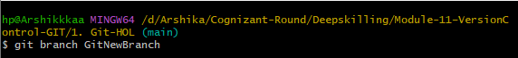Observation
A new branch named GitNewBranch was created successfully.

Step 2: List All Branches
Command
git branch -a
Output
Observation
The current branch is marked with *. The newly created branch is also displayed.

Step 3: Switch to the New Branch
Command
git checkout GitNewBranch
or
git switch GitNewBranch
Output
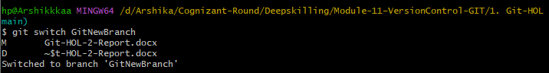Observation
Successfully switched to the GitNewBranch.

Step 4: Create a New File
Command
echo "This file is created in GitNewBranch." > branch.txt
Output
Observation
A new file named branch.txt was created in the new branch.

Step 5: Check Git Status
Command
git status
Output
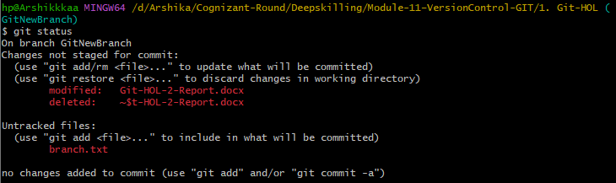Observation
Git shows the newly created file as an untracked file.

Step 6: Add and Commit Changes
Commands
git add branch.txt
git commit -m "Added branch file"
Output
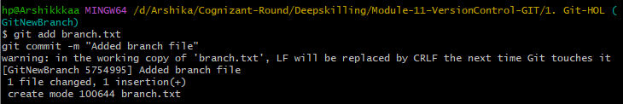Observation
The new file was added and committed successfully.

Step 7: Switch to Main Branch
Command
git checkout main
Output
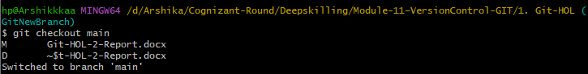Observation
Successfully switched back to the main branch.

Step 8: Compare Main Branch and GitNewBranch
Command
git diff main GitNewBranch
Output
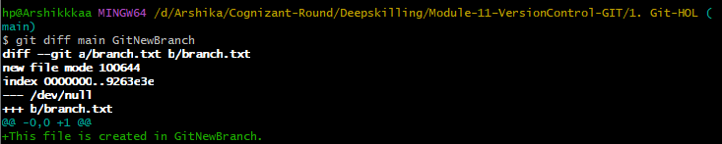Observation
The command displays the differences between the main branch and GitNewBranch.

Step 9: Visual Comparison using P4Merge
Observation
If P4Merge is configured, the visual differences between the branches can be viewed.
(Paste Screenshot Here if available)
If P4Merge is not installed, mention:
P4Merge was not configured on the local system. Therefore, only command-line comparison using git diff was performed.

Step 10: Merge Branch
Command
git merge GitNewBranch
Output
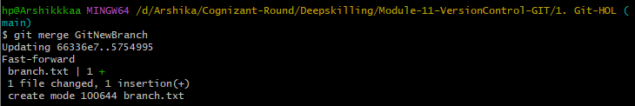Observation
The branch was successfully merged into the main branch.

Step 11: View Commit History
Command
git log --oneline --graph --decorate
Output
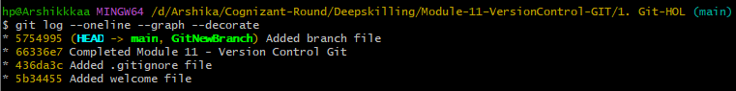Observation
The commit history displays the merge operation graphically.

Step 12: Delete the Branch
Command
git branch -d GitNewBranch
Output
Observation
The GitNewBranch was deleted successfully after merging.

Step 13: Verify Repository Status
Command
git status
Output
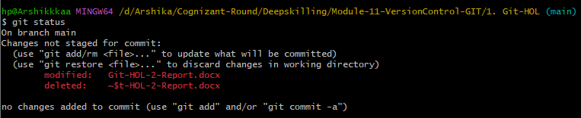Observation
The repository is clean and there are no pending changes.

