Module 7

1. Create an ERD containing the TestOrder and Specimen entity types and a 1-M relationship from Specimen to TestOrder. For each specimen collected, the database should record a unique SpecNo, SpecArea (vaginal, cervical, or endocervical), and SpecCollMethod (thin prep or sure path). A test order contains a TONo (primary key), TOTestName, TOTestType (HPV, CT/GC, CT, or GC), and TOTestResult (positive, negative, equivocal, or failure). A specimen does not have a test order until a delay, from hours to days. If a test order produces a failure, the specimen is given a new test order and tested again until a non-failure result is obtained. A test order is created for exactly one specimen.

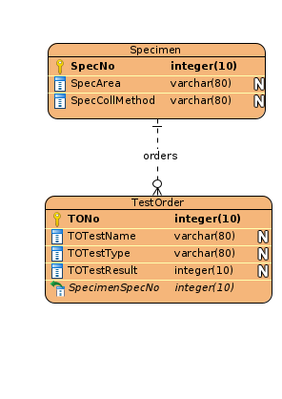

2. Augment your ERD from problem 1 with the Supply entity type and an M-N relationship between TestOrder and Supply. Choose a name for the relationship based on your common knowledge of test orders and supplies. A test order can use a collection of supplies (0 or more) and a supply can be used on a collection of test orders (0 or more). The Supply entity type contains SuppNo (primary key), SuppName, SuppLotNo, and SuppQOH.

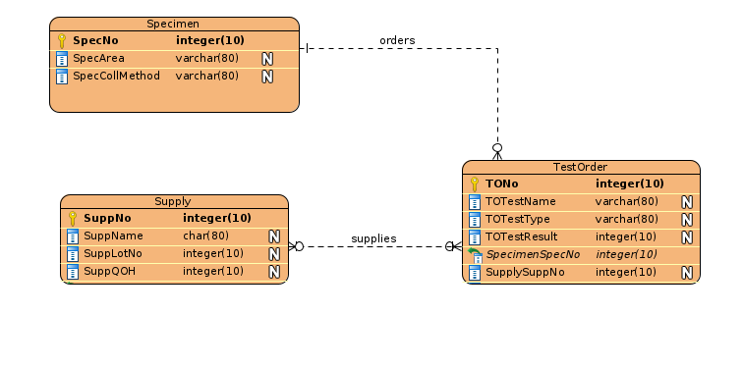

3. Use the M-N equivalence rule to transform the M-N relationship in Problem 2. You should choose appropriate names for the new relationships and entity type.

