Module 9

- For the following problem, define an ERD for the initial requirements and then revise the ERD for the new requirements. Your solution should have an initial ERD, a revised ERD, and a list of design decisions for each ERD. In performing your analysis, you may want to follow the approach presented in module 9.
Design a database for managing the task assignments on a work order. A work order records the set of tasks requested by a customer at a specified location.
- A customer has a unique customer identifier, a name, a billing address (street, city, state, and zip), and a collection of submitted work orders.
- A work order has a unique work order number, a creation date, a date required, a completion date, a customer, an optional supervising employee, a work address (street, city, state, zip), and a set of tasks.
- Each task has a unique task identifier, a task name, an hourly rate, and estimated hours. Tasks are standardized across work orders so that the same task can be performed on many work orders.
- Each task on a work order has a status (not started, in progress, or completed), actual hours, and a completion date. The completion date is not entered until the status changes to complete.

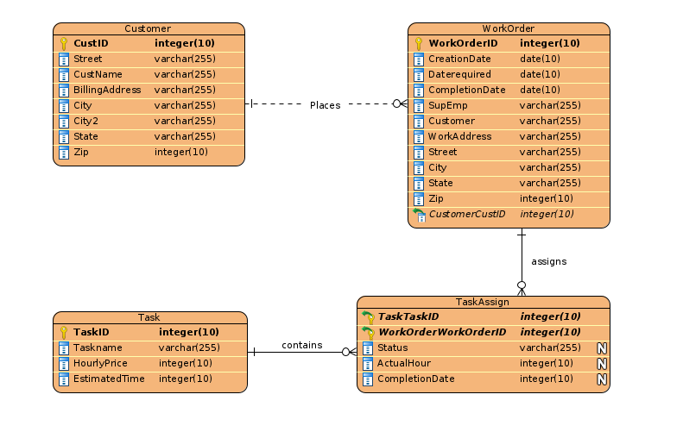

2. After reviewing your initial design, the company decides to revise the requirements. Make a separate ERD to show your refinements. Refine your original ERD to support the following new requirements:
- The company wants to maintain a list of materials. The data about materials include a unique material identifier, a name, and an estimated cost. A material can appear on multiple work orders.
- Each work order uses a collection of materials. A material used on a work order includes the estimated quantity of the material and the actual quantity of the material used.
- The estimated number of hours for a task depends on the work order and task, not on the task alone. Each task of a work order includes an estimated number of hours.

