**Event Report**

**INTRODUCTION:**

This event was organized as an activity of subject Professional Communication. The basic ideology behind this activity was to develop team spirit, how to think co-operatively in team represent their idea in efficient way.

**OBJECTIVES:**

Main objective of this activity was to make each team member work in co-ordination to achieve maximum outcomes. And also each one should avoid conflicts which can/may be created during the brainstroming for the representing the idea. Also it provides great learning opportunities, promotes workplace synergy, offers differing perspectives and feedback, motivates unity in the workplace.

**EVENT DETAILS:**

Date: 18th February, 2019

Time: 1:30 PM – 3:30 PM

Venue: Class Room Number: 19

Activity: Idea Representation for SSIP

Group Name: TechnoKite

**ORGANIZING COMMITTEE LIST:**

1. **Raj Jivani [EC 38]**
2. Harshal Khichada [EC 46]
3. Parth Donda [EC 41]
4. Aatman Kansagra [EC 28]

**POSTMORTEM REPORT:**

Everyone in the class was asked to gather for the activity and divided into group of four or five. At 2:45 PM eveyone was given an activity by the mentor of the class Prof. Kaisarajahan Ansari. As soon as instruction was completed we started to think innovative ideas and feasibility of it in real life problems. Finally we all represented our best optimal idea that we’ve thought during given time duration which was ‘Digital Fuel Meter’. And as we’ve asked questions on others’ idea – we faced their questions related to practical usage of our idea and we clarified them.

**FINANCIAL REPORT:**

The event neither generated any income nor lead to any expense.

**APPENDIX:**

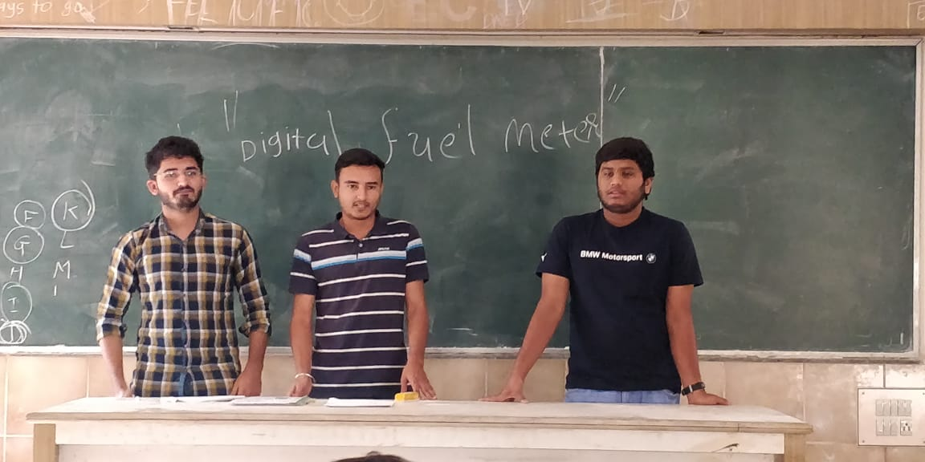

**CONCLUSION:**

The event made all the participants to think deeply about real life problems and find solutions for it. Also offers differing perspectives and feedback among team members and motivates unity.