Technical document of MPM gateway
Name | Designation
Kavin | Data analyst

Table of contents
- Introduction
  - 1.1 Overview of MPM Gateway
  - 1.2 Purpose and Goals
  - 1.3 Scope of the product
- System Requirements
  - 2.1 Hardware Requirements
  - 2.2 Software Requirements
- Installation
  - 3.1 Prerequisites
  - 3.2 ODBC Drivers Installation
  - 3.3 Python and its library installation
  - 3.4 linux packages installation
  - 3.5 Server_connection Service Installation
- Configuration
  - 4.1 Configuration Files Overview
    - 4.1.1 Gateway Configuration
    - 4.1.2 ETL Server Configuration
- Data Flow Structure
  - 5.1 Overview of Data Flow
  - 5.2 Sequence Diagrams
  - 5.3 Components of MPM Gateway
    - 5.3.1 Foundry Data (Files or DB)
    - 5.3.2 Gateway (Sending data : Foundry -> ETL server)
    - 5.3.3 ETL Server (Data Processing)
    - 5.3.4 Sandman Server (Storing Processed Data)
- Usage Guide
  - 6.1 Starting and Stopping MPM Gateway
  - 6.2 Monitoring and Logging
  - 6.3 Common Use Cases
- Appendix
  - 7.1 Sample Configurations
- Conclusion
  - 8.1 Summary of Key Points
  - 8.2 Next Steps
1. INTRODUCTION
In the context of data integration, the Internet of Things (IoT) Gateway plays a transformative role by serving as a bridge between IoT devices and centralized data storage, including file sharing folders and databases. Specifically tailored for the unique challenges of the IoT landscape, an IoT Gateway facilitates the seamless transfer of data between devices and databases, ensuring that valuable information is efficiently and securely processed.

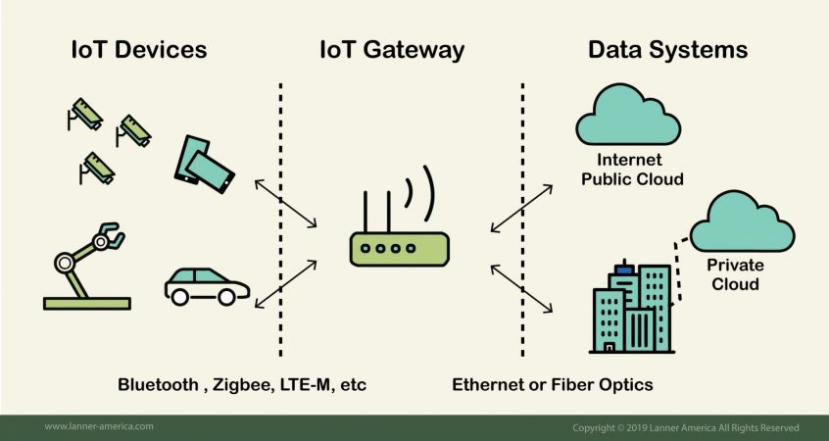Figure 1: IOT (Internet Of Things) Dataflow architecture

1.1 Overview of MPM Gateway

MPM Gateway, a data integration solution, is entirely crafted in Python. Designed to streamline data movement, it acts as a connector, facilitating seamless communication between foundry sources and the Sandman server in the cloud. This introduction provides a glimpse into the core technology, architecture, and purpose that make MPM Gateway a powerful tool for managing data workflows.

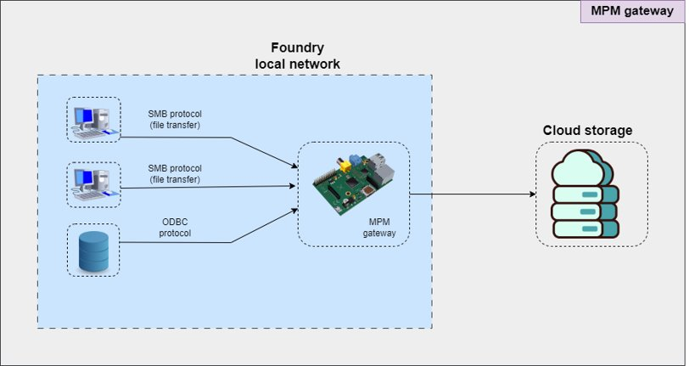Figure 2: Overview of MPM Gateway DataFlow architecture

1.2 Purpose and Goals

The primary purpose of MPM Gateway is to simplify and enhance the data integration process that satisfy the organization’s need. Recognizing the current dependency on third-party support for data integration(iByteCode Technologies Private Limited), MPM Gateway aims to bring this crucial operation in-house. By doing so, our organization aims to achieve a multi-faceted enhancement, striving to increase control, efficiency, and security in managing the seamless flow of data across diverse sources and destinations. Simultaneously, a key objective is to significantly reduce the setup time, ensuring swift configuration and initiation of data transfers.

1.3 Scope of the Product

The data flow within MPM Gateway involves retrieving data from the foundry, which could be on a local network, existing in either file formats or databases. This data is then subjected to processing through ETL (Extract, Transform, Load) logic, converting it into the Sandman format. The final step is storing the processed data securely in the Sandman server. Another important aspect of MPM Gateway is its generalization. The adaptability of the system hinges on a straightforward mechanism: the ability to switch out the ETL logic Python file. This simple modification makes the entire setup easily applicable to MPM’s foundry client as of now. By changing this single component, MPM Gateway becomes a broadly usable solution, ready to handle diverse data formats and structures for effective data integration for the sandman software.
2. System Requirements
This chapter provides information about the hardware and software requirements needed for the MPM gateway and ETL server.

2.1 Hardware Requirements
Gateway requirements :
Component | Minimum Requirment
Processor | 2 core
Memory (RAM) | 2 gb
Storage | 64 gb
Network Connectivity | Stable network connection

ETL Server requirements :
Component | Minimum Requirement
Processor | 2 core or higher
Memory (RAM) | 8 gb or higher
Storage | Adequate disk space

2.2 Software requirements
Gateway and ETL Server requirements
Software Component | versions
OS | Ubuntu 22.04.3 LTS
Python | 3.6 or higher
Python Library (mentioned in requirements.txt file [can be referred in appendix as well]) | -
Unix odbc driver | -
Mysql odbc driver | -
Sql server odbc driver | -

3. Installation
This chapter provides steps needed for installing all the necessary packages ,softwares and services needed for the MPM gateway software.
3.1 Prerequisites

Ensure that your device satisfies the software requirements outlined for the installation process. This may involve verifying the compatibility of the operating system, checking for necessary permissions, and ensuring that the system meets any other specified criteria mentioned in the system requirements chapter (refer the table).

3.2 ODBC Drivers Installation
- installing odbc driver manager
  - checking if the odbc is installedwhich
which odbcinst
which isql
  - if not installed:
    - check the bit of the system
uname -m
    - installing unixodbc
sudo apt install unixodbc
sudo apt install unixodbc-dev
- installing the mysql odbc driver
  - check if the mysql odbc driver installed
odbcinst -j
sudo nano <path of the DRIVERS>

[or]

odbcinst -q -d
  - if not installed:
    - download the specify package (refer below for the name) to install.
sudo dpkg -i mysql-connector-odbc-dbgsym_8.2.0-1debian11_amd64.deb
sudo apt --fix-broken install
- installing the sql server odbc driver
  - check if the sql server odbc driver installed
odbcinst -q -d
  - if not installed
    - please refer this website
      - https://learn.microsoft.com/en-us/sql/connect/odbc/linux-mac/installing-the-microsoft-odbc-driver-for-sql-server?view=sql-server-ver16&tabs=debian18-install%2Calpine17-install%2Cdebian8-install%2Credhat7-13-install%2Crhel7-offline
curl <https://packages.microsoft.com/keys/microsoft.asc> | sudo tee /etc/apt/trusted.gpg.d/microsoft.asc
curl <https://packages.microsoft.com/config/debian/11/prod.list> | sudo tee /etc/apt/sources.list.d/mssql-release.list
sudo apt-get update
sudo ACCEPT_EULA=Y apt-get install -y msodbcsql18

3.3 Python and its library installation
python installation
- check for python version
python3 --version
if not installed:
sudo apt update && sudo apt upgrade
sudo add-apt-repository ppa:deadsnakes/ppa -y
sudo apt update
sudo apt install python3.10

sudo apt install python3==<version>
- installing virtual environment
  - create virtual environment
python3.10 -m venv gatewayprodEnv
  - activate virtual environment
source <venv_place>/bin/activate
  - pip install -r requirements.txt

3.4 linux packages installation
autossh installation
sudo apt install autossh
cifs-utils installation
sudo apt install cifs-utils

3.5 Server_connection Service Installation

1. creating service
sudo nano /etc/systemd/system/server_connection.service
2. configuration for service
[Unit]
Description=connect_server

[Service]
ExecStart=/usr/bin/autossh -vv -N -L 6000:localhost:3306 -i <sshkeypath> -o PubkeyAcceptedKeyTypes=ssh-rsa -o <ssh_user>@<server_ip>
Restart=always
RestartSec=30

[Install]
WantedBy=default.target

=> reload the service to reflect the changes
sudo systemctl daemon-reload

= > enable the service
sudo systemctl enable connect_server

=> to start the service
sudo systemctl start connect_server

commands useful when debugging
=> to restart the service
sudo systemctl restart connect_server

=> to check the logs of the service
sudo journalctl -u connect_server.service
sudo journalctl -xe -u connect_server.service

=> to check the status of the service
systemctl status connect_server

=>list the given port information
lsof -i :6000
=> kill all the processes that uses autossh
pkill -9 autossh
=> get the processes that uses autossh
ps aux |grep autossh
=> list all the ports that are currently in use
netstat -tuln
=> kill a process
kill -9 14728(process_id)
=> get statistics on the process id
ps -p 7779 -o pid,ppid,cmd,%cpu,%mem,vsz,rss,tty,state,start,time
4. Configuration

4.1 Configuration Files Overview
This chapter serves as a guide on leveraging configuration files within the MPM (Multi-Platform Messaging) Gateway codebase. Configuration files, typically in JSON format, play a pivotal role in enabling seamless connections between various servers and facilitating file sharing across different folders. These files contain parameters that can be modified to adapt the MPM Gateway to diverse networking environments, ensuring smooth interactions between components.

4.1.1 Gateway Configuration
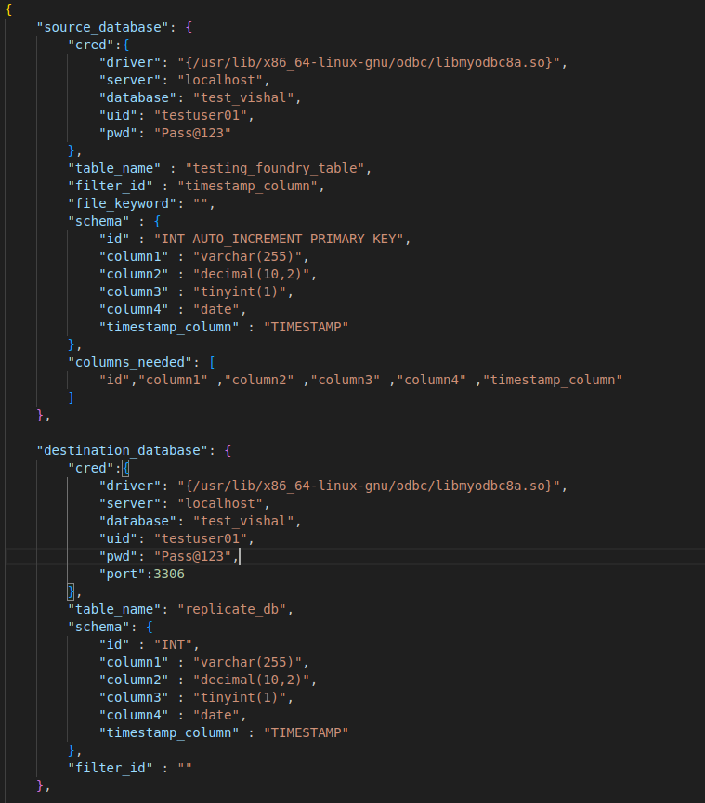
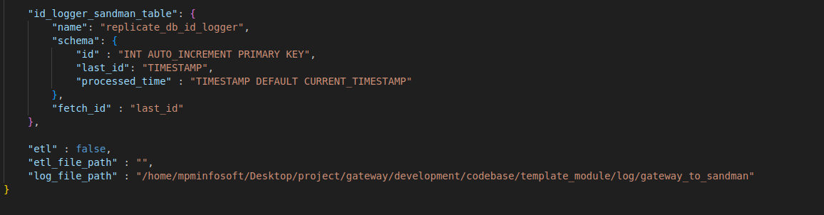

Keywords and its explanation

1. source database configuration (Foundry)
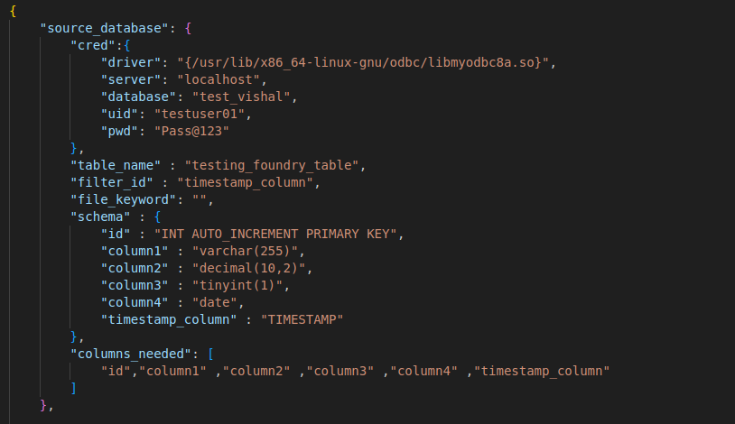
Keyword | Data type | Explanation
cred | dict | Credentials needed for the connection
[driver] | string | provide the address of the installed driver (based on the database(mysql or sql server))
[server] | string | IP address of the server(Foundry’s DB)
[database] | string | Database name to be fetched
[uid] | string | User id of the database server
[pwd] | string | Password of the database server
table_name | string | Name of the table from which the data is fetched
filter_id | string | Name of the column which is used for filtering the id
file_keyword | string | Keyword in the file such as “DAILY_REPORT” in “DAILY_REPORT_25102023.xlsx”
schema | dict | It is a dictionary containing column id and its data type as key value pair
Sample schema
{“column id in the database” : “datatype(in the context of sql)”} | string | Contains the dictionary with column id as keys and values as the datatype
columns_needed | list | Necessary column ids from the source table is added to the list

2. Destination database configuration
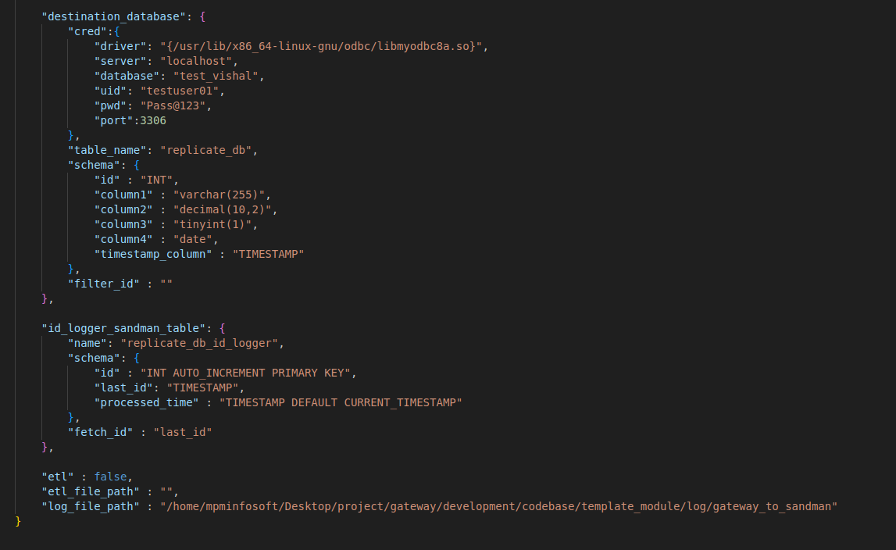
Keyword | Data type | Explanation
cred | dict | Credentials needed for the connection
[driver] | string | provide the address of the installed driver (based on the database(mysql or sql server))
[server] | string | IP address of the server(ETL server)
[database] | string | Database name to be fetched
[uid] | string | User id of the database server
[pwd] | string | Password of the database server
table_name | string | Name of the table from which the data is fetched
filter_id | string | Name of the column which is used for filtering the id
schema | dict | It is a dictionary containing column id and its data type as key value pair
Sample schema
{“column id in the database” : “datatype(in the context of sql)”} | string | Contains the dictionary with column id as keys and values as the datatype
id_logger_sandman_table | dict | It contains details necessary to create and use the idlogger table
name | string | Name of the id logger table
schema | dict | Dictionary containing the schema details in key value pair
fetch_id | string | Name of the column which is used for filtering the id

1. files to database configuration
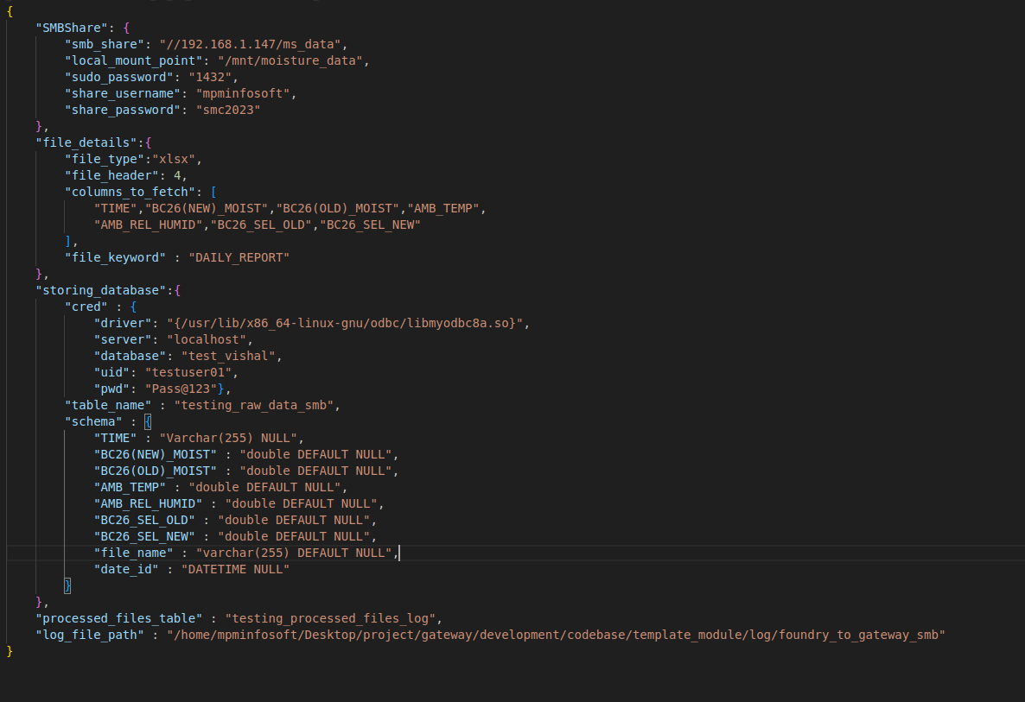
1. source – file sharing folder
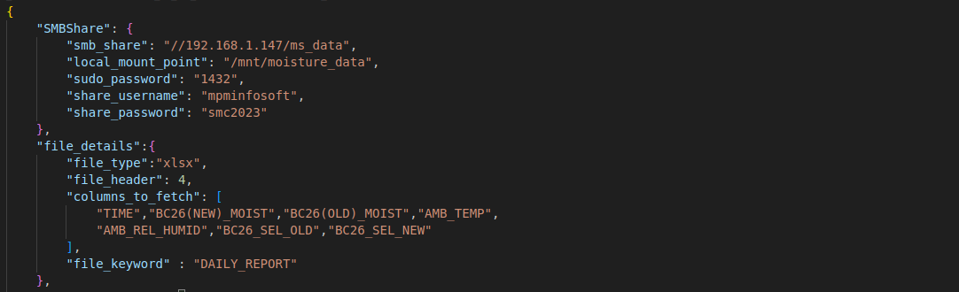
KEYWORD | DATA TYPE | DEFINITION
SMBShare | Dict | Contains credentials needed to connect the file sharing folder
smb_share | String | Address of the file sharing folder
local_mount_point | String | Path of the folder to mount the file sharing folder in the local directory
sudo_password | String | Super user password of the gateway
share_username | String | Username of the share folder if given if not leave a empty string
share_password | String | Password of the share folder if given if not leave a empty string
file_details | Dict | Contains the necessary information for the file to be read
file_type | String | Provide values either are “xlsx” or “csv”
file_header | String | The row number from where it should consider to read the data from
columns_to_fetch | List | The necessary column id that needs to be fetched.
file_keyword | String | Name of the column which is used for filtering the id

Destination database credentials
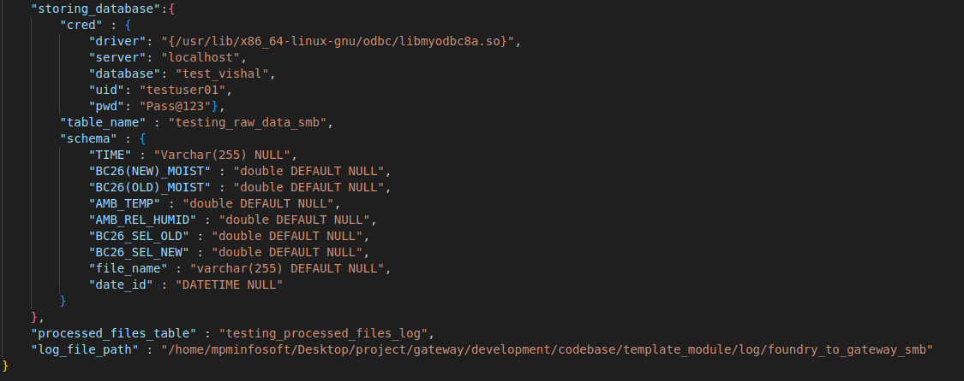
KEYWORD | DATATYPE | DEFINITION
storing_database | Dict | It contains necessary details regarding the destination database
cred | Dict | It contains the credentials needed to connect to the destination database
driver | String | Path of the odbc driver or description of the odbc driver
server | String | IP address of the server(it will be localhost since we are doing port forwarding)
database | String | Name of the database that needs to be fetched
uid | String | Username of the database
pwd | String | Password of the database
table_name | String | Name of the table in the database that needs to be fetched
schema | Dict | This contains the column id and its datatype as key value pair
processed_files_table | String | Name of the processed_files_table(alternate id logger)
log_file_path | String | Path of the log folder in local directory

4.1.2 ETL Server Configuration

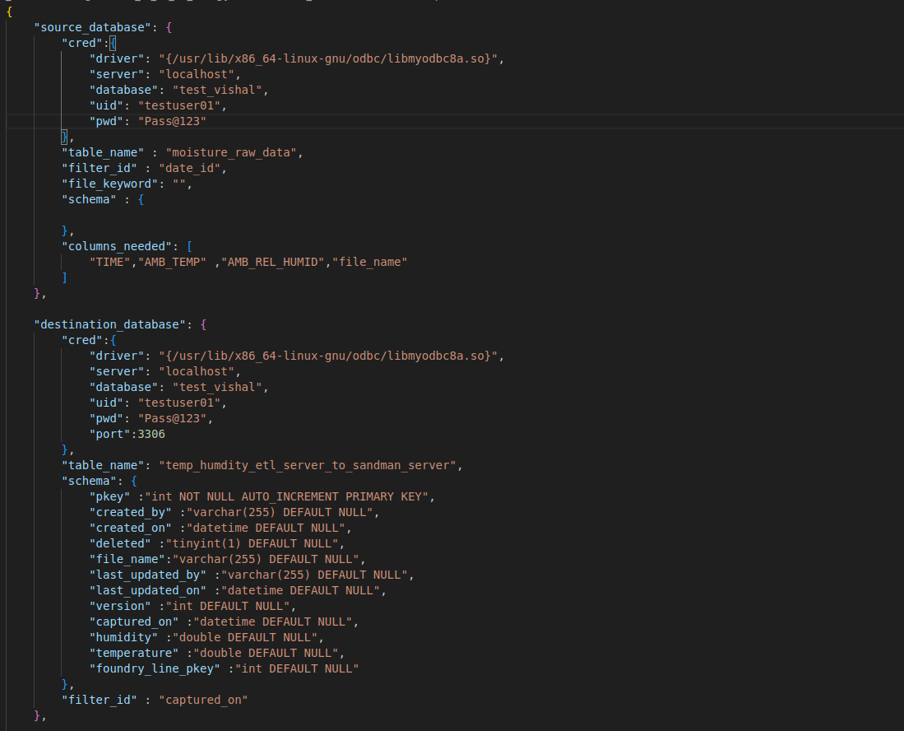
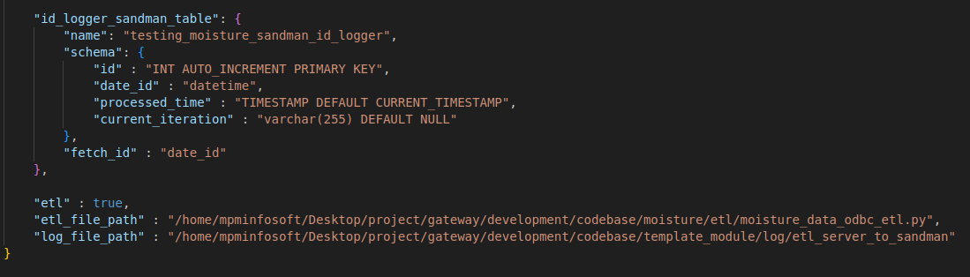

Source database
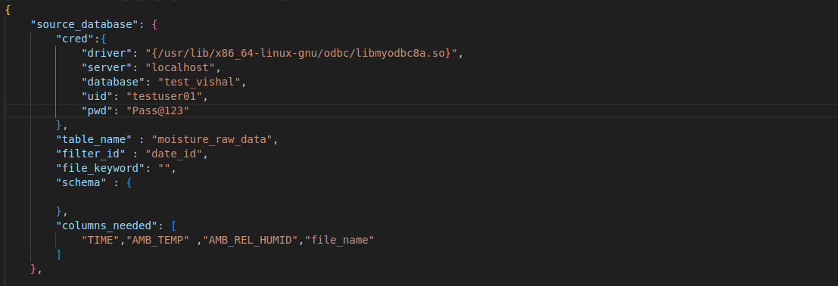
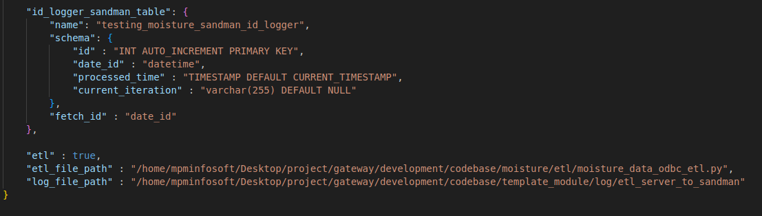

Keyword | Data type | Explanation
cred | dict | Credentials needed for the connection
[driver] | string | provide the address of the installed driver (based on the database(mysql or sql server))
[server] | string | IP address of the server(Foundry’s DB)
[database] | string | Database name to be fetched
[uid] | string | User id of the database server
[pwd] | string | Password of the database server
table_name | string | Name of the table from which the data is fetched
filter_id | string | Name of the column which is used for filtering the id
file_keyword | string | Keyword in the file such as “DAILY_REPORT” in “DAILY_REPORT_25102023.xlsx”
schema | dict | It is a dictionary containing column id and its data type as key value pair
Sample schema
{“column id in the database” : “datatype(in the context of sql)”} | string | Contains the dictionary with column id as keys and values as the datatype
columns_needed | list | Necessary column ids from the source table is added to the list
id_logger_sandman_table | dict | It contains details necessary to create and use the idlogger table
name | string | Name of the id logger table
schema | dict | Dictionary containing the schema details in key value pair
fetch_id | string | Name of the column which is used for filtering the id
etl | Boolean | True/False
etl_file_path | String | Path of the etl logic file (python file)
log_file_path | String | Path of the log file in the log folder

Destination database
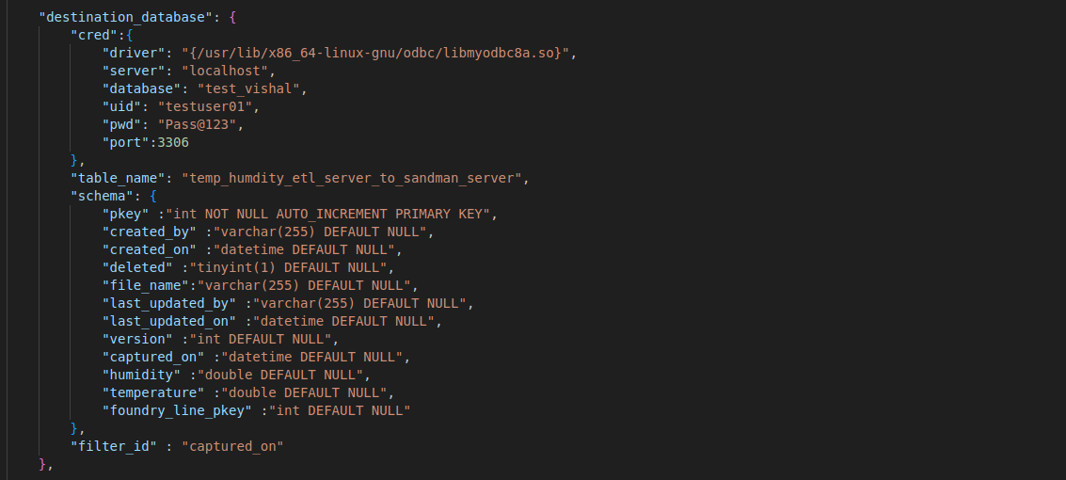
Keyword | Data type | Explanation
cred | dict | Credentials needed for the connection
[driver] | string | provide the address of the installed driver (based on the database(mysql or sql server))
[server] | string | IP address of the server(ETL server)
[database] | string | Database name to be fetched
[uid] | string | User id of the database server
[pwd] | string | Password of the database server
table_name | string | Name of the table from which the data is fetched
filter_id | string | Name of the column which is used for filtering the id
schema | dict | It is a dictionary containing column id and its data type as key value pair

5. Data Flow Structure
5.1 Overview of Data Flow

This section aims to provide a lucid understanding of how information moves through our MPM Gateway system. It provides information on how each component works and what is the reasoning behind it. It starts with how each components functions in this gateway ecosystem and goes on to explain how components works and the logic behind it.

5.2 Sequence Diagrams
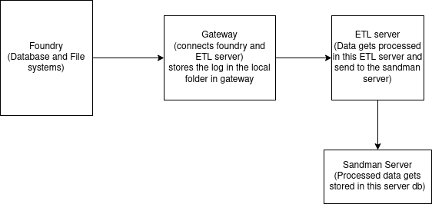

5.3 Components of MPM Gateway
MPM Gateway components include Foundry data system (can be Database or File system) , Gateway Device (raspberry pi device) , ETL server (like EC2 instance) and sandman server (like EC2 instance) . It is expected that the Foundry data system has the client data in the form of database or the
5.3.1 Foundry Data (Files or DB)
5.3.2 Gateway (Sending data : Foundry -> ETL server)
5.3.3 ETL Server (Data Processing)
5.3.4 Sandman Server (Storing Processed Data)

