EduPro Analysis: A Data-Driven Approach to Online Education Platform Analytics and Learner Segmentation
Abstract
The rapid growth of online education platforms has resulted in the generation of large volumes of data related to learners, courses, teachers, and transactions. Effective analysis of this data can provide valuable insights into learner behavior, course demand, revenue patterns, and platform performance. This research presents EduPro Analysis, a data analytics project developed to analyze an online education platform using exploratory data analysis, relational data modeling, learner segmentation, and business intelligence techniques.
The dataset consists of 3,000 users, 60 teachers, 60 courses, and 10,000 transactions. The analysis was performed using Python-based data analysis techniques and Microsoft Power BI. An interactive dashboard was developed to analyze revenue, course categories, payment methods, monthly revenue trends, and course pricing. In addition, learner segmentation was performed to classify users into different behavioral groups based on their course activity and spending patterns.
The analysis recorded a total transaction revenue of approximately 911.32K, with an average course price of 92.99. Learners were segmented into four groups: New Learners, Casual Learners, Premium Learners, and Power Learners. The findings demonstrate how data analytics and visualization can transform raw educational data into meaningful insights for understanding platform performance and learner behavior.
Keywords: EduPro, Online Education, Data Analytics, Learner Segmentation, Power BI, Python, Business Intelligence, Data Visualization

1. Introduction
Online education platforms have become an important part of modern learning. These platforms generate data from multiple sources, including learner profiles, course information, teacher records, and transactions. Analyzing such data can help organizations understand learner behavior, course demand, revenue generation, and overall platform activity.
However, raw datasets are difficult to interpret without appropriate analytical techniques. Data analytics and business intelligence tools can convert this raw information into meaningful insights through data preprocessing, exploratory analysis, visualization, and segmentation.
The EduPro Analysis project focuses on analyzing an online education platform using multiple interconnected datasets. The project integrates information about users, teachers, courses, and transactions. Python-based analysis was used for data exploration and learner segmentation, while Microsoft Power BI was used to develop an interactive dashboard.
The project therefore combines descriptive analytics, visualization, and learner segmentation to provide a comprehensive view of the EduPro platform.

2. Problem Statement
Online education platforms generate large amounts of data, but raw data alone cannot easily reveal important patterns.
The major problem addressed by this research is to determine how user, course, teacher, and transaction data can be analyzed and visualized to understand the performance of an online education platform and identify different learner behavior patterns.
The project addresses this problem by integrating multiple datasets, performing data analysis, creating an interactive dashboard, and applying learner segmentation techniques.

3. Objectives
The main objectives of the EduPro Analysis project are:
- To analyze user, teacher, course, and transaction data.
- To examine course categories, types, and levels.
- To analyze revenue generated through course transactions.
- To study payment-method distribution.
- To identify monthly revenue trends.
- To analyze course pricing across categories.
- To develop an interactive Power BI dashboard.
- To segment learners according to their activity and spending behavior.
- To generate meaningful insights from educational-platform data.
- To demonstrate the application of data analytics in the online education domain.

4. Dataset Description
The EduPro dataset contains four primary tables: Users, Teachers, Courses, and Transactions.
4.1 Users Dataset
The Users dataset contains 3,000 learner records. It includes demographic attributes such as age and gender along with user identification information.
The users in the dataset range from 15 to 35 years, with an average age of approximately 24.97 years.
4.2 Teachers Dataset
The Teachers dataset contains 60 teachers and includes their expertise, years of experience, and ratings.
The average teacher rating in the dataset is approximately 3.13, while the average teaching experience is approximately 6.28 years.
4.3 Courses Dataset
The Courses dataset contains 60 courses distributed across 12 course categories.
Each category contains five courses in the dataset. The courses include information about price, duration, type, level, and rating.
There are 38 free courses and 22 paid courses.
The courses are distributed across Beginner, Intermediate, and Advanced levels.
4.4 Transactions Dataset
The Transactions dataset contains 10,000 transaction records. It includes transaction date, user ID, course ID, transaction amount, payment method, and teacher ID.
The total transaction revenue is approximately 911.32K.

5. Methodology
The project follows the following analytical workflow:
Data Collection → Data Preprocessing → Exploratory Data Analysis → Data Modeling → Learner Segmentation → Power BI Visualization → Interpretation
5.1 Data Preprocessing
The datasets were inspected and prepared for analysis. Relevant columns were identified, data types were checked, and relationships between different tables were established using common identifiers.
5.2 Exploratory Data Analysis
Exploratory Data Analysis was performed to understand user demographics, course categories, course types, course levels, course prices, teacher experience, teacher ratings, transaction amounts, payment methods, and monthly revenue.
5.3 Data Modeling
Relationships were established between the datasets using identifiers such as UserID, CourseID, and TeacherID. This allowed information from different tables to be combined for analysis.
5.4 Learner Segmentation
Learner-level transaction information was used to create features such as total number of courses, total amount spent, average amount spent, preferred category, preferred level, average course rating, and diversity score.
Learners were then grouped into behavioral segments based on their activity and spending characteristics.
5.5 Power BI Visualization
Microsoft Power BI was used to create an interactive dashboard containing KPI cards, filters, charts, and graphs.

6. Power BI Dashboard
The EduPro Power BI dashboard provides a consolidated overview of platform performance.
The major KPIs displayed on the dashboard are:
KPI | Value
Total Revenue | 911.32K
Total Users | 3K
Total Courses | 60
Total Transactions | 10K
Average Course Price | 92.99
The dashboard contains filters for Course Level, Course Category, Course Type, Transaction Date, and Payment Method.
The main visualizations include Revenue by Course Category, Revenue by Payment Method, Monthly Revenue Trend, Average Course Price by Category, and Top Courses by Price-related analysis.
Figure 1. EduPro Power BI Dashboard
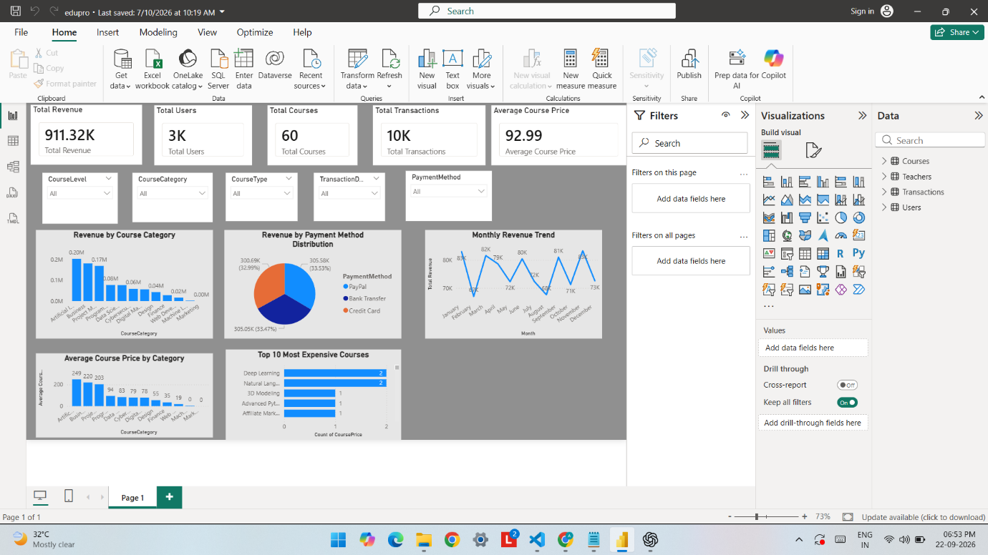

7. Results and Findings
7.1 Revenue Analysis
The EduPro platform generated approximately 911,323.47 in transaction revenue.
Among the course categories, Artificial Intelligence generated the highest revenue at approximately 202.75K.
Other major revenue-generating categories included Business at approximately 181.53K, Project Management at approximately 169.10K, Programming at approximately 77.45K, and Data Science at approximately 77.05K.
The Marketing category recorded no transaction revenue in the analyzed transaction data.
7.2 Payment Method Analysis
Revenue was distributed relatively evenly across the three payment methods.
Payment Method | Revenue | Approx. Share
PayPal | 305.58K | 33.53%
Bank Transfer | 305.05K | 33.47%
Credit Card | 300.69K | 32.99%
The results show that no single payment method dominates the transaction revenue in this dataset.
7.3 Monthly Revenue Analysis
The monthly revenue analysis shows variation throughout the year.
The highest monthly revenue was recorded in November, at approximately 83.35K.
The lowest monthly revenue was recorded in February, at approximately 66.98K.
The Power BI line chart provides a visual representation of these monthly fluctuations.
7.4 Course Pricing Analysis
The average course price across the 60 courses is approximately 92.99.
The categories with higher average course prices include Artificial Intelligence at approximately 248.82, Business at approximately 219.80, and Project Management at approximately 203.46.
8. Learner Segmentation
A major component of the EduPro project is learner segmentation.
The 3,000 learners were divided into four behavioral groups: New Learners, Casual Learners, Premium Learners, and Power Learners.
Learner Segment | Number of Users | Percentage
New Learners | 1,042 | 34.73%
Casual Learners | 995 | 33.17%
Premium Learners | 511 | 17.03%
Power Learners | 452 | 15.07%
8.1 New Learners
This group contains learners with relatively limited course activity and spending. The segment contains 1,042 users.
8.2 Casual Learners
The Casual Learners segment contains 995 users and represents learners with relatively limited course participation and spending.
8.3 Premium Learners
The Premium Learners segment contains 511 users. Their average spending is substantially higher than that of the New and Casual Learner groups.
8.4 Power Learners
The Power Learners segment contains 452 users. This group has the highest average course activity and spending in the segmentation output.
The average values calculated from the segmentation dataset are:
Segment | Average Courses | Average Amount Spent
New Learners | 1.60 | 67.60
Casual Learners | 1.54 | 54.31
Premium Learners | 1.44 | 431.91
Power Learners | 13.42 | 1,252.53
These segments demonstrate that learner behavior is not uniform across the platform and can be examined using activity and spending-based features.

9. Discussion
The EduPro Analysis project demonstrates the value of combining traditional data analysis with business intelligence and learner segmentation.
The Power BI dashboard provides an overview of the platform's revenue, users, courses, transactions, and pricing. Meanwhile, learner segmentation provides a more detailed view of user behavior.
The results show variation in revenue across course categories and across months. The payment-method analysis shows relatively balanced revenue contributions from PayPal, Bank Transfer, and Credit Card.
The learner segmentation further demonstrates differences in course participation and spending. This type of analysis can help an educational platform understand its learner base at a more granular level.

10. Conclusion
This research presented EduPro Analysis, a data-driven approach for analyzing an online education platform.
The project analyzed 3,000 users, 60 teachers, 60 courses, and 10,000 transactions using data analysis, learner segmentation, and Power BI visualization.
The analysis identified a total transaction revenue of approximately 911.32K and an average course price of 92.99. Artificial Intelligence was the highest-revenue course category in the analyzed transaction data, while monthly revenue varied throughout the year.
Learner segmentation divided users into four groups—New Learners, Casual Learners, Premium Learners, and Power Learners—based on behavioral characteristics such as course activity and spending.
Overall, the project demonstrates how educational-platform data can be transformed into meaningful insights through data preprocessing, exploratory analysis, segmentation, and interactive visualization.

11. Future Scope
The EduPro project can be extended in several ways:
- Developing a personalized course recommendation system.
- Predicting future course enrollments.
- Predicting learner churn.
- Performing advanced learner clustering.
- Developing real-time Power BI dashboards.
- Analyzing teacher performance in greater detail.
- Building a course-demand prediction model.
- Using machine learning for personalized learning paths.
- Integrating additional learner engagement data.

12. References
- Microsoft Power BI Documentation.
- Python Pandas Documentation.
- Matplotlib Documentation.
- Scikit-learn Documentation.
- EduPro Online Education Platform Dataset.
- Learner Segmentation Analysis Output.

