Disease Detecting in NIH Chest X-ray Images
Author Names Go Here Using the Author Name Style (Required)
Affiliations and Addresses Go Here Using the Affiliation and Address Style (Required)
publications21@aaai.org (email is text roman font using Affiliation and Address Style (Required)
[At least 3 carriage returns must separate the author affiliation block from the beginning of the two-column text block]

Abstract
Chest X-ray exams are one of the most frequent and cost-effective medical imaging examinations available.
However, clinical diagnosis of a chest X-ray can be challenging and sometimes more difficult than diagnosis via chest CT imaging. By using machine learning and deep learning techniques, we aim to ease the detection and classification of various lung disease.
Introduction
There are invisible characters after the word Line in the heading above. If you delete them, the copyright line will disappear. The AAAI copyright notice is required. This is example text. It is 10 point Times New Roman. The first sentence after the heading begins without a paragraph indent. Use of the text style (without alteration) is required.
This is example text. The second paragraph is indented 10 points, with no extra space between lines. The text is 10 point Times New Roman.
Background
The text below a second-level heading begins without indentation. Use of the subsection heading style is required.

Manual Feature Extraction
LBP
GLCM
Wavelet

Machine Learning Models
Logistic regression
Bernoulli NB
Gaussian NB
Decision Trees
Extra Tree Classifier

Deep Learning Models

CNN

Related Work

This Is a Subsubsection Heading. Use of This Style Sheet Is Required for all subsubsections.

This is example text. It is 10 point Times New Roman. This is example text. It is 10 point Times New Roman.
This is example indented text. It is 10 point Times New

Project Description
Dataset

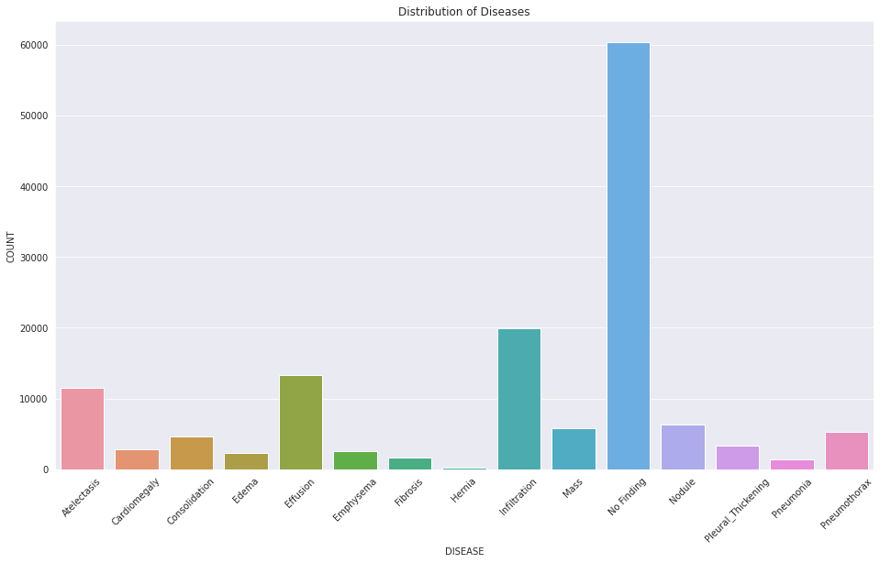
Flow

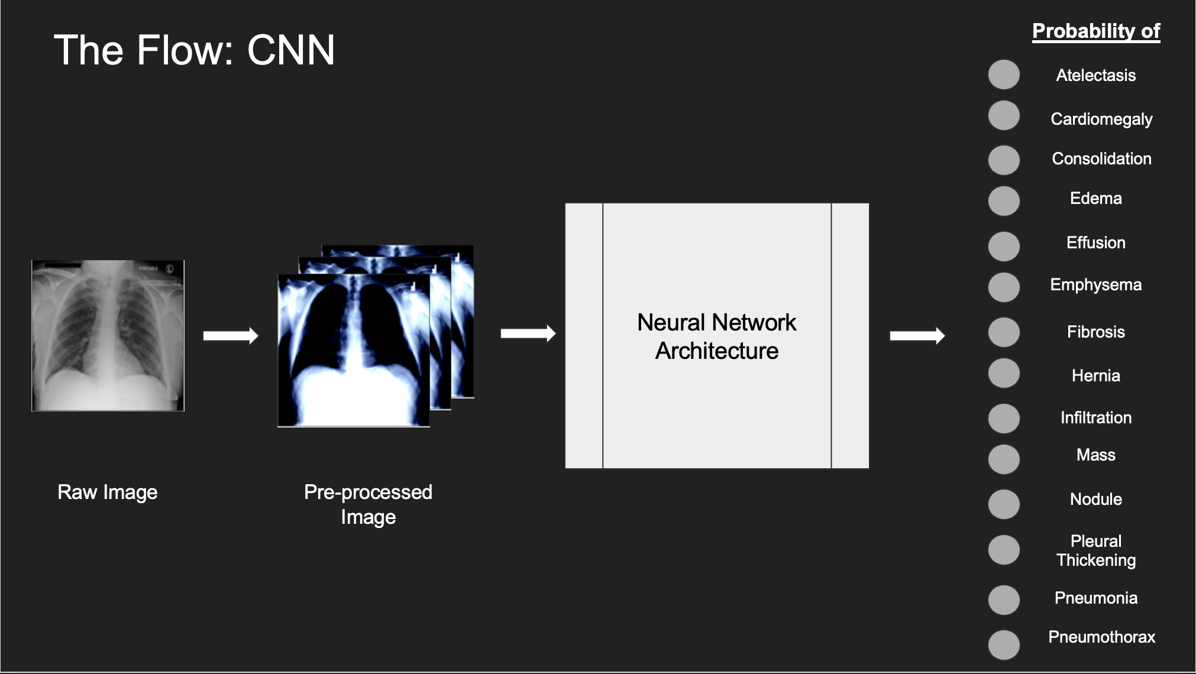

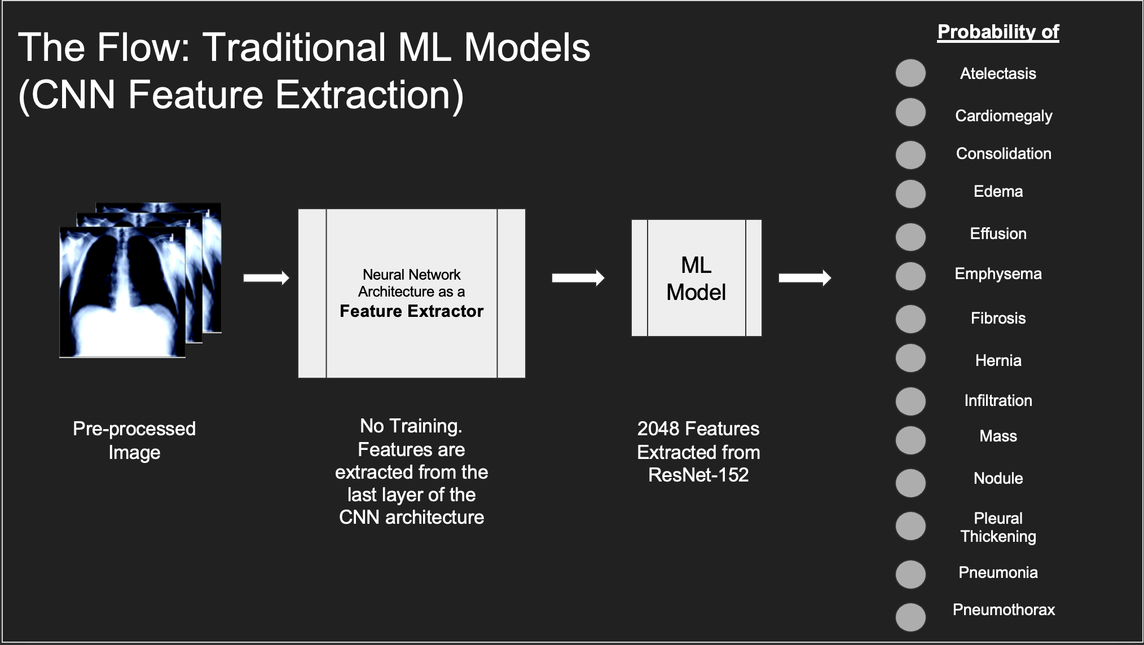
All AAAI papers must use author year citations in the text (Engelmore and Morgan 1986). Numbered references may not be used. The references must be formatted using the exact references style shown the Author

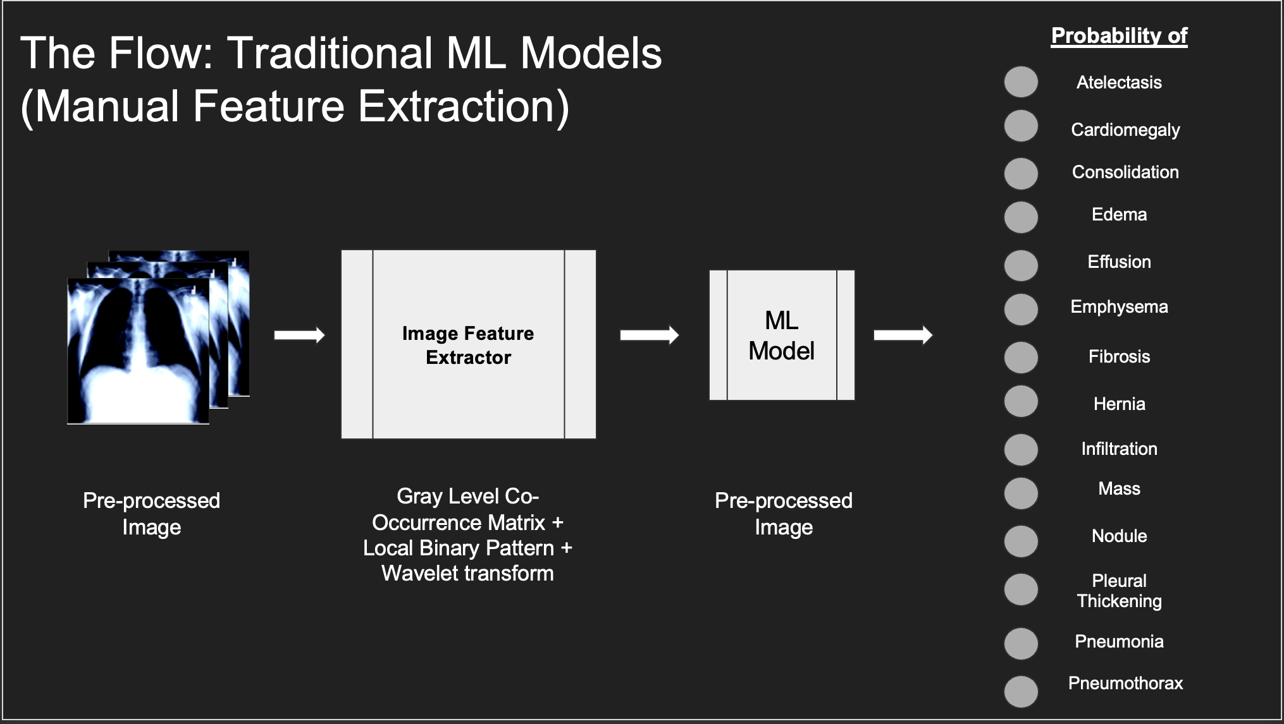
Experiments
All AAAI papers must use author year citations in the text (Engelmore and Morgan 1986). Numbered references may not be used. The references must be formatted using the exact references style shown the Author
CNN hyper Parameter Configurations

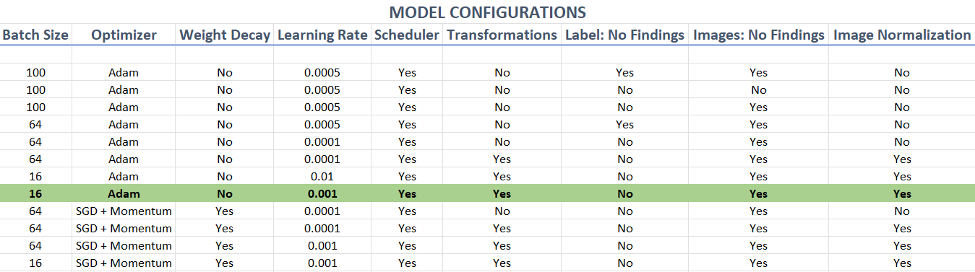

Conclusion
All AAAI papers must use author year citations in the text (Engelmore and Morgan 1986). Numbered references may not be used. The references must be formatted using the exact references style shown the Author

This Is a Section Heading
This Style Sheet Must Be Applied
to All Section Headings
Use of the section heading style is required.
Figures and Tables
This Is an Example of a Figure Caption or Table Caption. Captions must be placed below the table or figure.
You must leave at least 9 points minimum additional space between your figure or table and the figure or table caption. You must have at least 1 carriage return (12 points minimum space) after the caption. You must also have at least 1 carriage return of space (12 points additional space) before a figure or table that does not begin at the top of a page. Figures and tables must not intrude into any margin or gutter (this includes boxes and rules and frames).

Margins
Papers must be printed in two-column format on 8-1⁄2 x 11 inch paper. The margins if you use 8-1/2 x 11 inch paper must be exactly as follows:
• Top margin: 3⁄4 of an inch
• Left margin: 3⁄4 inch
• Right margin: 3⁄4 inch
• Bottom margin: 1-1⁄4 inches
Be certain that the margins apply to all pages in your document, not just the first section. The actual image size for your paper (minus margins) is 7 x 9 inches (17.78 x 22.86 cm). Papers that deviate from these measurements will not be published.

Style Sheet Use and Alterations
You are required to use the custom style sheets embedded in this document without alteration, including, but not limited to Paper Title, Author Name, Affiliation and Address, Abstract Head, Abstract Text, Section Heading, Text, Text-Indent, Subsection Heading, Subsubsection Heading, List Paragraph, Figure, and Figure Caption. Do not use the built-in Word styles such as Heading 1, Header, or Normal.

Fonts
All fonts must be embedded for your paper to be published. No exceptions.
Citation Style and Reference Style
All AAAI papers must use author year citations in the text (Engelmore and Morgan 1986). Numbered references may not be used. The references must be formatted using the exact references style shown the Author Formatting Instructions for Authors Using Word. Citations must be placed in alphabetical order. Lines must be justified. References may not be numbered. No indent is allowed. The style sheet will automatically add the proper amount of space between entries; no additional space should be added.

References
Clancey, W. J. 1984. Classification Problem Solving. In Proceedings of the Fourth National Conference on Artificial Intelligence, 49-54. Menlo Park, Calif.: AAAI Press.
Engelmore, R., and Morgan, A. eds. 1986. Blackboard Systems. Reading, Mass.: Addison-Wesley.
Hasling, D. W.; Clancey, W. J.; and Rennels, G. R. 1983. Strategic Explanations in Consultation. The International Journal of Man-Machine Studies 20(1): 3–19.
Rice, J. 1986. Poligon: A System for Parallel Problem Solving, Technical Report, KSL-86-19, Department of Computer Science, Stanford University, Stanford, CA.
Robinson, A. L. 1980a. New Ways to Make Microcircuits Smaller. Science 208:1019-1026.

Copyright © 2021, Association for the Advancement of Artificial Intelligence (www.aaai.org). All rights reserved.

