AHIP Public Overview, Replication Framework and Miami-Dade Case Study
  - A concise national housing decision-support framework with a local operational proof of concept
Version 1.0 | July 2026 | Project Owner: Ms. Arshalouys Awediss
Purpose of this release
This concise public-benefit package explains what AHIP offers, how selected methods can be adapted nationally, and how the work can be shared responsibly. It does not claim government adoption, endorsement, partnership, or national deployment.

1. What AHIP Is
The Affordable Housing Intelligence Platform (AHIP) is an AI-enabled business intelligence and decision-support initiative developed by Ms. Arshalouys Awediss. It is designed to help U.S. housing stakeholders understand affordability, housing need, housing supply, development activity, operational bottlenecks, and future housing needs using reliable data and governed analytical methods.
AHIP combines public housing and demographic data, business analysis, dashboards, forecasting, data-quality controls, and plain-English executive communication. The completed minimum viable product includes national and state analysis and a Miami-Dade County permitting pilot that demonstrates how selected methods can be applied to local operations.

2. Business Problem and National Relevance
Question | AHIP response
Business problem | Housing information is often spread across agencies, formats, time periods, and geographic levels. Decision-makers may lack a consistent way to connect affordability, supply, population growth, permitting, and operational performance.
National relevance | Housing affordability and supply challenges affect communities across the United States. Agencies, developers, lenders, nonprofits, researchers, and policymakers need clearer evidence for planning, prioritization, resource allocation, and operational review.
Who benefits | Public agencies, housing finance organizations, affordable housing developers, engineering firms, nonprofits, lenders, PropTech and title companies, real estate attorneys, researchers, and policymakers.
Decision improvement | AHIP converts fragmented information into governed indicators, geographic comparisons, forecasts, scenarios, data-quality alerts, process measures, and executive summaries that support professional review.

3. Completed AHIP Capabilities
Housing affordability and housing-need analysis.
Housing supply and residential development trend analysis.
Priority-area identification for further review.
National and state housing-permit forecasts with documented uncertainty.
Population and housing-stock scenario analysis.
Data-quality anomaly detection and review controls.
Governed executive summaries with evidence traceability and human review.
Power BI dashboards designed for executives and nontechnical users.
A Miami-Dade County permitting pilot using 2025 housing-use permit indicators.
Important interpretation control
AHIP is a decision-support tool. It does not make legal, policy, engineering, underwriting, appraisal, funding, or permitting decisions, and it does not replace professional judgment or community engagement.

4. National Replication Framework
Replication means using a consistent analytical framework while validating local data, definitions, workflows, policies, and stakeholder needs. It does not mean copying Miami-Dade results or ranking jurisdictions without context.
Step | Action | Minimum control
1 | Define the decision | Confirm the business problem, intended users, decisions supported, and what is out of scope.
2 | Validate sources | Record the source owner, period, geography, refresh frequency, access method, limitations, and permitted use.
3 | Map local data | Standardize field names, permit types, statuses, milestone dates, geography codes, and missing-value rules.
4 | Test quality | Check completeness, validity, consistency, uniqueness, timeliness, unusual values, and join integrity.
5 | Define KPIs | Approve formulas, units, denominators, periods, geography, and interpretation limits before publishing.
6 | Build and review | Develop dashboards or reports, reconcile totals, test filters, and obtain local subject-matter review.
7 | Publish and improve | Assign ownership, version releases, document changes, collect feedback, and refresh responsibly.

5. Miami-Dade Permitting Pilot
The Miami-Dade residential permitting pilot is the first local operational proof of concept within AHIP. It shows how public permit records can be organized into measures that help users understand permit volume, elapsed application-to-issuance time, the distribution of cases by age, and records that may require deeper review.
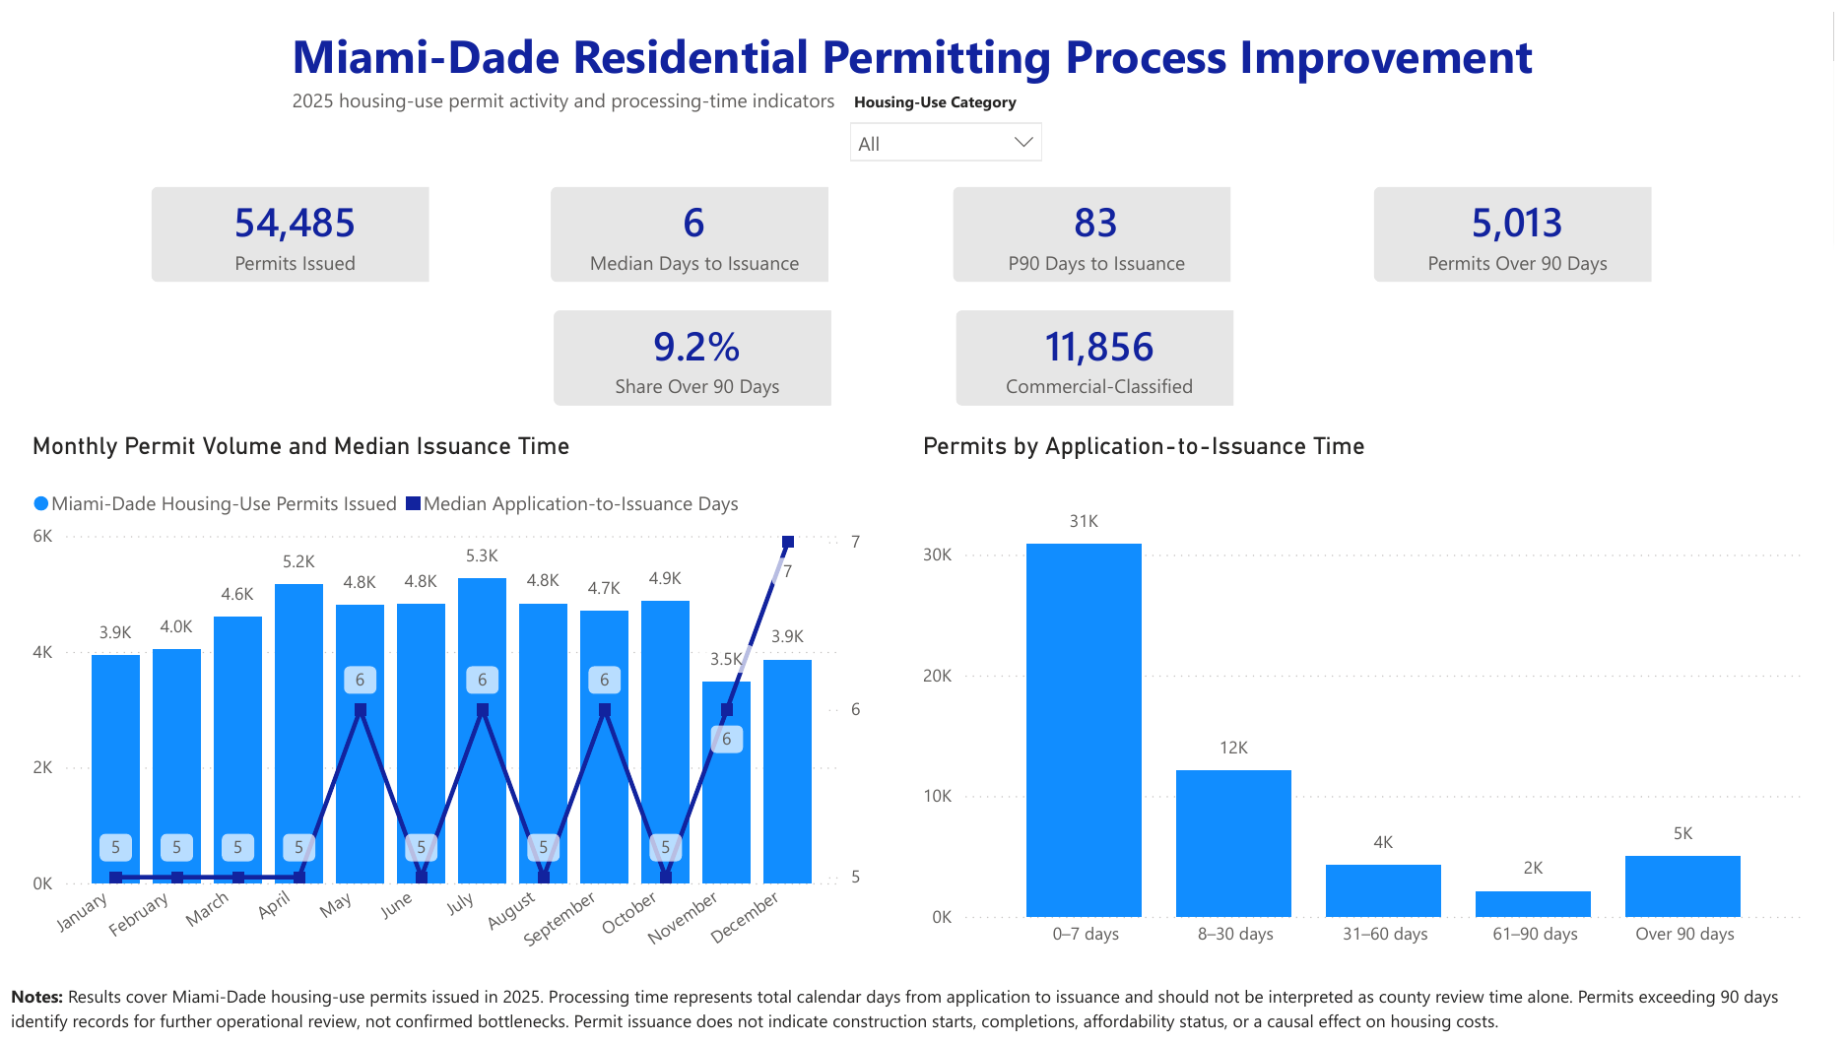
Figure 1. Miami-Dade Residential Permitting Process Improvement dashboard, AHIP Phase 07 v1.1.
Indicator | Result | Business interpretation
Housing-use permits issued | 54,485 | Scale of the 2025 issued-permit population included in the pilot.
Median days to issuance | 6 days | Half of included permits had an application-to-issuance duration of six calendar days or less.
90th-percentile duration | 83 days | Ninety percent were issued within 83 calendar days; the remaining tail took longer.
Permits over 90 days | 5,013 | Records selected for deeper review, not automatically classified as failures.
Share over 90 days | 9.2% | A meaningful minority that can be segmented by category, timing, or other available fields.
How the pilot should be interpreted
Application-to-issuance time is total elapsed calendar time. It may include applicant response time, document corrections, external dependencies, pauses, or other events. It must not be described as county review time unless the data separately supports that conclusion.

6. What the Pilot Can Support
Prioritize permit groups or records for further operational review.
Identify questions for process-mapping interviews with permitting staff and external stakeholders.
Design transparent KPIs and thresholds that are documented rather than assumed.
Support workload, staffing, service-level, and process-improvement discussions with evidence.
Provide a repeatable method that another jurisdiction can adapt after local validation.

7. Limitations and Current Status
The pilot covers housing-use permits issued in 2025 and does not represent every submitted, withdrawn, denied, cancelled, or open application unless included in the source population.
Permit issuance does not mean construction started or was completed, and it does not establish affordability status.
Long elapsed times do not by themselves prove a government bottleneck or identify the responsible party.
The analysis does not establish that permitting changes will reduce housing prices or increase housing supply.
Cross-jurisdiction comparison requires documented alignment of workflow, definitions, staffing, policy, and data quality.
No government adoption, partnership, endorsement, or national deployment is claimed. Public availability, release dates, and persistent identifiers should be verified through the official public repository and archive record.

8. Public-Benefit Use
The AHIP public-benefit toolkit is designed so that housing professionals, municipal teams, researchers, nonprofits, and other stakeholders can review and adapt selected methods without purchasing customized services. The public package emphasizes reusable definitions, checklists, templates, examples, and limitations rather than claiming universal conclusions from one county.
Source basis and project evidence: AHIP Project Charter; AHIP Phase 07 Dashboard v1.1 Final; AHIP Phase 08 completion evidence; approved internal QA artifacts; and the U.S. Census Bureau Building Permits Survey.

9. Public-Use Notice
Except where otherwise noted, the original narrative, definitions, tables, and templates in this document are made available under the Creative Commons Attribution 4.0 International license (CC BY 4.0). Users may share and adapt these original materials with appropriate attribution and an indication of changes.
This license does not grant additional rights to third-party datasets, source publications, logos, trademarks, or other materials that are separately credited or governed by their own terms. The document is provided for informational and decision-support purposes without a guarantee of results, completeness, or fitness for a particular use.
Suggested citation: Awediss, Arshalouys. 2026. AHIP Public Overview, Replication Framework and Miami-Dade Case Study. Version 1.0. Affordable Housing Intelligence Platform.

