School of computer science

University of petroleum and energy studies

DEHRADUN, UTTARAKHAND



Continuous Integration and Continuous Deployment

Lab File

(2023-2024)

For

5th Semester

Submitted To: - Submitted By: -

Dr. Hitesh Kumar Sharma Anshika Saxena

B. TECH CSE [DevOps]

Batch - 2

500093696

**Exp - 1 & 2**

Step 1: Create a maven project in Eclipse.

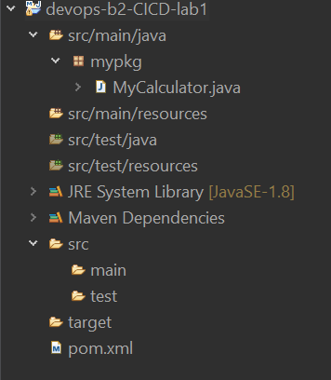

Step 2: Push project on Github.

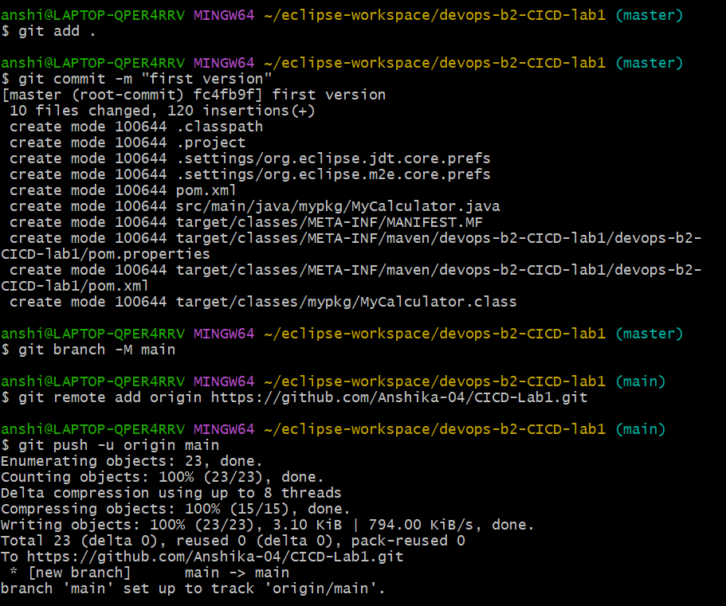

Step 3: Install and start Jenkins.

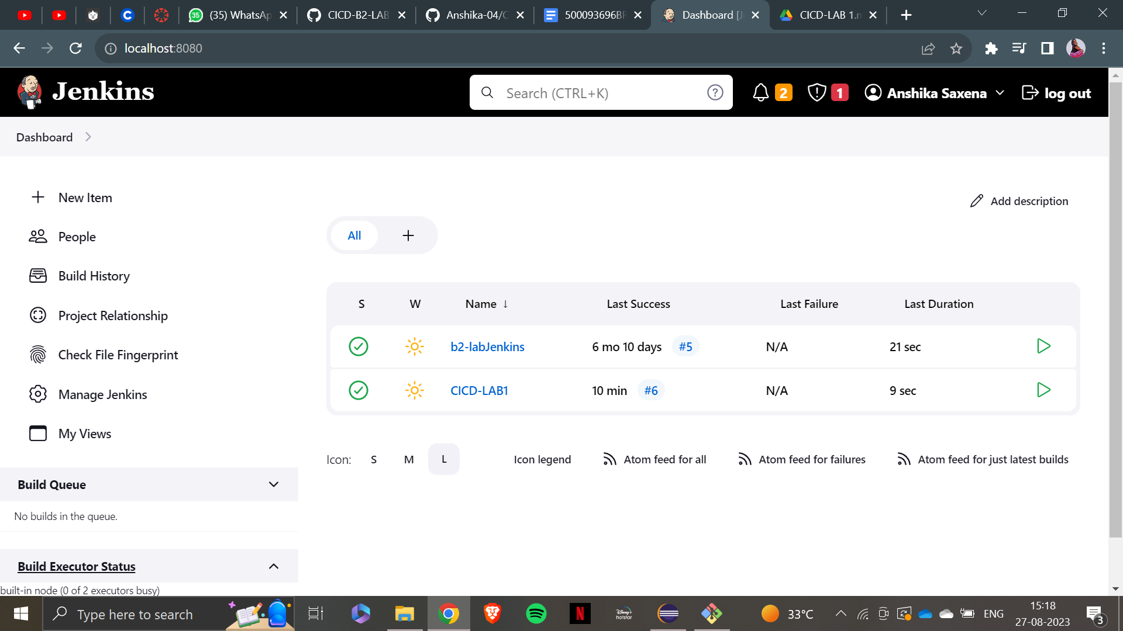

Step 4: Create a Jenkins job to clone Github project and make a build.

Step 5: Execute the build.

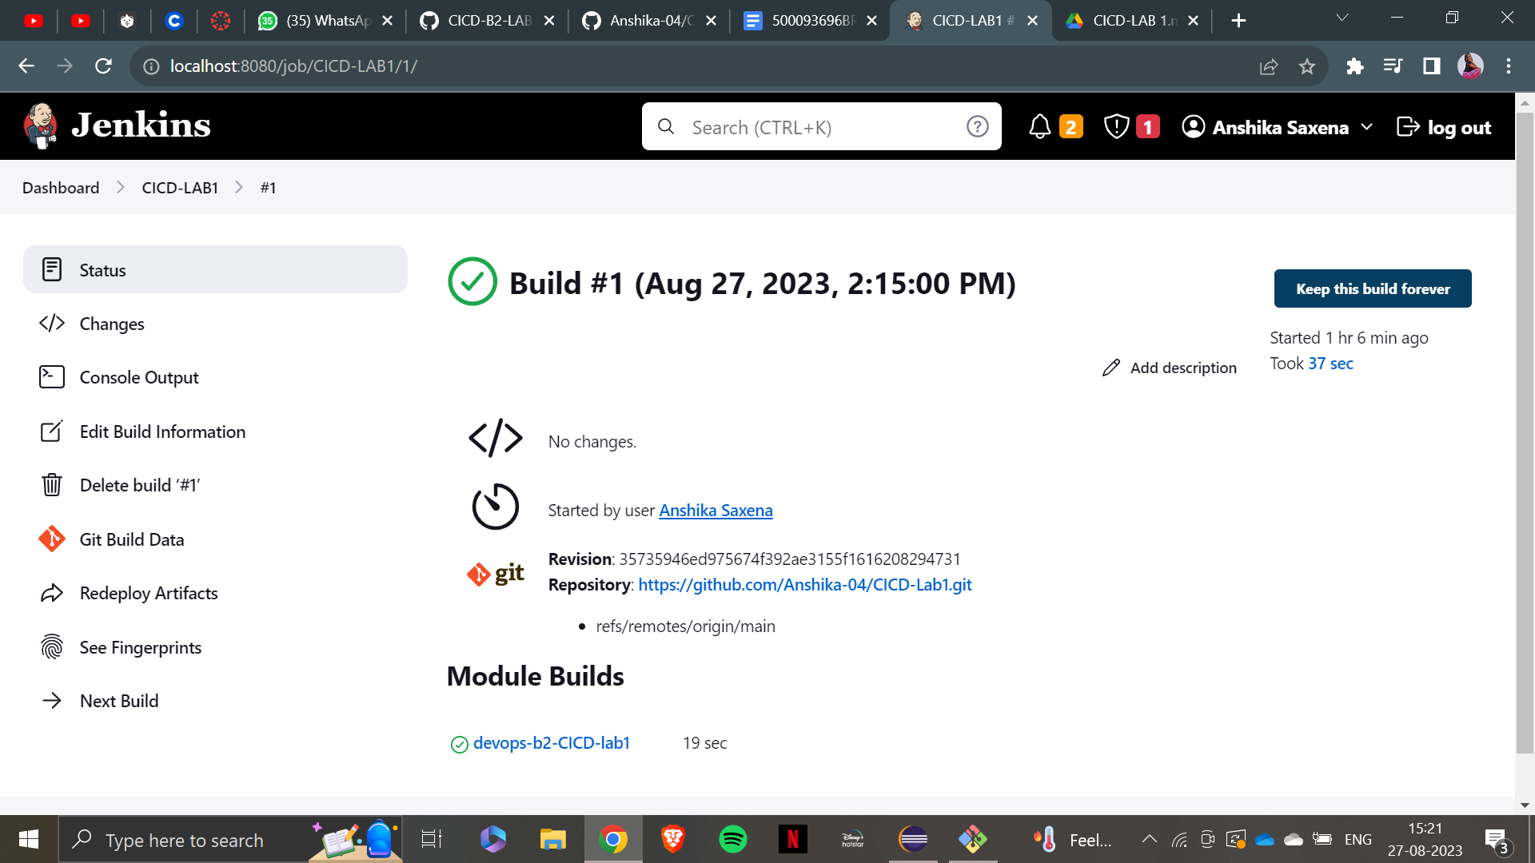

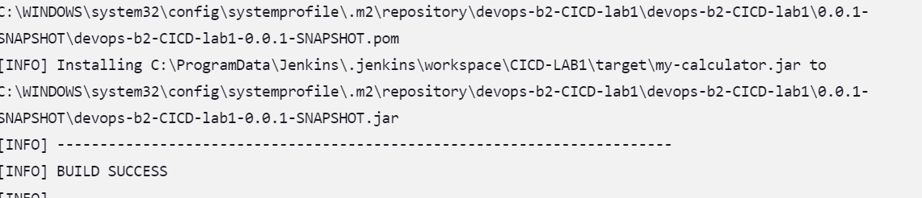

Step 6: Make changes in the project.

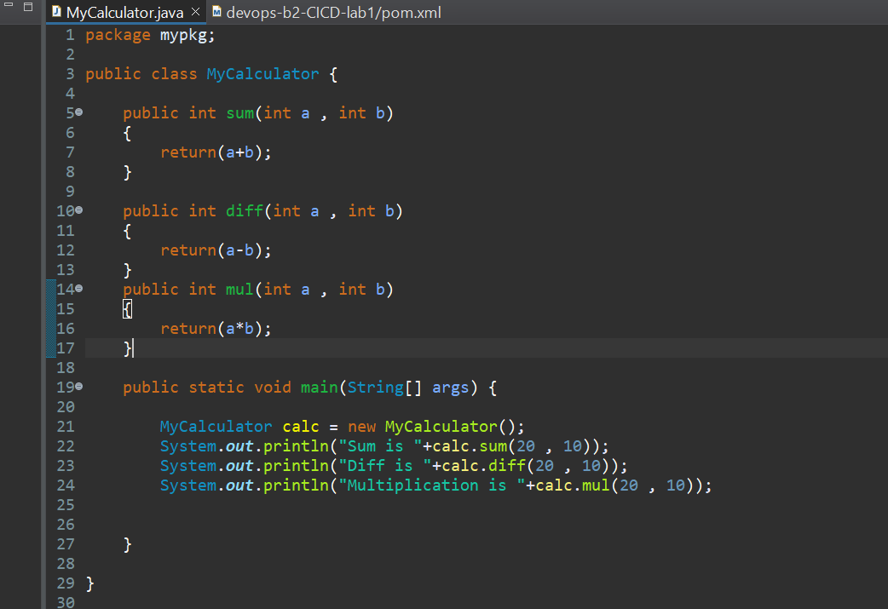

Step 7: Commit and push.

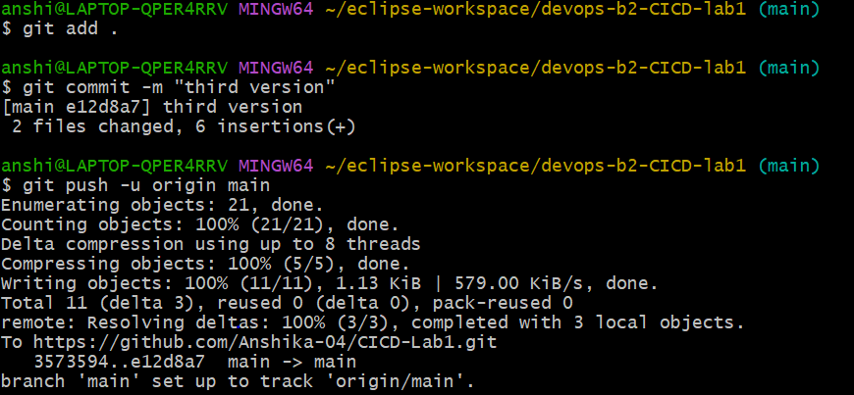

Step 8: Generate Auto-build using Jenkins.

