COMP 3340-30 WWW System

Information Devl. – Quiz2

School of Computer Science

Instructor: Abed Alkhateeb

July 9, 2019

15

mins



Answer all the questions, please.

True or False

1. **TRUE** Once the browser has received the cookie, it will then return it with every future request made to the issuing server until the cookie expires or is deleted.
2. **FALSE** setcookie('username', 'Hannah', ', time() + 60 * 24 * 7, '/'); this cookie expires in 24 hours.
3. **TRUE** PHP will eventually return the memory it has allocated for objects after you have finished with the script.
4. **TRUE** HTTP address doesn't maintain the state of the request after the response of the server.
5. **FALSE** sessions are stored in the browser.
6. **TRUE** ENGINE InnoDB is the proper database engine to use for concurrent access for transactions tables.
7. **FALSE( 3 does not exist on the refered table Employee)** For the following many-to-many relationship (as seen in Figure 1), where employee_id, and education_id in the employee_education table are foreign keys to education(id), and employee(id) in order.

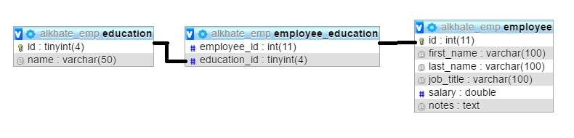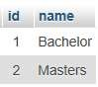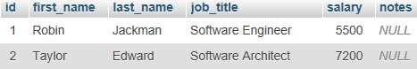

Figure 1: The Tables and their data The following statement will be successfully inserted:

INSERT INTO `employee_education`(`employee_id`, `education_id`) VALUES (2,3);

1. **TRUE** Based on Figure 1, the following statement will be successfully inserted: INSERT INTO `education`(`id`, `name`) VALUES (3,'Ph.D');

Fill in the blanks

1. Based on Figure 1, what does the following query return?

SELECT * FROM `employee` WHERE job_title like'%Software'

__**NOTHING(NO Job_title ends with Software**_______________

1. Using the ____**ROLLBACK**________ command, you can tell MySQL to forget all the queries made since the start of a transaction and to end the transaction.