Software Design
Specification

DOS Attack Implementation and Mitigation
Revision 1.0

Shubham Arora (14BCE0905)
Shray Khanna (14BCE0887)

Table of Contents
Table of Contents ii
Revision History iii
Approved By iii
1. Introduction 1
1.1 Purpose 1
1.2 System Overview 1
1.3 Design Map 1
1.4 Supporting Materials 1
1.5 Definitions and Acronyms 1
2. Design Considerations 1
2.1 Assumptions 1
2.2 Constraints 2
2.3 System Environment 2
2.4 Design Methodology 2
2.5 Risks and Volatile Areas 2
3. Architecture 2
3.1 Overview 2
3.2 Subsystem, Component, or Module 1 …N 2
3.3 Strategy 1…N 3
4. Database Schema 3
5. Detailed System Design 4
6. User Interface Design 13
Appendix A: Project Timeline 14

Revision History
Version | Name | Reason For Changes | Date
1.0 | Shubham Arora  Shray Khanna | Initial Revision | 8/19/2004

Approved By
Approvals should be obtained for project manager, and all developers working on the project.

Name | Signature | Department | Date

Introduction

Purpose
This design will detail the implementation of the requirements as defined in the Software Requirements Specification – DOS Attack Implementation and Mitigation.
This document is intended ethical hackers and service providers who maintains and keep a regular check on the server.

System Overview
This project implements the functionality of executing DOS Attacks via a GUI on a server, provided IP address, open port and clients network interface are provided. Additional fields and features will be added to the software on user demand. It also includes a server side script to prevent such attacks by limiting the number of connections by the offending users and banning them if a certain threshold is reached.

Design Map

Definitions and Acronyms
Teamplate – 3rd party workflow management software used by Clark Consulting
Process – One instance of a workflow - GI Request, for example
Task – One step or piece of a workflow
Metrics Reporting – Displays process breakdown by task and the amount of time it takes, on average, to complete a task in a process.
Task Views Reporting – Displays a single process type (Binder Request, Core, etc) tasks
Process Specific Reporting – Process specific reports where the filters are defined on a per process basis

Design Considerations
This section describes many of the issues which need to be addressed or resolved before attempting to devise a complete design solution.

Assumptions
Following assumptions are defined in building and using of this software suite.

- Appropiate header files for linux system are available for excuting such attack over the the network interface.
- In this phase we are only working on linux subsytem. It will however work on on Mac OS and Windows system through WSL;.

Constraints
Following constraints are there in the initial version of the software.
- Multiple systems are needed to execute a sizable DOS attack in order to get a visible result.

System Environment
- Server Environment
- Linux server (Ubuntu preferred)
- Open ports to execute attack.
- No web server installed as they have inbuilt functionality to prevent these types of DOS attacks over port 80 and 443
- Client Environment
  - Linux system
  - GCC 5+
  - Python 2.7 for drawing the interface

Design Methodology
The program was first implemented in the command line and then interfaced with a GUI for ease of use for the end user. However server code is in form of a script which is to the executed over ssh

Risks and Volatile Areas
- Multiple systems are needed to execute a sizable DOS attack in order to get a visible result.

Architecture
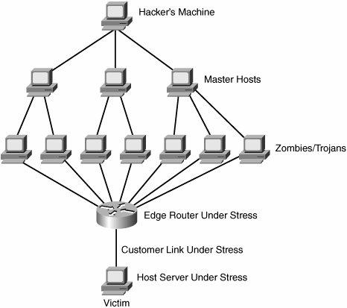
The architecture provides the top level design view of a system and provides a basis for more detailed design work

Overview
This section provides a high level overview of the structural and functional decomposition of the system. Focus on how and why the system was decomposed in a particular way rather than on details of the particular components. Include information on the major responsibilities and roles the system (or portions) must play.

Module 1
Module 1 consists of the client software of the program which performs DOS attacks on a given server.

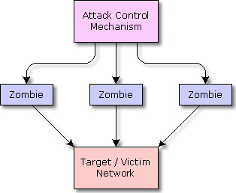
Module 2Module 2 consists of the shell script containing the firewall rules.

Database Schema
Not Applicable

Detailed System Design

Class Diagram
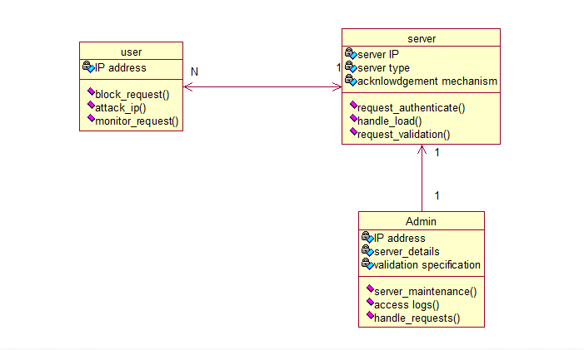

Activity Diagram
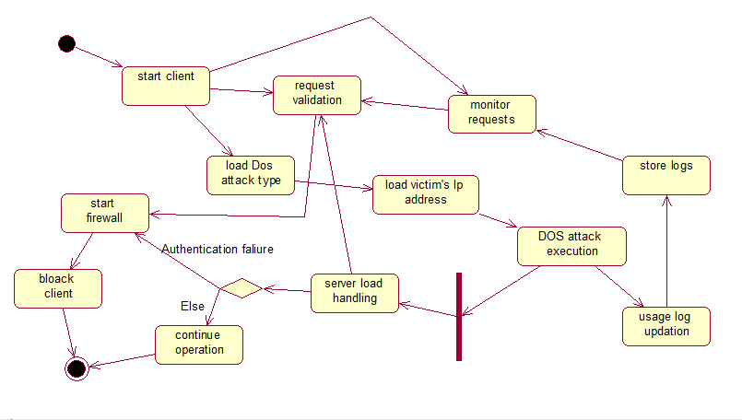

Component Diagram
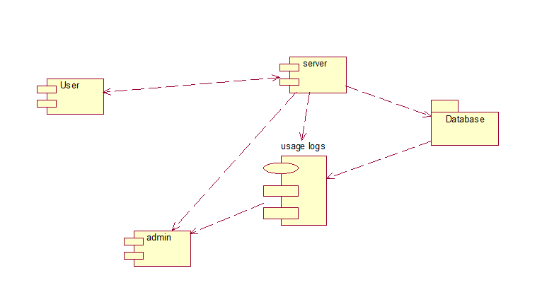

Deployment Diagram
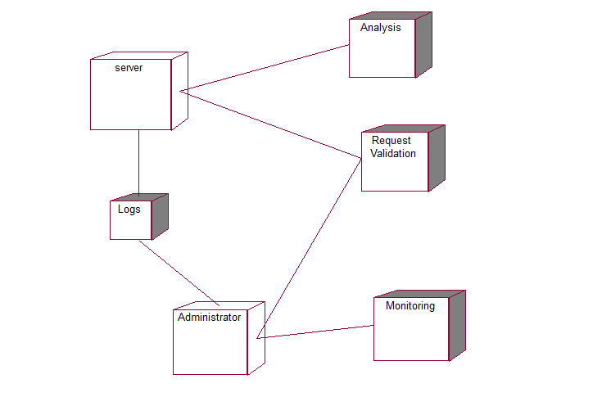

Block Diagram
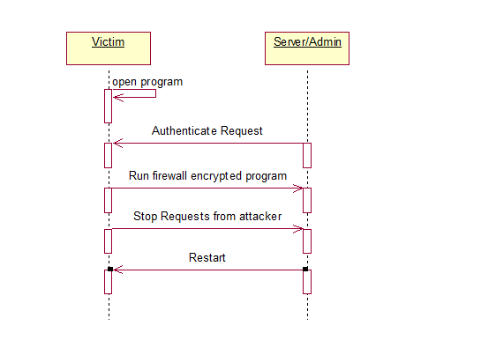

Collaborative Diagram
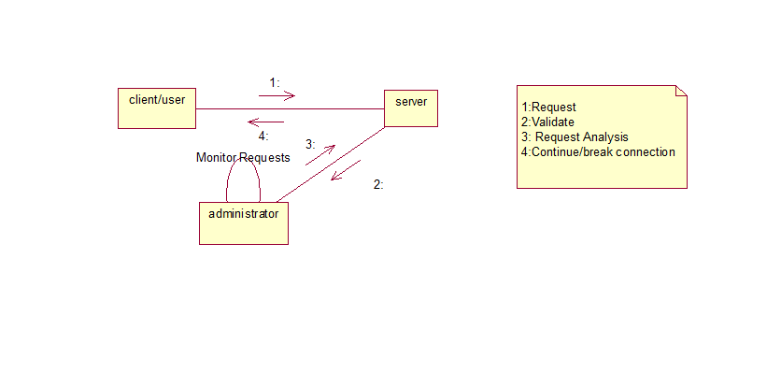

Component Diagram

Sequence Diagrams
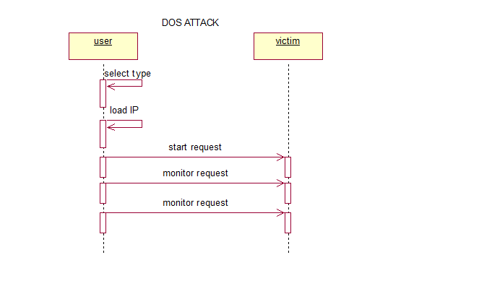
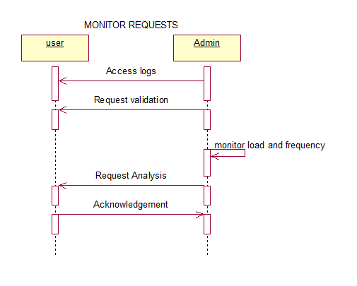

Appendix A: Project Timeline

Pert Chart
