**Database System Assignment**

**ON**

**Pedestrian Detection Of Infrared Image**

**Using Entropy Method**

**Prof. RAMANI S**



**An Assignment by:**

**NIKHIL KUMAR, 14BCE0785**

**SLOT :- D2+TD2**

**Abstract**

Pedestrian detection is very important and also has a big challenge in the Intelligent Transportation System. Use of IR images is advantageous for many surveillance applications where the systems must operate around the clock and external illumination is not always available. Experimental study of the use of thermal infrared (8 - 12 micro meter) imaging applied to the problem of pedestrian tracking. Generally it was found that infrared images enable better image segmentation.

**Introduction**

Human vision is limited to a small portion in the electromagnetic spectrum in the form of visible light. The infrared radiation is invisible to the human eye but can sense the heat emitting objects at any time. Protecting a country’s borders is vital to its Homeland Security. It is, however, very challenging to detect potential intruders or smugglers in total darkness or in diverse weather conditions. Thermal imaging cameras can help border control professionals to meet the demands they face at night and in other low-light situations. Thermal imaging cameras can be integrated in a border security project with radars and other sensors in a so called ”slew-to-cue” mode. But not only land borders need to be protected. Thermal imaging cameras are the perfect tools for coastal surveillance as well. Small vessels can be detected at extremely long ranges. thermal imagers operate like the human eye, but they are much more powerful. Energy from the environment comes through a lens and is registered on a detector. In the case of the infrared thermal imager, that energy is heat rather than light. By measuring very small relative temperature deference's, invisible heat patterns are converted by the thermal imager into clear, visible images that the human eye can see through a viewﬁnder or TV monitor.

**Method**

Saliency extraction became an important step in the segmentation of images and in object recognition. Visual attention analysis and saliency extraction are applied

**Infrared Image**

Infrared thermography (IRT), thermal imaging, and thermal video are examples of infrared imaging science. Thermographic cameras usually detect radiation in the long-infrared range of the electromagnetic spectrum (roughly 9,000–14,000 nanometers or 9–14 micro meter) and produce images of that radiation, called thermograms. Since infrared radiation is emitted by all objects with a temperature above absolute zero according to the black body radiation law, thermography makes it possible to see ones environment with or without visible illumination. The amount of radiation emitted by an object increases with temperature; therefore, thermography allows one to see variations in temperature. When viewed through a thermal imaging camera, warm objects stand out well against cooler backgrounds; humans and other warm-blooded animals become easily visible against the environment, day or night. As a result, thermography is particularly useful to the military and other users of surveillance cameras.

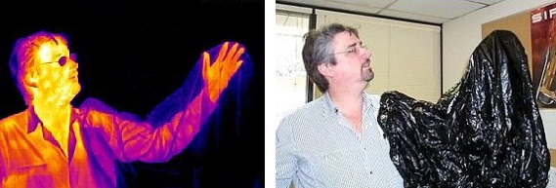

**Pre-processing Of Infrared Image**

It is observed that IR images are mainly degraded by the following eﬀects:

• Vignetting due to limited aperture

• Fixed pattern noise (FPN) in commonly used focal plane arrays (FPA) due to the pixel reading procedure

• Presence of dead pixels in FPA matrix and

• Radial distortion due to the noncolinear image points with respect optical center.

Preprocessing may include also some other procedures. Pixel enhancement is commonly used. Probably the most common preprocessing procedure is noise smoothing. Median ﬁltering prevents this. Median ﬁltering is good to remove spiky noise.

**Median Filter**

The median ﬁlter is normally used to reduce noise in an image, somewhat like the mean ﬁlter. However, it often does a better job than the mean ﬁlter of preserving useful detail in the image. How It Works Like the mean ﬁlter, the median ﬁlter considers each pixel in the image in turn and looks at its nearby neighbours to decide whether or not it is representative of its surroundings. Instead of simply replacing the pixel value with the mean of neighbouring pixel values, it replaces it with the median of those values. The median is calculated by ﬁrst sorting all the pixel values from the surrounding neighbourhood into numerical order and then replacing the pixel being considered with the middle pixel value. By calculating the median value of a neighbourhood rather than the mean ﬁlter, the median ﬁlter has two main advantages over the mean ﬁlter:

• The median is a more robust average than the mean and so a single very unrepresentative pixel in a neighbourhood will not aﬀect the median value signiﬁcantly.

• Since the median value must actually be the value of one of the pixels in the neighbourhood, the median ﬁlter does not create new unrealistic pixel values when the ﬁlter straddles an edge. For this reason the median ﬁlter is much better at preserving sharp edges than the mean ﬁlter.

Median ﬁltering is a nonlinear process useful in reducing impulsive, or salt-and pepper noise. It is also useful in preserving edges in an image while reducing random noise. Impulsive or salt-and pepper noise can occur due to a random bit error in a communication channel.

**Entropy**

Image entropy is a quantity which is used to describe the ‘business’ of an image, i.e. the amount of information which must be coded for by a compression algorithm. Low entropy images, such as those containing a lot of black sky, have very little contrast and large runs of pixels with the same or similar DN values. An image that is perfectly ﬂat will have an entropy of zero. Consequently, they can be compressed to a relatively small size. On the other hand, high entropy images such as an image of heavily cratered areas on the moon have a great deal of contrast from one pixel to the next and consequently cannot be compressed as much as low entropy images. Entropy eﬀectively bounds the performance of the strongest lossless compression possible Entropy is the uncertainty of the source.

Deﬁnes the average amount of info obtained by observing a single source output OR average information per source output (bits)

alphabet = 26 letters means 4.7 bits/letter

typical grey scale = 256 levels means 8 bits/pixel

**Saliency Map**

The salience (also called saliency) of an item – be it an object, a person, a pixel, etc. – is the state or quality by which it stands out relative to its neighbours. Saliency detection is considered to be a key attentional mechanism that facilitates learning and survival by enabling organisms to focus their limited perceptual and cognitive resources on the most pertinent subset of the available sensory data. Saliency typically arises from contrasts between items and their neighbourhood, such as a red dot surrounded by white dots, a ﬂickering message indicator of an answering machine, or a loud noise in an otherwise quiet environment. Saliency detection is often studied in the context of the visual system, but similar mechanisms operate in other sensory systems. What is salient can be inﬂuenced by training: for example, for human subjects particular letters can become salient by training. When attention deployment is driven by salient stimuli, it is considered to be bottom-up, memory-free, and reactive. Attention can also be guided by top-down, memory-dependent, or anticipatory mechanisms, such as when looking ahead of moving objects or sideways before crossing streets. Humans and other animals have diﬃculty paying attention to more than one item simultaneously, so they are faced with the challenge of continuously integrating and prioritizing diﬀerent bottom-up and top-down inﬂuences.

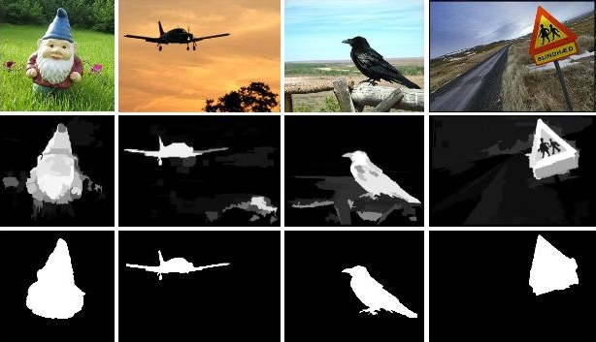

In computer vision, a saliency map is an image that shows each pixel’s unique quality. And saliency is an algorithm to compute the unique quality of each pixel and then showing each pixel’s unique quality in a new image, this image is saliency map. The goal of a saliency map is simpliﬁed and/or change the representation of an image into something that is more meaningful and easier to analyze. Like a pixel has a high grey level or other unique color quality sees in [color image], each pixel’s quality will show in the saliency map and in an obvious way. Saliency is a kind of Image segmentation. The result of saliency map is set of contours extracted from the image (see edge detection). Each of the pixels in a region is similar with respect to some characteristic or computed property, such as color, intensity, or texture. There are three major map calculation ways that obey linear computational complexity with respect to a number of image pixels. The ﬁrst saliency function is using each pixel value minus the rest of this image’s single pixel’s value and then sum those value together. Saliency sum is the distance of a pixel to the rest of pixels in an input image, and the value of the sum is every pixel’s saliency value of a saliency map. And this algorithm is using the grey value of each pixel. The second saliency function is very close to the previous one, and the only diﬀerence is the saliency distance calculation way. In the previous function, we use a pixel value minus same frame’s pixel value. However, in this function, we get two input images from a video, then use a pixel value in present image minus the rest pixel value in the previous image, then sum all of this value. This value is the saliency distance of the second function. This function is exactly using previous frame’s same coordinate pixels as compared pixels. The third saliency function uses the calculation result of the ﬁrst saliency function. After we get the result of the ﬁrst function, we use current frame’s saliency result minus the previous saliency result to get a new saliency map.

**Entropy-Based Saliency Extraction**

The entropy of the median-ltered image is calculated and compared with the local entropy of each block. The salience map is dened as

if (lent >gent) image block = 1;

else image block = 0;

end where lent is the local entropy of the image block of size 15 X 15 and gent is the global entropy of the image. The analogy is that if the local entropy exceeds the global entropy, the probability that the block contains the heatemitting object, i.e., target, is high. The saliency map thus obtained is a binary image where each white block represents the target and the rest is merged with the background.

The results obtained are statistically evaluated using the measures PD (detection rate) and PFA (false alarm rate). These are dened in Eqs. 1 and 2, respectively:

PD =( No of true targets detected/ Total no of targets)*100%

PFA =( No of false targets detected/ Total no of targets)*100%

**Conclusion**

A set of three approaches are proposed for target detection in IR images. The proposed approaches are trivial but due to block processing of images help inhigher detection rate and lower alarm rate. The combination of entropy and energy parameters led to an aggregate of around 96%. It is planned to improve the work towards 100% detection rate. To do that, a robust saliency map is planned by extracting robust features other than entropy and energy as future work.