Cloud-Native DevOps Implementation of a Campus Device Loan System

CIS3039 – Cloud Native DevOps Technical Implementation Report
Student Name: Arshad Aslam
Student ID: K0352250
Module: CIS3039 Cloud Native DevOps
Programme: BSc (Hons) Computer Science
University: Teesside University
Tutor: Tyrone Davison
Submission Date: 16th March 2026

Contents

1. Introduction 3
2. System Architecture 3
3. Development and DevOps Pipeline 6
4. System Implementation 8
2. Technology Choices and Trade-offs 13
System Limitations 13
Future Improvements 14
Conclusion 14
References 15

1. Introduction

Modern universities rely heavily on digital systems to manage shared resources such as laptops, tablets, and other portable devices. These devices are often loaned to students for temporary use during coursework or examinations. Managing this process manually can lead to errors in tracking availability, difficulties in monitoring reservations, and inefficient resource use. As universities increasingly adopt digital infrastructure, cloud-native systems provide scalable and maintainable solutions to these challenges.

This project presents the development of a Campus Device Loan System designed using cloud-native development principles and DevOps practices. The system enables users to view available devices, reserve them via a web interface, and manage loan activity via backend services. The architecture separates responsibilities between services to improve modularity and maintainability.
The system was implemented using Node.js for backend services and developed using Visual Studio Code. Architectural diagrams were created in draw.io to communicate the system design clearly. Source code was managed on GitHub, and a continuous integration workflow was implemented using GitHub Actions to automate build verification upon each commit.
This report describes the architecture, development workflow and implementation decisions used to build the system. It also evaluates design trade-offs and identifies areas for future improvement.

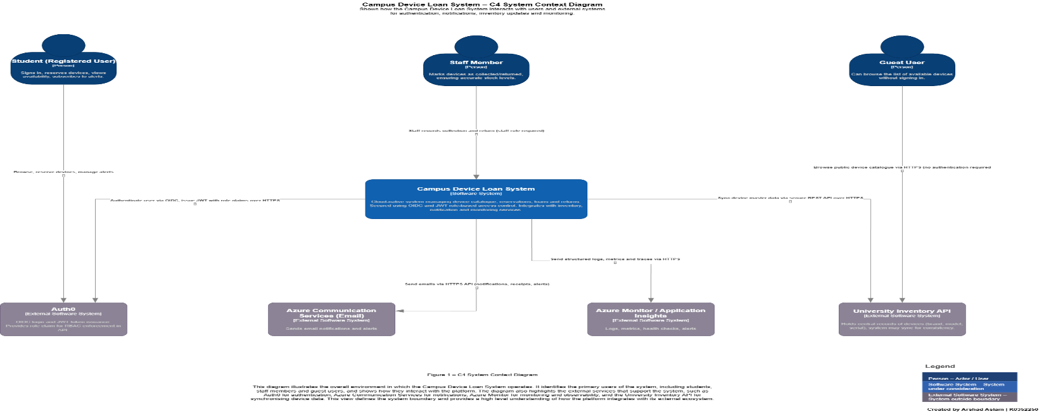
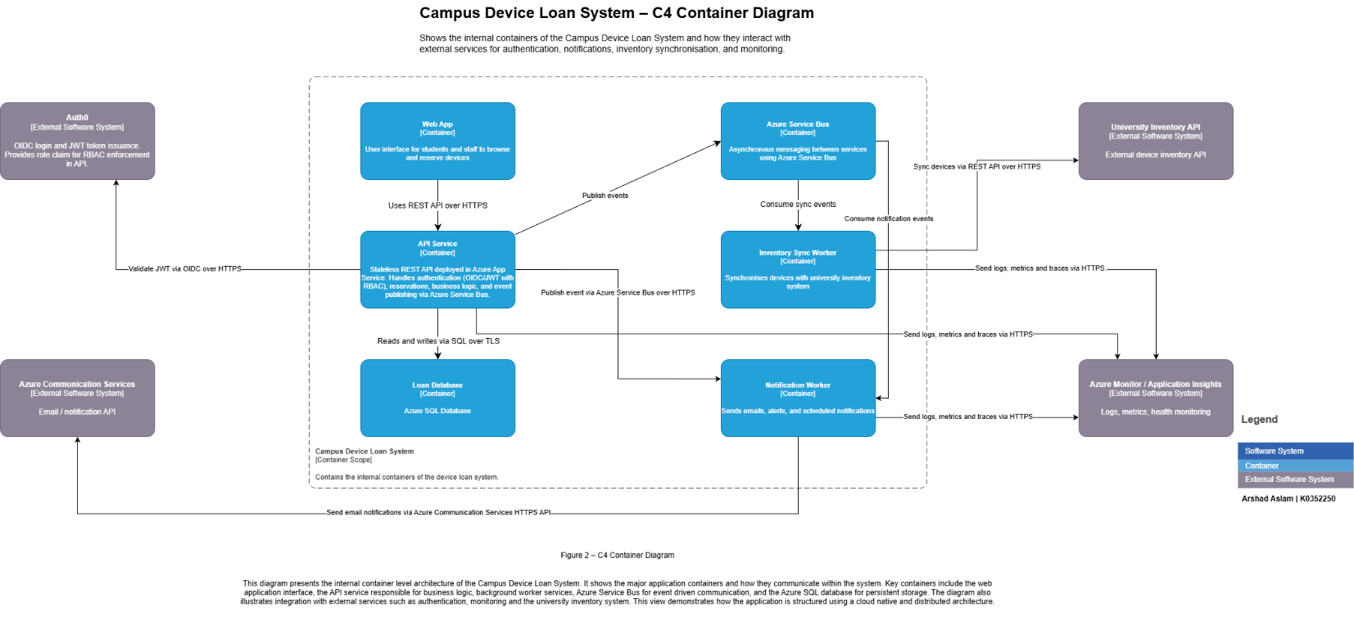
2. System Architecture
The architecture of the Campus Device Loan System was designed using the C4 architectural model, which provides multiple levels of abstraction for representing software systems (Brown, 2018). This modelling approach helps developers and stakeholders understand system structure while maintaining clarity across different architectural layers.
The system context diagram illustrates the overall environment in which the application operates. Users interact with the system through a web interface that communicates with backend services that process requests and manage device information.
Figure 1 – System context diagram showing interactions between users and the Campus Device Loan System.
The architecture was further refined through container-level modelling. Containers represent the system's major executable services and describe how they interact.
Figure 2 – Container architecture illustrating the web interface, API service and worker service.
The container architecture separates responsibilities between the user interface and backend services. The API service handles requests from the web interface, manages device data and processes reservation actions. A separate worker service performs background tasks that do not require immediate user interaction.
This design reflects common microservice architecture principles, in which independent services communicate via APIs while remaining loosely coupled. Such an approach improves scalability and allows individual services to evolve independently without affecting the entire system.
The internal structure of the API service is illustrated using a component diagram.
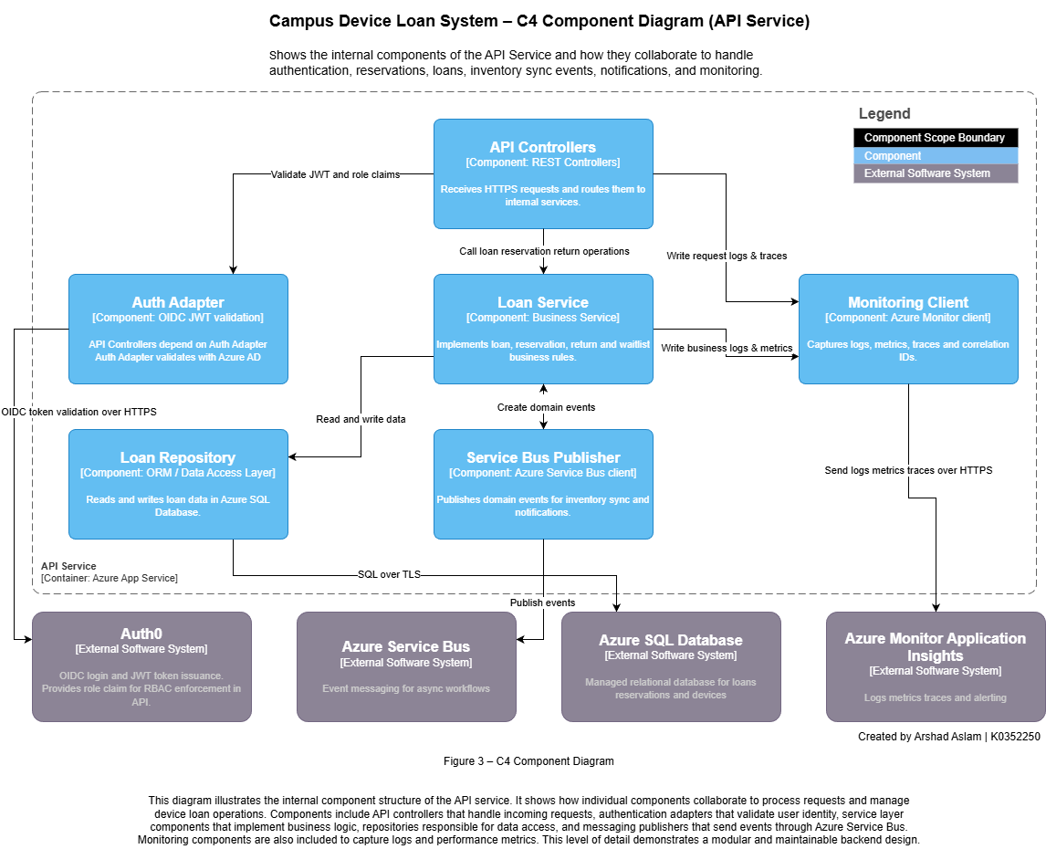
Figure 3 – Component diagram showing internal modules of the API service.
The component architecture divides functionality into smaller modules responsible for specific tasks such as request validation, reservation processing and device data management. Modular design improves maintainability and simplifies future development.
Finally, the deployment architecture illustrates how system components operate within a runtime environment.
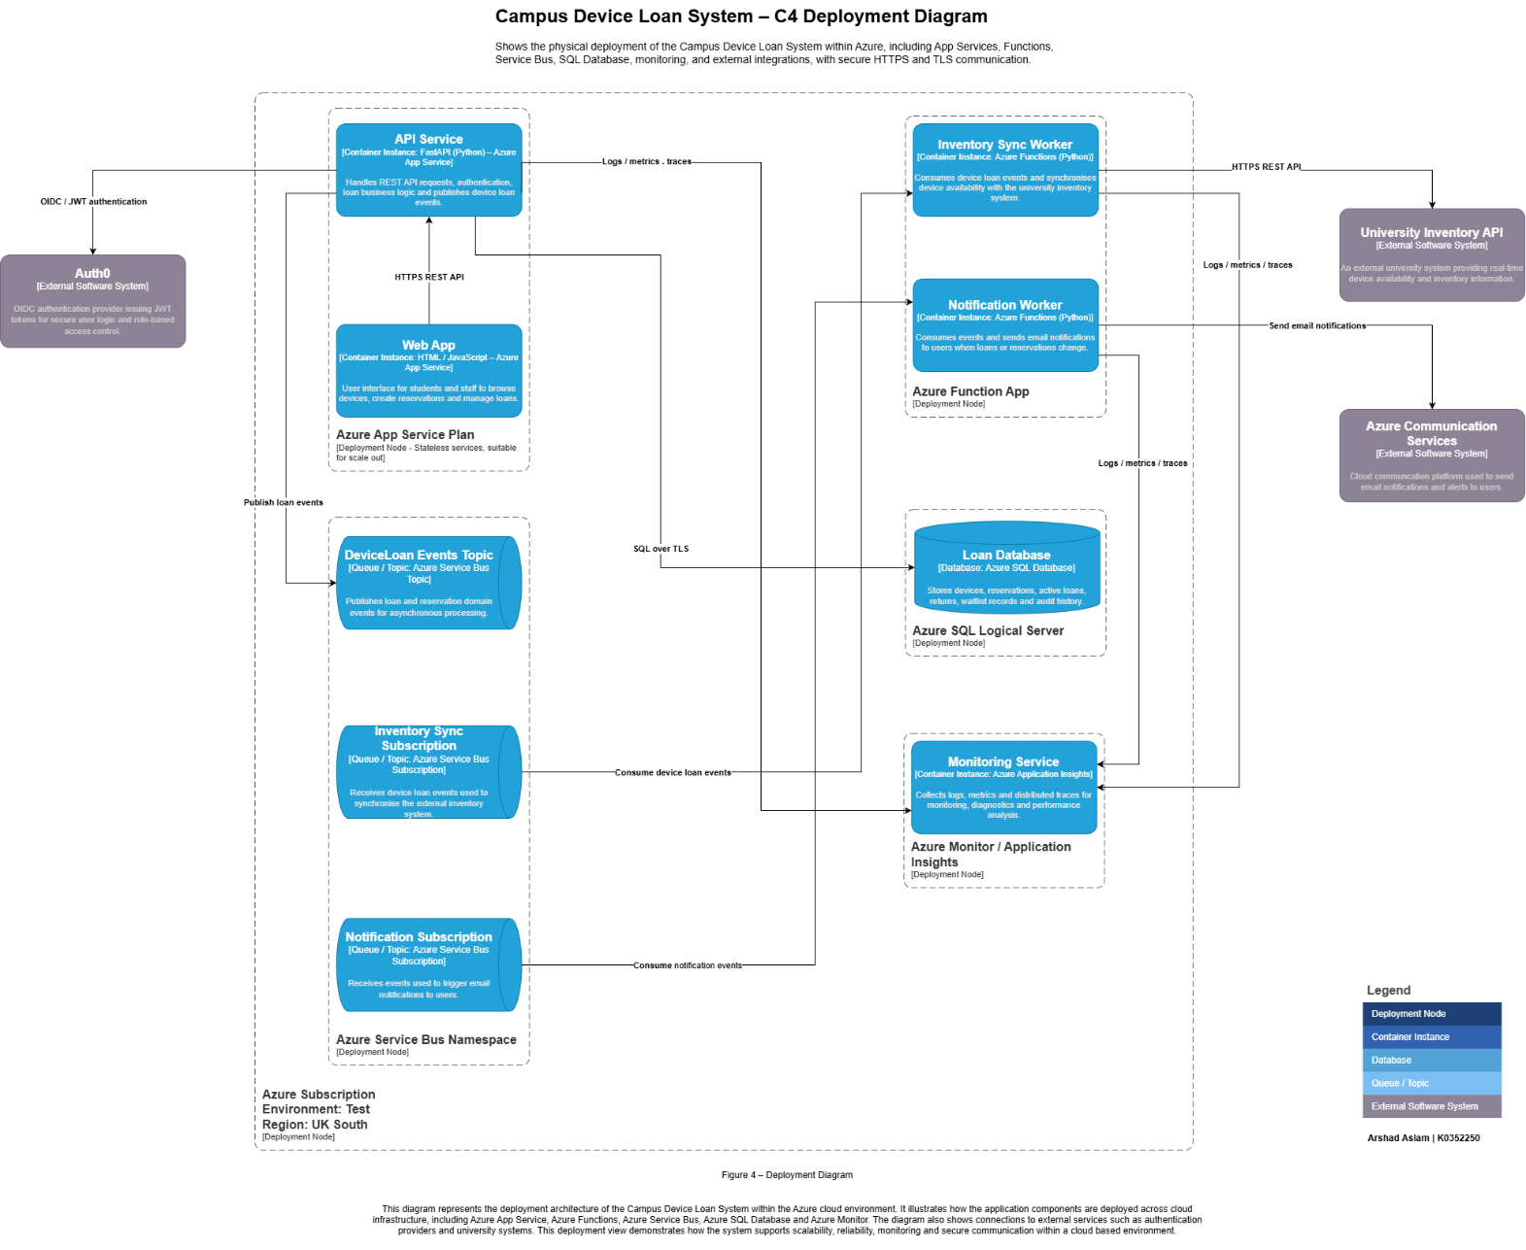
Figure 4 – Deployment diagram showing how services execute within a Node.js environment.
The deployment diagram demonstrates how services could be deployed independently in a cloud environment. This architecture aligns with cloud-native development practices, in which services are distributed across scalable infrastructure.
3. Development and DevOps Pipeline
DevOps practices were incorporated into the development workflow to improve reliability and streamline system integration. DevOps emphasises collaboration between development and operations teams while promoting automation throughout the software development lifecycle (Amazon Web Services, 2023).
The development pipeline begins with version control. All source code and configuration files were stored in a GitHub repository. Version control enables developers to track system changes, manage updates and maintain a complete history of development activity.
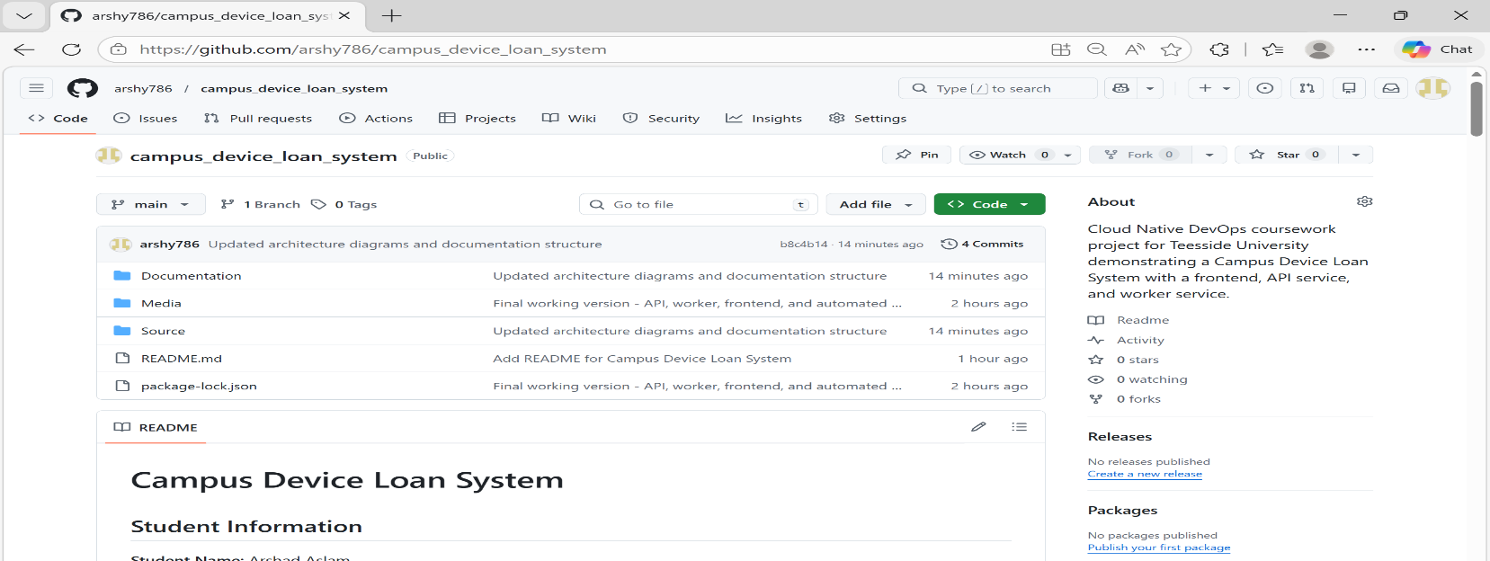
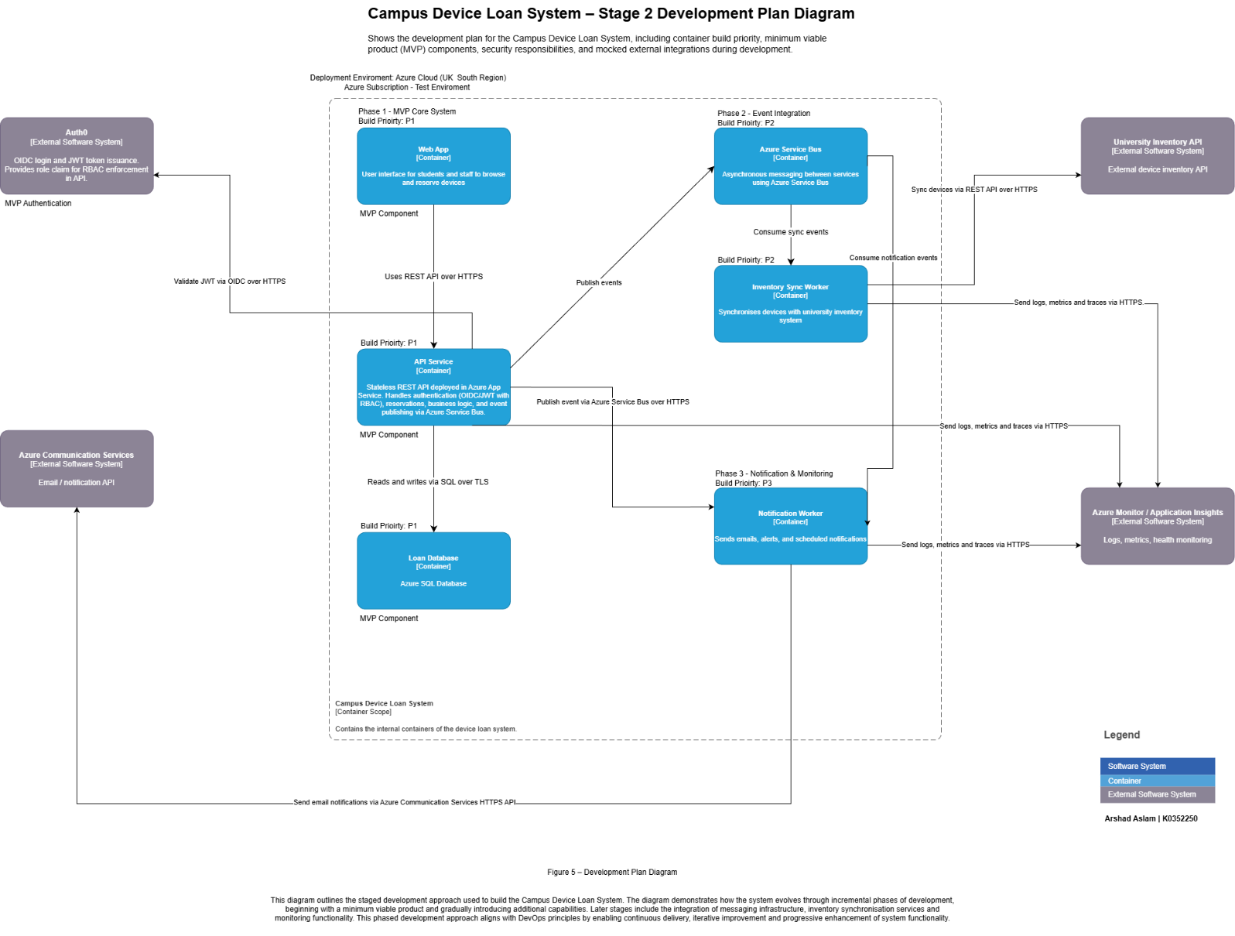
Figure 5 – DevOps pipeline architecture used during system development.
The DevOps pipeline integrates automated workflows that run whenever code is committed to the repository. These workflows install project dependencies and verify application configuration to ensure the system executes correctly.
Figure 6 – GitHub repository structure containing project source code.
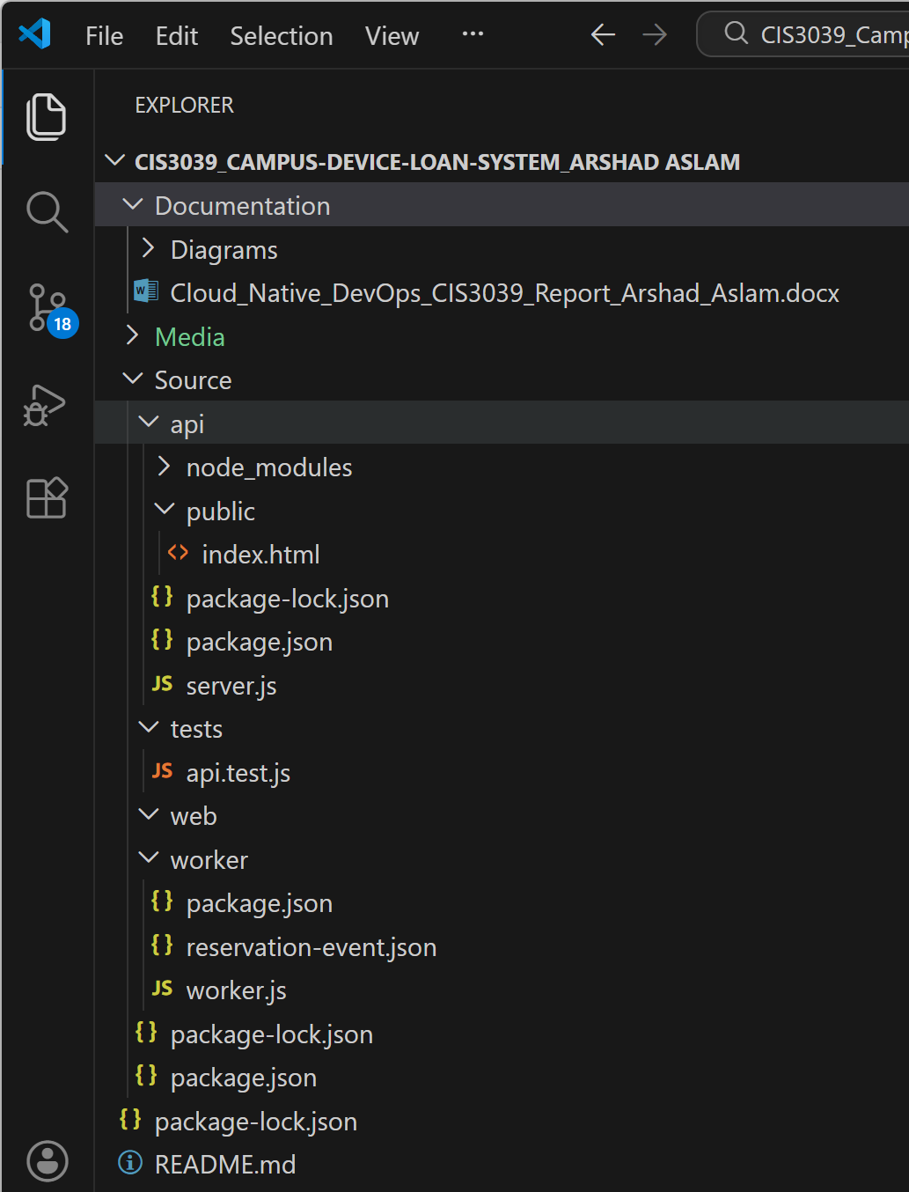
The repository structure separates different services and configuration files, making the project easier to maintain and understand.
Figure 7 – Project folder structure showing the separation of backend services.
This organised project structure supports modular development by separating the API service from the worker service and other supporting components.
4. System Implementation
The backend services were implemented using Node.js, an event-driven runtime environment designed for building scalable web applications (OpenJS Foundation, 2024). Node.js supports asynchronous processing, which allows the system to handle multiple requests efficiently.
Communication between system components adheres to REST architectural principles, enabling structured interactions among distributed services (Fielding, 2000). The API service exposes endpoints that allow the frontend interface to retrieve device information and submit reservation requests.
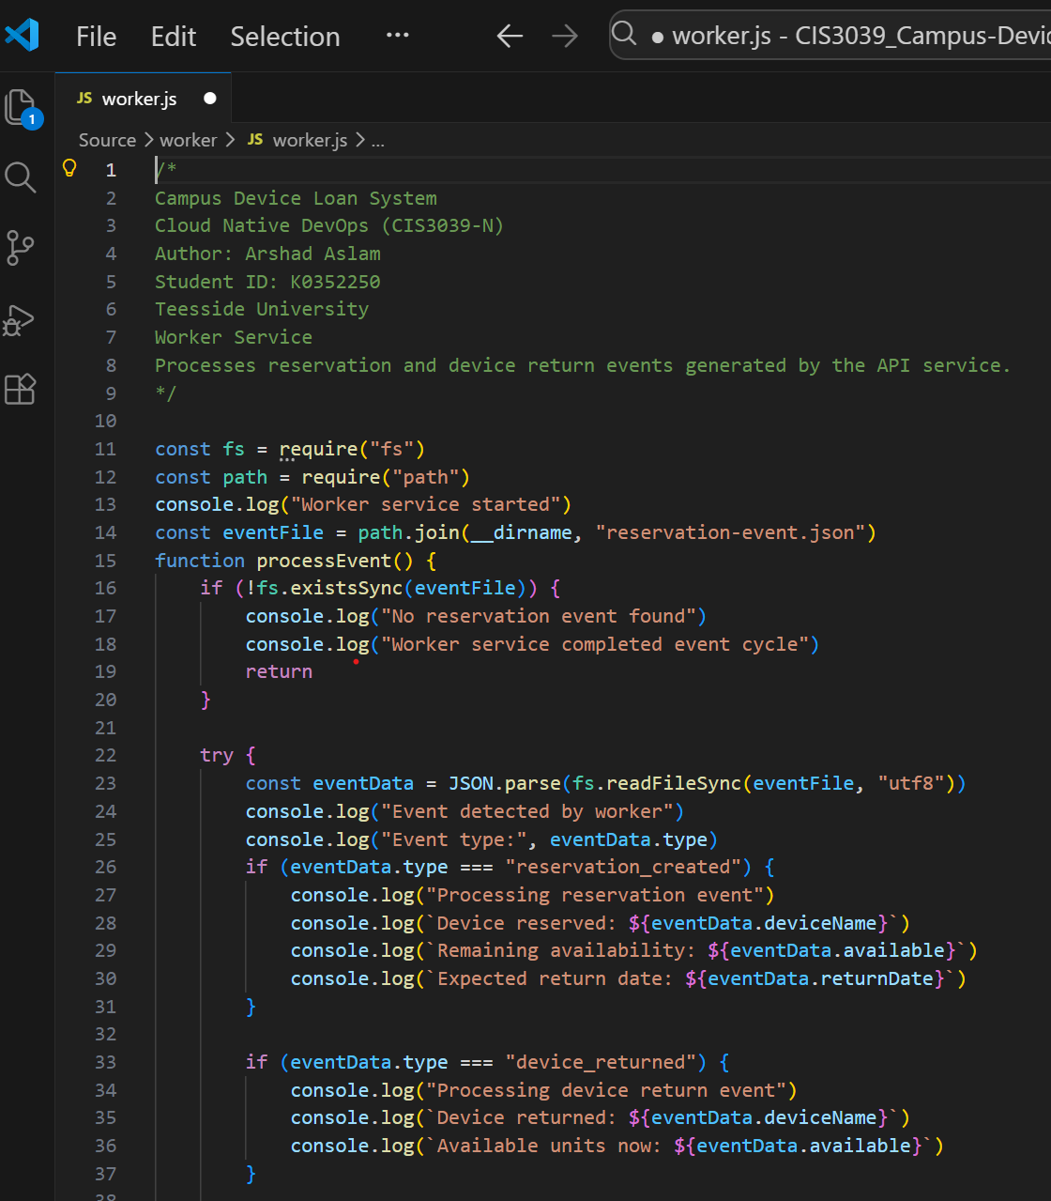
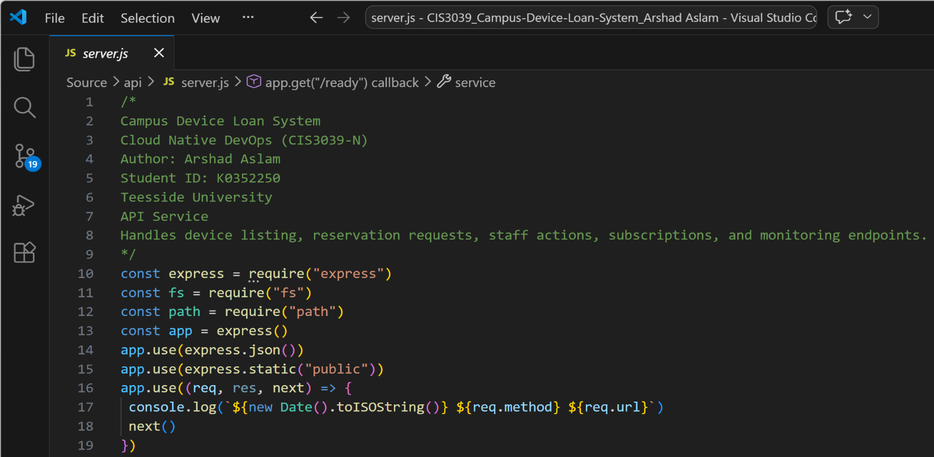
Figure 8 – Implementation of the Node.js API service.
The API service processes incoming requests from the web interface and returns responses in JSON format. It also performs validation to ensure that reservation data is processed correctly.
A worker service was implemented to handle background processing tasks.
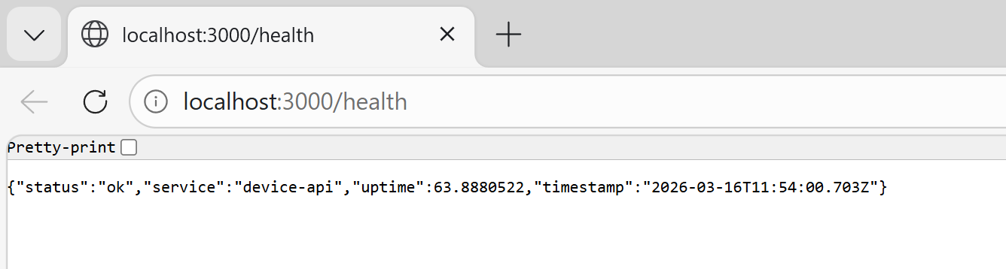
Figure 9 – Worker service responsible for background processing.
Separating background processing from the API service improves system performance by allowing the main service to focus on handling user requests.
A health endpoint was implemented to verify service availability.
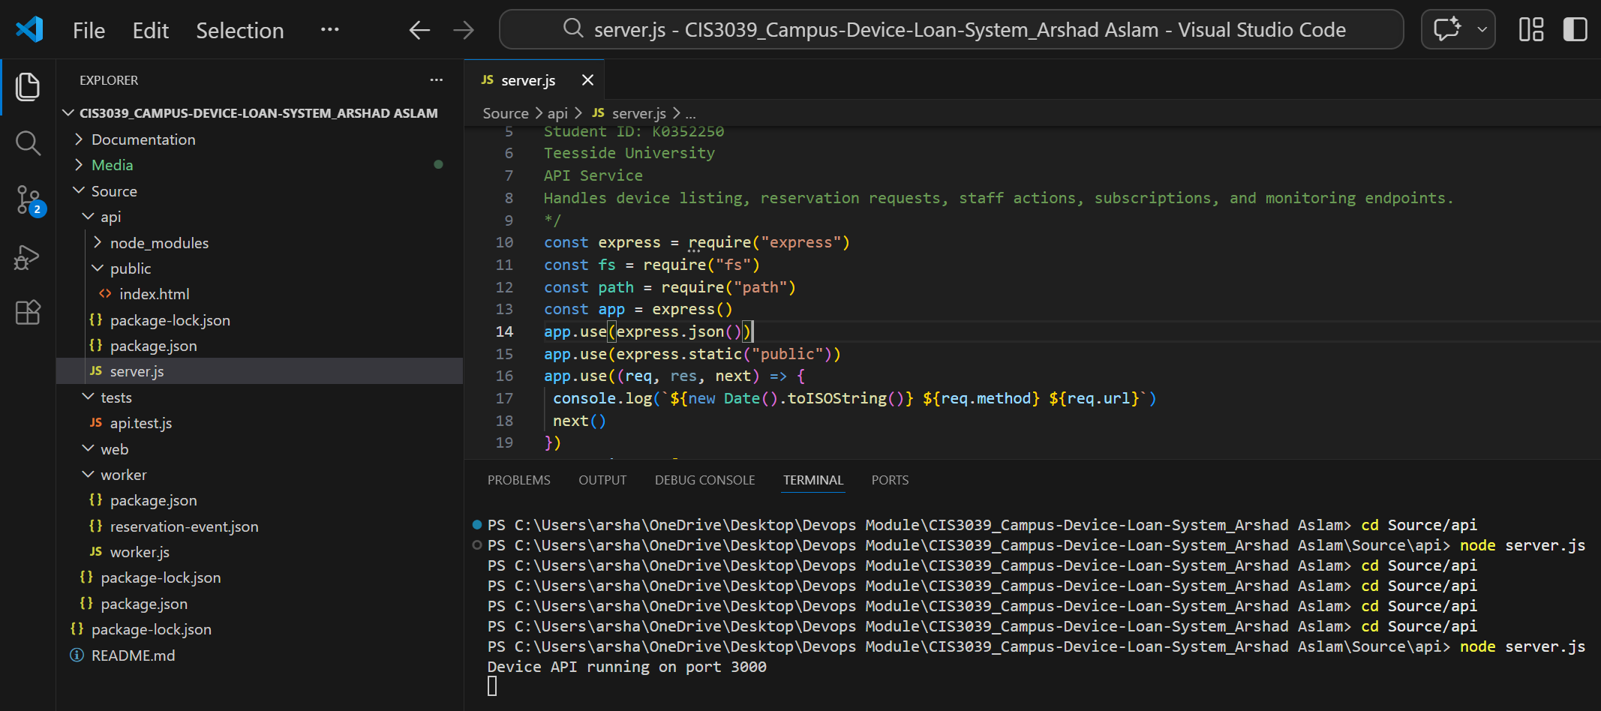
Figure 10 – API health endpoint used for monitoring service status.
Health endpoints are commonly used in distributed systems to confirm that services are operating correctly.
During development, the Node.js server was executed locally to test application functionality.
Figure 11 – Node.js server running during system testing.
The user interface allows students to browse available devices and manage reservations.
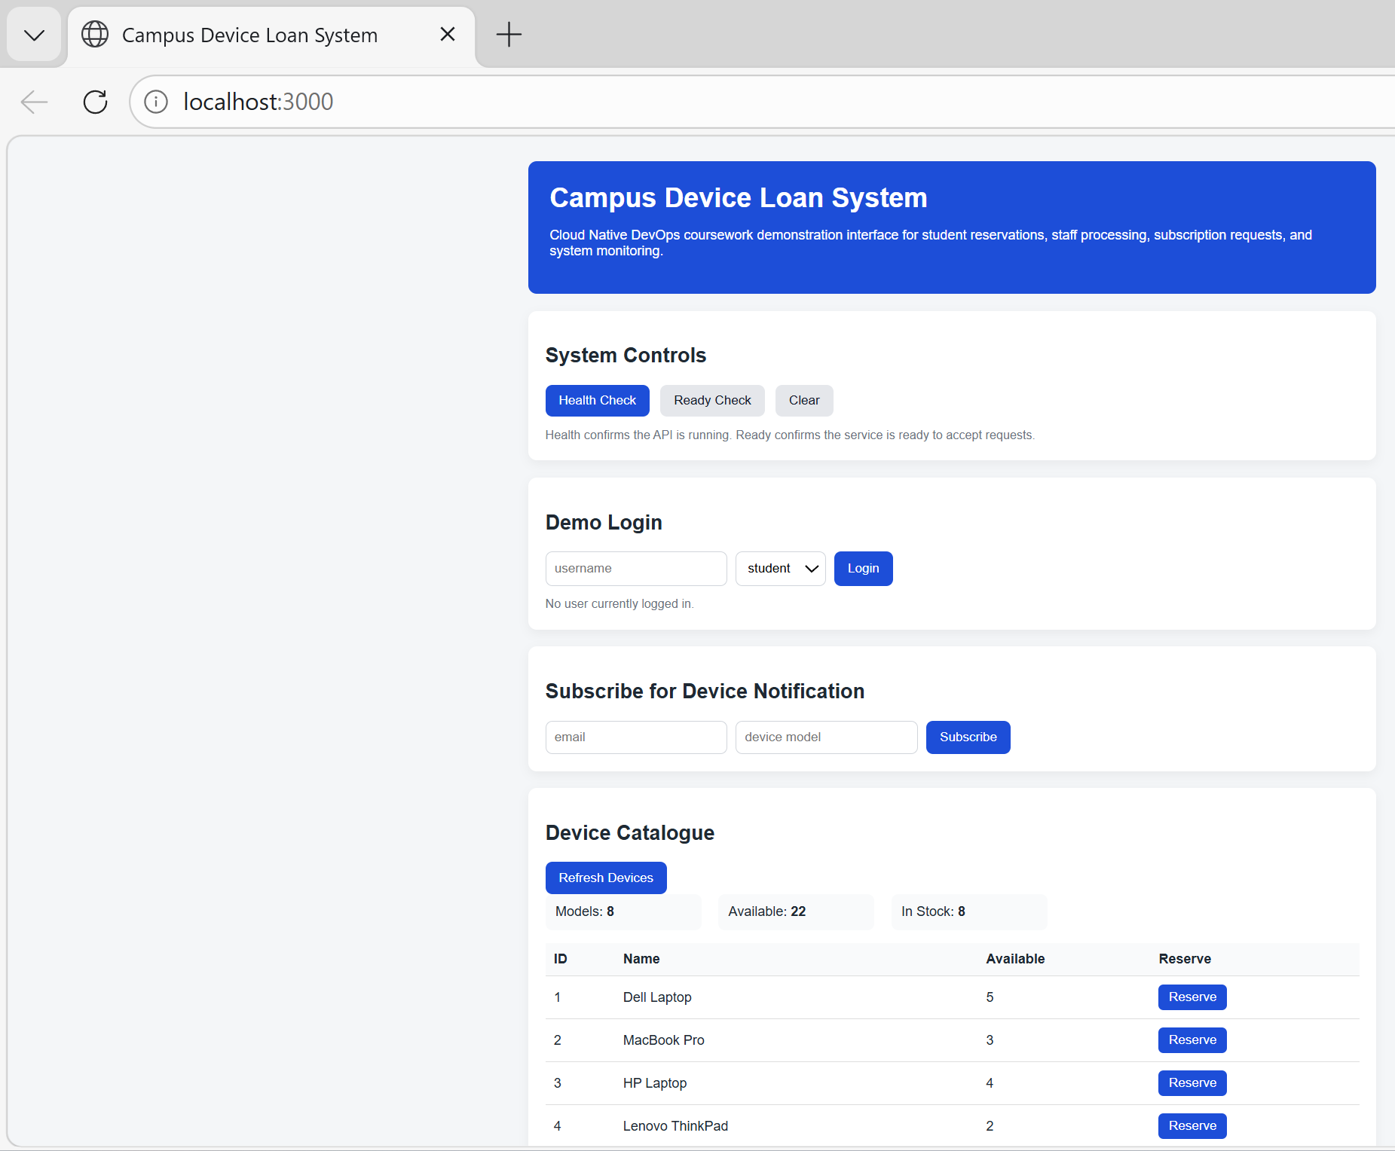
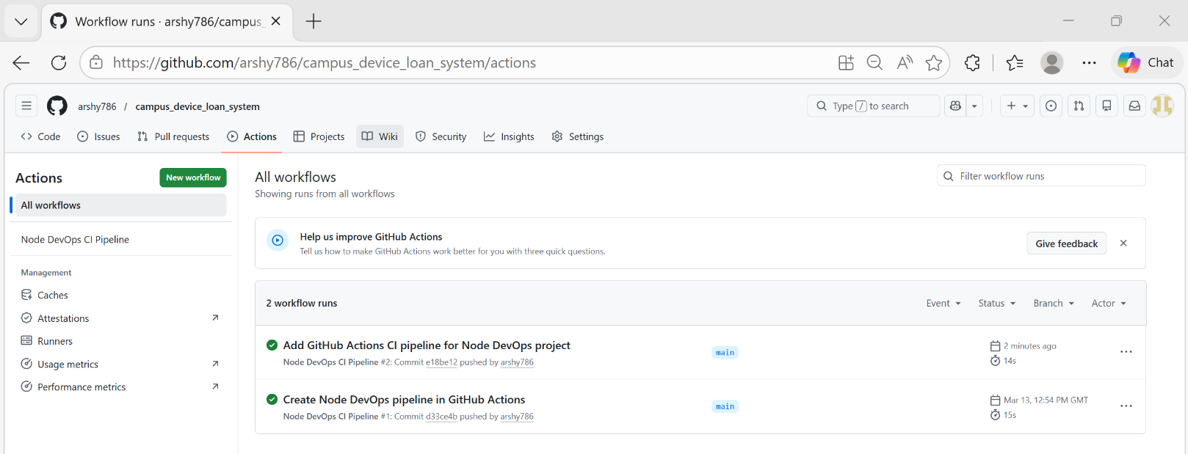
Figure 12 – Web interface of the Campus Device Loan System.
The interface communicates with the backend API using HTTP requests, allowing users to interact with system functionality.
Finally, continuous integration was implemented through GitHub Actions.
Figure 13 – Continuous integration pipeline executed using GitHub Actions.
The CI pipeline automatically verifies system configuration whenever code changes are committed. This automation reduces integration errors and ensures that the application remains functional throughout development.
5. Technology Choices and Trade-offs
The development of the Campus Device Loan System required several technology decisions that influenced how the system was designed and implemented. These decisions were made to balance simplicity, maintainability and the demonstration of DevOps practices.
Node.js was selected as the primary runtime environment for the backend services because it provides an asynchronous, event-driven model that is well-suited for lightweight API-based systems. This allows the application to handle multiple requests efficiently while keeping the implementation relatively simple. Alternative frameworks such as Spring Boot or Django offer more built-in features, particularly for large-scale enterprise systems, but they introduce additional complexity and configuration overhead. For this project, Node.js provided a more suitable balance between simplicity and functionality.
Express.js was used as the web framework to implement REST API endpoints. It offers a minimal and flexible structure, making it easier to define routes for device management, reservations and authentication. While more comprehensive frameworks exist, the lightweight nature of Express supports rapid development and improves the readability of the codebase.
Git and GitHub were used for version control and repository management. Version control is a key DevOps practice as it enables tracking of changes, collaboration and rollback of errors. GitHub was selected because it integrates seamlessly with automation tools such as GitHub Actions, making it easier to implement continuous integration.
Continuous Integration was implemented using GitHub Actions to automatically run tests when code is pushed to the repository. This ensures that the system remains stable as new changes are introduced. Alternative tools such as Jenkins or GitLab CI provide more advanced configuration options, but GitHub Actions offers a simpler setup that is well-suited for smaller projects.
The system architecture separates the API service and worker service to reflect a modular, service-based design. The API handles client interactions and device operations, while the worker service processes background events such as reservations and returns. Although this adds some complexity, it demonstrates how responsibilities can be separated in cloud-native systems to improve modularity and maintainability.
Overall, the selected technologies prioritise clarity, modularity and the demonstration of DevOps concepts rather than building a fully production-ready system.

6. System Limitations
Although the implemented system demonstrates core functionality for managing device reservations, several limitations remain. The current system operates primarily within a development environment and does not yet include full cloud deployment infrastructure.
In a production environment, services could be containerised using technologies such as Docker and deployed using orchestration platforms such as Kubernetes. These technologies would improve scalability and enable services to operate across distributed infrastructure.
Additionally, the system currently focuses on reservation functionality and does not yet implement advanced authentication mechanisms or integration with university identity services. Implementing role-based access control would improve system security and enable administrators to manage device inventories more effectively.
7. Future Improvements
The current implementation focuses on demonstrating DevOps concepts rather than delivering a fully production-ready system. As a result, several design decisions were made to keep the system simple and manageable within the scope of the project. While this supports clarity and ease of development, it also introduces limitations in areas such as scalability, security and monitoring. In a real-world deployment, additional improvements would be required to enhance authentication, introduce persistent data storage and implement more advanced deployment and monitoring strategies.

Future development of the system could focus on enhancing scalability, security and automation. Containerisation using Docker would enable consistent deployment across development and production environments. Container orchestration platforms, such as Kubernetes, could further enhance system resilience and support service scaling.
Security improvements could include implementing authentication mechanisms, such as JSON Web Tokens (JWT), to support role-based access control. This would allow different user types, such as administrators and students, to access system functionality according to their permissions.
Additionally, the CI pipeline could be expanded to include automated testing and deployment stages. This would enable continuous delivery practices where validated changes are automatically deployed to a hosting environment.
8. Conclusion
This project demonstrates the design and implementation of a cloud-native device loan management system using modern DevOps and service-oriented development practices. The architecture separates responsibilities among independent services that communicate via REST APIs, thereby improving modularity and maintainability.
The integration of version control and automated CI pipelines ensures that system changes are consistently validated during development. Combined with structured architectural modelling and modular implementation, the project illustrates how cloud-native development approaches can support scalable and maintainable software systems.
The system provides a strong foundation that could be extended into a fully deployed cloud application through additional improvements such as containerisation, authentication and automated deployment.

The design decisions made throughout this project reflect a balance between simplicity and the demonstration of DevOps practices. Technologies such as Node.js, Express and GitHub Actions enabled efficient development while supporting automated testing and continuous integration. However, these choices also introduce trade-offs. For example, the use of simplified authentication and local data handling limits the system in terms of security and scalability. Despite these limitations, the project demonstrates how modular architecture, version control and automated workflows contribute to maintainable and reliable software systems. These decisions highlight the practical considerations developers must evaluate when designing modern cloud-native applications.
9. References
Amazon Web Services (2023). What is DevOps? Available at: https://aws.amazon.com/devops/what-is-devops/ (Accessed: 10th December 2025).
Brown, S. (2018). The C4 Model for Software Architecture. Available at: https://c4model.com (Accessed: 18th September 2025).
Fielding, R. (2000). Architectural Styles and the Design of Network-Based Software Architectures. Available at: https://www.ics.uci.edu/~fielding/pubs/dissertation/top.htm (Accessed: 24th September 2025).
GitHub (2024) GitHub Actions Documentation. Available at: https://docs.github.com/en/actions (Accessed: 14th November 2025).
Microsoft (2024) Visual Studio Code Documentation. Available at: https://code.visualstudio.com/docs (Accessed: 12th October 2025).
h OpenJS Foundation (2024) Node.js Documentation. Available at: https://nodejs.org/en/docs (Accessed: 8th February 2026).
Red Hat (2023) Cloud-Native Application Architecture. Available at: https://www.redhat.com/en/topics/cloud-native-apps (Accessed: 4th March 2026

