Problem1

Done with python matplotlib, source included in the return.

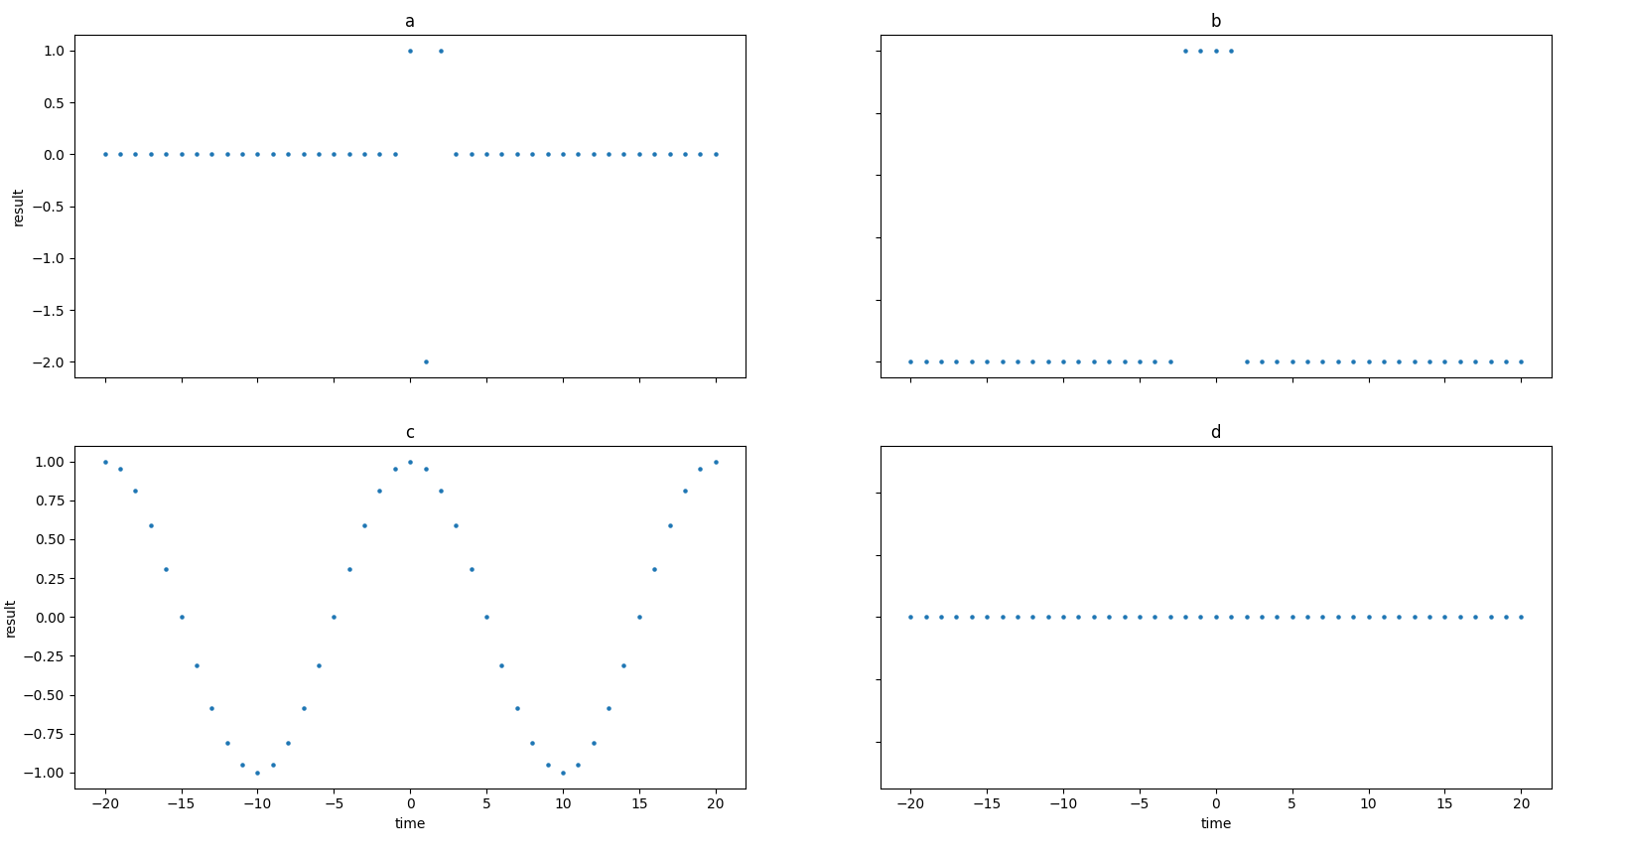

Problem2

a)

x(t)=x(t+T)

3cos((3pi/31)t) = 3cos((3pi/31)(t+T))

3cos((3pi/31)t) = 3cos((3pi/31)(t+3pi/31*T))

t = t+3pi/31*T

O = 3pi/31 * T = 2pi*k, k=N, T=R

T = 62k / 3 //

**Is periodic because it’s multiple of 2pi*k and base period is: 62 * 1 /3 = 62/3**

b)

x[n] = x[n+N] = 3 cos((3pi/31) n) = 3 cos((3pi/31) (n + N))

<=> 3 cos((3pi/31) n) = 3 cos((3pi/31)n + (3pi/31)N)

<=> 3 cos((3pi/31) n) = 3 cos((3pi/31)n + (3pi/31)N)

<=> (3pi/31)n = (3pi/31)n + (3pi/31)N

<=> (3pi/31)N = 2pi * k, N=N, k=N

N = (2pi*k) / (3pi/31)

N = 62k/3

**Is periodic, base period is 62 since this is the smallest integer value**

c)

x[n] = x[n+N] = cos((pi/2) n) + sin((pi/3) n) - 3 cos((pi/6 ) n) = cos((pi/2) (n+N)) + sin((pi/3) (n+N)) - 3 cos((pi/6 ) (n+N))

cos((pi/2) n) + sin((pi/3) n) - 3 cos((pi/6 ) n) = cos((pi/2)n + cos(pi/2)N) + sin((pi/3)n + sin((pi/3)N)) - 3 cos((pi/6)n) - 3 cos((pi/6)N)

cos(pi/2)N) + sin((pi/3)N)) - 3 cos((pi/6)N) = 2pi*k

{

(pi/2)N = 2pi*k1, k1=N

(pi/3)N = 2pi*k2, k2=N

(pi/6)N = 2pi*k3, k3=N

}

{

=> N = 4*k1

=> N = 6*k2

=> N = 12*k3

}

N is periodic with 12

so k1 = 12/4 = 3

k2 = 12/6 = 2

k3 = 12/12 = 1

**Is continuous and base period is 12**