**Infinite Cascading Lookups and Choices in SharePoint 2013**

1. Create Three SharePoint 2013 Lists with following Names
   1. Country
   2. Province (lookup in Country)
   3. City (lookup in Province)

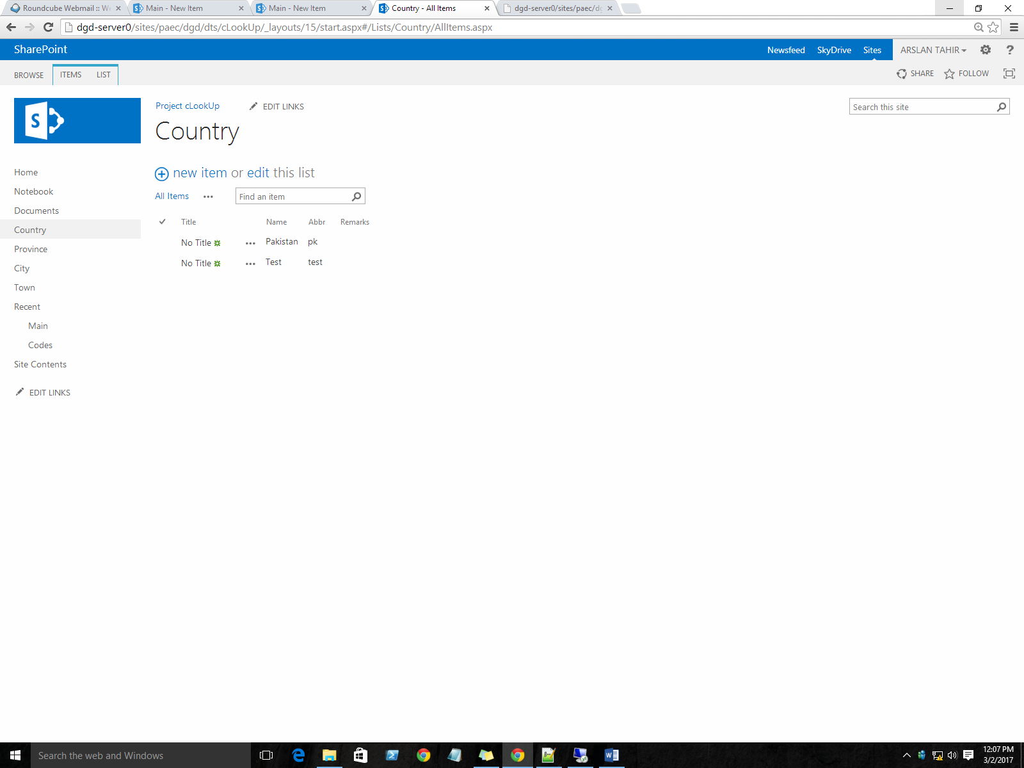

1. **Make Sure** that each list contains a column named “Name”.



1. Create cascaded lookup relationship between Country, Province and city.
   1. **Country** is lookup in **Province**
   2. **Province** is lookup in **City**
   3. And so on…………..

Use “**Name”** as return field from lookups. As shown in following list setting of “Province”. And Make Sure that Lookup column name and List names are same e.g. here in my “**Province”** list, lookup name is “**Country”** (which is also a list name).

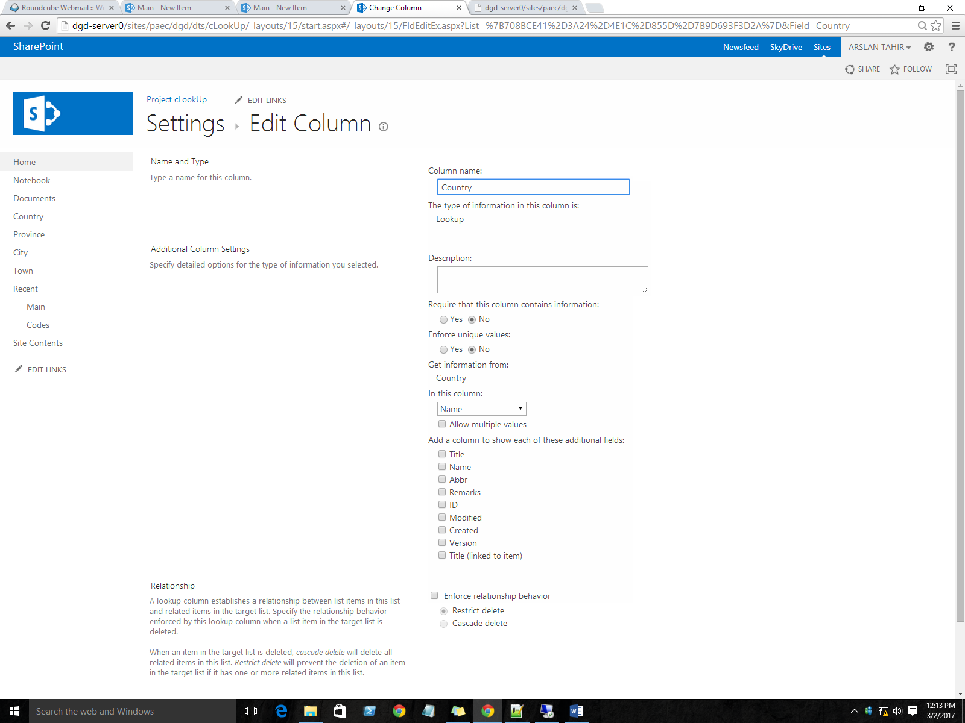

1. After Building Successful relationship between Country, Province and City; create a “**Main”** list where these cascading lookups will be used.
   1. **Make Sure** Order of Columns in Forms is same as that of relationship.

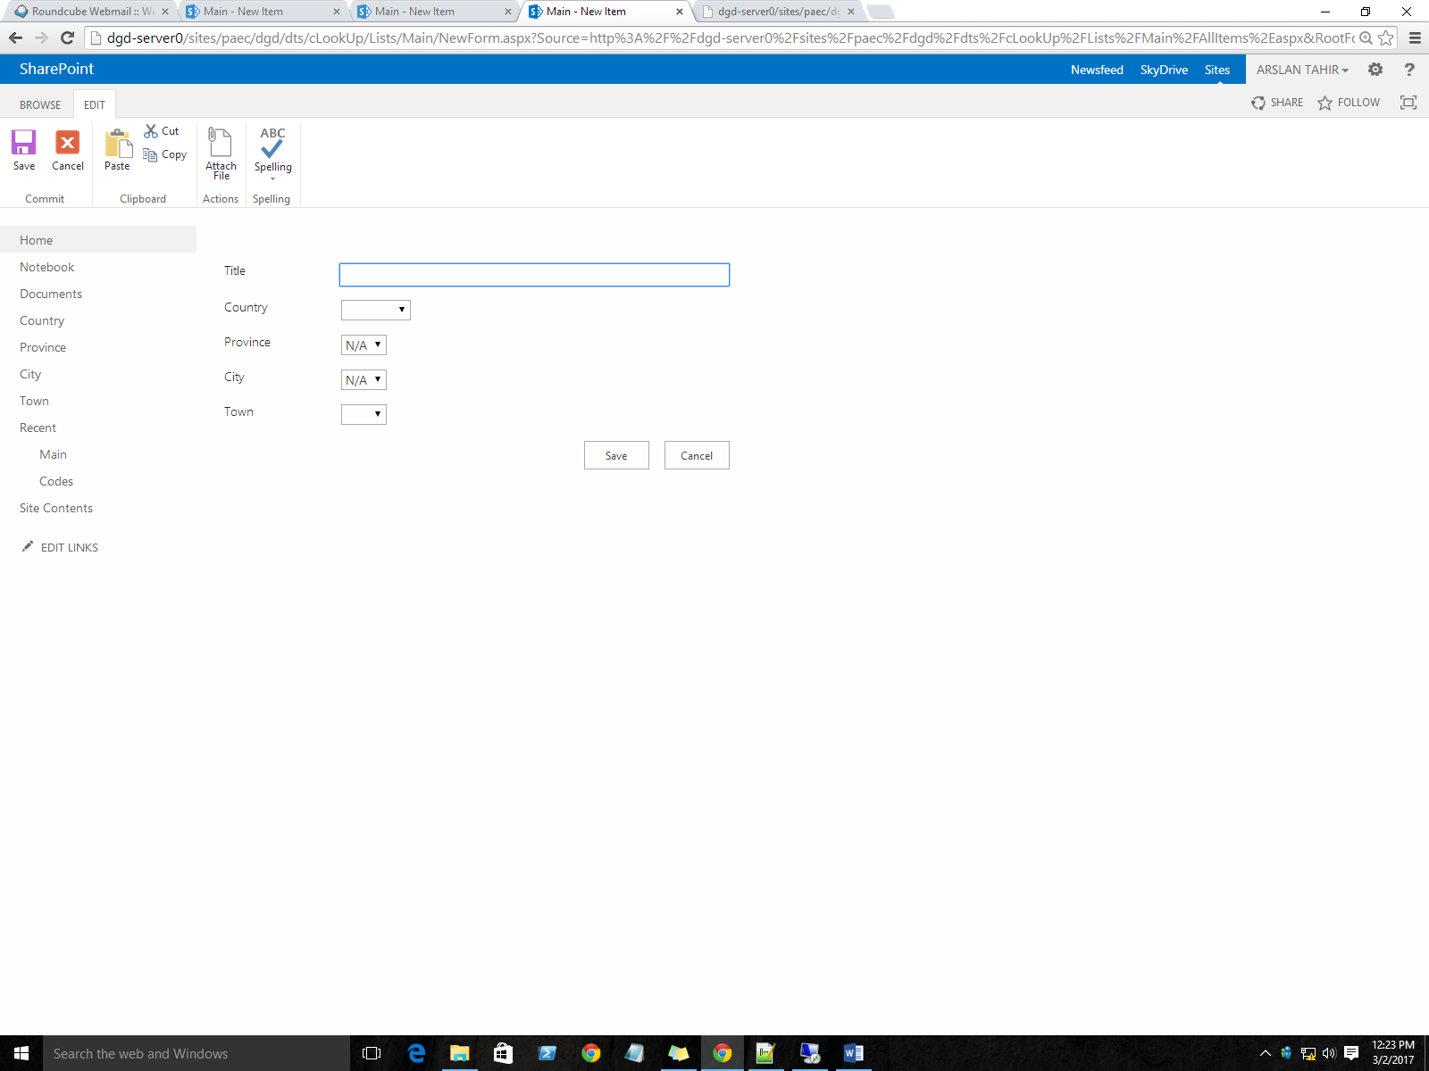

1. Create a document library named codes and upload the provided code files in this library and copy the Url of **cLookUp.html.**
   1. **NOTE**: Before uploading **cLookUp.Html** update the **src** attribute by editing it.



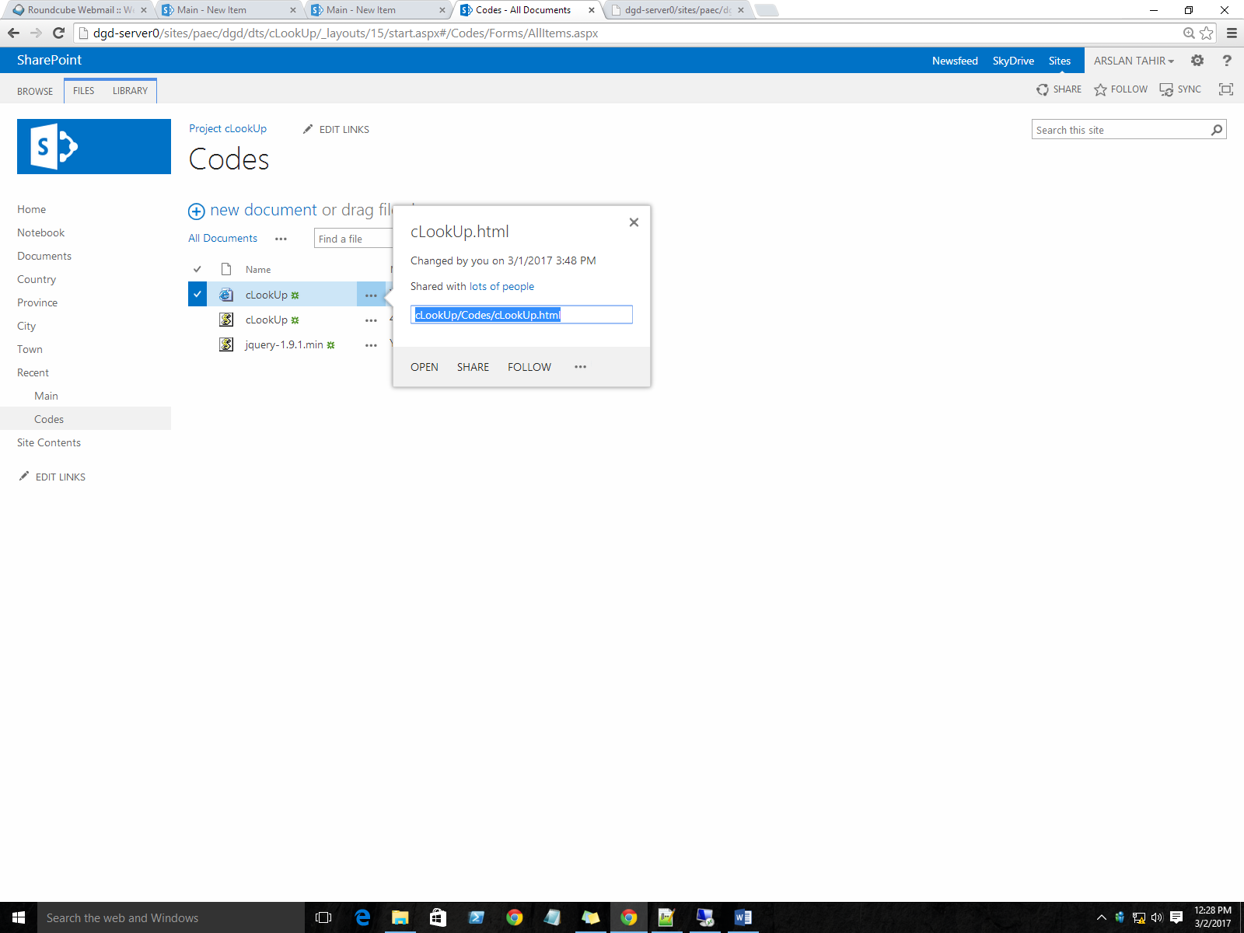

1. Goto “**Main”** List and add following **ContentEditor** webpat for both **New Item** and **Edit Item** Forms
   1. Edit Page->Add WebPart->Media and Contents->ContentEditor
   2. And paste URL(copied in previous step) in Content Link

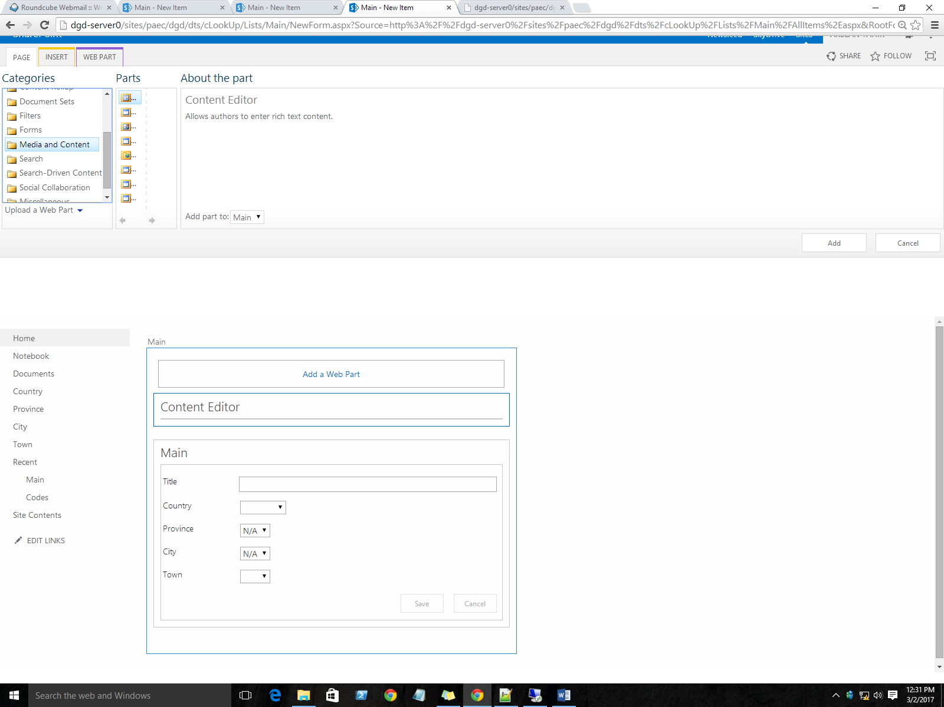

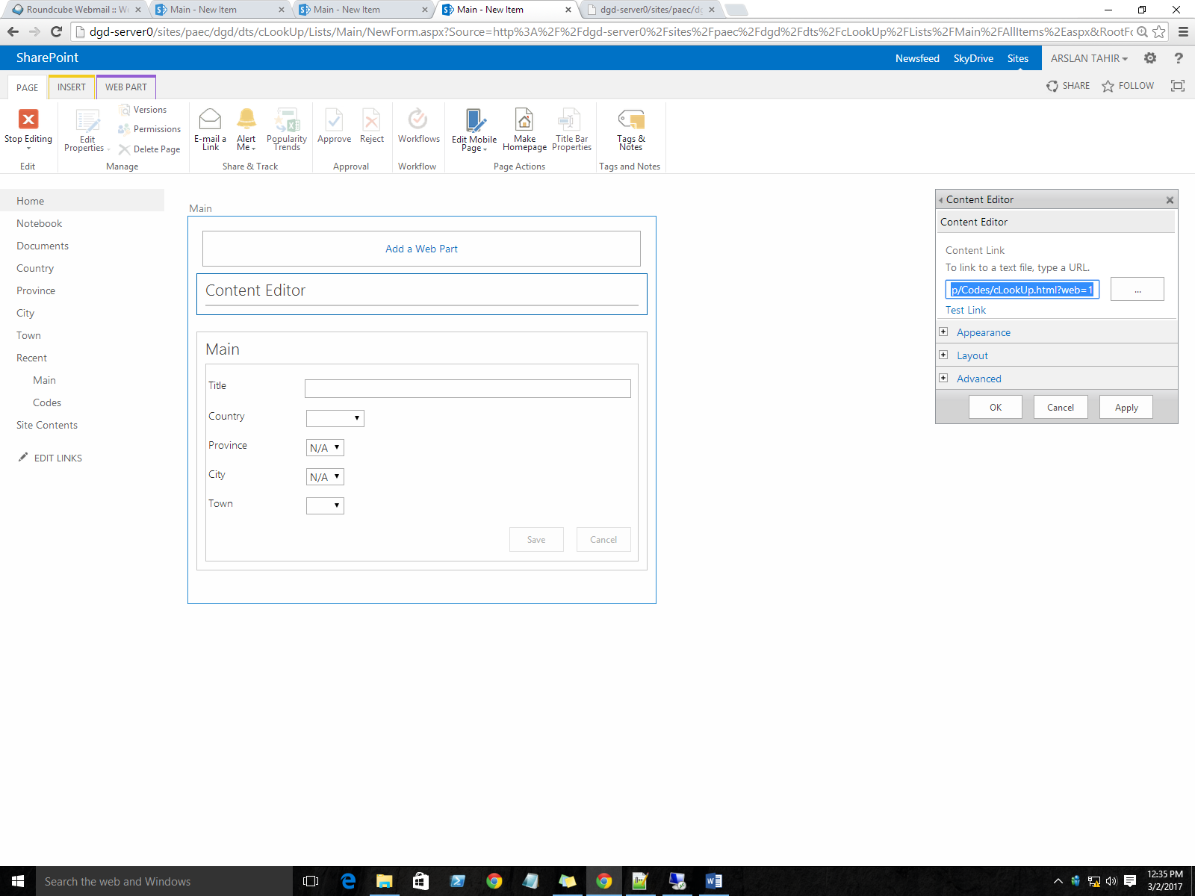

1. **TADA**……….In both NewItem and Edit Item forms you will have fully functional infinite cascaded lookups.

**Points to Reconsider**

* 1. Order of Choices columns should be the same as that of relationship.
  2. Column Name in Main List must have same name as that of LIST. .e.g. If a **column** name in main list is Country then LIST name with **Country** should also exists**.**
  3. Avoid Spaces and special characters in Column/List Names
  4. You must not change Column/List Names.