**FYP Final Report**

**Decentralized Credit Score System**



Final Year Project Report

By

**Arslan Ali**

**Muhammad Muzammil Raza**

In Partial Fulfillment

Of the Requirements for the degree

Bachelors of Science (CS/SE)

Sukkur IBA University,

Sukkur, Sindh Pakistan

(2020)

**Decentralized Credit Score System**

By

**Arslan Ali**

**Muhammad Muzammil Raza**

SUBMITTED TO THE DEPARTMENT OF COMPUTER SCIENCE IN PARTIAL FULFILLMENT OF THE REQUIREMENTS FOR THE DEGREE OF

**BACHELOR OF SCIENCE IN COMPUTERR SCIENCE / SOFTWARE ENGINEERING**

at the

SUKKUR IBA University

**Month, 2021**

**© 2021 Arslan Ali Muhammad Muzammil Raza.** All rights reserved. The author hereby grants permission to Sukkur IBA to reproduce and distribute publicly paper and electronic copies of this thesis and grant others the right to do so.

Signature of Author(s)

**Arslan Ali**

**Muhammad Muzammil Raza**

Certified by: Internal Examiner

**<Name>,<Designation>, <Department>**

External Examiner

**<Name>,<Designation>, <Department & Organization>**

Accepted by:

Dr. Ahmad Waqas,

Head Department of Computer Science

**DECLARATION**

We hereby declare that this project report entitled “Decentralized Credit Score System” submitted to the “Department of Computer Science**”**, is a record of an original work done by us under the guidance of Supervisor “Dr. Asif Raza Shah” and that no part has been plagiarized without citations. In addition, this project work is submitted in the partial fulfillment of the requirements for the degree of Bachelor of Computer Science.

|  |  |
| --- | --- |
| **Team Members** | **Signature** |
| Arslan Ali | ______________ |
| Muhammad Muzammil Raza | ______________ |
| **Supervisor:** | **Signature** |
| Dr. Asif Raza Shah | ______________ |
| **Date:** ______________ |  |
| **Place:** Sukkur IBA University |  |

**DEDICATION**

We are greatly thankful to our parents, teachers, fellow students and beloved friends for helping us through this entire journey. Without teachers’ love, prayers, support, proper guideline, direction, and without the support of fellow students and friends, this could have been never ever possible.

We dedicate my all work to my supervisors **Dr. Asif Raza Shah** who always appreciate and properly guide us to achieve the task and complete the project. We also thankful and dedicate our work to Mr. Touqeer Shah who help us and give support to complete the project.

In last we dedicate this work and give special thanks to the all the negativity for always being there with us throughout the entire bachelor program, which always encourage us to fight back and come out from our comfort zones. You made us the fighter in your every form either in a form of situations, thoughts or a human.

**ACKNOWLEDGEMENTS**

Our heartfelt thanks go to ALLAH for having given all the necessary knowledge to plan and execute this project and the curriculum. There was never a scarcity or a need. During all this research, he took control of all that might have hindered us and helped us even in our hardest moments.

we respect Professor Nisar Ahmed Siddiqui, the Vice Chancellor of the great institution, because he has pursued God 's guidance and creation and nurtured the vision of Sukkur IBA University, a great institution where we were educated to take up our destiny as a royalist and dominator. we can't ignore Computer Science Department Head Dr. Ahmed Waqas, a real gentlemen and a young leaders' mentor and the person who listens and act according to betterment for students. Never the less our all teachers who been there to motivate and guide us to achieve our goal.

**TABLE OF CONTENT**

Contents

**INTRODUCTION** 11

**INTRODUCTION** 11

1.1 Introduction 11

1.2 Project Objectives 11

1.3 Project Scope 12

1.4 Not in scope 12

**LITERATURE REVIEW** 13

**Problem definition** 15

**Methodology** 16

**Detailed design and architecture** 20

**5.1** **System archiecture** 20

**5.1.1** **Architecture Design Approach** 22

**5.1.2** **Architecture Design** 22

**5.1.3** **Subsystem Architecture** 23

**Fabric Network** 23

**5.2** **detailed system desing** 26

**IMPLEMENTATION AND testing** 31

**6.1** **Hyperledger fabric Network** 31

**6.1.1** **Fabric binaries:** 31

**6.1.2** **Docker Compose** 32

**6.1.3 Go language** 33

**6.1.4** **bash script** 36

**6.2** **Server-Side** 36

**6.2.1 npm** 37

**6.2.2** **REST architecture** 37

**6.3** **User Interface** 38

**Results and discussion** 39

**7.1** **Snap shots of system** 40

**7.1.1 Login screen** 40

**7.1.2** **Home screen** 41

**Conclusion and future work** 42

**REferences** 43

**LIST OF FIGURES**

Figure 1using Cryptogen & configtxgen 2

Figure 2run the containers 2

Figure 3 Insert Client Record 2

Figure 4 calculating the credit score 2

Figure 5REST Architecture with fabric network 2

**LIST OF TABLES**

**ABSTRACT**

In Pakistan only 49 million people are using banks’ services, and total 150 million people are unbanked meaning 75% of total population is fully deprived of banking services in Pakistan. Lending service can play an important role to lift the country’s economy and only small portion of the banked population is labeled as eligible for lending. Unfortunately, credit penetration in Pakistan is very low and only $4400 million private loans has been reported till July 2019 which is not a good figure to involve individual citizens in the economic cycle of country. We felt this chronic problem is only because of trust deficit and lack of transparent information between financial institutions and borrowers. The traditional way to evaluate the creditworthiness of an individual borrower is to make a prediction over one’s financial picture which involves income, expenditure, and credit history. In Pakistan, each bank is managing credit history of individual borrowers independently and they are not sharing the credit information with other banks because of competitive advantages. They are sharing the credit information of borrowers only with Govt. licensed credit bureau institutions to calculate the credit score. Credit scoring institutions in Pakistan (such as eCIB, DataCheck, AISL, etc.) are mostly centralized third-party systems that rely on obsolete techniques and technologies

We are going to propose a model called DCScore (decentralized credit score) system that will be composed of a decentralized identity and credit scoring system and it will be implemented by using a decentralized credit platform as a proof of concept. Our system will provide the solution of all above mentioned issues. We are going to develop a fully decentralize credit score calculating system by using permissioned Blockchain technology.

Our system will eliminate the dependency of centralized institutions (credit bureau) for credit score calculation, and it provide the secure and transparent solution to every financial institution with the feature of privacy. All lenders will be able to check the credit scores of individuals, and the complete information of individuals will be secret expect credit score. The purpose of credit score is to check the financial condition of individual that he or she either is eligible for lending or not.

***Chapter 1***

**INTRODUCTION**

## Introduction

“Credit Score” is considered very important factor for borrower while requesting for loan from any financial organization. Credit Score is numeric score which describes the credit-worthiness of individual. It also represents that borrower is risky or beneficial for that financial Institute. Our system “Decentralized credit score system” is web based application. The main motive of our system is to calculate the credit score to evaluate trustworthiness of an individual in term of returning the credit. The whole system is based on DLT (Distributed Ledger Technology) using Blockchain. There will be only two organizations which are allow to participate in our system. Both organization can add their client record, calculate the credit score, and also search the credit score on any client. Another other most important purpose of our system is to share the credit score of borrower to all organizations which are participated.

## Project Objectives

In Pakistan 75% of population are not using bank services. If we talk about the lending service, the ratio of using lending services is very low. As the research said that lending services play the big role to lift up the country’s economy. The question arises that why people are not taking benefit from the lending services? There are certain factors like trust issues between customer and Banks. And Banks also do not believe the information which they are taking from credit bureau institutes for checking the credit worthiness of his/her clients. The biggest factor of not sharing the client information is that one Bank does not share the information of his/her client to other Bank because of competitive reason. They only share information to government license credit bureau. Currently they are relying on centralized system, so the monopoly can occur while calculating the credit score. So by analysis on these problem we need a system where we can create trust between customer and Banks and it should be transparent and it will show correct credit score of customer based on his/her payment history or valid information. We also need a feature in our system where one Bank can see other Bank customer’s credit score with its permission. We need the technology where we store the data in distributed way because centralized way is not good for showing transparency in information because we do not know who change the information and also the source of information. We will use Blockchain technology to develop our “Decentralized Credit Score System”.

## Project Scope

* There should be only two banks.
* Each Bank can store their customer information and calculate credit score in decentralized system.
* Bank A cannot view the credit history of BankB’s client and similarly Bank B cannot view the credit history of Bank A client respectively.
* The only one thing they can share with each other that is general information (name, CNIC,) and “Credit Score” of customer.

## Not in scope

* No more than two banks can participate right now.
* You can’t directly communicate with other banks.
* Both bank are not setup at individual system

***Chapter 2***

**LITERATURE REVIEW**

**Overview**

In this chapter, we would start with background of project, problem statement and scope of the overall project namely “Decentralized Credit Score System”. In past 50 years we are making application by using centralized system. In centralized system we store all the data on same hardware at single system

For example, we have centralized database which has thousands of records and multiple users can access the database. So there will be have some issues like we do not know who made changes in database? Who removed or retrieve the records from the database or when?

Some data are very critical like banks customer’s data if someone hacked this type of data so it will gives big lose to the banks. So we also need the databased security plus databased status and it will create complexity and given us low performance. So we need technology who provide the solution all above problems. Blockchain is the famous technology which provide transparency, immutability and also show the status of data.

**Background**

In September of 2017 the American Credit Bureau company Equifax announced data breach where 147.9 million private recodes of Americans citizen along with 15.2 Million British citizens and about 19,000 Canadians citizen affect by this data breach. It is one the largest cybercrime of identity theft. The consequences of this data breach was very terrible, people did not trust on Equifax which is the largest credit agencies in the world.

Now credit agencies are trying to convince people to used lending services and motivate the people who are still not using bank services or unbaked. Like Bloom, MicroMoney and Pave are using blockcahin and applying different strategies to motivate people for using lending services.

Bloom provide end-to-end protocol which focus on risk assessment and credit scoring. Its aim is that to provide complete ecosystem to unbanked people so they can access credit services.

The BloomID is central to this system, allowing users to establish a "global federated identity with independent third parties who publicly vouch for their identity information and legal status." The Bloom network relies on established nodes to verify user identity information. All pre-ordained nodes are open and equally verified. So while a user could apply for credit using a set of fake information, it is extremely unlikely that it would receive confirmation.

MicroMoney differs from Bloom in that its main goal is to connect new customers to existing financial services. New customers can connect to existing businesses, or start their own using access to new lines of credit.

Pave is an existing alternative credit agency that focus on underwriting and lending to those with limited credit history. Pave has provided funds to over 1,600 individuals with limited credit history, with a focus on younger borrowers and immigrants.

We also proposed a system name as “Decentralized Credit Score System”. In this system we are using blockchain to developed this system. The main functionality of this system is that it is decentralized system where each bank can store their customer’s private information in a distributed way and there is no chance for breach or hacked the data. It’s also calculate the credit score automatically by taking different parameter from customer and calculate the credit score. One bank can only see the credit score of other Bank’s customer. So it will help to detect the defaulter who is applying for loan in other bank.

The scope of the project is that we create two banks and each bank will have two users like user1, user2 from Bank A and Bank B. Each Bank can store their customer information and calculate credit score in decentralized system. Where Bank A cannot view the information of Bank B and respectively Bank B cannot view the information of Bank A. The only one thing they can share with each other, which is “Credit Score” of customer.

***Chapter 3***

**Problem definition**

Suppose a person is requesting for loan/credit card to financial institute. Then how a bank validates the person’s will in term of returning the amount. It might be, already the person is availing the loan facility in another bank and failed to return the credit. In Pakistan, banks/financial institutions are not willing to share the sensitive data with another banks because of security and nature of data. In this case how an individual bank will measure the creditworthiness of person who is requesting. By resolving this problem, the third party is managing the individual’s credit history from its financial institute members which is known as credit bureau institutions. Currently in Pakistan credit bureau institutions are (such as eCIB, DataCheck, AISL, etc.) calculate the “credit score” on behalf of individual’s credit history, income, expenditure. Financial institute are sharing the credit information of borrowers only with Govt. licensed credit bureau institutions to calculate the credit score.it means the credit bureau institution is only one way to calculate the individual’s credit score.

Credit bureau institution stores the sensitive data in centralized system which leads to security issue and every financial institute is dependent on it. Centralized Systems that rely on obsolete techniques. What if, the credit bureau provides the inaccurate information. How We can validate, because the data is not transparent. Having in very few in number, they are playing monopoly role. Therefore, the existing system does not meet with the level of user’s satisfaction. We are going to develop a decentralize credit score calculating system, that will solve the above-mentioned problems

***Chapter 4***

**Methodology**

2.1. Overview

In this chapter, we will discuss the design, workflow and methodology relevant to the ‘Decentralized Credit Score System’. It investigates the approaches, procedures, concepts, theories and techniques relevant to this project. Some of the questions briefly explained in this chapter are:

1. What methods are used while development of DCScore System?

2. What inspection techniques are applied when system has been developed?

3. What tools and techniques are used, in designing and development of the

system?

2.2. Study Design

2.2.1 Product Design Phases

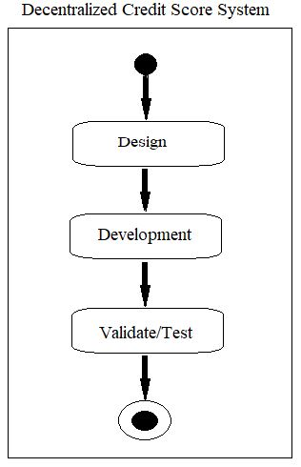

2.3. Agile Methodology

Agile is the ability to create and respond to change. It is an iterative approach and a way of dealing and succeeding in an uncertain environment. Agile methodology for the development of this system, Decentralized Credit Score System, is picked because we needed the rapid development of this project in the limited given time. That’s why this methodology deemed suitable, feasible and greatly served the purpose. While followings are some of the main features of this methodology which best fits as per our requirements to build DCScore System:

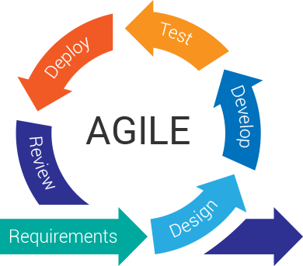

* Incremental Delivery (as this software was to be developed with multiple iterations and having green signal on current iteration is utmost necessity to move onto the next iteration)
* Maintain Simplicity
* Development according to user easiness

2.1.1. Design

We have designed our project using StarUML which is a highly sophisticated software modeler aimed to support agile and concise development which is what we needed [ 5]. We have made the use of domain model, use cases, and sequence diagram because of their

significance in making our path clear in the development phases. These type of diagrams are widely used and help model requirements accurately. However, main activities of this project are described in Chapter 4.

2.3.1.1. Techniques

* Use Case Model
* Sequence Diagram
* Domain Model

2.3.1.2. Procedure

The procedure starts with the design of the system initially by sketching on the paper. While for physical and abstract design, we used StartUML software which is great tool in this regard. Furthermore, we used Hyperledger Fabric framework along with curl, Docker engine, Docker compose, Go, Node JS SDK, Composer CLI and python for the development of the system, DCScore.

2.1.2. Development

The development of DCScore System contains the following screens and is designed using the mentioned language/editor.

2.3.2.1. Tools/Languages and Editor

* Star UML for modeling
* Hyperledger Fabric Framework, curl, Docker engine, Docker composer, Go, Node JS SDK, Composer CLI and python
* However, Atom and VS code editors are used.

2.1.1. Inspection

Inspection is minutely on every given functional requirement. With testing and inspection, we become able to know if the system is performing as per the requirements and generates desirable output at specified input. Wherefore, some of the important techniques are as following:

2.3.3.1. Manual inspection

Manual inspection is performed against each and every functional requirement. We are able to meet every functional requirement at satisfactory level which is dually checked and verified by the respective supervisor, and other core users.

***Chapter 5***

**Detailed design and architecture**

* 1. **System archiecture**

Decentralized credit score system is based own blockchain technology. In this technology, it will store the data in distributed form and used key-value pair structure to get or set the data. The main components of this technology is smart contract, consensus algorithm and nodes. In smart contract we define the rule and the business logic and it is also process input data and provide based on defining rules and business logic in the smart contract. The transparency of data sustains by consensus algorithm. Node are any type of computer (like laptop, servers etc.) which form the infrastructure of blockchain. All nodes are connected to each other and they constantly exchange the latest blockchain data with each other so all nodes stay up to date. It is the brief overview about of blockchain technology.

Now I will tell you why I choose this technology in over decentralized credit score system. Because It is banking side application and it will store the sensitive data of their customers. So maintain the transparency and existence of sensitive data we used blockchain technology.

Now, I will like to tell you about brief introduction of our systems architecture and its component. The first step is user identification and authentication. So we making login screen which check user credentials and allow him to use our decentralized application. Now user enter their client information and this information will be store in ledger in the form of key value pair. After saving the client information the system will create the transaction proposal and send it to the blockchain network. The endorsement peer in the blockchain network receive the transaction proposal and send it to the smart contract. Smart contract will reject or accept the transactional proposal based on defining rules and business logic in the smart contract. After accepting the transaction proposal, the smart contract endorsing the node and calculate the hash. Now system will save and commit the transaction on the ledger. After save and commit, system will update all the ledger and display the credit score after the calculation.

**Decentralized Credit Score Systems**

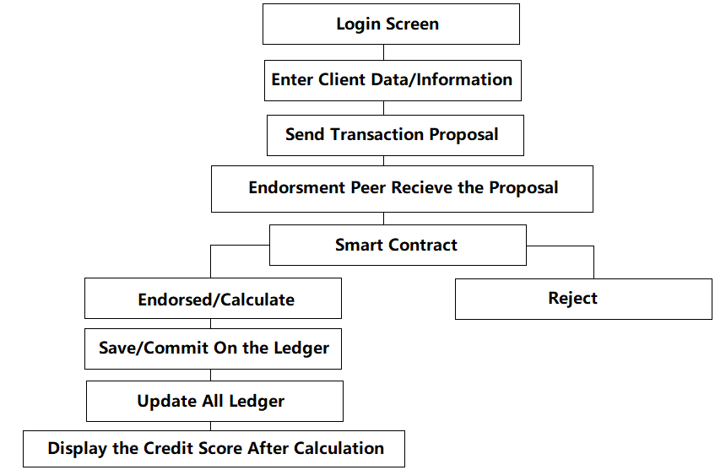

System Architecture Decentralized Credit Score Systems

* + 1. **Architecture Design Approach**

The design approach on which our system is based, is client-server architecture. Client-Server Architecture is an architecture in which much of the tools and facilities to be utilized by application are stored, distributed and handled on the cloud. The design of this sort is linked by a network or Internet by one or more client computers to a system.

* + 1. **Architecture Design**

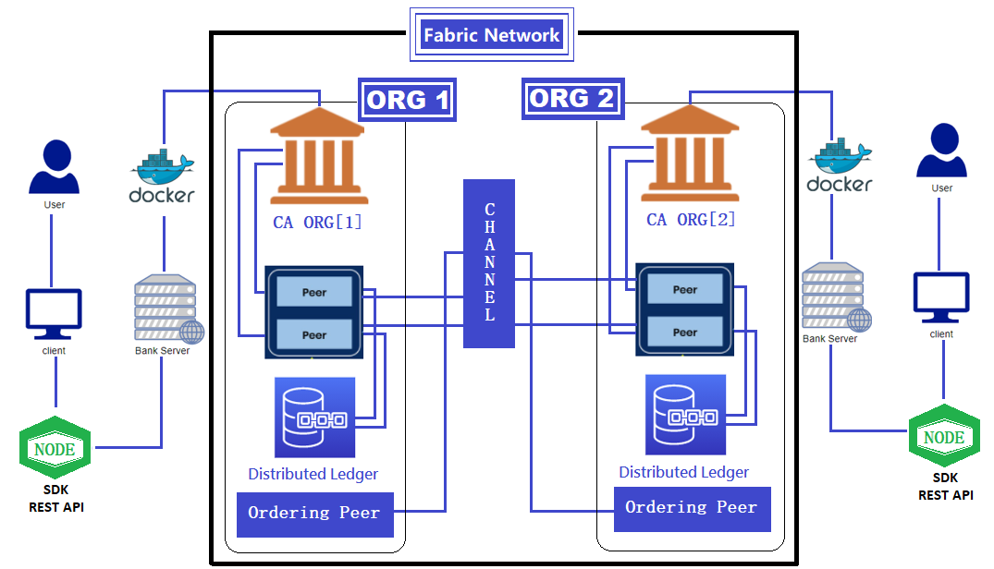

This is the overall architecture design of the project. It consists of main three parts along with multiple subparts which are working together to give desired output.

We can see that, Organization one and organization two are connected to the fabric network. They are communicating to each other by using channel which is the part of fabric network. The design approach we used is not much complex. The authenticate user of an organization use the application and the Node SDK and Rest API connect to the web server of an organization. The web server connects to the docker and the docker also further connected to the fabric network. The fabric network also has some components like certificate authority (CA), peer, ordering peer, chaincode, ledger and the channel. The certificate authority assign certificate to the peer node.

Peers are a fundamental element of the network because they host ledgers and smart contracts. Recall that a ledger immutably records all the transactions generated by smart contracts. Smart contracts and ledgers are used to encapsulate the shared processes and shared information in a network, respectively.

Because a peer is a host for ledgers and chaincodes, applications and administrators must interact with a peer if they want to access these resources. That’s why peers are considered the most fundamental building blocks of a Fabric network. Application clients submit transactions containing endorsed transaction proposal responses to an ordering service node. The ordering service creates blocks of transactions which will ultimately be distributed to all peers on the channel for final validation and commit. After the final validation and commit the user can see the credit score.

* + 1. **Subsystem Architecture**

**Fabric Network**

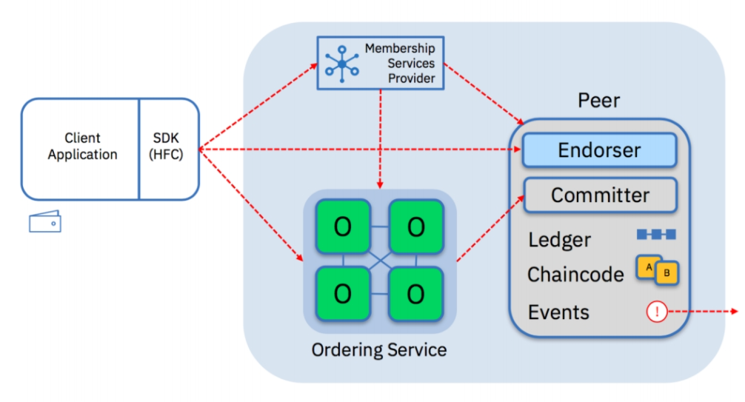

It is a simple subsystem architecture which tell us how the client application interacts with fabric network and how the transaction will process and update on a ledger.

Committing Peer, which supports the local version of the registry, records transactions and updates data in the registry. In this node, you can optionally install smart contracts.

Endorsing Peer, which is involved in deciding on the execution of a transaction. In this node, smart contracts are required.

Ordering Nodes, which form transaction blocks for adding them to the registry. They provide communication channels between other peers in the network.

**Membership Service Provider (MSP)**

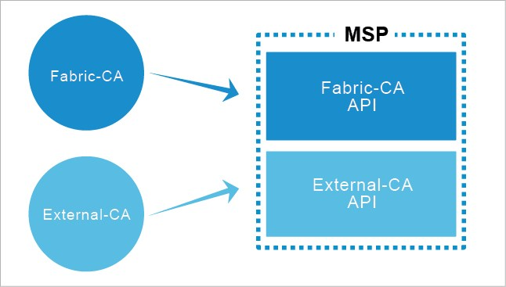

An MSP mange a set of identities within a distributed fabric network.

It provides identity for the following components of fabric network:

* Peers and orderers
* Client application
* Administrator

Identity can be issued by Fabric CA or External CA.

The MSP provides authentication, validation, signing and issuance.

It also supports different crypto standers with a pluggable interface.

The fabric network can include multiple MSPs (typically one MSP for organization). Include with Transport Layer Security (TLS) crypto material for secure communication.

**Transaction endorsement**

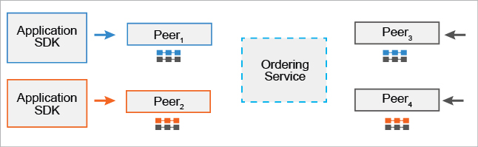

A transaction endorsement is a signed response to the results of the simulated transaction. The method of transaction endorsements depends on the endorsement policy, which is specified when the chaincode is deployed. An example of an endorsement policy would be something like, “The majority of the endorsing peers must endorse the transaction.” Since an endorsement policy is specified for a specific chaincode, different channels can have different endorsement policies.

**Smart contracts**



Smart contracts are computer programs that contain logic to execute transactions and modify the state of the assets stored within the ledger. Hyperledger Fabric’s smart contracts are called chaincode. The chaincode serves as the business logic for a Hyperledger Fabric network, in that it directs how you manipulate assets within the network.

Chaincode is a program, written in Go, node.js, or Java that implements a prescribed interface. Chaincode runs in a secured Docker container isolated from the endorsing peer process. Chaincode initializes and manages ledger state through transactions submitted by applications.

* 1. **detailed system desing**

**Client application**

* + 1. **Classification**

The client application is the module of decentralized credit score system.as a subsystem.

* + 1. **Definition**

This module is a web interface module through which user will interact.

* + 1. **Responsibilities**

This module will be first responsible for user authentication, secondly, will be responsible for make transaction and fabric network. After processes the transaction, dapp will provide desire output and update data in distributed ledger.

* + 1. **Constraints**

There is some constraint with this module

* The user machine should have 8 GB RAM plus Linux operating system
* It also needs internet connectivity to connect with the network
* Authenticate user can login in the client app
* If user want to see the credit score, then user should send the transaction
* When system validate the traction now user can only see the credit score
  + 1. **Composition**

There are three sub components of this module such as web server, docker container and the fabric network camera.

* + 1. **Uses/Interactions**

This module will be interacted with three other modules such as web server, docker container and fabric network.

* + 1. **Resources**

This module requires resources from the Linux machine and all the software should be installed to run the application. They should have a web server where client can use dapp.

* + 1. **Processing**

The first task that system is going to perform is authentication of user and after completion of this task user will be able to perform his primary task like make transaction to check credit score then user send transaction to the peer node. Now smart contract will accept or reject the transaction and display credit score to the user if transaction is successful accepted and system will commit or update all distributed ledger.

**5.2.9 Interface/Exports**

The data will be store in the form of key-value pair. The system provide exception if user not provide right authenticate credential to the system then system will generate the message to provide right credential. If transaction is rejected by system, then system will not be stop and display the message about transaction rejection.

The precise definition or declaration of each such element which are using in the system both abstractly or visually.

**Anchor Peer**

This gets used for communications between organizations. It makes peers in different organizations aware of each other.

**Blocks**

Consist of a header, block data (transactions) and block metadata (information about nodes involved with creating the block).

**Certificate Authorities**

Everyone who wants to interact with the networks needs an identity. The CA provides the means for each actor to have a verifiable digital identity. Hyperledger Fabric has a built in CA component for use in the blockchain network.

**Chaincode**

The Hyperledger Fabric term for a smart contract. Note that chaincode does not have to be installed on every peer in a channel.

**Channel**

A channel allows a group of participants to create a separate ledger of transactions. The transactions are only visible to the members of the channel.

**Channel Configuration**

Rules that govern the channel, the channel is governed by the channel members. The channel configuration is separate from the network configuration.

**Consortium**

A group of organizations that share a need to transact.

**Committing Peer**

Every peer in the channel.

**Endorsing Peer**

Every peer that has the smart contract installed can be an endorsing peer.

**Endorsement Policy**

The rules for which organizations much approve a transaction before the other organizations will accept a copy. This is specific to the chaincode.

**Leader Peer**

An organization can have multiple peers in a channel. Only one peer from the organization needs to receive the transactions. The leader distributes transactions from the orderers.

**Membership Service Provider**

Is a trusted authority.

The MSP identifies which Root Certificate Authorities (CA) and Intermediate CA’s are trusted by the network. The MSP identifies what roles different actors in an organization can play in the network. Nodes join the network through a Membership Service Provider.

**Ledger**

This is an append only file while can be used to recreate the world state.

**Ordering Nodes**

Is like a network administration point. The ordering nodes support the application channels for ordering transactions into blocks.

**Peer Nodes**

Each peer maintains a copy of the ledger for each channel it is a member of.

**Policies**

These determine who has control over the network configuration.

**Private Data Collection**

This is used for keeping the data in a transaction confidential. The data is stored in a private database that is separated from the channel ledger.

**Public Key Infrastructure**

This provides secure communication in a network. CAs issue digital certificates that get used to authenticate messages in the network. The PKI provides a list of identities and the MSP says which of them are part of an organization.

**System Chaincode**

Is code that defines operating parameters for the entire channel.

Lifecycle and configuration system chaincode defines the rules for the channel. Endorsement and validation system chaincode defines the requirements for endorsing and validating transactions.

**World State**

A database that holds current values of a set of ledger states.

***Chapter 6***

**IMPLEMENTATION AND testing**

Our project “Decentralized credit score system” is web based application. Our system is consists of two organizations. The whole project is mode up multiple components but at the high level components are (1) Hyperledger fabric framework, (2) server side, (3) client and further more component are mentioned below

* 1. **Hyperledger fabric Network**

Hyperledger fabric framework comes under the umbrella of Hyperledger, hosted by Linux foundation .Hyperledger fabric is distributed ledger technology that develop to solve the enterprises problems. Fabric architecture delivers scalability, flexibility, resiliency, and high degrees of confidentiality. It’s designed to support pluggable implementations of different components to solve the different level of problem.

**6.1.1 Fabric binaries:**

Hyperledger fabric binaries are tools which are used to develop the architecture of organizations admin, and users and credentials as well. We use different binaries tools for different sort of operation. Fabric binaries contains.

* 1. **Cryptogen**:Cryptogen tool is used generate the crypto material for organizations.
  2. **Configtxgen**:configtxgen tool is used to create channel configuration artifacts, and other like genesis block, anchor peer.
  3. **Peer** : peer binary is used to create peers to communicate within the organization

And with other organizations

* 1. **Orderer** : order binary tool is used to put the transactions in ordering way
  2. **Fabric-ca-client**: this binary tool is used to fabric CA and users.

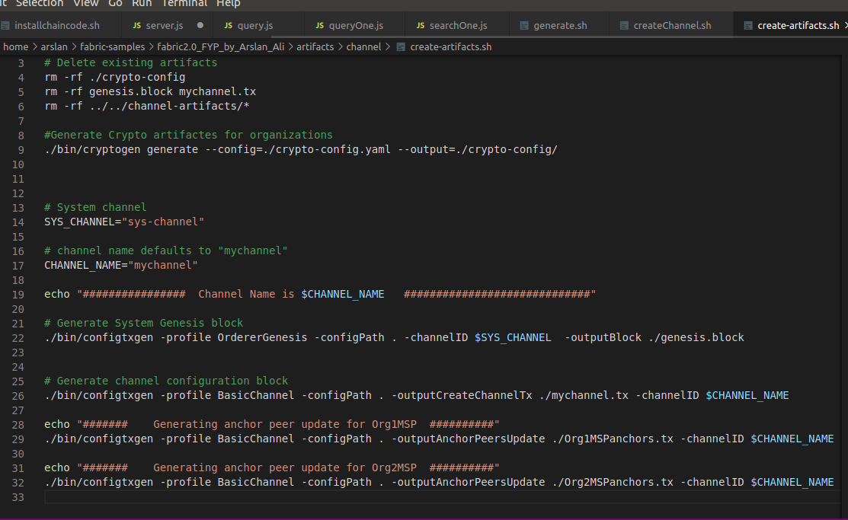

Figure 1using Cryptogen & configtxgen

* + 1. **Docker Compose**

Basically our project is developed with containerization concept .Where we use images and containers, in our project every entity is individual container, for that we use docker compose to manage multiple containers/entities

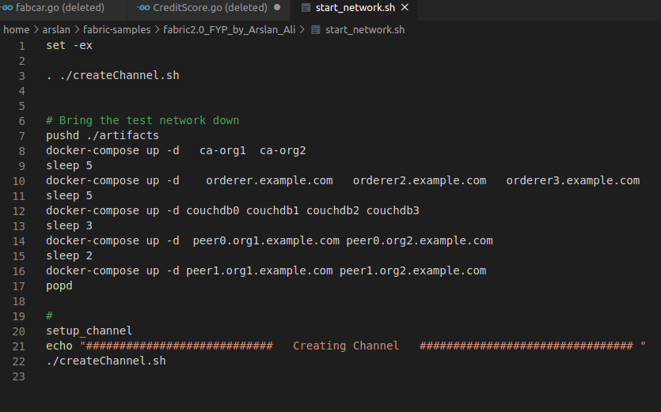

Figure 2run the containers

**6.1.3 Go language**

Go language is programming language.it is efficient, reliable and easy to use. Hyperledger supports many programing languages in the development of chaincode (smart contract) such as go, java, JavaScript (Node.js) .But we use go language for chaincode development, because go language is base and default chaincode language

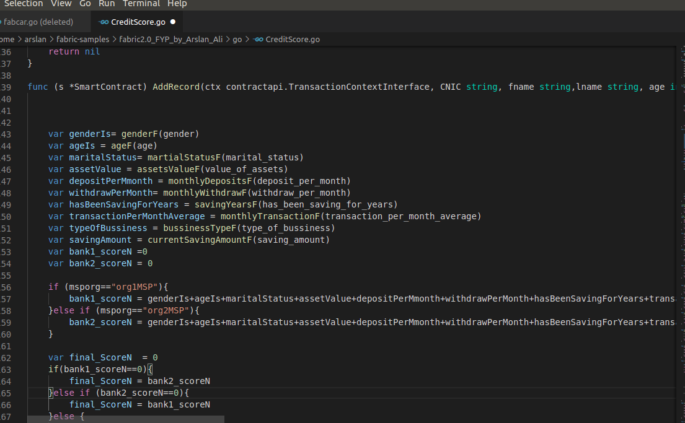

Figure 3 Insert Client Record

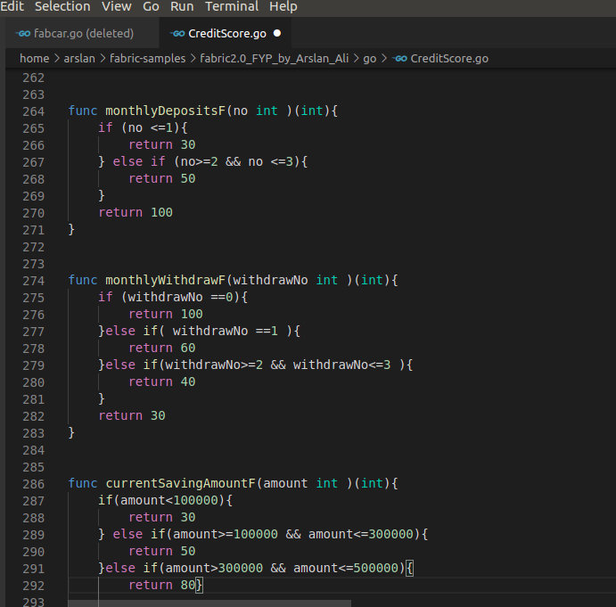

Figure 4 calculating the credit score

* + 1. **bash script**

Linux Bash script is command line interface (CLI) used to direct interact with the operation system (OS).It is very powerful interface it has high priority among other interface. it is also used for system administration .A bash script is simple plain text file which contain no: of commands to be executed .we use bash script in our project to developed and up the fabric network.to run the fabric files bash script has important role

.

* 1. **Server-Side**

Node.js is JavaScript runtime environment, it is open-source and cross-platform which execute JavaScript code at client side as well as server side. Developers of node.js use JavaScript code for server-side to develop the web pages with dynamic content. It is very popular paradigm because single programming language supports both client and server side. Node sdk also use to interact with Hyperledger fabric network by using gateway object.Gatway is object which establish the connection peer and verify the identity with wallet.

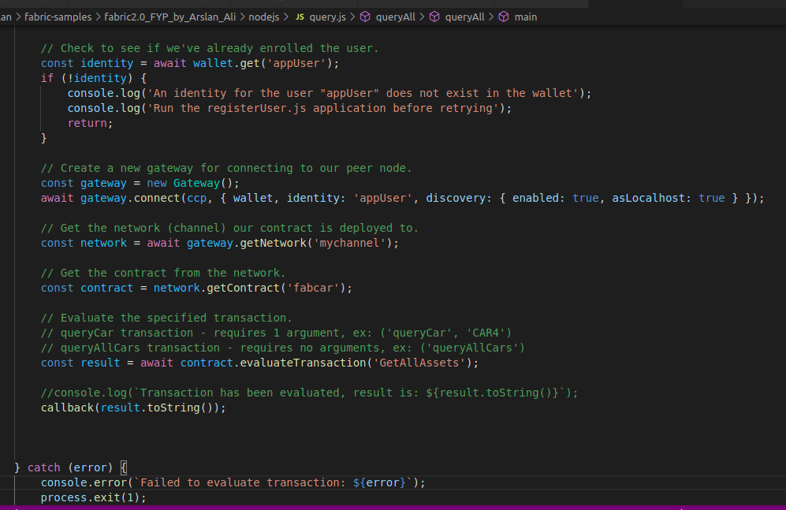

**6.2.1 npm**

Npm is node module registry.it is open source community where everyone can use the node module and can contribute in npm .multiple organization use npm in there system. The npm is also used node SDK packages to interact the application with fabric network. The node sdk package API used to interact with orderer, peers, fabric network, the transaction is also done with the help of npm packages, that direct call the function in chaincode .there is another npm package for Hyperledger fabric used to interact with fabric-ca and manages the user identity

* + 1. **REST architecture**

REST (REpresentational State Transfer.) uses the http protocol to send and receive the data .In REST architecture server provides the resource to access where client is access the provided server using http protocol .there are four http method which are commonly used in REST .

* GET – is used to allow read only access to client
* PUT – PUT is used to allow user to update the existing data
* DELETE – to delete the data.
* POST –used to create the data at the server.

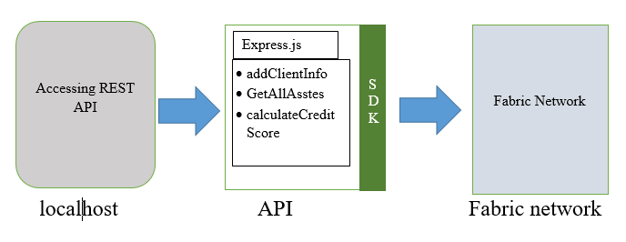

Figure 5REST Architecture with fabric network

* 1. **User Interface**

Client-Side script are those that run for Application user. As we discuss that our system is web based, so for, there should be interface to user through which he can interact with system .In our system we use multiple language html, css, JavaScript, Bootstrap. Each language has its own functionality. Html is used for basic structure .css and bootstrap are used together for graphical interface like button, textbox, label, etc. And the last one JavaScript is used for invalidation .The input validation is called front-end validation, where every user input is validate. If the input user is valid the desire action will be performed, but vise-versa if the user input is not valid.

***Chapter 7***

**Results and discussion**

Our system “Decentralized credit score system” is developed to calculate the credit score of borrower .Our system is type of permissioned Blockchain network. Initially there is only two organizations that are allow to participate in our System (Blockchain network). In our system both organization have equal rights to do any operations. They can insert their client record in the distributed ledgers, calculate the credit score and Maintain the credit history and credit score of each individual. But there is also limitation of each organization in order to maintain the confidentiality, our system does not allow organizations’ to view the client credit history of other organizations client. They can view the credit history of their own client.

* 1. **Snap shots of system**

**7.1.1 Login screen**

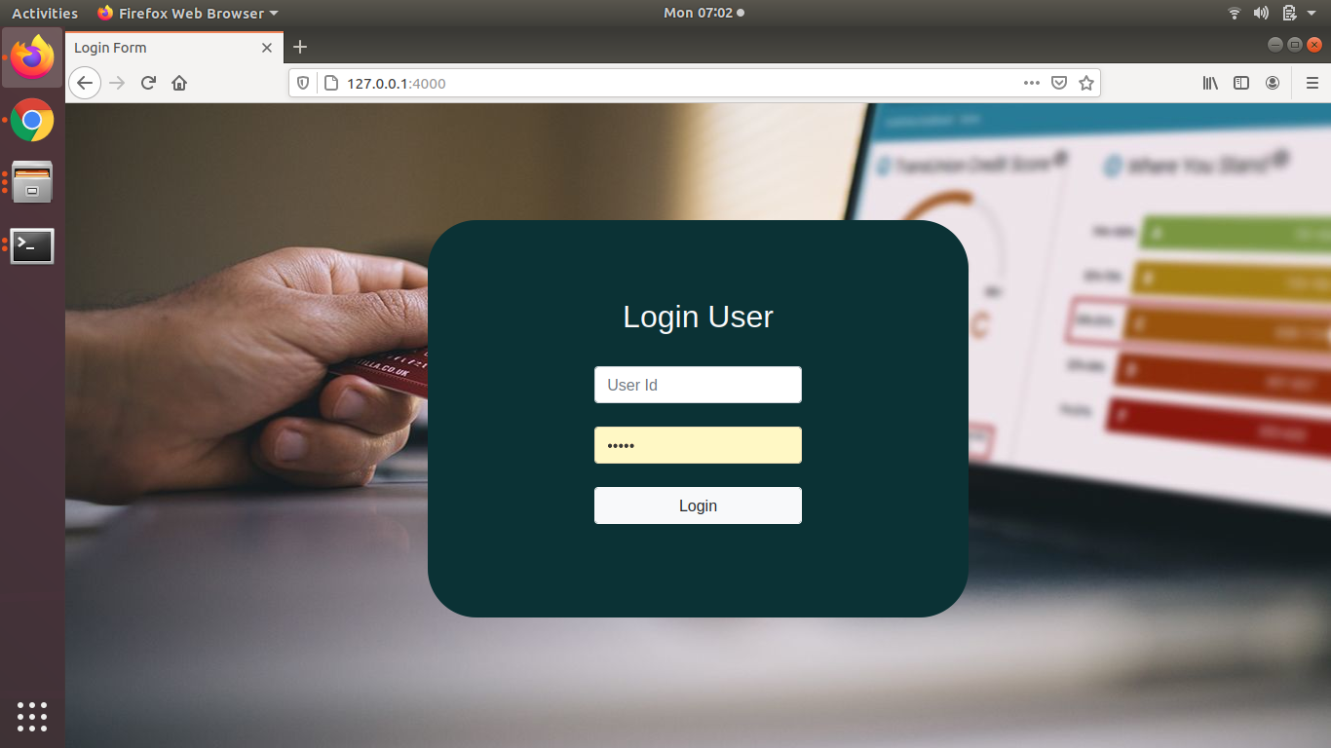

The first screen in our system which is used to authenticate the user. The authentication system require userid, password to login successfully. User credentials, userid and password are provided by their organization. If the user successfully logined into the system, it means the user is trusted and now he can interact with system.

**7.1.2 Home screen**

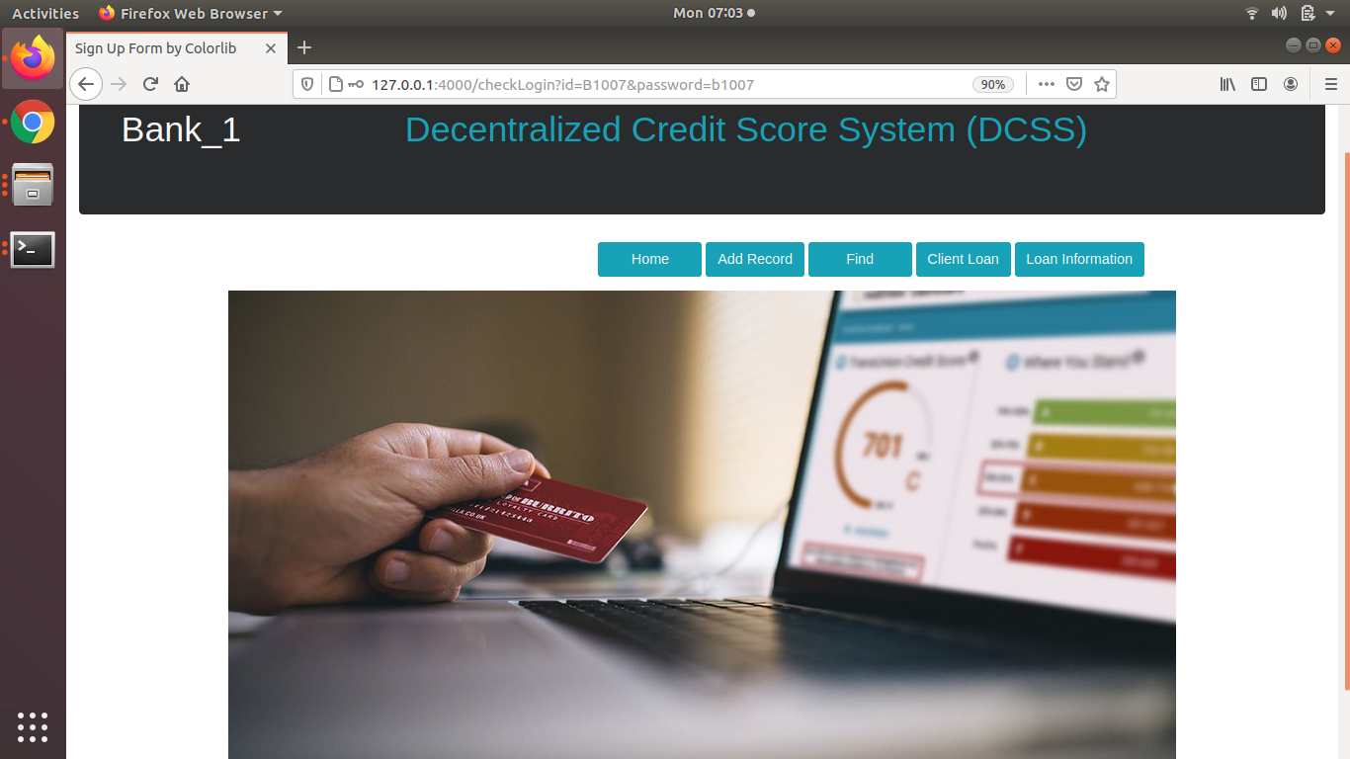

This is Home screen. After successful login into the system, now the users can perform actions like add record, view record, grant the loan, and view the credit history of borrower.

***Chapter 8***

**Conclusion and future work**

Include a brief summary of how the proposed solution is going to/has addressed the problem statement specified in the introduction section. Provide an overview of what kind of evaluations were undertaken in order to prove that the solution really solves the problem with evidence on results findings.

Provide an overview of the recommendations and Include a future direction which is required as part of the future work.

***Chapter 9***

**REferences**

A comprehensive list of references is cited using a standard format.