**MINISTRY OF EDUCATION AND SCIENCE OF UKRAINE NATIONAL TECHNICAL**

**UNIVERSITY «KHARKIV POLITECNIC INSTITUTE» DEPARTMENT OF**

**COMPUTER-AIDED MANAGMENT SYSTEMS**

**Course Work**

**on course: << Object Oriented Programming>>**

**entitled: << Wpf Applications "Dictionary">>**

**Performer:**

**Berk Arslan**

**If-32 j**

**Kharkiv 2014**

**1.Graph Results**

Graph 1.1 shows results according to stored data "Results".

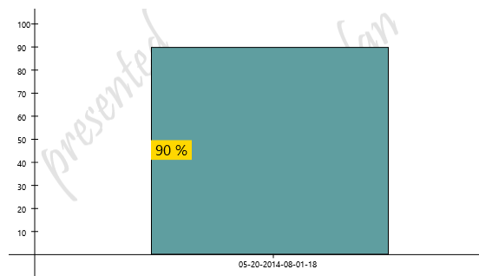

graph 1.1 - Results

According to these result you can see the progress day by day. This graph is directly created by dictionary program to provide feedbacks due to test has been done by shariar.

**2.Result Details**

Here there is shown detailed results due to questions and their answers. This comparison will help you to understand exactly which questions were wrong.

**05-21-2014-01-04-53, success:100%**

1. word was "hurt" ,its translation was "обидеть" , and you answered "обидеть".

2. word was "theme" ,its translation was "тема" , and you answered "тема".

3. word was "warn" ,its translation was "предупреждать" , and you answered "предупреждать".

4. word was "dictionary" ,its translation was "словарь" , and you answered "словарь".

5. word was "stomach" ,its translation was "желудок" , and you answered "желудок".

6. word was "allow" ,its translation was "позволять" , and you answered "позволять".

7. word was "wing" ,its translation was "крыля" , and you answered "крыля".

8. word was "file" ,its translation was "файл" , and you answered "файл".

9. word was "father" ,its translation was "отец" , and you answered "отец".

10. word was "know" ,its translation was "знать" , and you answered "знать".

**05-21-2014-12-54-00, success:100%**

1. word was "hair" ,its translation was "волос" , and you answered "волос".

2. word was "team" ,its translation was "команда" , and you answered "команда".

3. word was "father" ,its translation was "отец" , and you answered "отец".

4. word was "mutual" ,its translation was "общего" , and you answered "общего".

5. word was "paper" ,its translation was "бумага" , and you answered "бумага".

6. word was "know" ,its translation was "знать" , and you answered "знать".

7. word was "dictionary" ,its translation was "словарь" , and you answered "словарь".

8. word was "news" ,its translation was "новости" , and you answered "новости".

9. word was "file" ,its translation was "файл" , and you answered "файл".

10. word was "stomach" ,its translation was "желудок" , and you answered "желудок".

**3.Conclusion**

Dictionary program presented graphical presentation of results and detailed results which include questions and their answers with user answers.If success rate is less than 50% then it means result is bad, and average result is between 50-80 %, if success is greater than 80% then it means the result is very good.