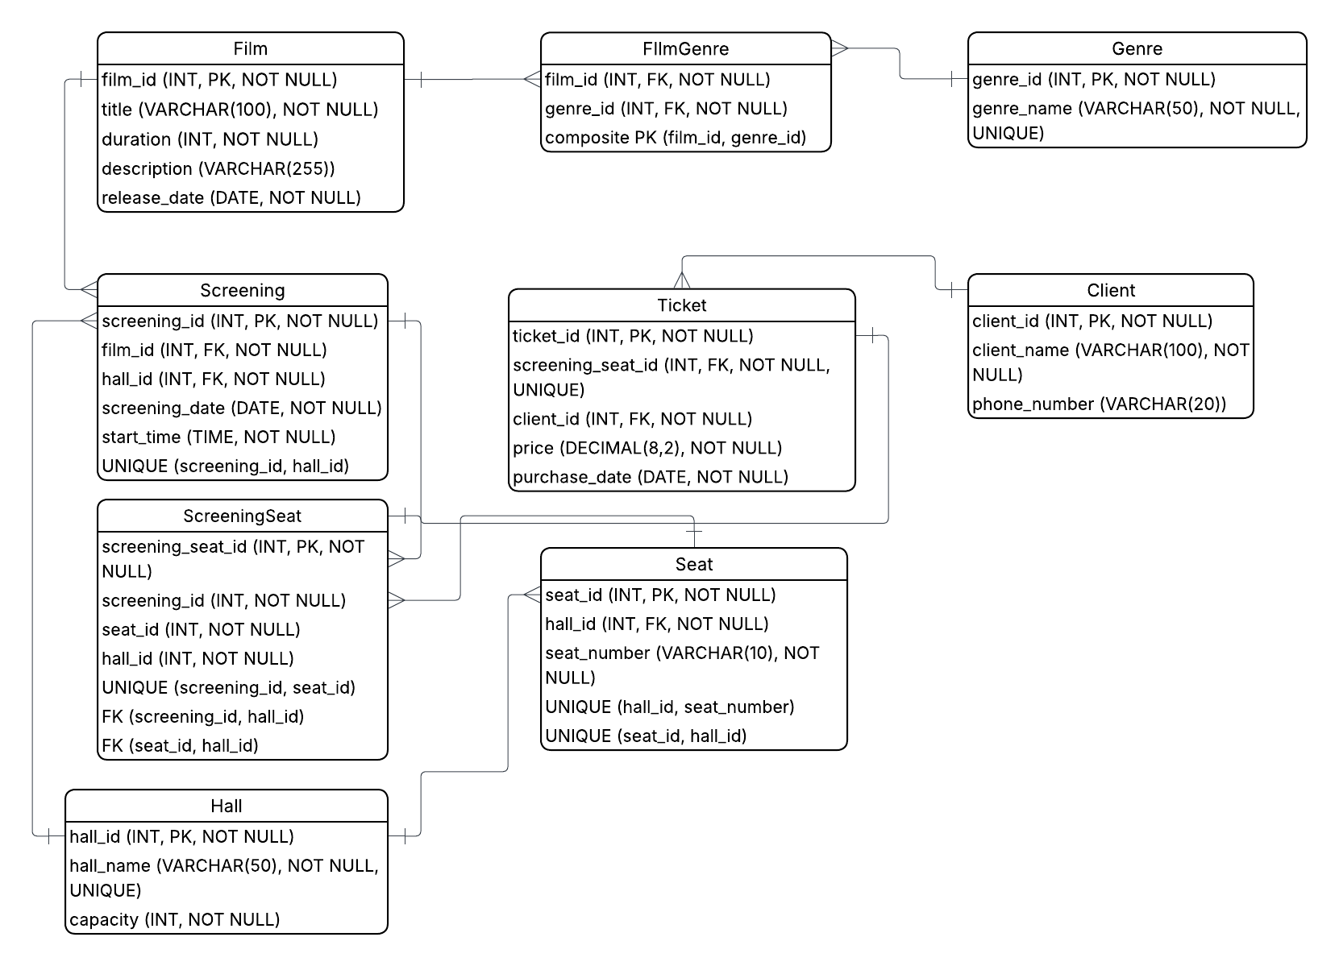
1.1 Logical Scheme

1.2 Objects
Table Name | Field name | Field Description | Data Type / Constraints
Film | film_id | Unique identifier of the film | INT, PK, NOT NULL
 | title | Title of the film | VARCHAR(100), NOT NULL
 | duration | Duration of the film in minutes | INT, NOT NULL
 | description | Short description of the film | VARCHAR(255)
 | release_date | Release date of the film | DATE, NOT NULL

Table Name | Field name | Field Description | Data Type / Constraints
Genre | genre_id | Unique identifier of the genre | INT, PK, NOT NULL
 | genre_name | Name of the genre | VARCHAR(50), NOT NULL, UNIQUE
Table Name | Field name | Field Description | Data Type / Constraints
FilmGenre | film_id | Identifier of the film linked to the genre | INT, FK, NOT NULL
 | genre_id | Identifier of the genre linked to the film | INT, FK, NOT NULL

Table Name | Field name | Field Description | Data Type / Constraints
Hall | hall_id | Unique identifier of the hall | INT, PK, NOT NULL
 | hall_name | Name of the hall | VARCHAR(50), NOT NULL, UNIQUE
 | capacity | Number of seats in the hall | INT, NOT NULL

Table Name | Field name | Field Description | Data Type / Constraints
Screening | screening_id | Unique identifier of the screening | INT, PK, NOT NULL
 | film_id | Identifier of the film shown in the screening | INT, FK, NOT NULL
 | hall_id | Identifier of the hall where the screening takes place | INT, FK, NOT NULL
 | screening_date | Date of the screening | DATE, NOT NULL
 | start_time | Start time of the screening | TIME, NOT NULL

Table Name | Field name | Field Description | Data Type / Constraints
ScreeningSeat | screening_seat_id | Unique identifier of the screening-seat assignment | INT, PK, NOT NULL
 | screening_id | Identifier of the screening | INT, NOT NULL
 | seat_id | Identifier of the seat assigned to the screening | INT, NOT NULL
 | hall_id | Identifier of the hall used to validate seat and screening consistency | INT, NOT NULL

Table Name | Field name | Field Description | Data Type / Constraints
Client | client_id | Unique identifier of the client | INT, PK, NOT NULL
 | client_name | Full name of the client | VARCHAR(100), NOT NULL
 | phone_number | Phone number of the client | VARCHAR(20)

Table Name | Field name | Field Description | Data Type / Constraints
Ticket | ticket_id | Unique identifier of the ticket | INT, PK, NOT NULL
 | screening_seat_id | Identifier of the reserved seat for a specific screening | INT, FK, NOT NULL, UNIQUE
 | client_id | Identifier of the client who bought the ticket | INT, FK, NOT NULL
 | price | Price of the ticket | DECIMAL(8,2), NOT NULL
 | purchase_date | Date when the ticket was purchased | DATE, NOT NULL

3. Comments on table relationships
The database contains several one-to-many relationships. One film can have many screenings, because the same film can be shown at different dates and times. One hall can have many screenings, because different screenings can take place in the same hall. One hall can also have many seats, because each hall contains multiple seat positions. One client can have many tickets, because a client may purchase more than one ticket.
The database also contains a many-to-many relationship between Film and Genre. This relationship is implemented through the bridge table FilmGenre. It is necessary because one film can belong to several genres, and one genre can be associated with many films.
The relationship between Screening and Seat is handled through the ScreeningSeat table. This table connects a specific seat to a specific screening. It helps correctly manage seat assignment for each screening and prevents the same seat from being assigned incorrectly. The Ticket table is linked to ScreeningSeat, because a ticket must refer to a seat in a specific screening, not just to a seat in general.

4. Example with data
film_id | title | duration | release_date
1 | Inception | 148 | 2010-07-16
2 | Interstellar | 169 | 2014-11-07
3 | The Batman | 176 | 2022-03-04

