◆ SKILLFORGE AI
FINAL SUBMISSION DOCUMENTATION
Deterministic Resume Intelligence for Career Direction and Learning Paths
A complete as-built technical report covering the implemented pipeline, evaluation evidence, API surface, interface, deployment configuration, limitations, and future work.
Project scope: Phases 3–14 implemented • Phase 13 omitted by design • Phases 16–17 documented
Published application
https://skillforgeaitest.replit.app
Prepared for final project submission
18 August 2026

Document control
Field | Value
Project | SkillForge AI
Document | Final Submission Documentation
System type | Deterministic resume-intelligence web application
Implemented scope | Phases 3–14; evaluation and deployment documentation in Phases 16–17
Primary stack | Python 3.12, FastAPI, SQLite, PyMuPDF, pdfplumber, spaCy, DistilBERT, Transformers, RapidFuzz, NetworkX
Live URL | https://skillforgeaitest.replit.app
Data boundary | Synthetic, controlled resume corpus and hand-curated knowledge base
Decision policy | Code makes all ranking, gap, and learning-path decisions; no LLM decision layer

Abstract
SkillForge AI is an explainable resume-intelligence system that transforms a PDF resume into a structured skill profile, recommends a likely career direction, measures proficiency gaps against a curated role definition, and generates a prerequisite-aware learning path. The project was intentionally designed as a deterministic machine-learning and rules-based pipeline: a resume is parsed, matched against a canonical skill taxonomy, normalized, scored against career vectors, analyzed for target proficiency deficits, and ordered through a directed prerequisite graph. The API returns structured JSON at every stage, allowing the outputs to be inspected, tested, and reproduced.
The final implementation combines deterministic dictionary/regex extraction with offline evaluation of spaCy EntityRuler and DistilBERT NER. DistilBERT is the only deep-learning component. The live upload path uses the dictionary matcher because it produced the best F1 on the controlled held-out set and is easier to audit. Phase 13 LLM narration, Neo4j, K-Means, and the larger multi-agent framework were excluded from the accepted scope so that the final submission remains traceable and reproducible.
The submitted system is deployed through FastAPI with a static HTML/CSS/vanilla-JavaScript interface. The saved live smoke run using the frontend synthetic resume returned 19 extracted skills, ranked Frontend Developer first with a 0.9916560553218191 score, returned 8 gap records, and generated an 8-skill prerequisite-aware roadmap. These results describe behavior on controlled project fixtures and should not be interpreted as claims of generalization to real resumes or labor-market outcomes.
Keywords: resume parsing, skill extraction, career recommendation, proficiency gap analysis, prerequisite graph, deterministic machine learning, FastAPI, DistilBERT, NetworkX, explainable AI.

Table of contents
The contents field below is configured for Microsoft Word. If page numbers are not visible immediately, right-click the field in Word and select “Update Field”.

1. Introduction and problem statement

1.1 Background
Modern resumes contain a mixture of technologies, abbreviations, project names, section-specific context, and inconsistent formatting. A simple keyword search may identify a skill mention but does not automatically answer three practical questions: which career direction is most compatible with the profile, where is the learner below the expected proficiency level, and what should be learned first when skills have prerequisites?

1.2 Problem statement
SkillForge AI addresses the gap between resume text and an actionable development plan. It accepts a PDF resume, extracts canonical skills, compares the profile with a curated career knowledge base, computes requirement-level proficiency deficits, and orders the missing skills so that prerequisites are learned before dependent technologies.

1.3 Project objectives
- Build a repeatable PDF resume parsing and section-detection pipeline.
- Extract skills using deterministic dictionary and regular-expression matching with word-boundary protection.
- Evaluate a spaCy EntityRuler stage and a DistilBERT token-classification model on controlled synthetic data.
- Normalize aliases and near-matches through a calibrated deterministic matching sequence.
- Recommend careers using importance-weighted skill vectors and cosine similarity.
- Quantify proficiency gaps using an explicit formula and calibrated buckets.
- Produce a learning path that respects prerequisite relationships and deterministic tie-breaking.
- Expose the pipeline through a small, testable FastAPI service and a usable static interface.

1.4 Guiding design principles
Principle | How it appears in the project
Deterministic decisions | Career ranking, gap arithmetic, and learning-path ordering are implemented in code rather than delegated to an LLM.
Traceability | Metrics are saved in JSON artifacts; phase status and assumptions are recorded in PROJECT_STATE.md.
Explainability | The system exposes intermediate profile, career, gap, learning, and progress structures.
Controlled scope | Only DistilBERT is treated as the deep-learning component; Neo4j, K-Means, LLM narration, and the larger multi-agent framework are out of scope.
Reproducibility | A repository-relative runner, SQLite database, seeded JSON exports, fixed thresholds, and synthetic fixtures support repeatable execution.

2. System overview and as-built scope
The implementation is organized as a three-layer system. The Deterministic Core converts unstructured resume input into normalized skills. The Recommendation and Reasoning Engine compares that profile with structured career requirements and plans learning actions. The Interaction Layer exposes the pipeline through FastAPI and renders the results in the static browser interface.
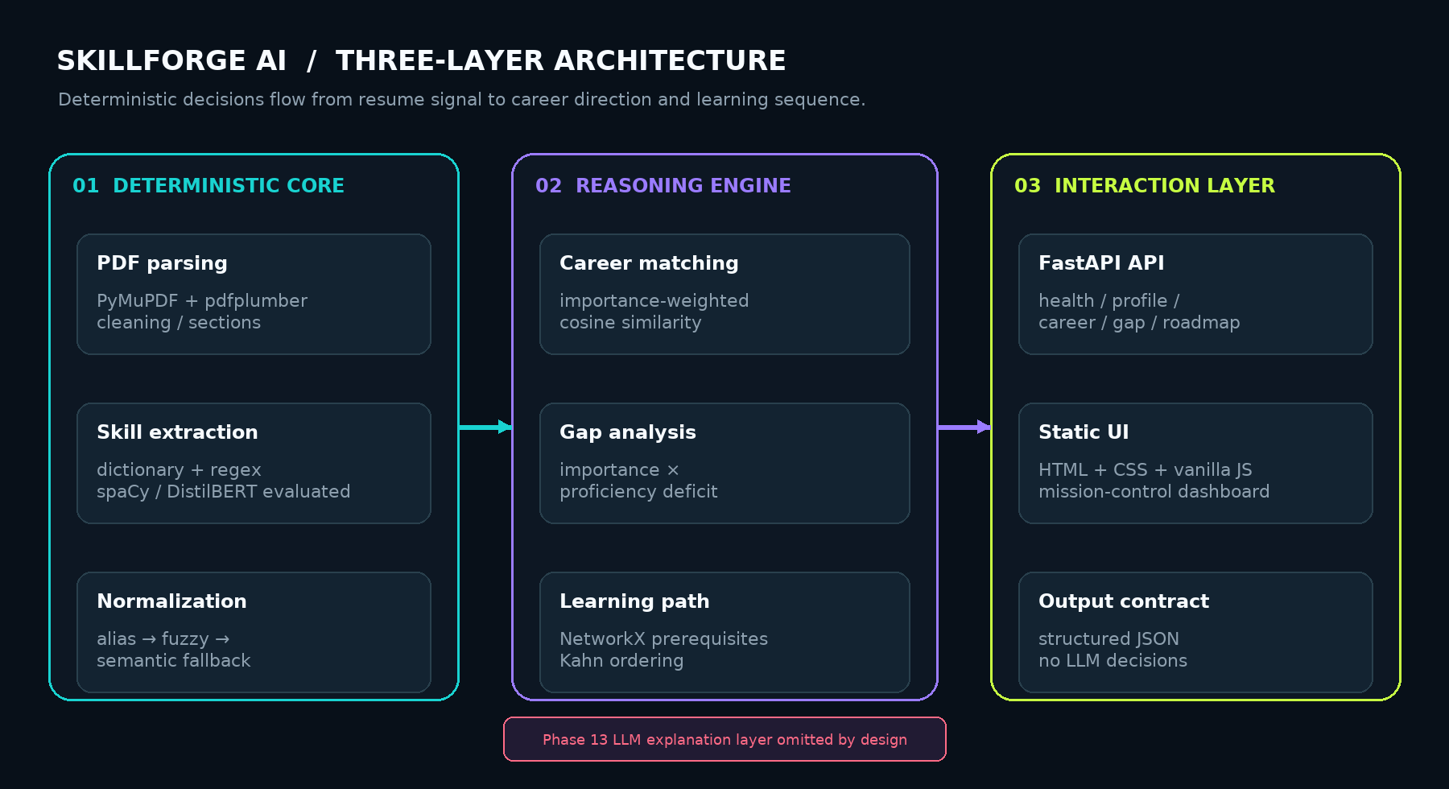
Figure 1. Three-layer architecture of the implemented SkillForge AI system.
Scope boundary
The Phase 13 LLM explanation layer is intentionally omitted. The Phase 12 structured dictionary is the final pipeline output; the interface visualizes the returned deterministic data rather than generating a narrative explanation.

2.1 Implemented phase map
Phase | Implemented responsibility | Status / evidence
3 | Schema, seeded taxonomy, career requirements, aliases, prerequisite edges, SQLite initialization | DONE; 9-table schema and JSON exports
4 | PDF extraction, cleaning, section detection, parser tests | DONE; parser tests 3/3 PASS
5 | Dictionary/regex skill extraction and word-boundary guards | DONE; extraction tests 56/56 PASS
6 | spaCy EntityRuler and DistilBERT NER evaluation | DONE; saved synthetic held-out metrics
7 | Alias, full-string RapidFuzz, semantic fallback, threshold calibration | DONE; checkpoint tests 8/8 PASS
8 | In-memory NetworkX prerequisite graph and cycle/topology checks | DONE; checkpoint tests 8/8 PASS
9 | Importance-weighted career vectorization and cosine ranking | DONE; face-validity fixtures 3/3 PASS
10 | Proficiency-gap arithmetic and buckets | DONE; deterministic formula
11 | Prerequisite-safe learning-path ordering | DONE; Kahn topology + gap priority
12 | Structured profile → career → gap → learning → progress orchestrator | DONE; agent tests 8/8 PASS
13 | LLM narrative/explanation layer | OMITTED BY DESIGN
14 | FastAPI service, routes, static interaction surface | DONE; live smoke flow PASS
15 | Separate full frontend scope | OMITTED BY ACCEPTED PLAN
16–17 | Evaluation reporting and basic deployment configuration | DONE

3. End-to-end pipeline
The live request path begins when a user uploads a PDF. The profile endpoint stores the parsed resume and deterministic matches. The agent endpoint then reloads the persisted profile and runs the Phase 12 stages in sequence. Offline evaluation and calibration modules remain part of the project but are not unconditionally chained into the upload handler.
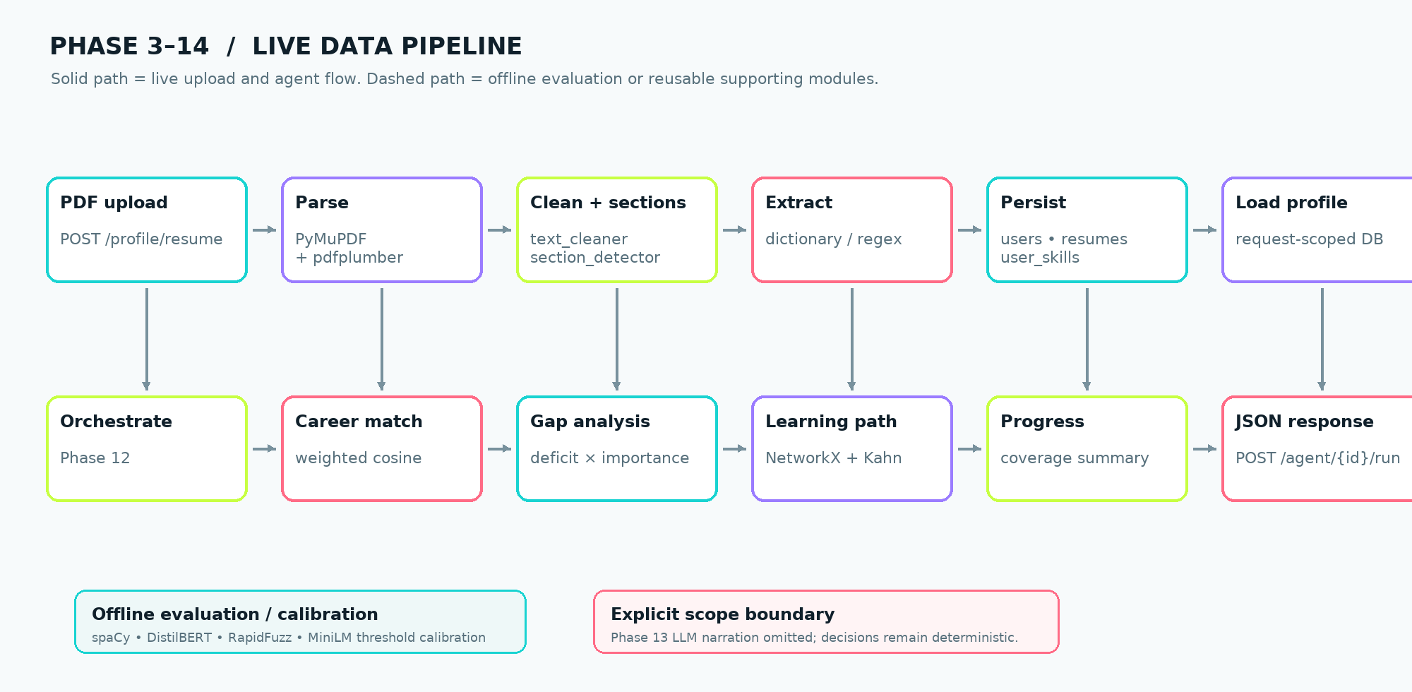
Figure 2. Live Phase 3–14 data pipeline with offline evaluation boundaries.

3.1 Runtime sequence
- The user selects a PDF in the static interface and submits the intake form.
- FastAPI validates the upload, parses the PDF using PyMuPDF with pdfplumber fallback, cleans text, and detects sections.
- The dictionary matcher loads canonical skill names and aliases from the database and applies a single case-insensitive regex with word-boundary guards.
- The profile, resume record, and user-skill rows are persisted through the db_client abstraction.
- The agent route loads the persisted profile and invokes profile, career, skill-gap, learning, and progress stages.
- The API returns JSON containing the pipeline identity, ordered stage sequence, and structured stage outputs.
- The browser renders the match ring, gap bars, and prerequisite-aware learning timeline.

3.2 Data contracts
Stage | Input | Output
Profile | Persisted user/resume/profile rows | Canonical skill records with proficiency and evidence fields
Career | Normalized profile + curated career requirements | Ranked careers with scores and matched skill identifiers
Gap | Selected career + learner skill levels | Requirement-level deficit records, buckets, and missing skills
Learning | Missing skills + NetworkX prerequisite graph | Ordered GapItem list that respects prerequisites
Progress | Profile, selected career, gap records, learning path | Coverage and remaining-gap summary

4. Data, knowledge base, and persistence
The knowledge base is intentionally hand-curated for an explainable final-year project. It is not learned from employment outcomes and is not presented as a labor-market benchmark. Skills, aliases, careers, importance weights, preferred proficiency levels, and prerequisite relationships are project assumptions encoded as structured data.

4.1 Seeded knowledge-base inventory
Resource | Count | Construction and use
Canonical skills | 101 | Hand-curated technology taxonomy used for extraction and vector dimensions
Skill aliases | 26 | Abbreviations and alternate forms such as ML, ReactJS, sklearn, K8s, REST, Postgres, and TF
Careers | 15 | Hand-curated role set used as recommendation candidates
Prerequisite edges | 62 | Domain-judged directed learning relationships
Career-skill requirements | 116 | Importance, minimum proficiency, and preferred proficiency values on 1–5 scales

4.2 Resume corpus and evaluation split
Split | Count | Purpose
Phase 4 synthetic PDFs | 3 | Parser and dictionary smoke fixtures: data science, frontend, and DevOps
Phase 6 labelled PDFs | 18 | Weak-supervision dataset with 14 training and 4 held-out resumes
Held-out ground-truth mentions | 39 | Skill-level micro evaluation target
Recommendation profiles | 3 | Face-validity fixtures for Data Science, Frontend, and DevOps

Interpretation note
The corpus is synthetic and controlled. Phase 6 labels are produced by the same Phase 5 dictionary matcher used by the system, so the metrics demonstrate pipeline behavior on saved fixtures rather than independent real-resume generalization.

4.3 Database and persistence boundary
SQLite is used for local and development persistence through the db_client abstraction. The source schema is PostgreSQL-compatible and is translated during SQLite initialization. SKILLFORGE_DB_PATH is used to select the project database so the application does not accidentally bind to an unrelated platform DATABASE_URL during local runs. FastAPI creates request-scoped connections that are compatible with synchronous worker-thread execution.
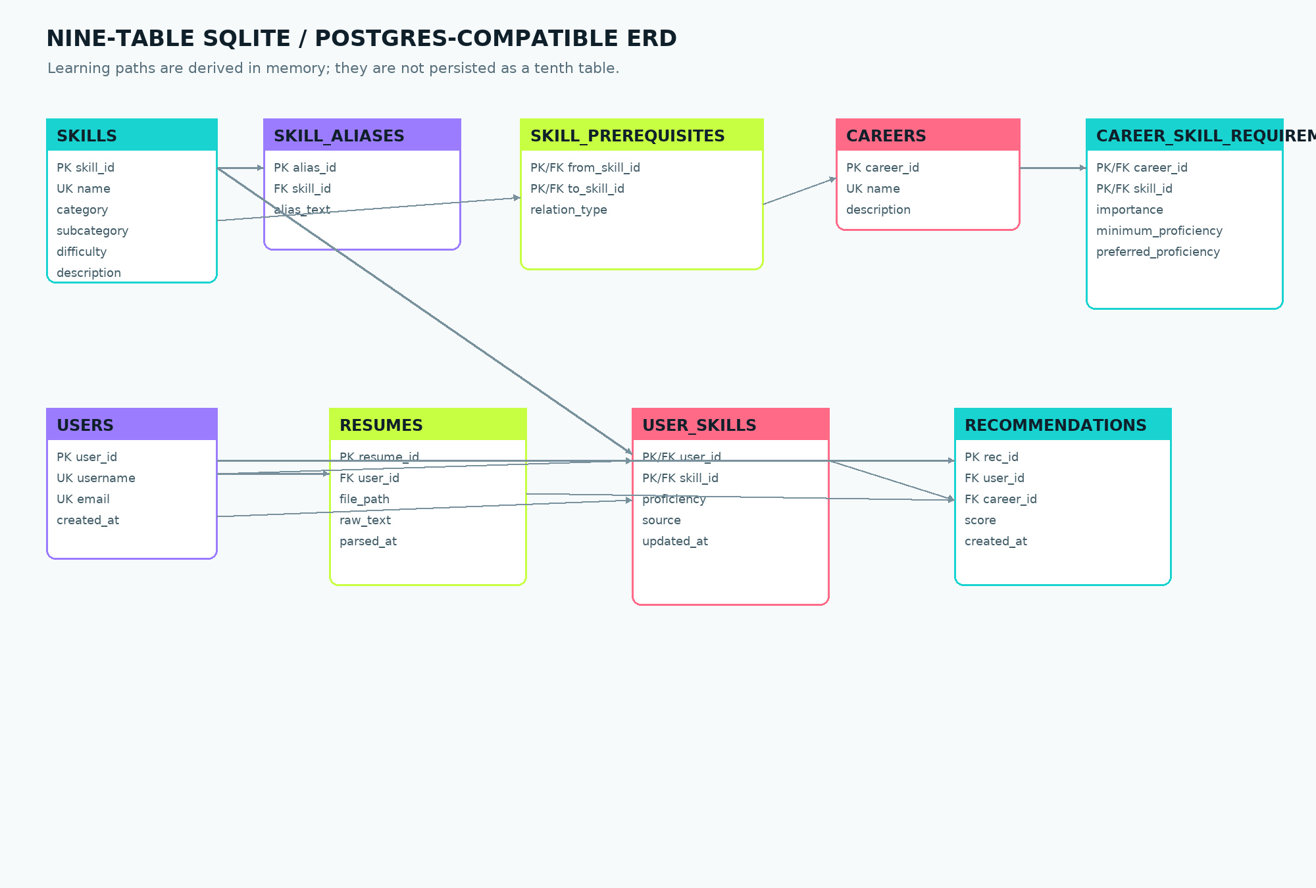
Figure 3. Actual nine-table entity-relationship diagram. Learning paths are computed in memory.

5. Models, algorithms, and decision logic
The project uses a hybrid architecture: deterministic rules and vector arithmetic make production decisions, while the evaluated NLP models provide a documented comparison for skill extraction. This separation is important because the project goal is not simply to add a neural model; it is to produce a reproducible and explainable pipeline.
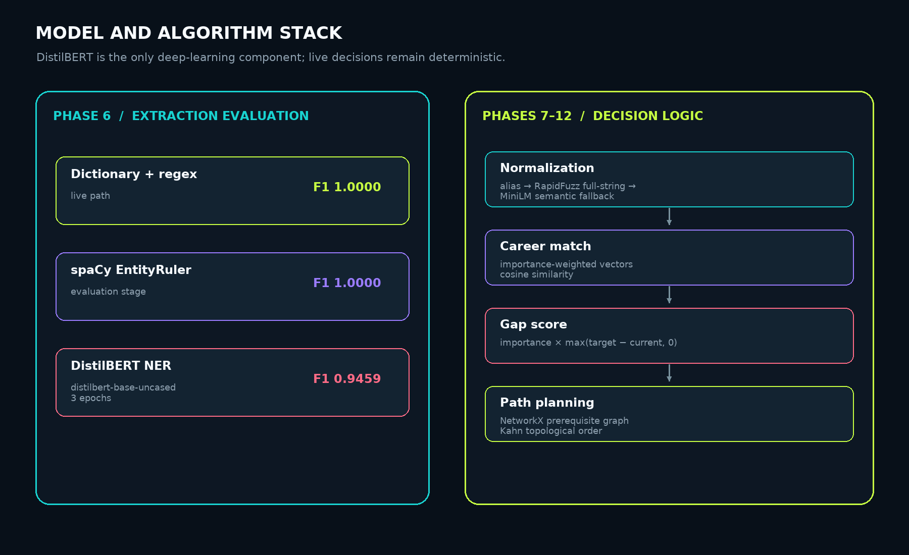
Figure 4. Model and algorithm stack. DistilBERT is the only deep-learning component.

5.1 Resume parsing
PDF text is extracted with PyMuPDF as the primary path and pdfplumber as a fallback. Text is cleaned through whitespace and bullet normalization. Section detection uses common resume headers and a structural fallback for short all-caps lines. The parser returns text and structured sections so extraction results can preserve evidence location.

5.2 Deterministic dictionary and regex extraction
The live extractor loads canonical skill names and aliases from the database, compiles a single case-insensitive regular expression, and uses word-boundary guards. Each match includes skill_id, matched_text, canonical_name, section, and char_span. This design supports auditability and creates the weak-supervision structure used by the Phase 6 DistilBERT training process.

5.3 Phase 6 model comparison
Three extraction stages were compared on four held-out synthetic resumes containing 39 ground-truth skill mentions. The dictionary baseline and spaCy EntityRuler both achieved perfect micro metrics on this controlled set. DistilBERT achieved perfect precision but lower recall because it missed four mentions. The dictionary matcher therefore won by F1 and remains the live production path.
Stage | TP | FP | FN | Precision | Recall | F1
Dictionary baseline | 39 | 0 | 0 | 1.0000 | 1.0000 | 1.0000
spaCy EntityRuler | 39 | 0 | 0 | 1.0000 | 1.0000 | 1.0000
DistilBERT NER | 35 | 0 | 4 | 1.0000 | 0.8974 | 0.9459

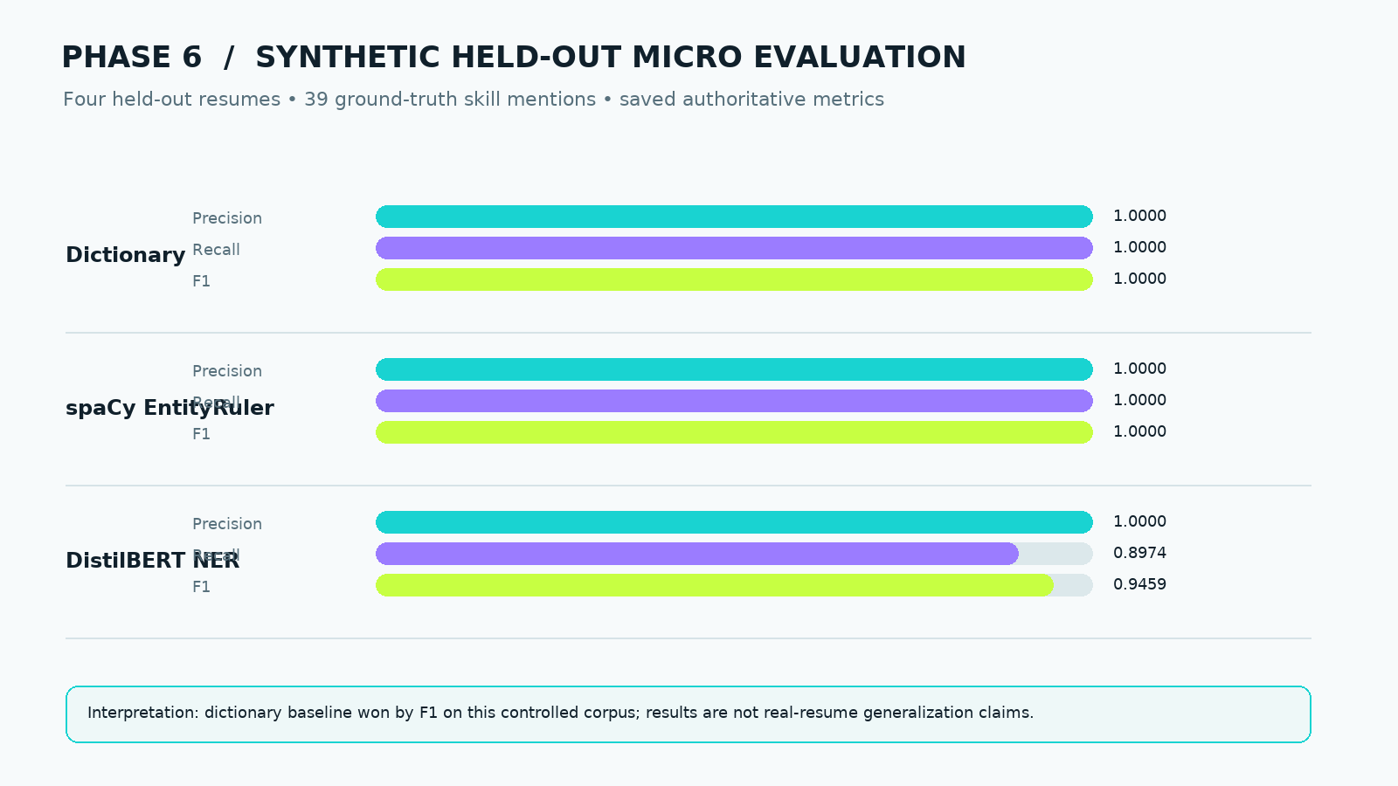
Figure 5. Phase 6 saved held-out micro metrics.

5.4 Skill normalization
Normalization follows an explicit order: exact alias/canonical matching, full-string RapidFuzz similarity, then calibrated semantic fallback. The semantic fallback uses sentence-transformers/all-MiniLM-L6-v2 through raw Transformers with mean pooling because the wrapper package was unavailable in the package index. The empirical threshold was selected by the best F1 across labelled equivalent/different pairs.
Calibration measurement | Value
Positive score range | 0.3420–1.0000
Negative score range | 0.0673–0.3226
Chosen threshold | 0.3323
Calibration F1 | 1.0000

5.5 Career recommendation
For each career, the vectorizer creates one dimension per canonical skill. The learner value is normalized proficiency/5 and weighted by the career requirement importance. The career target uses preferred proficiency/5 with the same importance weights. Cosine similarity ranks all seeded careers. This approach measures coverage and target alignment against the curated role definition, not real-world hiring probability.
learner_value(skill) = current_proficiency / 5 × importance
career_value(skill) = preferred_proficiency / 5 × importance
career_score = cosine_similarity(learner_vector, career_vector)

5.6 Gap analysis
The gap analyzer compares current proficiency with the preferred proficiency for every requirement. Resume-extracted skills receive current proficiency 1, while omitted skills receive 0. The gap score is:
gap_score = importance × max(preferred_proficiency − current_proficiency, 0)
Bucket | Score range | Interpretation
Strong | 0 | At the preferred target
Minor | 1–5 | Small improvement needed
Moderate | 6–10 | Meaningful improvement needed
Major | 11–15 | Substantial improvement needed
Critical | 16+ | High-priority deficit

5.7 Prerequisite-aware learning path
The learning-path planner constructs or consumes an in-memory directed NetworkX graph. Missing skills are scheduled using Kahn topological ordering. At every step, only currently unlocked skills are eligible; among eligible skills, the larger gap score is selected first and skill ID provides the final deterministic tie-breaker. This ensures that urgency does not violate prerequisite structure.

6. API and interface documentation
The FastAPI backend is intentionally compact. It exposes one health route, one upload/profile route, three analysis routes, and one direct orchestrator route. Pydantic models define the public response contract. The static page is served at the root route and adds no frontend build dependency.

6.1 Route summary
Method | Route | Purpose
GET | /health | Service health and phase status
POST | /profile/resume | Upload, parse, extract, and persist resume profile
GET | /careers/{user_id}/recommendations | Rank the seeded career set for a persisted user
GET | /gap/{user_id}/{career_id} | Return requirement-level proficiency gaps
GET | /roadmap/{user_id}/{career_id} | Return the prerequisite-aware learning path
POST | /agent/{user_id}/run | Run the complete Phase 12 structured pipeline

6.2 Example health contract
GET /health
{
"status": "ok",
"phase": "14"
}

6.3 Example profile contract
A real local smoke run using resume_2_frontend.pdf returned an anonymous user profile with 19 extracted skills. Each skill record retained canonical name, proficiency, source, matched text, section, skill identifier, and character span.
{
"user_id": 1,
"skill_count": 19,
"sections": ["_header", "experience", "education", "skills", "projects"],
"skills": [
{"skill_id": 45, "canonical_name": "React", "proficiency": 1,
"source": "resume", "matched_text": "React",
"section": "experience", "char_span": [78, 83]}
]
}

6.4 Example career, gap, roadmap, and agent outputs
Endpoint | Live smoke-test result
GET /careers/1/recommendations | Frontend Developer ranked first with score 0.9916560553218191; 8 required skills in the selected career contract.
GET /gap/1/4 | Frontend Developer gap report returned 8 career requirements; example JavaScript gap score 20.0, bucket Critical.
GET /roadmap/1/4 | Roadmap returned 8 skills in prerequisite-safe order: JavaScript, HTML, CSS, React, TypeScript, Git, Tailwind CSS, Jest.
POST /agent/1/run | Direct Phase 12 structure returned profile, career, gap, learning, and progress stages without an explanation field.

6.5 User interface walkthrough
The interface is a dark, cinematic mission-control surface designed to make the pipeline feel like a directional instrument rather than a generic form. It communicates three stages: intake, analysis, and results. The UI uses a lime/teal/purple accent system, an animated loading orbit, a career-match ring, proficiency-versus-target gap bars, and a connected learning timeline.

Figure 6. Resume intake screen: PDF upload and expected output signals.

Figure 7. Analysis state: animated processing feedback while the API pipeline runs.
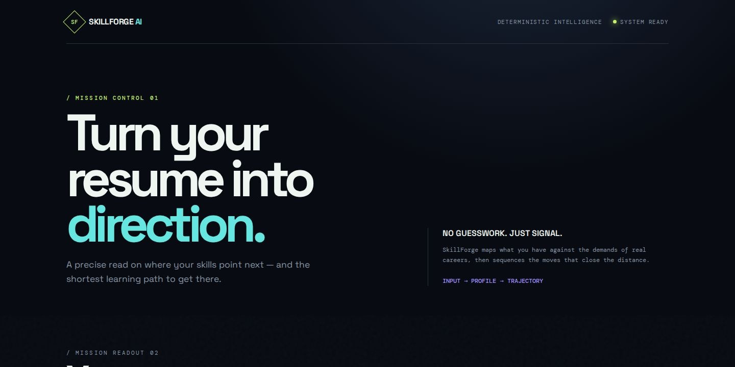
Figure 8. Results dashboard upper section: extracted profile count and career match visualization.
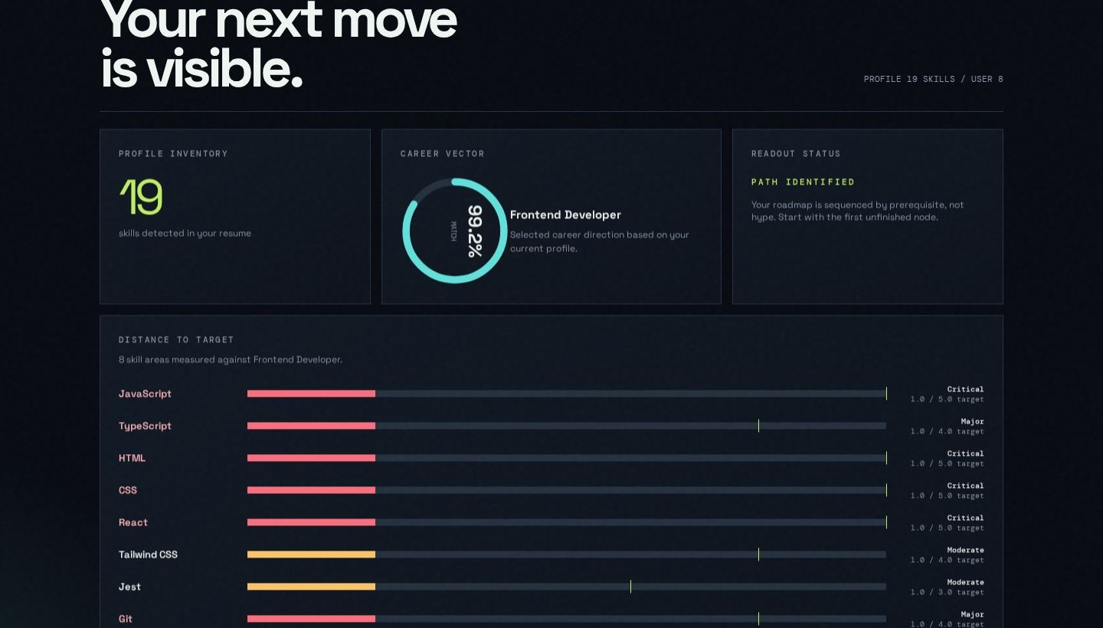
Figure 9. Results dashboard gap view: proficiency versus preferred target bars.

Figure 10. Results dashboard roadmap view: ordered prerequisite-aware learning path.

7. Evaluation and verification
Evaluation evidence is deliberately separated into extraction metrics, normalization calibration, face-validity recommendation checks, regression tests, and live API verification. The report does not convert synthetic or face-validity results into claims of real-world accuracy.

7.1 Phase 6 extraction results
The saved evaluation covers 4 held-out synthetic resumes and 39 ground-truth skill mentions. DistilBERT was trained for 3 epochs using 70 weakly labelled examples and a maximum sequence length of 256.
Model | Precision | Recall | F1 | Decision
Dictionary baseline | 1.0000 | 1.0000 | 1.0000 | Selected for live path
spaCy EntityRuler | 1.0000 | 1.0000 | 1.0000 | Evaluation comparator
DistilBERT NER | 1.0000 | 0.8974 | 0.9459 | Evaluated deep-learning option

DistilBERT training losses decreased across the three saved epochs: 0.1931835584756401, 0.0733108561899927, and 0.04826043359935284. These are training-loss observations on weak labels, not evidence of external generalization.

7.2 Phase 7 calibration results
The normalization calibration produced separated positive and negative score ranges. The chosen cutoff of 0.3323 was selected empirically by the best F1 on labelled equivalent/different pairs, rather than being selected as an arbitrary constant. Calibration F1 was 1.0000 on the saved pair set.

7.3 Phase 9 recommendation face validity
The recommender was tested on three hand-built plausibility profiles. All three expected careers ranked first. This is explicitly face-validity testing, not accuracy evaluation.
Profile | Expected career | Top career | Cosine score | Result
data-science profile | Data Scientist | Data Scientist | 1.0 | PASS
frontend profile | Frontend Developer | Frontend Developer | 0.9999999999999998 | PASS
devops profile | DevOps Engineer | DevOps Engineer | 1.0 | PASS

Face-validity result: 3/3 passed. No precision, recall, ranking-accuracy, or generalization claim is made from this fixture set.

7.4 Regression and live verification matrix
Verification | Result
Phase 4 parser tests | 3/3 PASS
Phase 5 dictionary extraction tests | 56/56 PASS
Checkpoint 2 normalization and graph tests | 8/8 PASS
Checkpoint 3 recommendation, gap, and learning tests | 8/8 PASS
Phase 9 face-validity evaluator | 3/3 PASS
Phase 12 deterministic agent tests | 8/8 PASS
Python compilation | PASS
Database query sanity suite | ALL PASS
FastAPI startup and /health | PASS
Live PDF upload | 200 OK; 19 skills
Live career recommendation | 200 OK; Frontend Developer first
Live gap analysis | 200 OK; 8 requirements
Live roadmap | 200 OK; 8-skill path
Live full agent run | 200 OK; no explanation field

8. Deployment and reproducibility
The application is packaged as a runnable API artifact. The repository-relative wrapper sets the database path and Python path before starting Uvicorn. This avoids the portability problem of hard-coded workspace absolute paths and makes the same command usable in the artifact runtime.

8.1 Local run
sh artifacts/api-server/run-skillforge.sh
The equivalent explicit command is:
SKILLFORGE_DB_PATH="$PWD/skillforge/db/skillforge.db" \
PYTHONPATH="$PWD/skillforge" \
python3.12 -m uvicorn backend.main:app \
--app-dir skillforge --host 0.0.0.0 --port 8080

8.2 Runtime boundaries
- SKILLFORGE_DB_PATH selects the project SQLite database.
- FastAPI dependencies create request-scoped database connections.
- Uploaded files are written to the project upload directory.
- Learning paths are derived in memory and returned in API responses.
- The artifact runner binds Uvicorn to the PORT configured by the workflow.
- The deployment is suitable for a checkpoint/demo and is not a shared multi-instance production architecture.

8.3 Published application
The current published application is available at:
https://skillforgeaitest.replit.app
Deployment note
A horizontally scaled production system would require a shared durable database, durable shared upload storage, migration management, and stronger operational observability. Those concerns are documented as future work rather than hidden by the current checkpoint deployment.

9. Limitations, ethics, and responsible interpretation

9.1 Synthetic and circular evaluation
Phase 6 and Phase 7 evaluations are circular by construction: synthetic resumes, weak labels, and matching taxonomy are generated from the same controlled project resources. The ground truth is skill-level rather than independently annotated token-level real-resume data.

9.2 Curated knowledge base
Career requirements, importance weights, proficiency targets, and prerequisite edges are expert-curated project assumptions. They are not learned from job postings, employment outcomes, or observed career transitions. The system should therefore be presented as a transparent decision-support prototype, not as an authoritative employment predictor.

9.3 Deep-learning boundary
DistilBERT is the only deep-learning component. It learned weak labels generated by the Phase 5 dictionary matcher. The saved metrics show controlled benchmark behavior and should not be reported as independent model quality on real resumes.

9.4 Coverage versus depth
Career match and gap analysis intentionally measure different axes. Career match primarily reflects skill coverage: whether the required skill appears in the profile. Gap analysis measures proficiency depth against the preferred level. A learner can therefore receive a high career match while still having meaningful depth gaps. This divergence is an intentional product behavior.

9.5 Privacy and data handling
The interface communicates “private by default” for the prototype workflow, but the checkpoint deployment should not be treated as a complete enterprise privacy system. A production version would require explicit retention policies, access control, encryption at rest, audit logging, deletion workflows, and clear user consent for resume processing.

9.6 Out of scope
- Neo4j graph persistence
- K-Means clustering
- LLM narration and prompt generation
- The larger multi-agent framework
- Independent real-resume benchmarking
- Labor-market outcome prediction
- The deferred separate/full frontend scope
- Shared multi-instance production data architecture

10. Future work
The following improvements would be appropriate after the final-year-project checkpoint, while preserving the deterministic core as the decision authority:
- Evaluate against independently labelled real resumes with token-level skill annotations and a documented consent process.
- Expand the taxonomy and career requirements through versioned domain review rather than untracked manual edits.
- Add calibrated proficiency estimation from evidence strength, duration, project complexity, and recency instead of assigning resume-extracted skills a uniform proficiency of 1.
- Add shared PostgreSQL and object storage for production scale, with migrations and retention controls.
- Add authentication, user-owned resume history, deletion, and audit logging.
- Add automated evaluation reports and regression gates for knowledge-base changes.
- Add optional human-readable narration only as a post-processing layer that cannot alter structured decisions.
- Develop a separate richer frontend only if the deferred Phase 15 scope is formally re-approved.

11. Conclusion
SkillForge AI delivers a complete, inspectable path from resume PDF to career direction and learning sequence. Its strongest contribution is architectural discipline: the system avoids hiding decisions behind a generative model and instead exposes the intermediate structures that support each recommendation. Parsing, extraction, normalization, vectorization, gap arithmetic, graph ordering, orchestration, and API response contracts are all separately testable.
The final implementation is appropriate for a final-year-project submission because it demonstrates applied NLP, information extraction, deterministic recommendation, graph reasoning, backend API design, frontend visualization, evaluation methodology, deployment configuration, and explicit limitations. The saved results support claims about reproducible behavior on the controlled project fixtures. They do not claim that the prototype predicts labor-market outcomes or generalizes to all real resumes.
Final project statement
SkillForge AI converts resume evidence into a transparent, prerequisite-aware development direction: profile → career → gap → learning path. The system is live, documented, and testable within the accepted deterministic scope.

Appendix A. Repository and module map
skillforge/
├── schema.sql Phase 3: nine-table source schema
├── data/ curated exports and labelled resumes
├── db/ SQLite initialization and DB abstraction
├── parser/ PDF extraction, cleaning, sections
├── extraction/ dictionary, spaCy, DistilBERT stages
├── normalization/ alias, fuzzy, semantic matching
├── knowledge_base/ NetworkX prerequisite graph
├── recommendation/ weighted vectors and career ranking
├── gap_analysis/ deterministic gap arithmetic
├── learning_path/ prerequisite-safe ordering
├── agent/ Phase 12 structured orchestrator
├── backend/ FastAPI routes and static interface
└── evaluation/ saved Phase 6, 7, and 9 results

Appendix B. Traceability matrix
Report content | Authoritative source
Knowledge-base counts and phase status | skillforge/PROJECT_STATE.md; skillforge/docs/dataset_methodology.md
Phase 6 metrics | skillforge/evaluation/phase6_extraction_results.json
Phase 7 calibration | skillforge/evaluation/phase7_threshold_calibration.json
Phase 9 face-validity results | skillforge/evaluation/phase9_face_validity_results.json
Gap formula and buckets | skillforge/PROJECT_STATE.md; skillforge/docs/limitations.md
Route contracts | skillforge/backend/*.py; skillforge/backend/schemas.py; docs/API_REFERENCE.md
Table and relationship definitions | skillforge/schema.sql; skillforge/db/skillforge.db
UI screenshots | screenshots/skillforge-*.jpg
Published URL and startup evidence | README.md; artifact runner; deployment metadata

Appendix C. API quick reference
Method | Route
GET | /health
POST | /profile/resume
GET | /careers/{user_id}/recommendations
GET | /gap/{user_id}/{career_id}
GET | /roadmap/{user_id}/{career_id}
POST | /agent/{user_id}/run

For full request formats, response models, error behavior, and live excerpts, see docs/API_REFERENCE.md in the repository.

Appendix D. Glossary
Term | Definition
Canonical skill | The normalized skill name used as the knowledge-base identity.
Alias | An alternate or abbreviated form mapped to a canonical skill.
Proficiency | The current or target level on the project’s 1–5 scale.
Importance | The curated 1–5 weight of a skill for a career.
Gap score | Importance multiplied by the positive preferred-minus-current proficiency deficit.
Face validity | A plausibility check that outputs look correct for hand-built profiles; not accuracy.
Weak supervision | Training labels generated by a deterministic heuristic rather than independent human annotation.
Prerequisite graph | A directed graph whose edges encode prerequisite → dependent relationships.
Phase 12 | The final structured deterministic orchestrator output.
Phase 13 | The intentionally omitted LLM explanation layer.

End of final submission documentation.

