Tutorial 1 Extra: Elementary Programming

MUST READ - Put all the source code and answers into a word file, and upload the word file (just ONE Word file! name it with “your ID+date”, e.g. 202512340001_20250930.doc).  Note: there’s a deadline for uploading. | NAME: | ARSLAN REJEBOV
 | STU ID: | 312024704046
 | DATE: | 9 October 2025

1. Write a program that reads an integer between 0 and 1000 and adds all the digits in the integer. For example, if an integer is 932, the sum of all its digits is 14.
Hint: Use the % operator to extract digits, and use the / operator to remove the extracted digit. For instance, 932 % 10 = 2 and 932 / 10 = 93.
Here is a sample run:


- SOURCE CODE (TEXT)
import java.util.Scanner;

public class sumofdigits {
public static void main(String[] args){
Scanner input = new Scanner(System.in);
System.out.print("Enter a number between 0 and 1000: ");
int number = input.nextInt();
int sum = 0;
while(number > 0){
sum += number % 10;
number /= 10;
}
System.out.println("The sum of the digits is: " + sum);
input.close();
}
}

- EXECUTION RESULTS (TEXT OR SNAPSHOTS)
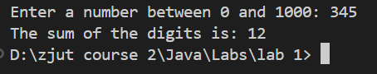
- THINKING ON THE QUESTION, DISCUSSION AND CONCLUSION
Good task for logical also for syntax.

2. Write a program that prompts the user to enter the minutes (e.g., 1 000 000 000), and displays the number of years and days for the minutes. For simplicity, assume a year has 365 days. Here is a sample run:

- SOURCE CODE (TEXT)
import java.util.Scanner;

public class minuteCounter {
public static void main(String[] args){
Scanner input = new Scanner(System.in);
System.out.print("Enter the minutes:");
int num=input.nextInt();
int days = num / (24 * 60);
int years = num / (365 * 24 * 60);
System.out.println("Days: " + days);
System.out.println("Years: " + years);
}
}

- EXECUTION RESULTS (TEXT OR SNAPSHOTS)
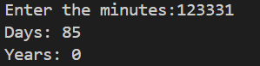
- DISCUSSION AND CONCLUSION
Task was good for practice

3. Body Mass Index (BMI) is a measure of health on weight. It can be calculated by taking your weight in kilograms and dividing by the square of your height in meters. Write a program that prompts the user to enter a weight in pounds and height in inches and displays the BMI. Note that one pound is 0.45359237 kilograms and one inch is 0.0254 meters. Here is a sample run:


- SOURCE CODE (TEXT)
import java.util.Scanner;

public class BMI {
public static void main(String[] args) {
Scanner input = new Scanner(System.in);System.out.print("Enter weight in pounds: ");
double weightInPounds = input.nextDouble();
System.out.print("Enter height in inches: ");
double heightInInches = input.nextDouble();
double weightInKilograms = weightInPounds * 0.45359237;
double heightInMeters = heightInInches * 0.0254;
double bmi = weightInKilograms / (heightInMeters * heightInMeters);
System.out.println("BMI is " + bmi);
}
}
- EXECUTION RESULTS (TEXT OR SNAPSHOTS)
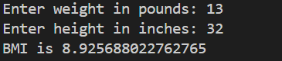
- DISCUSSION AND CONCLUSION
Mostly good for practice logical thinking of programmer

4. Write a program that prompts the user to enter the exchange rate from currency in U.S. dollars to Chinese RMB. Prompt the user to enter 0 to convert from U.S. dollars to Chinese RMB and 1 to convert from Chinese RMB and U.S. dollars. Prompt the user to enter the amount in U.S. dollars or Chinese RMB to convert it to Chinese RMB or U.S. dollars, respectively. Here are the sample runs:
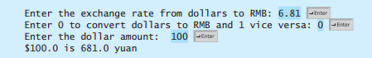

- SOURCE CODE (TEXT)
import java.util.Scanner;

public class USDtoRMB {
public static void main(String[] args){
Scanner input = new Scanner(System.in);

System.out.print("Enter exchange rate from USD to RMB: ");
float rate = input.nextFloat();

System.out.print("Enter 0 for converting USD to RMB and 1 vice versa: ");
int converter = input.nextInt();

switch (converter) {
case 0: {
System.out.print("Enter USD amount: ");
double dollar = input.nextDouble();
double yuan = dollar * rate;
System.out.println("$" + dollar + " is " + yuan + " RMB.");
break;
}
case 1: {
System.out.print("Enter RMB amount: ");
double yuan = input.nextDouble();
double dollar = yuan / rate;
System.out.println(yuan + " RMB is $" + dollar + ".");
break;
}
default:
System.out.println("Invalid input! Please enter 0 or 1.");
}
}
}

- EXECUTION RESULTS (TEXT OR SNAPSHOTS)
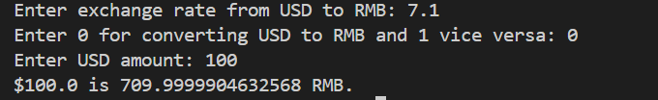
- DISCUSSION AND CONCLUSION
Really good question it took me some time to wrote it fully

5. Write a program that displays all possible combinations for picking two numbers from integers 1 to 7. Also display the total number of all combinations.
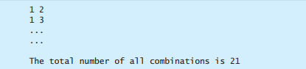

- SOURCE CODE (TEXT)
public class twonumbers {
public static void main(String[] args){
int counter=0 ;
for(int num1=1;num1<=7;num1++){
for (int num2=1;num2<=7;num2++){
if (num1!=num2){
System.out.println(num1+" "+num2);
counter++;
}
}
}
System.out.println("Total number of all combinantion is "+ counter);
}
}

- EXECUTION RESULTS (TEXT OR SNAPSHOTS)
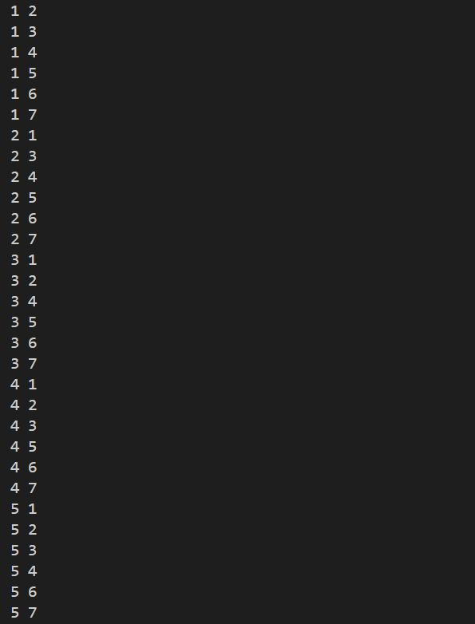
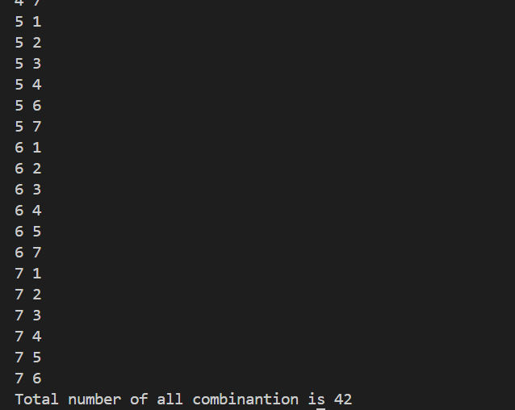
- DISCUSSION AND CONCLUSION
Task deserves to be 5^{th.} Has good logical meaning.

