Tutorial 3 & QUIZ: Implementation of Arrays

MUST READ - Put all the source code and answers into a word file, and upload the word file (just ONE Word file! name it with “your ID+date”, e.g. 202512340001_20250930.doc).  Note: there’s a deadline for uploading. | NAME: | REJEBOV ARSLAN
 | STU ID: | 3142024704046
 | DATE: | 23 October 2025

Attempt ALL questions. Each question is worth 2.5 marks, with 10 marks in total.

1. Write a Java program called Arithmetic that takes three command-line arguments: two integers followed by an arithmetic operator (+, ‐, *, /). The program shall perform the corresponding operation on the two integers and print the result.
HINT: to convert a string value (e.g. str) to integer, invoke method like this: Integer.parseInt(str), the method would return an int value. str.charAt(0) will return the first character within the string.
For example:
> java Arithmetic 3 2 +
3+2=5.0
> java Arithmetic 3 2 ‐
3-2=1.0
> java Arithmetic 3 2 /
3/2=1.5

- SOURCE CODE (TEXT)
public class Arithmetic {
public static void main(String[] args) {
if (args.length != 3) {
System.out.println("Usage: java Arithmetic <num1> <num2> <operator>");
return;
}

double num1 = Double.parseDouble(args[0]);
double num2 = Double.parseDouble(args[1]);
char op = args[2].charAt(0);
double result = 0;
boolean valid = true;

switch (op) {
case '+':
result = num1 + num2;
break;
case '-':
result = num1 - num2;
break;
case '*': // <-- multiplication works here
result = num1 * num2;
break;
case '/':
if (num2 != 0)
result = num1 / num2;
else {
System.out.println("Error: Division by zero!");
valid = false;
}
break;
default:
System.out.println("Error: Invalid operator! Use +, -, *, or /");
valid = false;
}

if (valid)
System.out.println(num1 + "" + op + num2 + "=" + result);
}
}

- EXECUTION RESULTS (TEXT OR SNAPSHOTS)
- DISCUSSION AND CONCLUSION
Discussion:
This program uses command-line arguments to perform basic arithmetic operations (+, -, *, /). The operator is given as a character, and two numbers are parsed from string to numeric values. A switch statement determines which operation to perform.
Conclusion:
The program correctly performs the desired arithmetic operation and displays the result. It also handles division by zero and invalid operators properly.

2. Two arrays list1 and list2 are strictly identical if they have the same length and list1[i] is equal to list2[i] for each i. Write a program with a method that returns true if list1 and list2 are strictly identical, using the following header:
public static boolean equal(int[] list1, int[] list2)
Write a test program that prompts the user to enter two lists of integers and displays whether the two are strictly identical. Here are the sample runs. Note that the first number in the input indicates the number of the elements in the list.
Note: method with “static” as the modifier in its header can be invoked using class name like this: ClassName.methodName().
Enter list1: 5 2 5 6 1 6
Enter list2: 5 2 5 6 1 6
Two lists are strictly identical

Enter list1: 5 2 5 6 6 1
Enter list2: 5 2 5 6 1 6
Two lists are not strictly identical

- SOURCE CODE (TEXT)
import java.util.Scanner;

public class IdenticalArrays {

public static boolean equal(int[] list1, int[] list2) {
if (list1.length != list2.length)
return false;

for (int i = 0; i < list1.length; i++) {
if (list1[i] != list2[i])
return false;
}
return true;
}

public static void main(String[] args) {
Scanner input = new Scanner(System.in);

// Read first list
System.out.print("Enter list1: ");
int size1 = input.nextInt();
int[] list1 = new int[size1];
for (int i = 0; i < size1; i++)
list1[i] = input.nextInt();

// Read second list
System.out.print("Enter list2: ");
int size2 = input.nextInt();
int[] list2 = new int[size2];
for (int i = 0; i < size2; i++)
list2[i] = input.nextInt();

// Compare and display result
if (equal(list1, list2))
System.out.println("Two lists are strictly identical");
else
System.out.println("Two lists are not strictly identical");
}
}

- EXECUTION RESULTS (TEXT OR SNAPSHOTS)
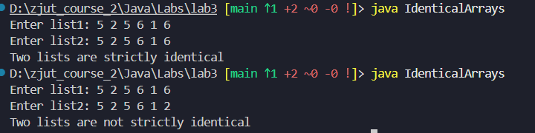
- DISCUSSION AND CONCLUSION
Discussion:
Two arrays are strictly identical if they have the same length and their corresponding elements are equal in order. The program reads two integer lists from the user and compares them element by element.
Conclusion:
The method accurately checks equality between two lists. If all elements match in the same order, the program confirms they are strictly identical.

3.
Enter list1: 5 2 5 6 6 1
Enter list2: 5 5 2 6 1 6
Two lists are identical

Enter list1: 5 5 5 6 6 1
Enter list2: 5 2 5 6 1 6
Two lists are not identical

- SOURCE CODE (TEXT)
import java.util.Arrays;
import java.util.Scanner;

public class IdenticalArraysContent {

public static boolean equal(int[] list1, int[] list2) {
if (list1.length != list2.length)
return false;

// Sort both arrays so order doesn’t matter
Arrays.sort(list1);
Arrays.sort(list2);

// Compare element by element
for (int i = 0; i < list1.length; i++) {
if (list1[i] != list2[i])
return false;
}
return true;
}

public static void main(String[] args) {
Scanner input = new Scanner(System.in);

// Read first list
System.out.print("Enter list1: ");
int size1 = input.nextInt();
int[] list1 = new int[size1];
for (int i = 0; i < size1; i++)
list1[i] = input.nextInt();

// Read second list
System.out.print("Enter list2: ");
int size2 = input.nextInt();
int[] list2 = new int[size2];
for (int i = 0; i < size2; i++)
list2[i] = input.nextInt();

// Display result
if (equal(list1, list2))
System.out.println("Two lists are identical");
else
System.out.println("Two lists are not identical");
}
}

- EXECUTION RESULTS (TEXT OR SNAPSHOTS)
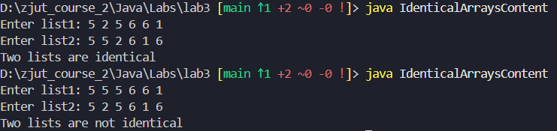
- DISCUSSION AND CONCLUSION
Discussion:
This program compares two arrays to check if they contain the same numbers, regardless of order. Both arrays are sorted first and then compared element by element.
Conclusion:
After sorting, if all values match, the program reports the arrays as identical. The approach successfully ignores order differences while ensuring identical content.

4. Write a method that sums all the integers in a matrix of integers using the following header:
public static double sumMatrix(int[][] m)
Write a test program that reads a 4-by-4 matrix and displays the sum of all its elements. Here is a sample run:
Enter a 4-by-4 matrix (row by row):
1 2 3 4
5 6 7 8
9 10 11 12
13 14 15 16
The sum of the matrix is 136.

- SOURCE CODE (TEXT)
import java.util.Scanner;

public class SumMatrix {

// Method to sum all integers in a matrix
public static double sumMatrix(int[][] m) {
double sum = 0;
for (int i = 0; i < m.length; i++) {
for (int j = 0; j < m[i].length; j++) {
sum += m[i][j];
}
}
return sum;
}

public static void main(String[] args) {
Scanner input = new Scanner(System.in);

int[][] matrix = new int[4][4];

System.out.println("Enter a 4-by-4 matrix (row by row):");
for (int i = 0; i < 4; i++) {
for (int j = 0; j < 4; j++) {
matrix[i][j] = input.nextInt();
}
}

double total = sumMatrix(matrix);
System.out.println("The sum of the matrix is " + total + ".");
}
}
- EXECUTION RESULTS (TEXT OR SNAPSHOTS)
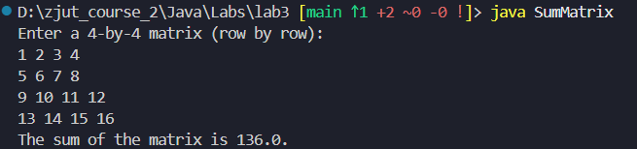
- DISCUSSION AND CONCLUSION
Discussion:
The program reads a 4×4 integer matrix and calculates the total sum of all elements using nested loops. The method sumMatrix() returns the total as a double.
Conclusion:
It correctly sums all elements of the matrix and displays the total. The program demonstrates the use of 2D arrays and nested looping effectively.

5. (Optional: 2 marks BONUS) Write a program that reads 10 integers from the keyboard and prints only the distinct ones (each value appears once).
Requirements: You must use only a plain int[] array—no List, Set, or any other Java-SE collection class. Define a method as following:
public static int[] collectUnique(int[] raw)
The method returns a new array containing only the distinct numbers; the logical size (number of valid elements) is given by the return value of collectUnique.
Enter ten numbers: 1 2 3 2 1 6 3 4 5 2
The number of distinct number is 6
The distinct numbers are: 1 2 3 6 4 5

- SOURCE CODE (TEXT)
import java.util.Scanner;

public class DistinctNumbers {

// Method to collect unique numbers from raw array
public static int[] collectUnique(int[] raw) {
int[] unique = new int[raw.length]; // max possible size
int count = 0;

for (int i = 0; i < raw.length; i++) {
boolean found = false;
// check if raw[i] is already in unique[]
for (int j = 0; j < count; j++) {
if (raw[i] == unique[j]) {
found = true;
break;
}
}
// if not found, add it
if (!found) {
unique[count] = raw[i];
count++;
}
}

// create a new array with exact size
int[] result = new int[count];
for (int i = 0; i < count; i++) {
result[i] = unique[i];
}
return result;
}

public static void main(String[] args) {
Scanner input = new Scanner(System.in);
int[] numbers = new int[10];

System.out.print("Enter ten numbers: ");
for (int i = 0; i < 10; i++) {
numbers[i] = input.nextInt();
}

int[] distinct = collectUnique(numbers);

System.out.println("The number of distinct numbers is " + distinct.length);
System.out.print("The distinct numbers are: ");
for (int n : distinct) {
System.out.print(n + " ");
}
System.out.println();
}
}

- EXECUTION RESULTS (TEXT OR SNAPSHOTS)
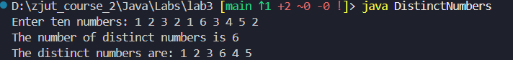
- DISCUSSION AND CONCLUSION
Discussion:
This program reads 10 integers and prints only unique values without using advanced data structures like lists or sets. It manually checks for duplicates using arrays and counts the number of distinct elements.
Conclusion:
The program successfully identifies and prints distinct integers. It shows how array-based logic can be used to remove duplicates manually.

