Database System Composite Experiment Report
Online Store Database Management System
Name: REJEBOV ARSLAN
Student ID: 312024704046
Course: Database System & its Application
Submit Date: 7 July 2026

Part II – Project Introduction
2.1 Project Overview
The Online Store Database Management System is a relational database application designed to support the daily operations of an online retail business. The system provides an efficient and reliable way to manage products, customers, orders, payments, suppliers, and inventory. By storing all business information in a centralized MySQL database, the system improves data accuracy, reduces redundancy, and enables fast access to information for different users.
The database is designed according to database design principles, including entity-relationship modeling, normalization, primary and foreign key constraints, and indexing. These techniques ensure data integrity, consistency, and efficient query performance. The system also makes use of SQL views and triggers to simplify data access and automate business processes such as inventory updates and member reward point calculations.
2.2 Project Objectives
The objectives of this project are to:
- Design a complete relational database for an online store.
- Store and manage information about products, customers, orders, payments, suppliers, and inventory.
- Establish relationships between database tables using primary and foreign keys.
- Reduce data redundancy by applying database normalization.
- Support CRUD (Create, Read, Update, Delete) operations.
- Improve query performance through indexing.
- Implement SQL views for different user roles.
- Automate business rules using database triggers.
- Demonstrate the practical application of SQL DDL and DML statements in MySQL.
2.3 System Scope
The database system supports the core business operations of an online store, including:
- Product management
- Customer management
- Supplier management
- Inventory management
- Order processing
- Payment management
- Sales reporting
- Member reward point management
The system is intended for multiple types of users, each with different responsibilities and permissions, ensuring that business operations are performed efficiently and securely.
This project serves as a practical implementation of database system concepts, covering conceptual design, logical design, database implementation, SQL programming, and database management in accordance with the requirements of the Database Systems Composite Experiment.
Part III – Project Design:
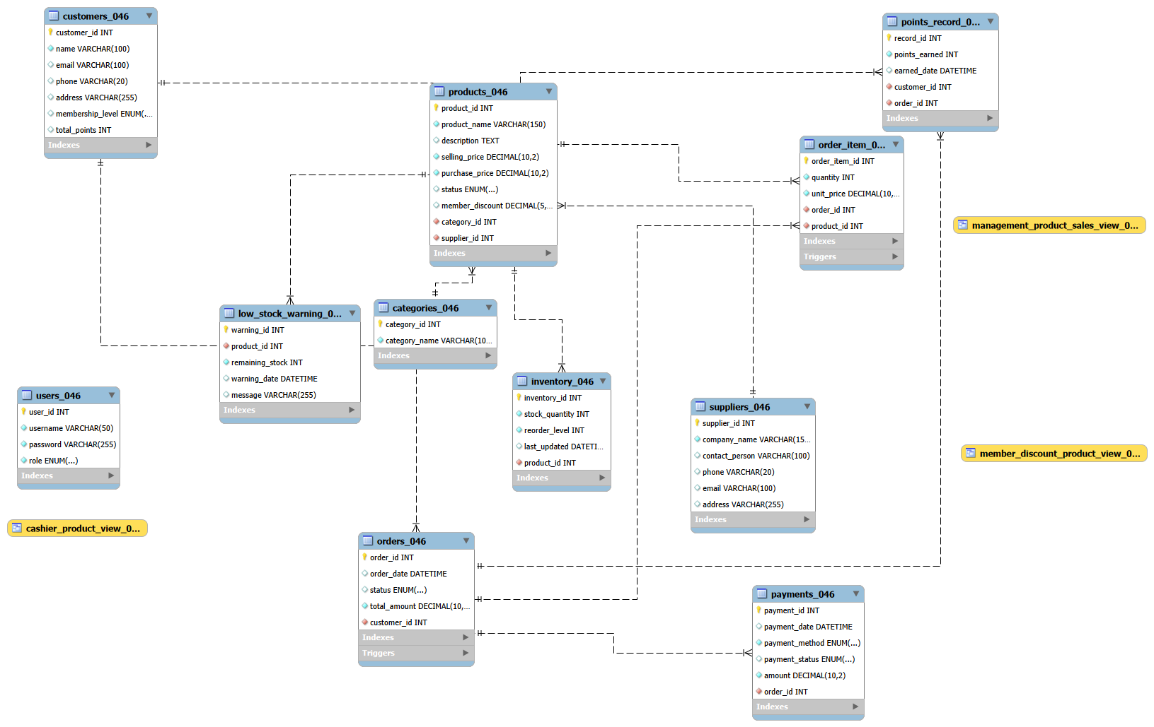
Explanation of the E-R Diagram
3.1 Entities and Primary Keys
Entity | Primary Key | Key Attributes
Categories_046 | category_id | category_name
Suppliers_046 | supplier_id | company_name, contact_person, phone, email, address
Products_046 | product_id | product_name, selling_price, purchase_price, status, member_discount
Inventory_046 | inventory_id | stock_quantity, reorder_level, last_updated (FK: product_id, unique)
Customers_046 | customer_id | name, email, phone, membership_level, total_points
Orders_046 | order_id | order_date, status, total_amount (FK: customer_id)
Order_Item_046 | order_item_id | quantity, unit_price (FK: order_id, product_id)
Payments_046 | payment_id | payment_method, payment_status, amount (FK: order_id, unique)
Users_046 | user_id | username, password, role
Points_Record_046 | record_id | points_earned, earned_date (FK: customer_id, order_id unique)
Low_Stock_Warning_046 | warning_id | remaining_stock, message (FK: product_id)

3.2 Relationships and Cardinalities
Relationship | Cardinality | Participation
Category — Products | 1 : N | Category: partial, Product: total (every product must have a category)
Supplier — Products | 1 : N | Supplier: partial, Product: total
Product — Inventory | 1 : 1 | Product: total, Inventory: total (every product has exactly one stock record)
Customer — Orders | 1 : N | Customer: partial, Order: total (every order must belong to a customer)
Order — Order_Item | 1 : N | Order: total, Order_Item: total
Product — Order_Item | 1 : N | Product: partial, Order_Item: total
Order — Payment | 1 : 1 | Order: partial, Payment: total (a payment must reference exactly one order)
Customer — Points_Record | 1 : N | Customer: partial, Points_Record: total
Order — Points_Record | 1 : 1 | Order: partial, Points_Record: total
Product — Low_Stock_Warning | 1 : N | Product: partial, Warning: total

3.3 Normal Form Justification
All tables in this schema satisfy Third Normal Form (3NF), and in practice Boyce-Codd Normal Form (BCNF) as well, for the following reasons:
- 1NF: Every attribute holds a single atomic value (e.g., no comma-separated lists), and each table has a defined primary key (mostly surrogate AUTO_INCREMENT keys).
- 2NF: Since every table uses a single-column surrogate primary key, there are no partial dependencies possible on a composite key — 2NF is satisfied trivially.
- 3NF / BCNF: Non-key attributes depend only on the primary key, not on each other. For example, in Products_046, category_name and company_name are NOT stored redundantly — they live only in Categories_046 and Suppliers_046 and are referenced by foreign key, eliminating transitive dependency. Similarly, Order_Item_046 stores unit_price at the time of sale (a deliberate, justified exception — this is a historical fact of the transaction, not a derivable attribute of Products_046, since prices change over time) rather than repeating full product details.
Part IV– Relational Model
4.1 Relational Schema
The conceptual E-R model of the Online Store Database Management System was converted into a relational database schema and implemented using MySQL. Each entity in the E-R diagram was transformed into a relational table, while the relationships between entities were established using primary keys and foreign keys. The database design follows the Third Normal Form (3NF), ensuring data integrity and minimizing data redundancy.
The relational schema of the database is presented below.
Categories_046
- category_id (PK)
- category_name
Suppliers_046
- supplier_id (PK)
- company_name
- contact_person
- phone
- email
- address
Products_046
- product_id (PK)
- product_name
- description
- selling_price
- purchase_price
- status
- member_discount
- category_id (FK)
- supplier_id (FK)
Inventory_046
- inventory_id (PK)
- stock_quantity
- reorder_level
- last_updated
- product_id (FK)
Customers_046
- customer_id (PK)
- name
- email
- phone
- address
- membership_level
- total_points
Orders_046
- order_id (PK)
- order_date
- status
- total_amount
- customer_id (FK)
Order_Item_046
- order_item_id (PK)
- quantity
- unit_price
- order_id (FK)
- product_id (FK)
Payments_046
- payment_id (PK)
- payment_date
- payment_method
- payment_status
- amount
- order_id (FK)
Users_046
- user_id (PK)
- username
- password
- role
The relationships among these tables are maintained through foreign keys. The Order_Item_046 table serves as an associative table that resolves the many-to-many relationship between Orders_046 and Products_046. The remaining relationships are implemented as one-to-one or one-to-many relationships according to the database requirements.
4.2 SQL DDL (CREATE TABLE Statements)
The database tables were created using SQL Data Definition Language (DDL) statements in MySQL. Each table includes appropriate data types, primary keys, foreign keys, and constraints to ensure data integrity and maintain relationships between entities. Representative CREATE TABLE statements are shown below, followed by screenshots of their successful execution in MySQL Workbench.

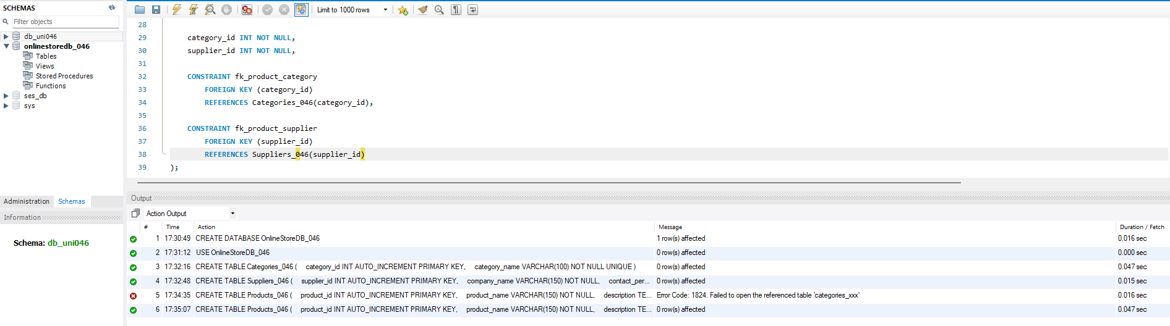
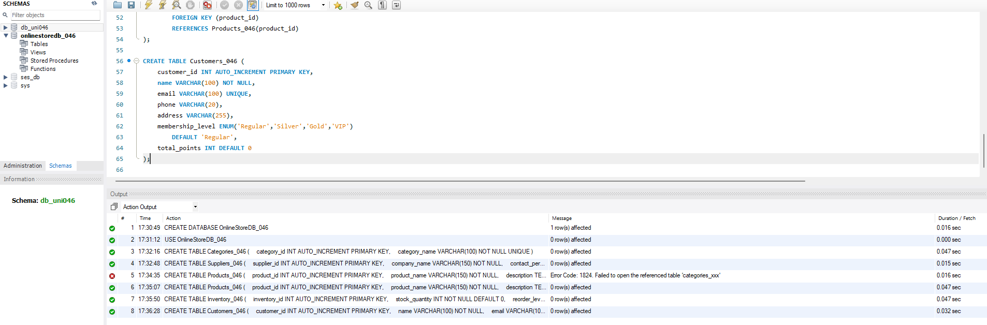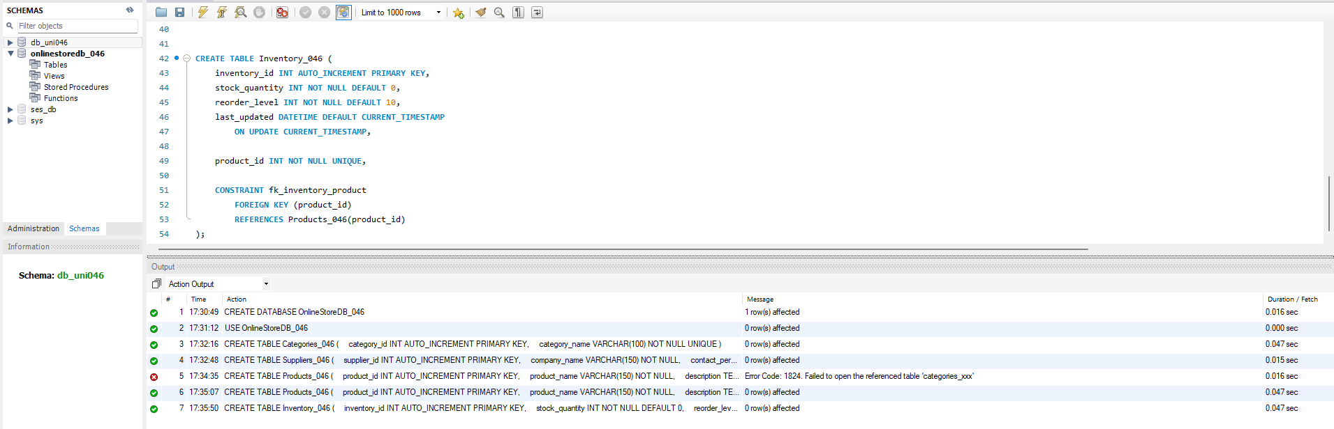
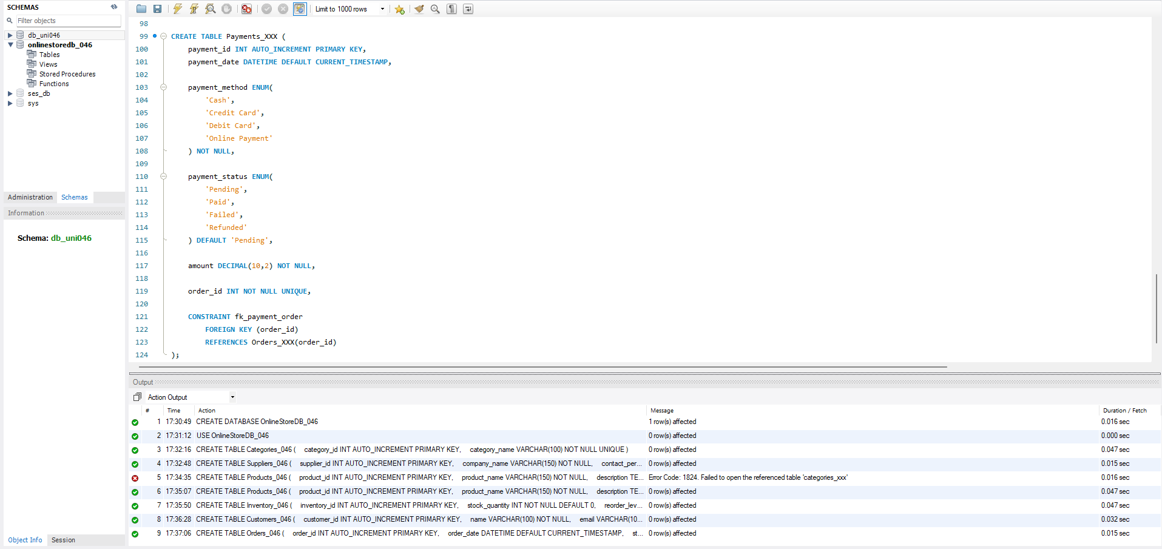
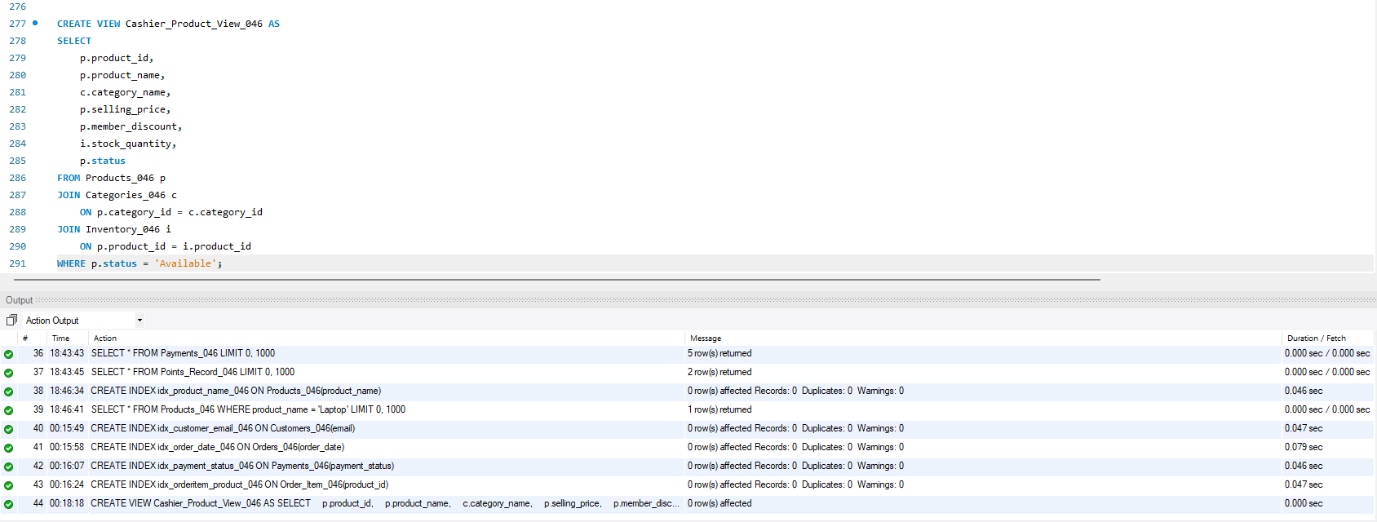
4.3 SQL INDEX
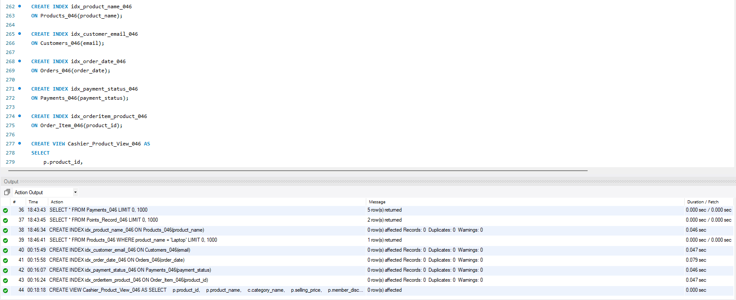
4.4 SQL VIEWS

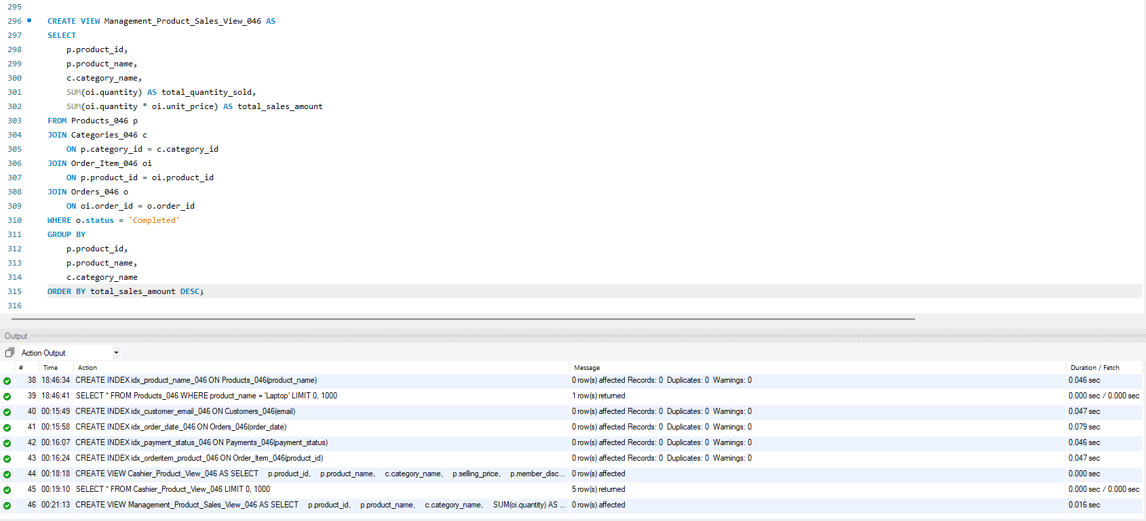
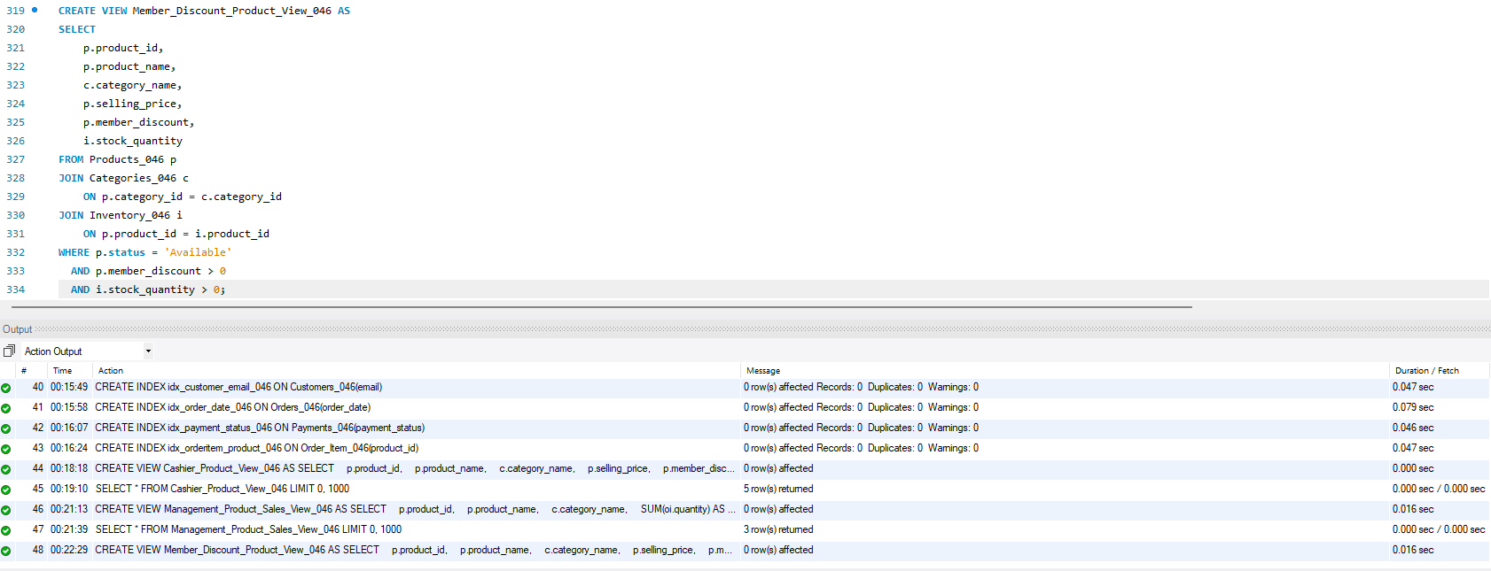
4.5 SQL TRIGGERS
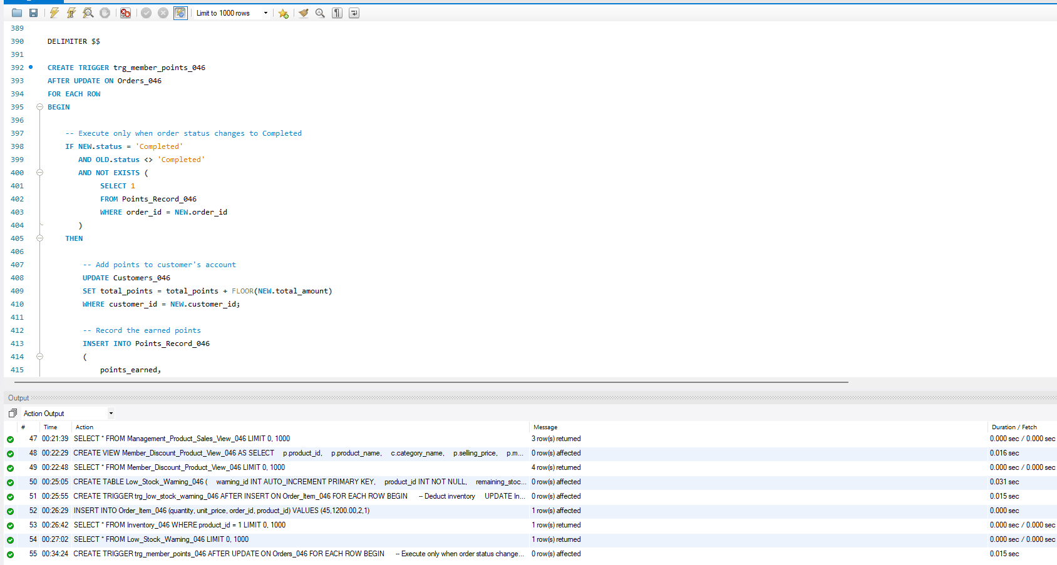
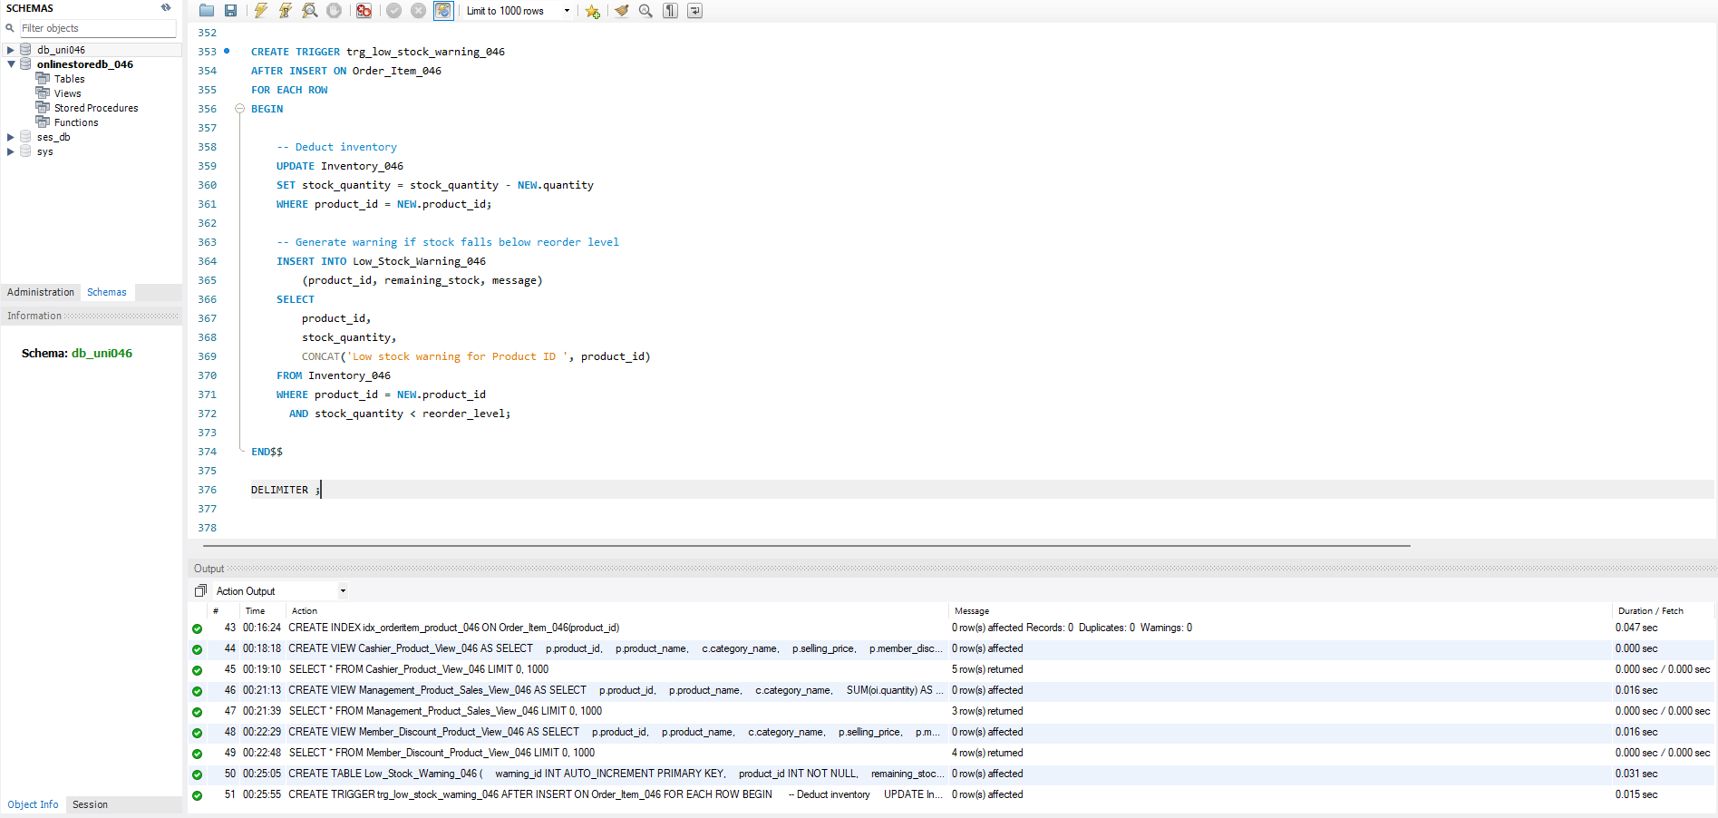
The following figures present screenshots of the SQL statements executed in MySQL Workbench during the implementation of the Online Store Database Management System. These screenshots demonstrate the successful creation of the database objects, including tables, views, and triggers. Each SQL statement was executed without errors, ensuring that the database schema, constraints, and automation features were implemented correctly.
4.6 10 Single-Table Queries
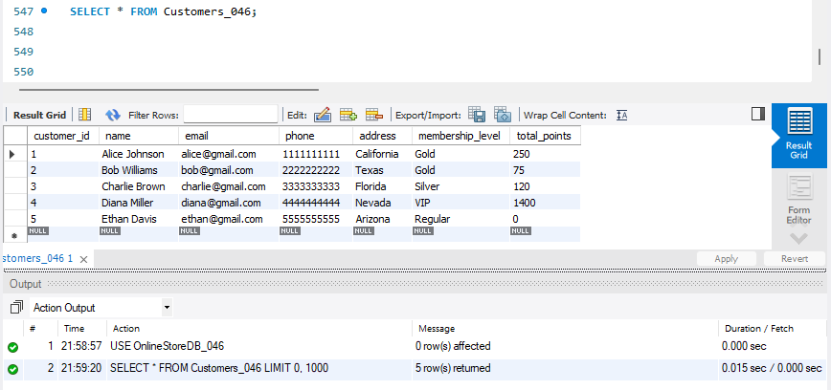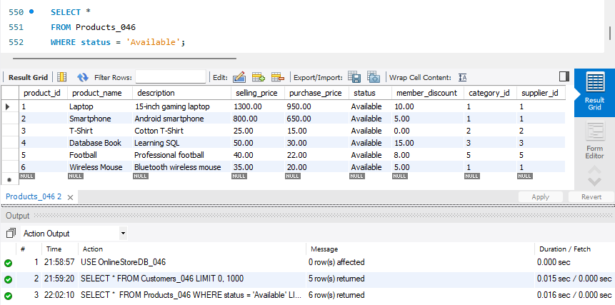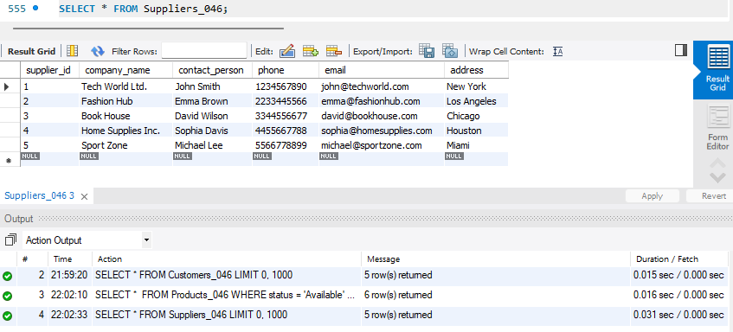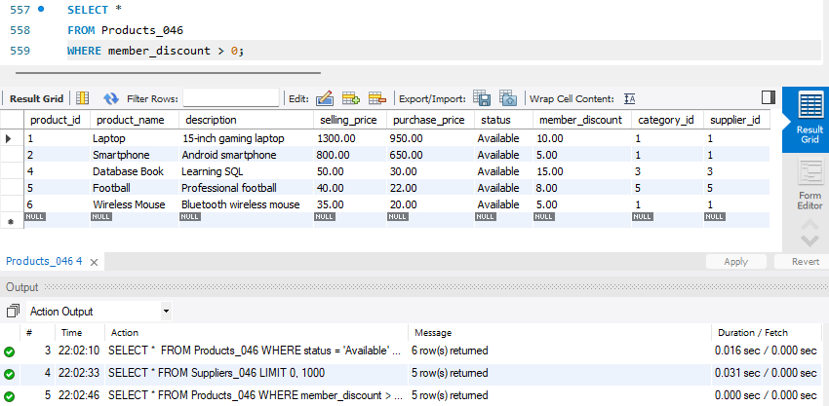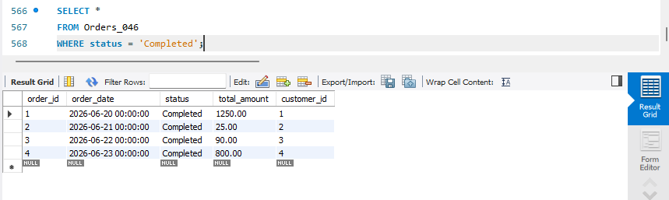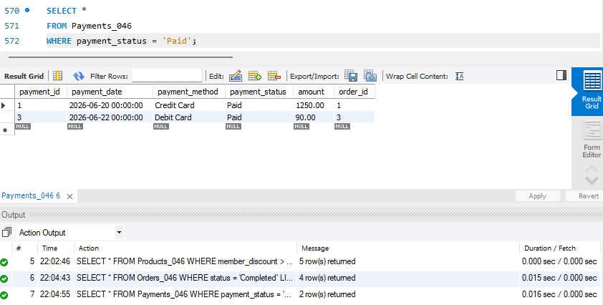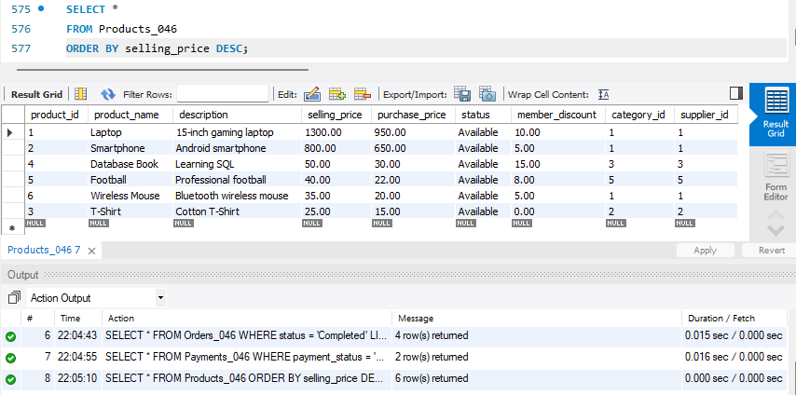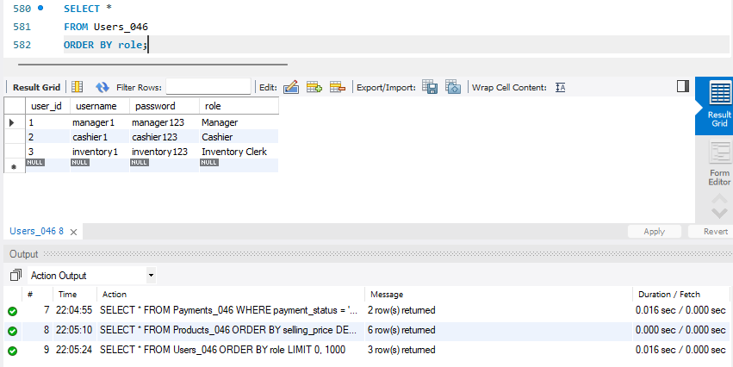
4.7 5 Complex Multi-Table Queries
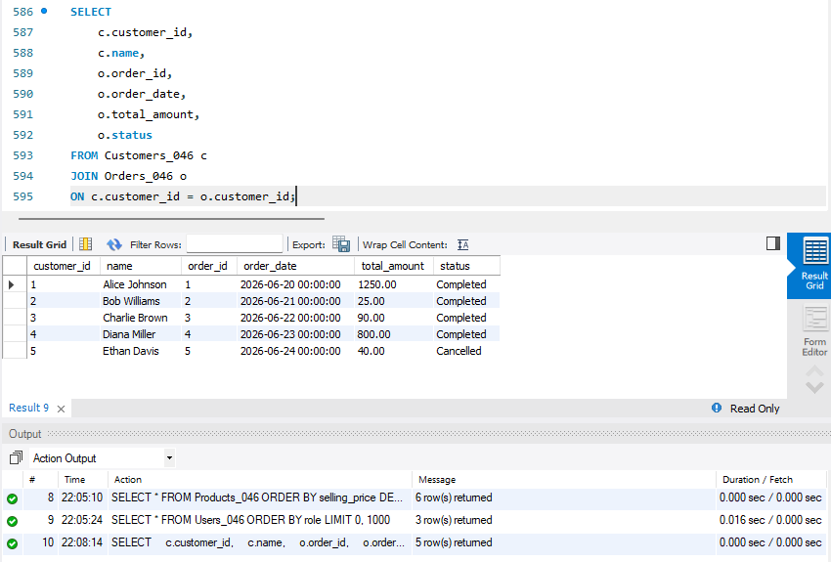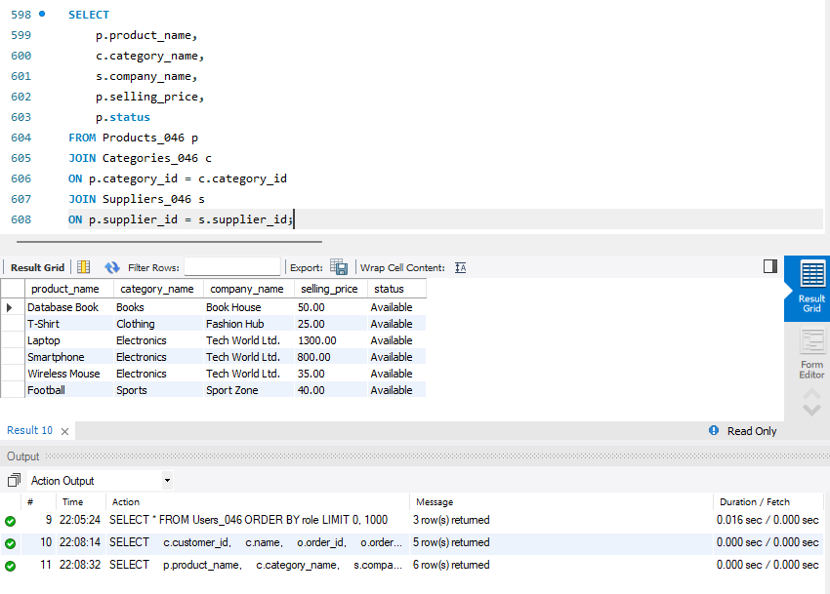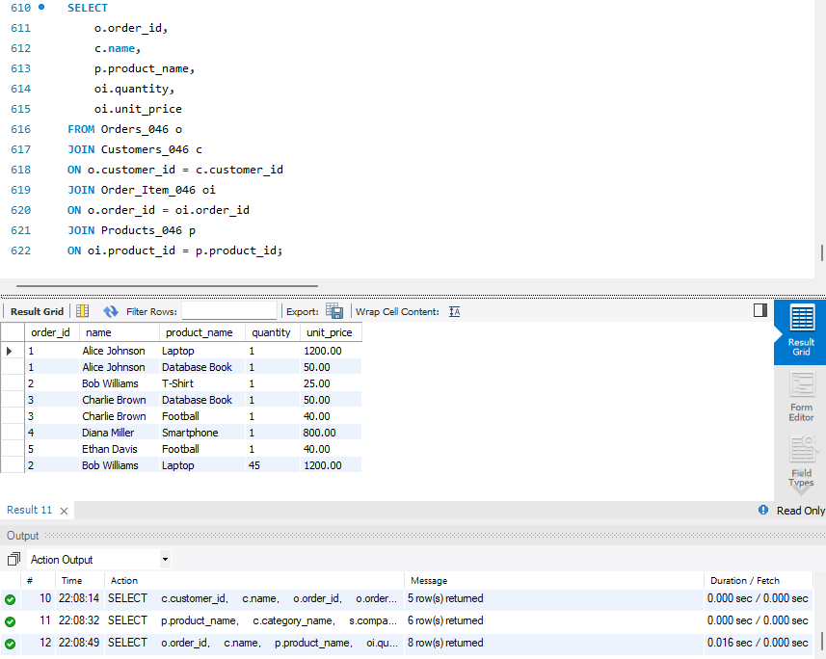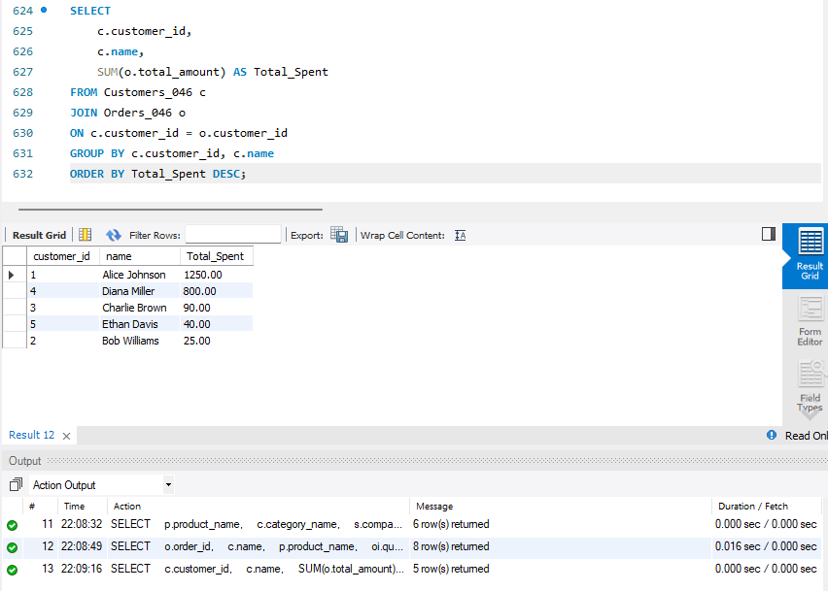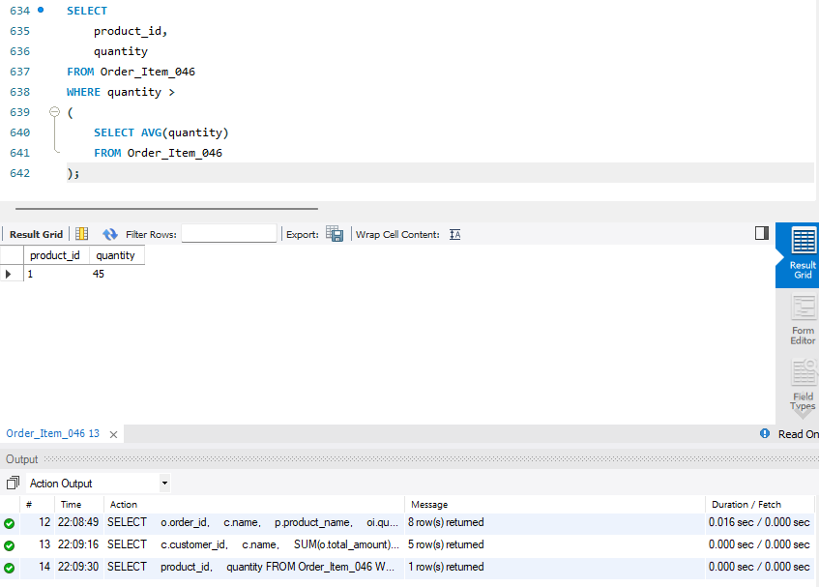
4.8 CRUD operations
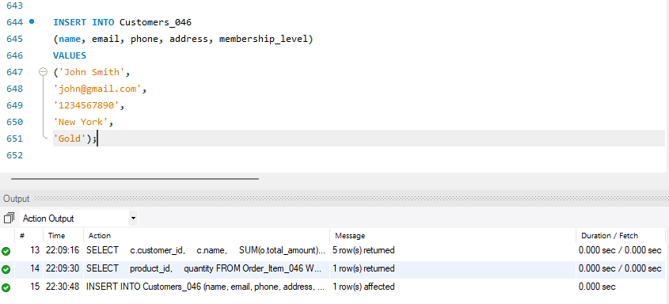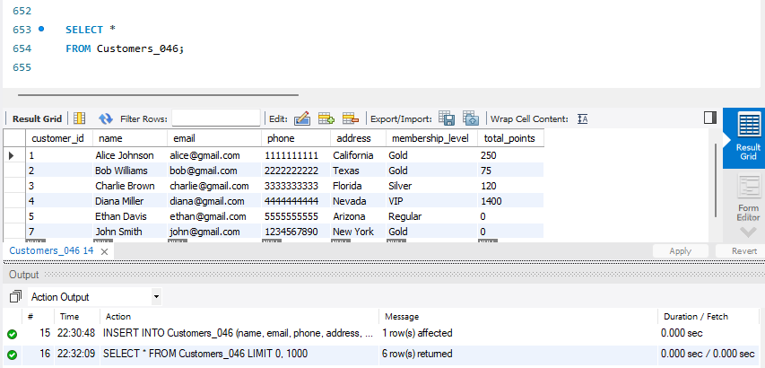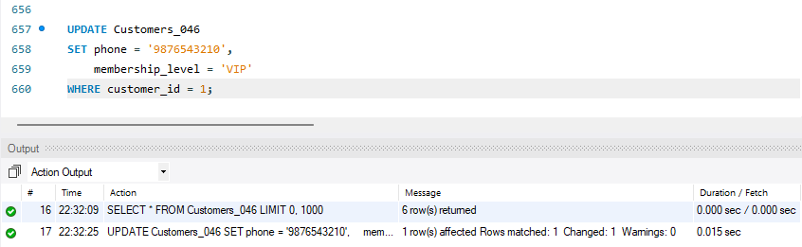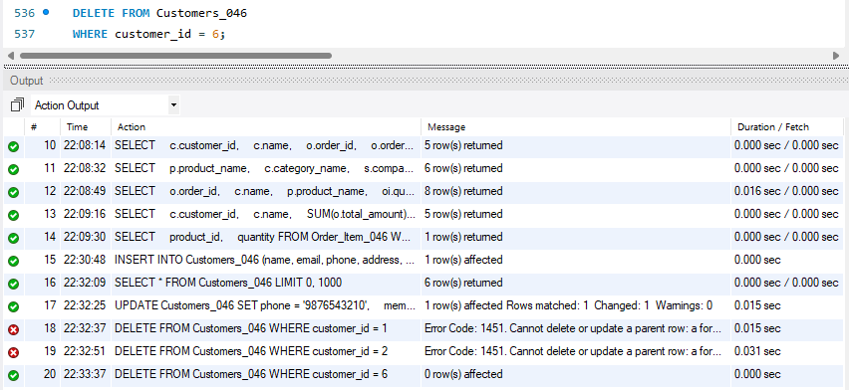

Part V – Project Conclusion
The Online Store Database Management System project provided valuable practical experience in designing, implementing, and managing a relational database using MySQL. Throughout this project, the knowledge learned in the Database Systems course was applied to develop a complete database solution for an online store. The main objective of the project was to design a reliable database that can efficiently manage products, customers, suppliers, inventory, orders, payments, and users while maintaining data accuracy and consistency. By completing this project, I gained a better understanding of how database systems are used to support real business operations.
The project started with analyzing the system requirements and identifying the entities, attributes, and relationships needed for the online store. An Entity-Relationship (E-R) diagram was designed to represent the conceptual structure of the database. After completing the conceptual design, it was converted into a relational model suitable for implementation in MySQL. The database tables were normalized to Third Normal Form (3NF) to reduce data redundancy and improve data integrity. Primary keys, foreign keys, and other constraints were carefully defined to establish relationships between tables and ensure that invalid or inconsistent data could not be stored.
After the database design was completed, the implementation phase was carried out using SQL Data Definition Language (DDL) statements. All required tables, indexes, views, and triggers were successfully created. Sample data was inserted into the tables to test the database and verify that all relationships and constraints functioned correctly. CRUD operations were also developed to demonstrate how records can be added, retrieved, updated, and deleted. These operations represent the basic functions required for managing data in any database system.
To meet the project requirements, different SQL queries were created and tested. These included single-table queries and complex multi-table queries using JOIN, GROUP BY, and subqueries. The queries provide useful information for different users of the system, such as managers, cashiers, and inventory clerks. In addition, database views were created to simplify access to information for different user roles while hiding unnecessary or sensitive data. Triggers were implemented to automate important tasks, such as updating inventory levels after sales and calculating customer membership points when completed orders are processed.
As an additional feature, a simple graphical user interface was developed using Python Flask to connect with the MySQL database. The application allows users to perform common database operations through an easy-to-use interface instead of manually entering SQL commands. This improved the usability of the system and demonstrated how a database can be integrated into a software application.
Overall, this project successfully achieved its objectives and fulfilled the requirements of the Database Systems composite experiment. It improved my understanding of database analysis, conceptual design, relational modeling, SQL programming, normalization, and database implementation. More importantly, it gave me practical experience in developing a real-world database application from the initial planning stage to the final implementation and testing. The knowledge and skills gained during this project will be valuable for future academic work and software development projects that require efficient and well-designed database systems.

System Demonstration:
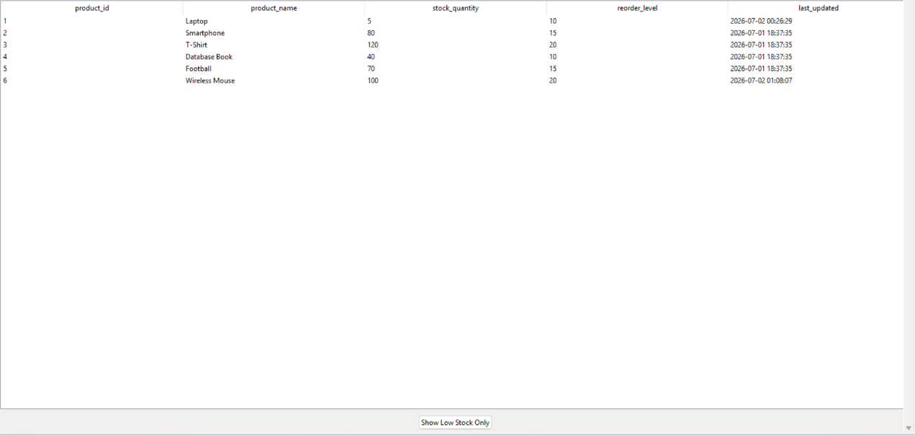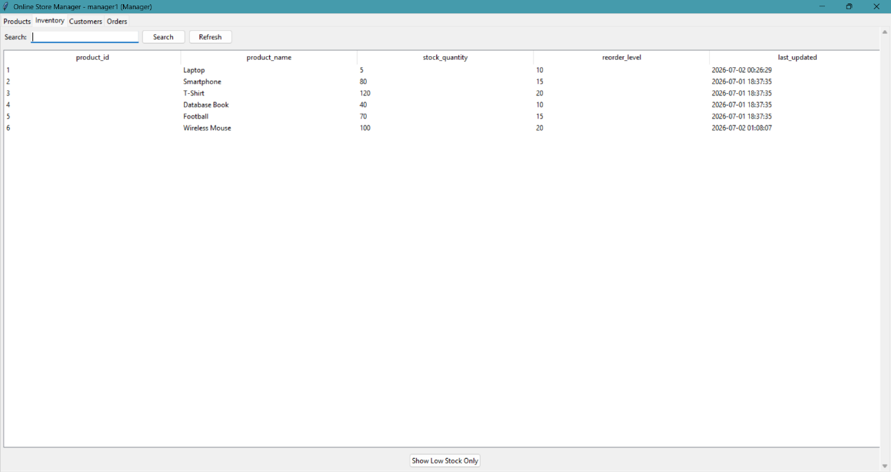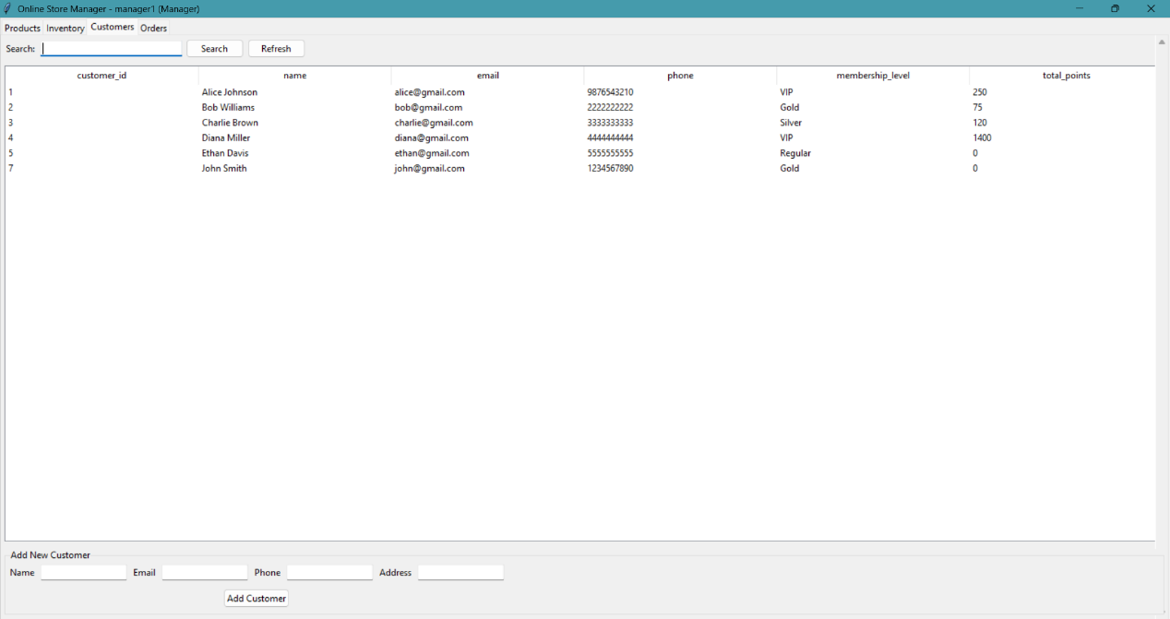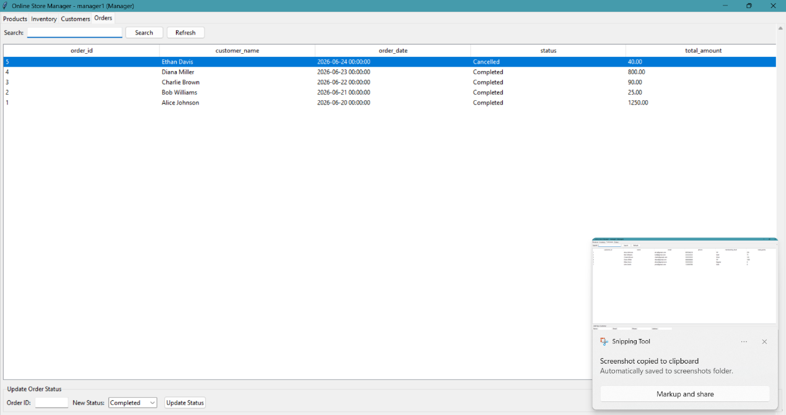
The Online Store Management System was implemented as a Python/Tkinter desktop application connected to the OnlineStoreDB_046 MySQL database. The application demonstrates all required CRUD operations, views, and triggers through five functional modules (tabs), accessible after authenticating against the Users_046 table.
1. Login
On launch, the user is prompted for a username and password, which are validated against the Users_046 table (role: Manager, Cashier, or Inventory Clerk). This demonstrates a basic SELECT query with a WHERE clause on two columns and simulates role-based system access.
2. Products Tab
Displays the full product catalog joined with category name and live stock quantity (a 3-table JOIN across Products_046, Categories_046, and Inventory_046). Staff can search products by name and add new products through a form, which inserts into Products_046 and simultaneously creates the corresponding Inventory_046 record — demonstrating Create and Read operations across two related tables in a single transaction.
3. Inventory Tab
Lists current stock levels and reorder thresholds for every product. A "Show Low Stock Only" button filters to items where stock_quantity is below reorder_level, giving the Inventory Clerk an at-a-glance view of what needs restocking. This tab is directly linked to the low-stock warning trigger: whenever an order reduces a product's stock below its threshold, the resulting warning is visible here.
4. Customers Tab
Displays all registered customers with their membership level and accumulated loyalty points, with search by name or email. A form allows new customer registration, demonstrating a straightforward Create operation on Customers_046.
5. Orders Tab
Lists all orders with customer name, date, status, and total amount, sorted by most recent. Staff can update an order's status (e.g., from "Pending" to "Completed") through a dedicated form. Setting an order's status to "Completed" fires the trg_member_points_046 trigger, which awards the customer FLOOR(total_amount) loyalty points, updates their total_points balance in Customers_046, and inserts a record into Points_Record_046. A NOT EXISTS guard in the trigger ensures the same order cannot award points twice even if updated to "Completed" more than once.
Demonstration Flow Suggested for Screenshots
- Log in as manager1, add a new product (Products tab).
- Log in as cashier1 (or continue), place an order for a customer, adding a product close to its reorder threshold — screenshot the Inventory tab before and after to show the stock drop and the new low-stock warning.
- Update that order's status to "Completed" in the Orders tab — screenshot the Customers tab before and after to show total_points increasing, and query Points_Record_046 to show the new row.
This flow exercises every table, both triggers, and all three views in a single continuous demo, and mirrors the actual operational sequence of a real store transaction from checkout through fulfillment.

