SPARWRIGHT / WORKING BRAND
B2B WEBSITE
DESIGN SYSTEM
A practical visual, content and component framework for a custom fight-gear manufacturer serving clubs, gyms and private-label brands.
BUILT FOR YOUR CORNER.

VERSION | PREPARED | PRIMARY MARKET | PRIMARY OUTCOME
1.0 | 09 September 2026 | UK and Europe | Qualified B2B enquiries

Working-name note
“Sparwright” is used throughout as a working brand. The visual system, components and page architecture remain valid if the final company name changes.

DESIGN-SYSTEM INTENT
A focused B2B operating system, not a retail theme.
This document defines how the website should look, speak and behave—from brand positioning and visual tokens to quote forms, page templates and launch measurement.
North star
Make a UK or European club owner feel that they have found a specialized, transparent manufacturing partner—not another broad exporter and not a consumer sports shop.

Project frame
Dimension | Decision
Business model | B2B custom manufacturing and private label
Specialization | Boxing gloves, combat equipment, fightwear and club apparel
Manufacturing story | Sialkot-based production with 10+ years of hands-on experience
Initial buyers | Boxing clubs, martial-arts gyms, small fightwear brands and retailers
Initial market | UK first; broader Europe after repeatable validation
Primary conversion | Request a custom mockup or manufacturing quote
Budget posture | Lean, evidence-led and manual where automation is not yet justified

How to use this system
Design  Use the foundations, tokens, components and page patterns to build consistent interfaces. | Development  Translate the component inventory and CSS tokens into reusable frontend primitives.
Content  Follow the messaging hierarchy, voice rules and approved call-to-action language. | Sales operations  Connect forms, mockup requests and follow-up ownership to a simple CRM workflow.

Contents
01 Brand foundations | 09 Imagery and graphic language
02 Visual direction | 10 Content design
03 Logo system | 11 Information architecture
04 Colour system | 12 Responsive and accessibility
05 Typography | 13 Implementation system
06 Layout and spatial system | 14 MVP, analytics and roadmap
07 Motion system | 15 Launch checklist
08 Core components | A Starter copy library
SECTION 01

Brand foundations
The brand must be understood before it is admired. Every major page should quickly establish the product, buyer, manufacturing model and next action.

Positioning statement
Primary position
Custom fight gear for clubs and brands.

Supporting statement
Boxing gloves, fightwear and club apparel manufactured in Sialkot with your logo, colours and specifications.

Brand promise
A clear path from initial concept to approved sample, controlled production and repeat orders.

Messaging hierarchy
Level | Question answered | Message
1. Category | What do you do? | Custom fight-gear manufacturing
2. Audience | Who is it for? | Clubs, gyms, retailers and private-label brands
3. Capability | What can be customized? | Product, construction, colour, branding and packaging
4. Credibility | Why trust you? | Real makers, real process, sample approval and visible quality checks
5. Action | What happens next? | Send the logo, quantity, destination and product brief

Primary audiences
Boxing clubs  Need coordinated equipment and apparel with club identity, practical quantities and a dependable reorder path. | Martial-arts gyms  Need fightwear, equipment and team apparel suited to their discipline and member base.

Additional B2B buyers
Fightwear brands  Need a private-label partner for product development, labels, packaging and repeatable production. | Specialist retailers  Need differentiated products, clear specifications and commercially sensible order planning.

Conversion hierarchy
Priority | Action | Use
Primary | Request your mockup | Lead magnet for clubs and gyms
Secondary | Get a manufacturing quote | Qualified buyers with defined requirements
Tertiary | View custom products | Research-stage visitors
Support | WhatsApp / email | Human follow-up, not the main data-capture path

Brand personality
Trait | Desired expression | Avoid
Confident | Strong, clear and evidence-led | Boastful “number one” claims
Technical | Specific materials, process and approvals | Dense jargon without buyer value
Human | Named makers and real workshop evidence | Anonymous corporate stock imagery
Premium | Controlled, intentional and consistent | Luxury effects or over-styling
Direct | Clear steps, requirements and responsibilities | Vague “contact us for everything” language
Specialized | Combat sports first | Manufacturing every imaginable product
SECTION 02

Visual direction
The visual identity should combine manufacturing precision, combat-sports energy and human craftsmanship without becoming aggressive or theatrical.

Concept: Crafted Combat
The system uses warm neutral surfaces, disciplined dark typography, a focused forge-red accent and real product/process imagery. It should feel like a specialist product-development partner.
70% neutral surfaces  Bone, white, black and charcoal create clarity, confidence and space for product photography. | 20% real imagery  Manufacturing, materials, makers and completed products provide most of the trust.
10% red accent  Red signals action, active states, stage numbers and selective emphasis. | Structured, not sterile  Measurement marks, specification labels and maker-stamp details add character without noise.

The website should feel like
- A specialized manufacturing partner for combat-sports organizations.
- A modern digital sales experience connected to an experienced production team.
- A clear, inspectable process from product brief to sample and bulk production.
- A company small enough to communicate directly and disciplined enough to deliver consistently.

The website should not feel like
- A generic exporter with hundreds of unrelated product categories.
- A consumer fightwear store built around discounts and “shop now” language.
- A fight-promotion poster using flames, blood, distressed textures and constant motion.
- A large factory using invented statistics, stock photography and unsupported claims.

Visual decision rules
Decision | Rule
Hierarchy | One dominant message and one primary action per section.
Photography | Product and process first; fighters are secondary context.
Red usage | Reserve for action, active state, stage number or brief emphasis.
Cards | Use only when content benefits from grouping; avoid “carding” every paragraph.
Texture | Use subtle material or seam detail; never obscure type.
Density | Alternate information-rich areas with visual proof and generous whitespace.
SECTION 03

Logo system
The identity must work equally well in a website header, on a glove wrist label, in embroidery, on product packaging and in small digital contexts.

Recommended lockups
Primary horizontal | SPARWRIGHT  Custom Fight Gear
Wordmark only | SPARWRIGHT
Maker’s mark | SW

Construction direction
- Uppercase geometric wordmark with stable proportions and excellent small-size legibility.
- A subtle customized cut in the W or R can reference glove panels or pattern construction.
- The maker’s mark may sit inside a rectangular stamp or restrained seam-inspired frame.
- Keep details simple enough for embroidery, woven labels, debossing and one-colour printing.

Clear space and minimum size
Asset | Clear space | Minimum digital size | Typical use
Primary lockup | Height of the S on all sides | 140 px wide | Desktop header, documents, packaging
Wordmark | Height of the S on all sides | 100 px wide | Compact header, labels, quotation
Maker’s mark | Half the mark width | 24 px wide | Favicon, avatar, product label

Do not use
- Generic glove or clenched-fist symbols as the entire identity.
- Flames, wings, complex shields, metallic effects or three-dimensional gradients.
- Stretched, outlined, rotated or recoloured wordmarks outside approved variants.
- The mark over busy imagery without a controlled contrast panel.
SECTION 04

Colour system
A restrained palette supports product texture and manufacturing evidence while preserving strong conversion signals.

Core palette
Swatch | Token | Hex | Primary use
 | ink-950 | #0B0D10 | Main text, dark backgrounds and footer
 | carbon-900 | #15191F | Dark cards and secondary dark surfaces
 | steel-700 | #39424E | Secondary text on light surfaces
 | slate-500 | #69737E | Muted labels and secondary metadata
 | line-200 | #DDE1E4 | Borders, dividers and input outlines
 | bone-50 | #F4F1E8 | Main warm page background
 | white | #FFFFFF | Cards, forms and alternate sections
 | forge-600 | #D83A20 | Primary actions and active states
 | forge-700 | #B8321F | Hover state and stronger text accent
 | forge-100 | #FBE6E0 | Soft highlight panels
 | success-600 | #1F7A4D | Confirmations and successful uploads

Theme recipes
Theme | Background | Heading | Body | Card / border | Primary action
Light | Bone | Ink | Steel | White / Line | Forge
White | White | Ink | Steel or Slate | Bone / Line | Forge
Dark | Ink | White | #C5CBD1 | Carbon / translucent white | Forge
Action band | Forge | White | White | None | Ink

Usage rules
- Use forge red to indicate action, selection, progress or compact emphasis—not as a general background colour.
- Do not place long paragraphs on red; reserve red bands for short conversion moments.
- Do not use low-contrast grey text over bone or photography.
- Error, warning and success states must include icons and written messages, not colour alone.
- Validate every final text/background pair against current accessibility contrast requirements.
SECTION 05

Typography
Two complementary sans-serif families create a technical, modern system that remains highly readable across content, forms and product specifications.

Font pairing
Role | Typeface | Weights | Use
Display and headings | Archivo | 600, 700 | Hero, page titles, section headings and major labels
Body and interface | Inter | 400, 500, 600 | Paragraphs, navigation, buttons, forms, tables and captions
Code / tokens | Liberation Mono | 400 | Implementation snippets and technical labels in the document only

Implementation note
If Archivo is not available at launch, Inter Display may be used temporarily for headings. Do not introduce a third decorative display face.

Responsive type scale
Token | Desktop | Mobile | Line height | Primary use
display-xl | 72–80 px | 46–52 px | 0.98 | Homepage hero
display-lg | 56–64 px | 40–44 px | 1.02 | Major campaign or audience hero
heading-1 | 48–56 px | 36–40 px | 1.08 | Page title
heading-2 | 38–44 px | 30–34 px | 1.12 | Major section
heading-3 | 28–32 px | 24–28 px | 1.20 | Component group
heading-4 | 21–24 px | 20–22 px | 1.30 | Card or subsection title
body-large | 18 px | 17 px | 1.65 | Lead paragraph
body | 16 px | 16 px | 1.65 | Primary body copy
small | 14 px | 14 px | 1.55 | Labels and metadata
eyebrow | 12 px | 12 px | 1.40 | Short uppercase context label

Typography rules
- Keep most headlines under ten words and one dominant idea.
- Limit paragraph width to approximately 55–72 characters.
- Use sentence case for headings; uppercase is reserved for short labels and specification tags.
- Do not centre paragraphs longer than two lines.
- Use bold to create hierarchy, not to emphasize every sentence.
- Use fluid CSS type with clamp() rather than abrupt jumps between breakpoints.
FLUID HERO TYPE
.hero-title {
font-family: var(--font-display);
font-size: clamp(3rem, 7vw, 5rem);
line-height: 0.98;
letter-spacing: -0.035em;
text-wrap: balance;
}
SECTION 06

Layout and spatial system
The grid should make the site feel deliberate and spacious while keeping product specifications, forms and manufacturing evidence easy to scan.

Container system
Container | Maximum width | Use
Page shell | 1280 px | Primary page sections
Standard working area | 1200 px | Most content and component grids
Prose | 720 px | Long-form copy, FAQs and manufacturing explanations
Form | 640 px | Quote, mockup and sampling workflows

Grid
Viewport | Columns | Gutter | Outer margin | Notes
Desktop | 12 | 24 px | 32 px | Hero commonly uses 7 / 5 split
Tablet | 8 | 24 px | 24 px | Two-column layouts where comfortable
Mobile | 4 | 16 px | 20 px | Single-column content and full-width actions

Breakpoints and testing widths
Token | Breakpoint | Mandatory QA widths
small | 480 px | 360 and 390 px
medium | 768 px | 768 px
large | 1024 px | 1024 px
xlarge | 1280 px | 1280 px
wide | 1440 px | 1440 px

Spacing scale
Token | Value | Typical use
space-1 | 4 px | Micro gap
space-2 | 8 px | Icon / label gap
space-3 | 12 px | Compact controls
space-4 | 16 px | Default internal gap
space-5 | 24 px | Card padding
space-6 | 32 px | Component separation
space-7 | 48 px | Subsection spacing
space-8 | 64 px | Mobile section spacing
space-9 | 80 px | Tablet / compact desktop section
space-10 | 96 px | Standard desktop section
space-11 | 128 px | Large visual section

Shape, border and elevation
Token | Value | Use
radius-sm | 4 px | Tags and small controls
radius-md | 6 px | Buttons and inputs
radius-lg | 10 px | Cards and images
radius-xl | 16 px | Feature panels
radius-pill | 999 px | Status labels only
border-standard | 1 px Line 200 | Cards, dividers and inputs
border-selected | 2 px Forge 600 | Selected form cards
shadow-card | Very soft two-layer | Occasional raised card
shadow-overlay | 24 / 60 soft shadow | Menus and modal overlays

Shape rule
Avoid excessive rounded cards. The identity should feel constructed and precise rather than soft or playful.
SECTION 07

Motion system
Motion should confirm responsiveness and state change. It should never compete with the product, delay access to content or imitate a fight-promotion video.

Motion tokens
Token | Duration | Use
motion-fast | 120 ms | Press, icon and micro-state
motion-standard | 200 ms | Hover, focus and accordion change
motion-emphasis | 360 ms | Form-step or panel transition
ease-standard | cubic-bezier(0.2, 0, 0, 1) | Most entering and state transitions
ease-exit | cubic-bezier(0.4, 0, 1, 1) | Elements leaving the interface

Approved motion
- Button arrow translates approximately two pixels on hover.
- Product image may scale gently to 1.02 inside a clipped frame.
- Accordion, mobile navigation and form-step transitions use short fade-and-slide movement.
- Header may gain an opaque surface and border after scrolling.
- Upload controls show real progress and clear success or failure states.

Avoid
- Automatic carousels, parallax, constant floating objects or delayed content reveals.
- Punch animations, aggressive shakes, sound effects or decorative loading sequences.
- Background video that lowers text contrast or consumes mobile data without clear value.
Accessibility requirement
Respect prefers-reduced-motion. Essential state changes must remain understandable with animation disabled.
SECTION 08

Core components
Every page should be assembled from a controlled set of reusable components with complete interaction states and consistent content rules.

Header and navigation
Element | Specification
Desktop header | 76 px high, sticky, light surface, one-pixel bottom border.
Navigation | Products, For Clubs, Private Label, Manufacturing, How It Works.
Primary action | Request a Mockup, positioned at the far right.
Products menu | Custom Boxing Gloves, Fightwear, Club Apparel, View All Products.
Mobile header | 64 px high with wordmark and menu control.
Mobile conversion | Sticky bottom “Request a Mockup” action after the hero.

Navigation rule
Keep the top-level navigation to six items or fewer. Do not expose a catalogue of dozens of product categories in the header.

Button system
Variant | Visual rule | Recommended labels
Primary | Forge fill, white text, 52 px height, 6 px radius | Request Your Mockup; Get a Manufacturing Quote
Secondary | Transparent surface, Ink border and text | View Custom Products; How It Works
Inverse | White fill on dark surfaces, Ink text | Start Your Product Brief
Text link | Visible arrow or underline, no ambiguous label | Explore Custom Gloves; View Manufacturing Process
Avoid labels such as Submit, Click Here, Discover More, Let’s Go and Shop Now.

Hero component
Area | Content rule
Eyebrow | CUSTOM FIGHT-GEAR MANUFACTURING
Heading | Custom fight gear, built for your club.
Body | State products, Sialkot manufacturing, customization and buyer relevance.
Primary CTA | Request Your Mockup
Secondary CTA | View Custom Products
Image | One excellent custom glove, coordinated product set or construction close-up.
Proof | 10+ Years; Custom Branding; Sample Before Bulk; Made in Sialkot.

Proof bar
Place immediately after the hero. Use four concise, factual trust points. Never invent customer totals, reorder rates or satisfaction scores.
10+ years  Hands-on manufacturing experience. | Custom branding  Club or private-label identity.
Sample first  Approval before bulk production. | Made in Sialkot  Transparent manufacturing origin.

Product card
Property | Specification
Image | 4:5 ratio; consistent angle; clear product detail.
Category label | Short uppercase context label.
Title | Product category, not marketing poetry.
Description | Maximum three lines: use, buyer and customization.
Action | Explore Custom Gloves → or equivalent.
Surface | White; Line border; 10 px radius; 24 px padding. Show pricing only when the offer is genuinely standardized.

Customization panel
Your brand  Logo placement, print, patch, label or embroidery where suitable. | Your colours  Club or brand colour combinations with agreed references.
Your construction  Materials, padding, closure, stitching and performance requirement. | Your packaging  Labels, bags, boxes, inserts and export cartons.

Process stepper
Stage | Title | Buyer outcome
01 | Share requirements | Product, quantity, logo, use case and destination are captured.
02 | Review the concept | Colours, logo placement and initial specifications are aligned.
03 | Approve the sample | Materials, construction, sizing and finish are confirmed.
04 | Production and QC | Bulk is made against the approved specification and checked.
05 | Packing and delivery | Final quantity, packing and shipment documentation are completed.

Quote and mockup form
Use a two-stage workflow rather than a generic name/email/message contact form.
Step | Fields
1. Product requirements | Category, product type, quantity, intended use, material, colours, logo, references and target delivery month.
2. Buyer information | Name, club/business, country, email, phone/WhatsApp, website/Instagram, notes and preferred contact method.

Product choices
- Boxing Gloves
- MMA Gloves
- Focus Mitts and Pads
- Fight Shorts
- Rashguards
- Club T-Shirts
- Hoodies and Tracksuits
- Multiple Products

Quantity choices
- Not sure
- Under 20
- 20–49
- 50–99
- 100–249
- 250+

File upload
State | Required behaviour
Default | Explain accepted file types and show a clear choose-file action.
Uploading | Show real progress and preserve form data.
Success | Show file name, success status, remove and replace controls.
Error | Explain what failed and how to correct it; do not clear the rest of the form.

Accepted logo guidance
SVG, PDF, AI, EPS, PNG or JPG. The production team must still confirm whether the uploaded artwork is suitable for the chosen manufacturing method.

Case studies and testimonials
- Hide the entire case-study area until a genuine customer project can be documented.
- Show buyer type, requirement, products, process and approved results—not only a flattering quote.
- Use the customer’s name, logo and imagery only with permission.
- Do not use anonymous initials or invented social proof to make the site appear established.

FAQ accordion
- What is your minimum order quantity?
- Can you add our club logo?
- Do you create a sample before bulk production?
- Can you work from a reference product?
- What materials are available?
- How long does production take?
- Do you ship to the UK and Europe?
- What information is needed for a quote?
- Can we reorder the same approved design?

Footer
Column | Content
Brand | Wordmark and “Custom fight gear for clubs and brands.”
Products | Boxing Gloves, MMA Equipment, Fightwear, Club Apparel
Manufacturing | Customization, Private Label, Quality, How It Works
Contact | Quote form, email, WhatsApp and Sialkot, Pakistan
Legal row | Privacy, Terms, Cookie settings and company details when available
SECTION 09

Imagery and graphic language
Credibility will come primarily from real products, real materials, real makers and a visible production process—not from stock images or decorative sports graphics.

Photography direction
Product photography  Neutral or dark surfaces, side lighting, texture, consistent angles, clean shadows and one primary subject. | Manufacturing photography  Cutting, padding, stitching, printing, label application, inspection, weighing and packing.
People photography  Actual team members working naturally; named roles are stronger than posed corporate portraits. | Customer context  Real club use after permission. Keep fighters secondary to product and manufacturing proof at launch.

Minimum launch shot list
☐ Hero boxing-glove image | ☐ Full glove front
☐ Full glove side | ☐ Wrist closure close-up
☐ Stitching close-up | ☐ Padding or construction detail
☐ Logo application | ☐ Fight shorts
☐ Rashguard | ☐ Club apparel flat lay
☐ Coordinated product collection | ☐ Pattern cutting
☐ Stitching process | ☐ Printing or embroidery
☐ Quality inspection | ☐ Packaging
☐ Manufacturing brother portrait | ☐ Team photograph
☐ Workshop wide view | ☐ Finished sample ready to ship

Image ratios
Use | Ratio
Hero | 5:6 or 4:5
Product card | 4:5
Process card | 3:2
Case-study banner | 16:9
Portrait | 3:4
Mobile hero | 4:5

Graphic motifs
- Fine seam lines and glove-panel outlines.
- Measurement marks and restrained coordinate-like labels.
- Product specification tags such as MODEL / USE / SHELL / BRANDING.
- Rectangular maker’s stamps and cropped material textures.

Avoid
- Camouflage, flames, blood effects, ring ropes on every section and heavy distressed textures.
- Artificial factory imagery, images from other manufacturers or AI imagery presented as real evidence.
- Fake technical diagrams that add decoration without useful product information.

Iconography
Property | Rule
Style | One consistent 20/24 px line-icon family.
Stroke | Approximately 1.75–2 px with restrained rounded or squared ends.
Colour | Single colour; Forge only for active or emphasized states.
Required subjects | Glove, shirt, colour, logo, material, sample, QC, package, shipping, upload, quote, email and WhatsApp.
Avoid | Filled cartoon icons, emoji in production UI and mixed icon families.
SECTION 10

Content design
The site should sound specific, calm and operational. Clear manufacturing language will build more trust than exaggerated marketing claims.

Voice principles
Direct  State the product, buyer, decision and next step without unnecessary introduction. | Specific  Use concrete terms such as sample, construction, branding, quantity and destination.
Calm  Confidence comes from clarity and evidence, not urgency or hype. | Human  Name the people and responsibilities behind manufacturing and buyer communication.

Preferred vocabulary
Use | Avoid
Custom manufacturing | Leading exporter
Approved sample | Best quality
Product specifications | World-class
Materials and construction | Top-notch
Branding and packaging | One-stop solution
Production and quality control | Cheapest price
Buyer, club, brand and destination | We deal in all kinds of products

Bad versus better
Weak copy | Better copy
We are a leading manufacturer and exporter of high-quality sports goods. | We manufacture custom boxing gloves, fightwear and club apparel against approved branding and product specifications.
We always provide the best quality at the best price. | Materials, construction, branding and sample details are confirmed before bulk production begins.
Contact us for all types of sports products. | Send your product, quantity, logo and destination to receive a manufacturing quote.

Headline formulas
- Outcome + audience: “Custom boxing gloves for your club.”
- Process + confidence: “Turn your design into an approved sample.”
- Identity + range: “Build a coordinated club fight kit.”
- Service + buyer: “Private-label fightwear for growing brands.”
- Proof + stage: “Manufacturing you can inspect before bulk.”

Product-description formula
Formula
What it is → who it is for → what can be customized → what the buyer should do next.
Example: Custom sparring and training gloves for boxing clubs and fightwear brands. Choose the shell material, padding profile, colours, closure, logo placement and packaging before approving a production sample.

CTA library
Intent | Approved CTA
Mockup | Request Your Mockup
Quote | Get a Manufacturing Quote
Sample | Start a Sample Request
Brief | Send Your Product Brief
Product | View Custom Gloves
Process | See How Production Works
Audience-specific landing pages may use “Build Your Club Kit” when the destination and next step are clear.
SECTION 11

Information architecture and page templates
Launch with a focused set of pages that answer buyer questions and move the visitor toward a structured mockup or quotation request.
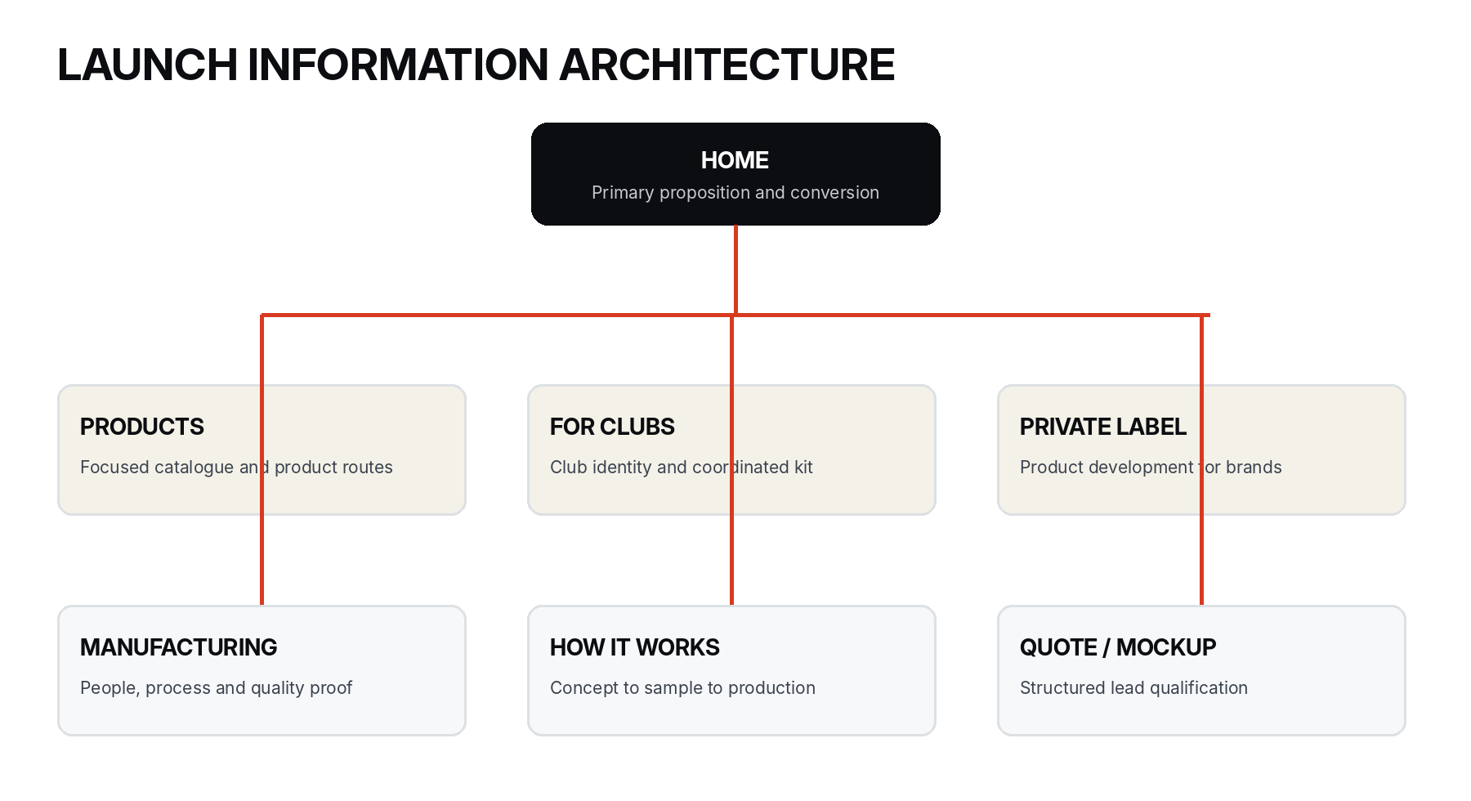
Launch architecture: six focused pathways connected to a conversion-oriented homepage.

Core launch pages
Page | Primary job
Home | Establish proposition, proof and next action.
Products | Route visitors to focused product categories.
Custom Boxing Gloves | High-intent page for the anchor product.
Fightwear and Club Apparel | Present apparel and coordinated-kit opportunities.
For Clubs and Gyms | Address club identity, quantities, members and reorders.
Private Label | Explain development, labels, packaging, sampling and repeatability.
Manufacturing and Quality | Show people, process, checks and origin.
Request a Quote / Mockup | Capture product and buyer requirements in a structured workflow.

Homepage order
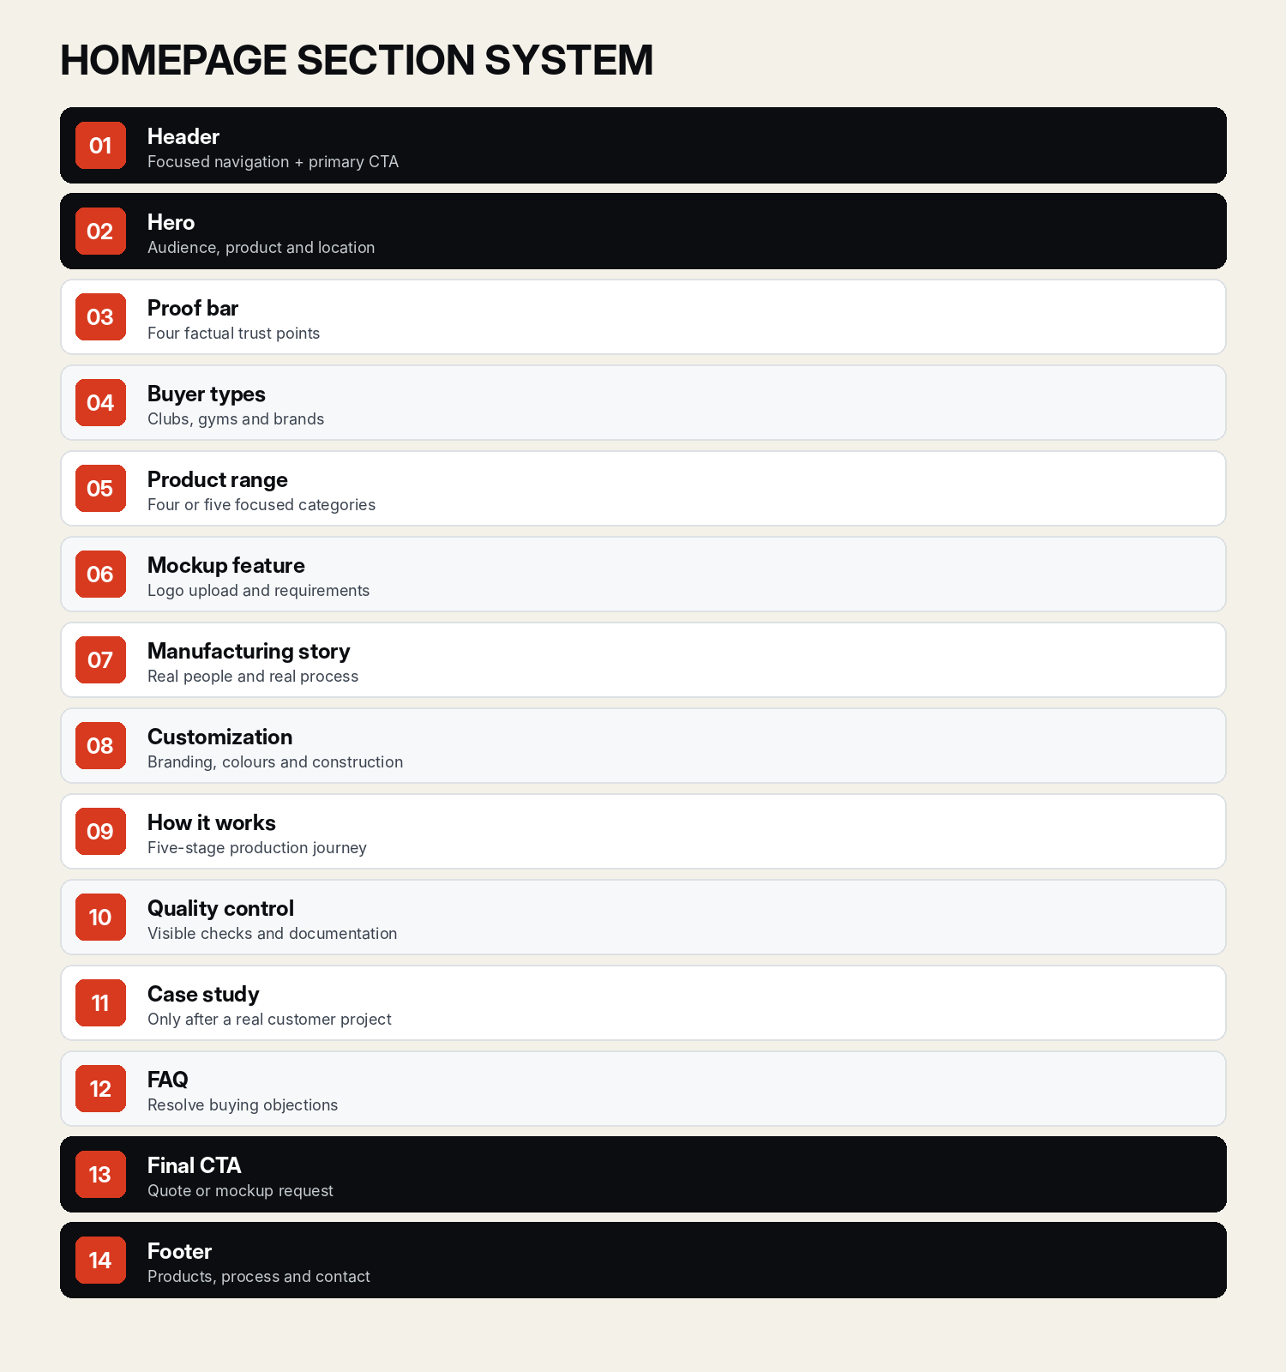
Recommended homepage stack. Remove the case-study section until genuine evidence exists.

Product page template
1. Breadcrumb and product hero.
2. Image gallery and short product overview.
3. Available use cases.
4. Materials and construction.
5. Customization options.
6. Sample and approval process.
7. Quality-control points.
8. Related products.
9. Product-specific FAQ.
10. Quote or mockup CTA.
Product hero example
Custom Boxing Gloves — Training, sparring and bag gloves manufactured with your preferred materials, branding, colours and closure specifications.

For Clubs and Gyms template
Section | Purpose
Hero | Put your club identity across the entire kit.
Common requirements | Explain typical club equipment and apparel needs.
Coordinated kit visual | Show gloves, fightwear and apparel using one identity.
Product options | Help the buyer choose practical categories.
Mockup request | Capture logo, colours, products and quantity.
Size and quantity planning | Support member and team ordering.
Sampling and production | Reduce overseas-manufacturing uncertainty.
Reorders | Explain how approved specifications will be preserved.

Private-label template
1. Brand-oriented hero and positioning.
2. Product development from reference, sketch or defined brief.
3. Materials and construction choices.
4. Labels, care information and brand application.
5. Packaging and presentation.
6. Sampling and revisions.
7. Bulk production and quality control.
8. Approved specification retention for reorders.
9. Structured quote form.

Manufacturing and Quality template
- Open with ten years of hands-on fight-gear manufacturing experience.
- Name who owns product development, manufacturing, quality, buyer communication and digital systems.
- Show the actual production stages and workshop evidence.
- Publish only quality checks that the team will consistently perform and record.
- Include dimensions, weight, material, stitching, closure, branding, colour, labels, quantity and packaging where applicable.

Quality-control evidence matrix
Check | Evidence to show
Dimensions and weight | Measurement against the approved sample or product specification.
Material and construction | Shell, fabric, padding, closure and stitching verified as agreed.
Branding and colour | Logo placement, method and agreed colour reference checked.
Labels and sizing | Size, care, wrist, neck or packaging labels checked where applicable.
Quantity and packing | Count, assortment, inner packing and export-carton details recorded.
Final approval | Photographs or inspection record retained before dispatch.
SECTION 12

Responsive behaviour and accessibility
The lead journey must remain clear and comfortable on a 360 px device, and every interaction must work without a mouse, perfect vision or animation.

Responsive behaviour
Viewport | Rules
Mobile | Single column; full-width primary buttons; hero image below copy; vertical process; stacked specifications; one-column forms; upload works without drag-and-drop; sticky CTA does not overlap WhatsApp.
Tablet | Two-column product grids; split hero where space permits; centred form; process may wrap to two rows.
Desktop | Use whitespace rather than oversized text; maximum four product cards per row; narrow prose; forms never stretch full width.

Accessibility requirements
☐ Logical heading order on every page. | ☐ Visible keyboard focus for every interactive control.
☐ Proper programmatic labels for form fields. | ☐ Error icon plus written error message.
☐ Meaningful alternative text for informative imagery. | ☐ Keyboard-operable menus, accordions and upload controls.
☐ Comfortable tap targets and spacing on mobile. | ☐ Captions or transcript for meaningful video.
☐ Reduced-motion support. | ☐ No colour-only status communication.
☐ No critical text embedded only inside an image. | ☐ Clear button labels that describe the action.
☐ Form data preserved after recoverable errors. | ☐ Sufficient colour contrast in all states.

Alternative-text pattern
Weak | Better
Image123 | Black custom sparring glove with red wrist label and white club logo.
Factory image | Team member inspecting glove stitching at the Sialkot workshop.
SECTION 13

Implementation system
Build the site from reusable primitives and semantic tokens so that pages remain consistent, responsive and easy to extend after market validation.

Core CSS tokens
COLOUR AND FONT TOKENS
:root {
--font-display: "Archivo", "Inter Display", Arial, sans-serif;
--font-body: "Inter", Arial, sans-serif;
--color-ink-950: #0b0d10;
--color-carbon-900: #15191f;
--color-steel-700: #39424e;
--color-slate-500: #69737e;
--color-line-200: #dde1e4;
--color-bone-50: #f4f1e8;
--color-white: #ffffff;
--color-forge-100: #fbe6e0;
--color-forge-600: #d83a20;
--color-forge-700: #b8321f;
--color-success-600: #1f7a4d;
--color-bg: var(--color-bone-50);
--color-surface: var(--color-white);
--color-text: var(--color-ink-950);
--color-text-secondary: var(--color-steel-700);
--color-border: var(--color-line-200);
--color-action: var(--color-forge-600);
--color-action-hover: var(--color-forge-700);
}
SPACING, SHAPE AND LAYOUT TOKENS
:root {
--space-1: 0.25rem;
--space-2: 0.5rem;
--space-3: 0.75rem;
--space-4: 1rem;
--space-5: 1.5rem;
--space-6: 2rem;
--space-7: 3rem;
--space-8: 4rem;
--space-9: 5rem;
--space-10: 6rem;
--space-11: 8rem;
--radius-sm: 0.25rem;
--radius-md: 0.375rem;
--radius-lg: 0.625rem;
--radius-xl: 1rem;
--radius-pill: 999px;
--container: 80rem;
--content: 45rem;
--form: 40rem;
}
MOTION TOKENS
:root {
--motion-fast: 120ms;
--motion-standard: 200ms;
--motion-emphasis: 360ms;
--ease-standard: cubic-bezier(0.2, 0, 0, 1);
}
FOUNDATION UTILITIES
.section {
padding-block: clamp(3.5rem, 8vw, 7rem);
}
.container {
width: min(100% - 2.5rem, var(--container));
margin-inline: auto;
}
.prose {
max-width: var(--content);
}
.button-primary {
min-height: 3.25rem;
padding-inline: 1.5rem;
border: 0;
border-radius: var(--radius-md);
background: var(--color-action);
color: var(--color-white);
font: 600 0.9375rem/1 var(--font-body);
transition:
background-color var(--motion-standard) var(--ease-standard),
transform var(--motion-fast) var(--ease-standard);
}
.button-primary:hover {
background: var(--color-action-hover);
}
.button-primary:focus-visible {
outline: 3px solid var(--color-ink-950);
outline-offset: 3px;
}

Component inventory
Group | Components
Foundation | Logo, Button, TextLink, SectionHeader
Navigation | Header, MobileNavigation, Footer, Breadcrumb, Pagination, CookieBanner
Content | Hero, ProofBar, ProductCard, AudienceCard, CustomizationCard, ProcessStepper, SpecificationTable, ImageGallery, Testimonial, CaseStudyCard, FAQAccordion, CallToAction
Forms and feedback | QuoteForm, FileUpload, FormField, SelectField, RadioCard, Checkbox, Alert, SuccessPanel

Required component states
State | Requirement
Default | Clear base appearance and content.
Hover | Useful pointer feedback without layout movement.
Focus | High-visibility keyboard focus distinct from hover.
Active / selected | Persistent state using more than colour alone.
Disabled | Visibly unavailable and programmatically disabled.
Loading | Progress communicated without losing context.
Error | Specific cause, correction and preserved user input.
Success | Confirmation and clear next action.

Design-file organization
SUGGESTED FILE PAGES
00 — Cover and Instructions
01 — Brand Foundations
02 — Colours
03 — Typography
04 — Grid and Spacing
05 — Icons and Imagery
06 — Components
07 — Patterns
08 — Page Templates
09 — Desktop Pages
10 — Mobile Pages
11 — Prototype
12 — Archive
Component properties: Theme / Light–Dark; Size / Small–Medium–Large; State / Default–Hover–Focus–Disabled; Icon / None–Leading–Trailing; Layout / Horizontal–Stacked.
SECTION 14

MVP, analytics and roadmap
The first version should validate demand and improve response quality. It should not become a six-week configurator project before real buyers use the service.

Launch MVP
☐ Eight core pages and legal/support pages. | ☐ Real product and manufacturing photography.
☐ Manual mockup-request form with logo upload. | ☐ Structured quote form and product-category selection.
☐ Email or CRM notification with assigned owner. | ☐ Lead status and follow-up tracking.
☐ WhatsApp as secondary contact. | ☐ Mobile sticky CTA.
☐ Basic analytics events and funnel reporting. | ☐ Approved artwork and specification storage process.

Manual-first mockup workflow
Workflow
Buyer uploads logo and selects product/colours → team prepares a concept manually → sales owner sends it and qualifies the request → quote or sample discussion begins.

Phase 2: evidence-led automation
- Live colour switching on selected product templates.
- Logo preview on approved mockup positions.
- Automated PDF product brief.
- Saved buyer projects and quote history.
- Approved artwork and specification records.
- Reorder request flow and customer portal.

Phase 3: scale features
- Three-dimensional product preview and controlled logo positioning.
- Automated pricing ranges where inputs are standardized.
- Production status, distributor access and account-based pricing.
- Multi-language content after market demand justifies it.

Analytics events
EVENT NAMING
hero_mockup_click
hero_quote_click
product_card_open
mockup_form_start
logo_upload_start
logo_upload_complete
quote_form_start
quote_form_submit
whatsapp_click
email_click
sample_request
case_study_open

Commercial funnel
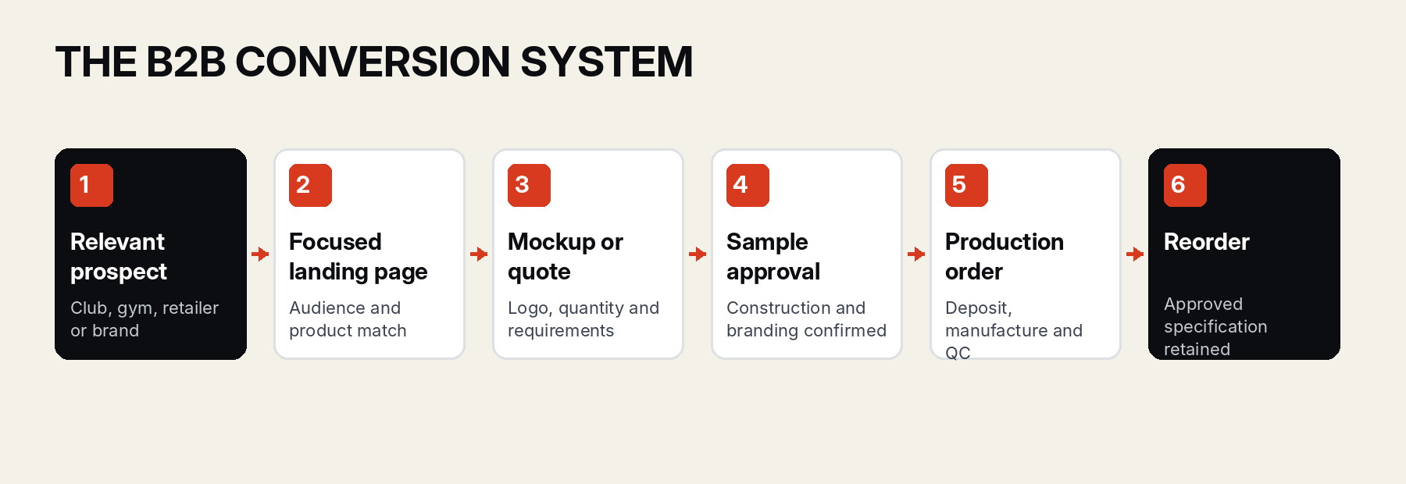
Measure qualified requests, sample conversion, production orders and reorders—not traffic alone.

Recommended build order
1. Foundation tokens and global styles.
2. Header, footer, buttons and form primitives.
3. Homepage and proof structure.
4. Reusable product-page template.
5. For Clubs and Private Label pages.
6. Manufacturing and Quality evidence page.
7. Quote and mockup workflow with file upload.
8. Mobile and keyboard QA.
9. Accessibility and performance QA.
10. Analytics, CRM routing and launch.
SECTION 15

Launch checklist
Launch only when the website accurately represents what the team can manufacture, communicate and fulfil. Trust lost through an unsupported claim is more expensive than an unfinished feature.

Brand and content
☐ Working or final name is used consistently. | ☐ Product, buyer and manufacturing model are clear above the fold.
☐ No invented customer, capacity or satisfaction statistics. | ☐ Every MOQ, material, lead-time and process statement is confirmed internally.
☐ Primary CTA language is consistent across the site. | ☐ Sialkot origin and team roles are presented accurately.

Design and responsive QA
☐ All required pages tested at 360, 390, 768, 1024, 1280 and 1440 px. | ☐ No clipped text, overflow, broken grids or overlapping sticky controls.
☐ Hero and product imagery crop correctly at every breakpoint. | ☐ Forms are comfortable on mobile and preserve user input.
☐ Typography, colour, radius and spacing use approved tokens. | ☐ WhatsApp does not compete with the primary CTA.

Accessibility and interaction
☐ Keyboard navigation completed without traps. | ☐ Visible focus states verified.
☐ All fields have labels and helpful errors. | ☐ Meaningful images have accurate alternative text.
☐ Contrast and reduced-motion behaviour tested. | ☐ Menus, accordions and uploads work without a mouse.

Operations and measurement
☐ Form submissions reach the correct sales owner. | ☐ Lead source, product, quantity and destination are recorded.
☐ Logo and reference uploads are accessible and secure. | ☐ Response and follow-up stages are defined.
☐ Sample, quote, order and reorder outcomes can be tracked. | ☐ Analytics events have been tested in production.
☐ Privacy, cookie and retention rules match the actual implementation. | ☐ Backups, spam protection and error monitoring are active.

Non-negotiables
# | Rule
1 | Use real manufacturing and product images.
2 | Present combat sports as the specialization.
3 | Make the quote and mockup process obvious.
4 | Keep one primary CTA per section.
5 | Never invent metrics, customers or certifications.
6 | Do not publish unconfirmed MOQs or lead times.
7 | Do not create dozens of weak product pages.
8 | Do not use generic exporter language.
9 | Do not build the full configurator before demand is proven.
10 | Make every page work properly at 360 px.
11 | Preserve approved artwork and specifications for reorders.
12 | Hide social proof until genuine evidence exists.
SECTION A

Starter copy library
Use these examples as controlled starting points. Replace details only when the manufacturing and commercial policies are confirmed.

Homepage hero
Eyebrow
CUSTOM FIGHT-GEAR MANUFACTURING

Heading
Custom fight gear, built for your club.

Body
Boxing gloves, fightwear and club apparel manufactured in Sialkot with your colours, logo and specifications.

Actions
Request Your Mockup / View Custom Products

Mockup feature

See your club identity before production.
Upload your logo and send your product requirements. We’ll review the practical concept or sampling step before bulk production.

Manufacturing introduction

Ten years of hands-on fight-gear manufacturing experience.
Based in Sialkot, our production work is built around clear product requirements, approved samples and checks before dispatch.

For Clubs and Gyms hero

Put your club identity across the entire kit.
Custom gloves, fightwear and apparel created around your club colours, logo and practical ordering requirements.

Private-label hero

Your fightwear brand, supported by a clear manufacturing process.
Develop products, labels and packaging through an approved sample before bulk production begins.

Form confirmation
Your request has been received.
We’ll review your product, quantity, branding and destination details before confirming the next practical step.

Final CTA

Ready to develop your custom fight gear?
Send your product, branding, quantity and destination.
REQUEST A QUOTE

Document control
Field | Value
Document | Sparwright B2B Website Design System
Version | 1.0
Status | Baseline for design and implementation
Working brand | Sparwright; replaceable without changing the system
Primary market | UK and Europe
Primary conversion | Custom mockup or manufacturing quote
Review trigger | After first 100 qualified prospects or first 3–5 club customers

