FAST National University
Of Computing And Emerging Sciences
Software Design and Architecture (SDA)
Assignment Task 2
University Fuel Management System
Designing the UML Diagrams Based on the Task no 1
Group Members
Saad Ahmed Ijaz (Roll No: 24P-0669)
Arif Ali (Roll No: 0736)
Arslan Tariq (Roll No: 24P-0610)
Submitted To:
Professor Umer Haroon
Date: April 2026

1.Class Diagram:
Class Diagram for Fuel Management System :

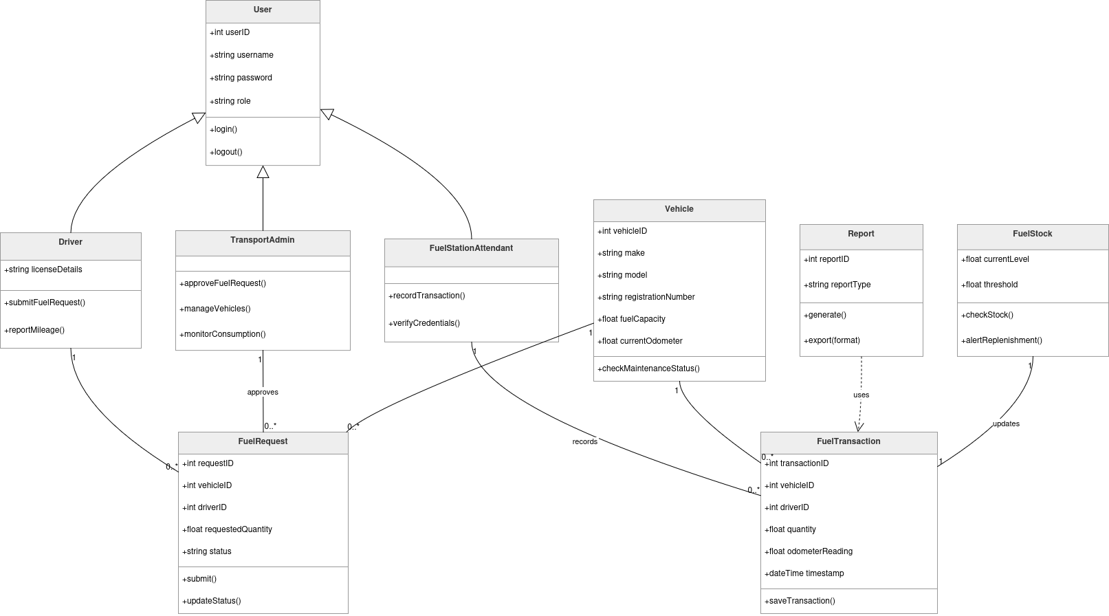

2.State Machine Diagram:
State Machine For the Fuel Management System:
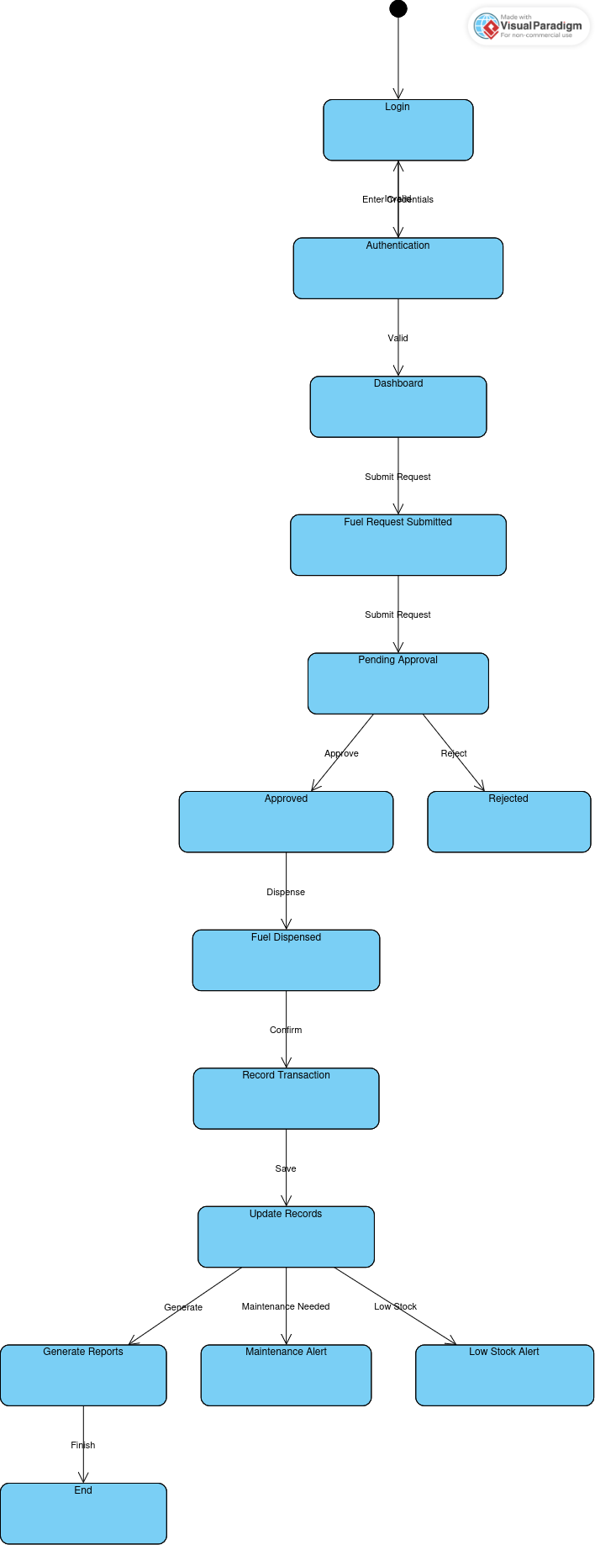

3.Sequence Diagram:
The Sequence Diagram For the Fuel Management System is :
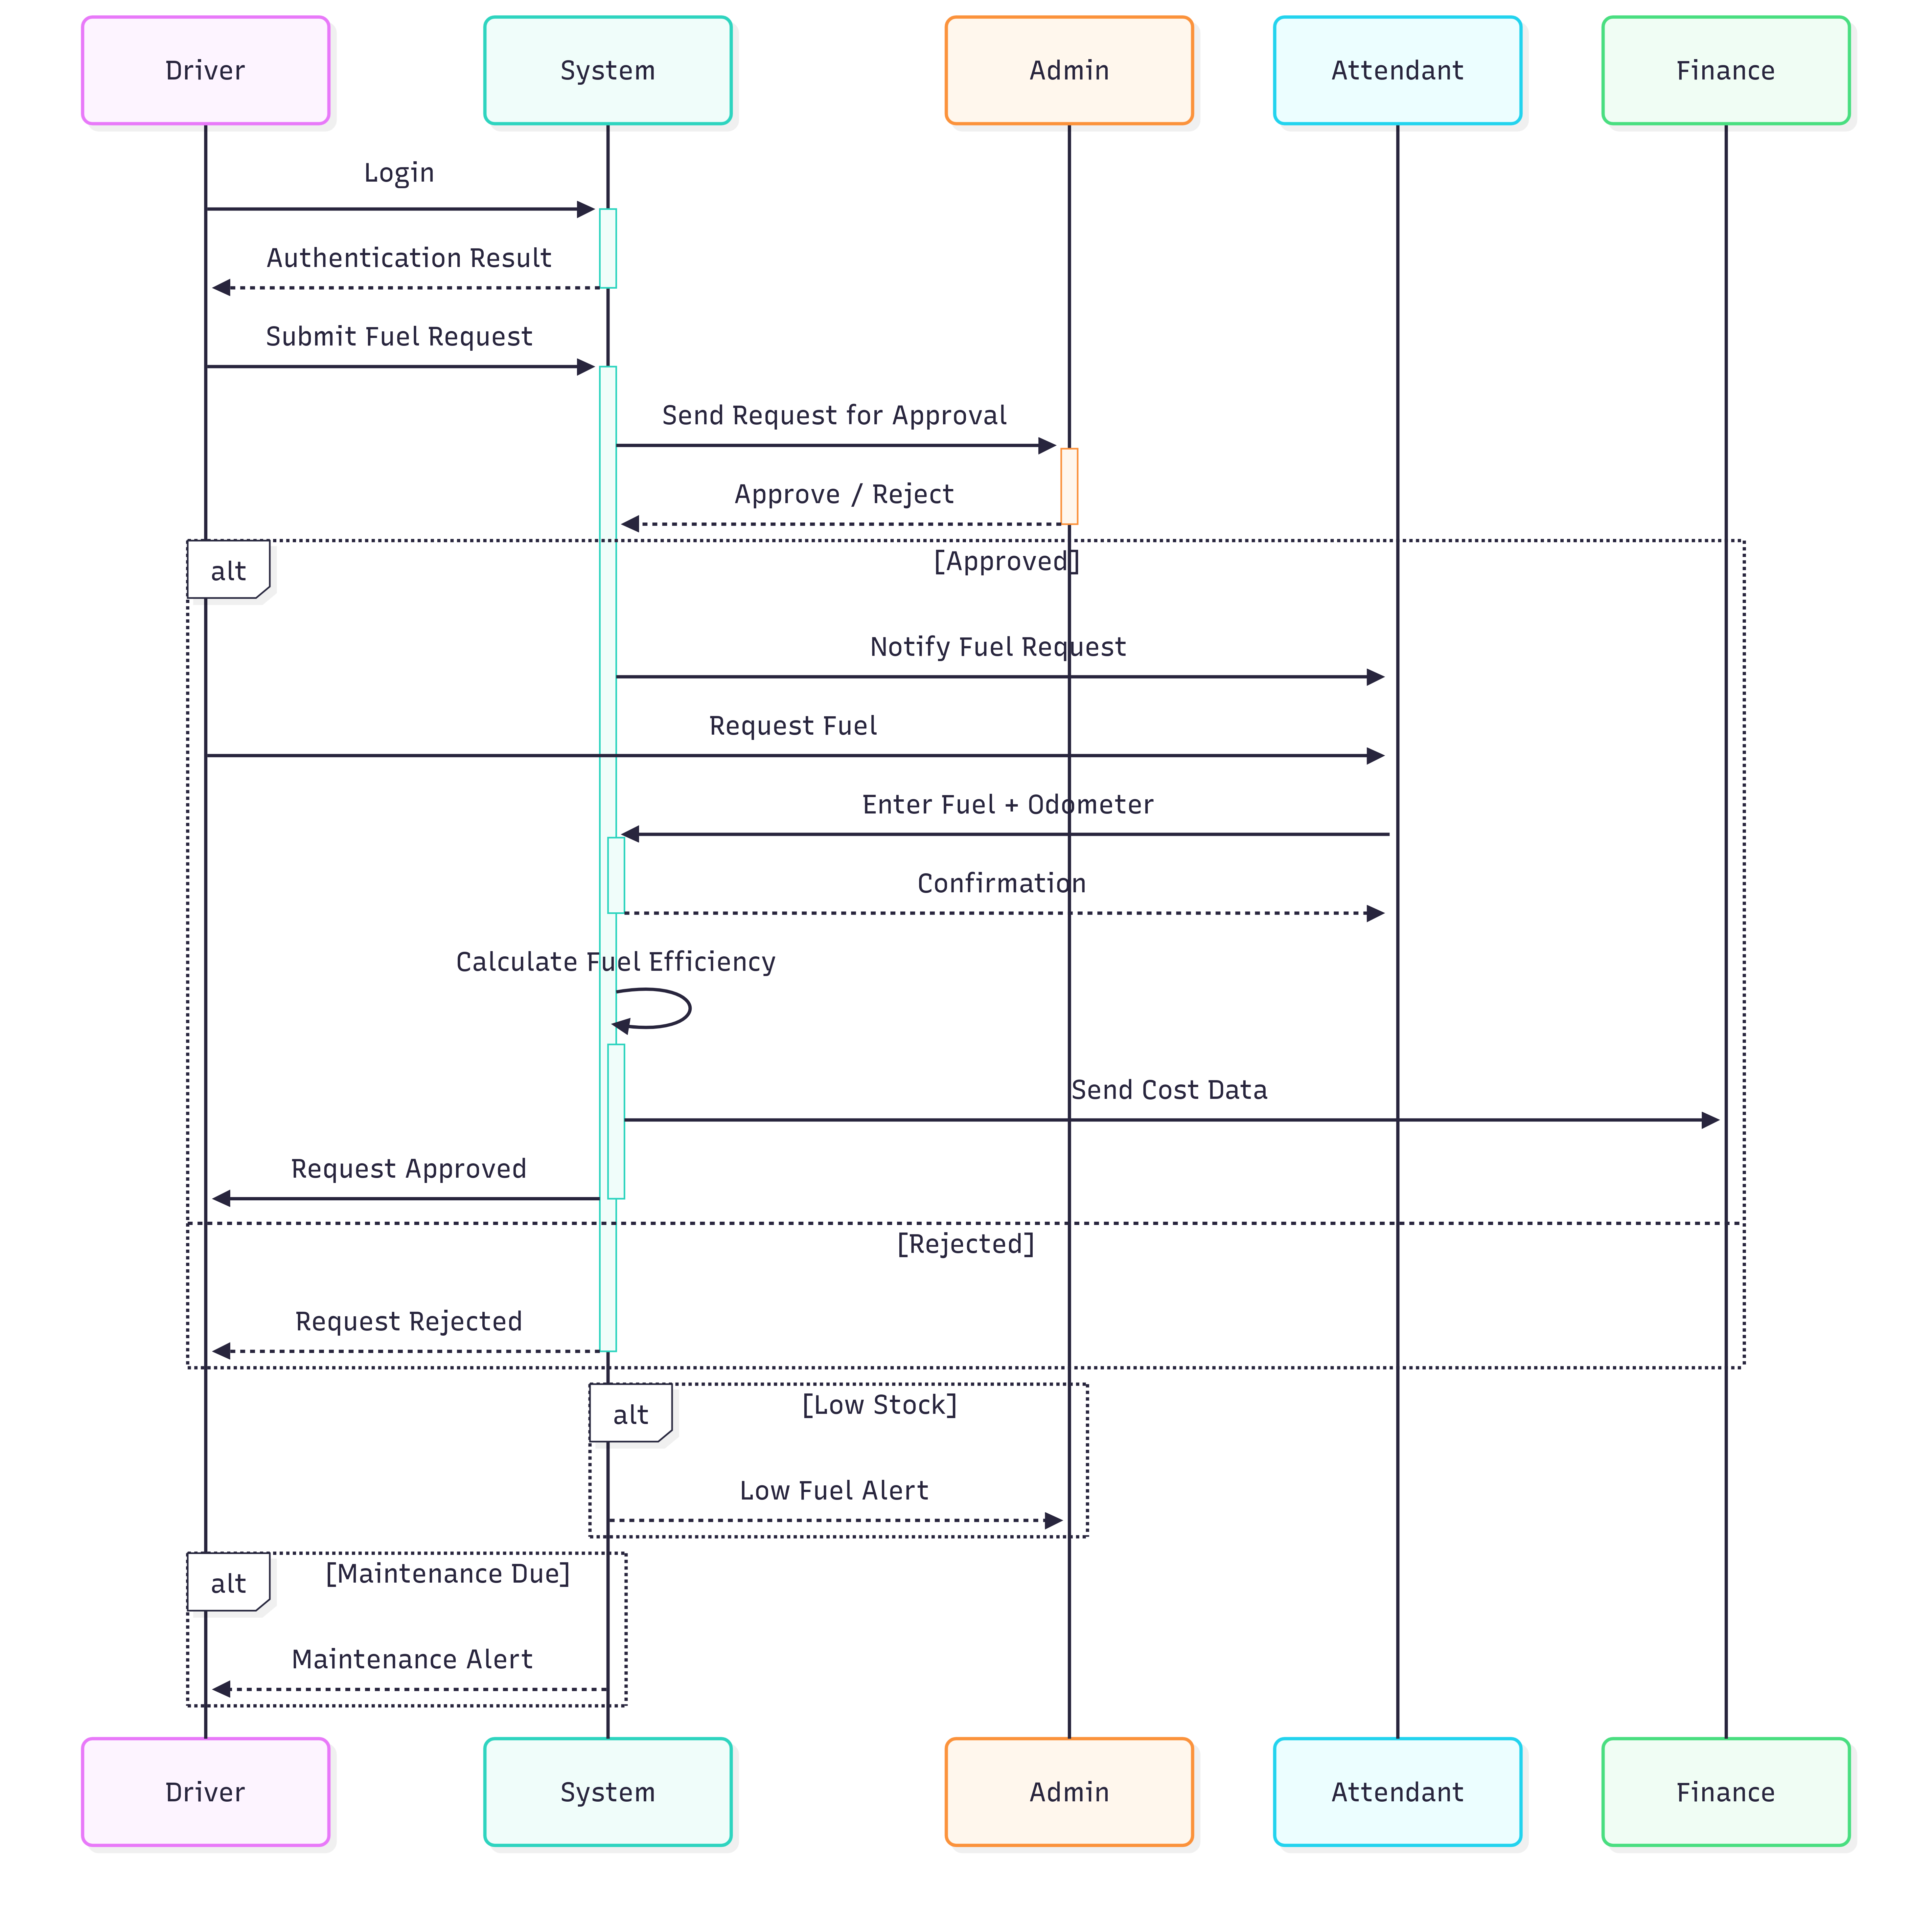

4.Class Activity Diagram:
The Class Activity UML Diagram is:
