CST-227 Activity 4: Hero Maker Guide

Contents

Overview 2

How to Pass Variables Between Forms in C# 4

# Overview

**Objective**: Install and configure a wide range of form controls. Manage and read the properties of each kind of control. Create a class with properties that match each type of control.

The goal of the project is to create a form with as many control types as possible. Save all the values in the properties of a class called SuperHero. Store the SuperHeroes in an ArrayList and display them on a second form.

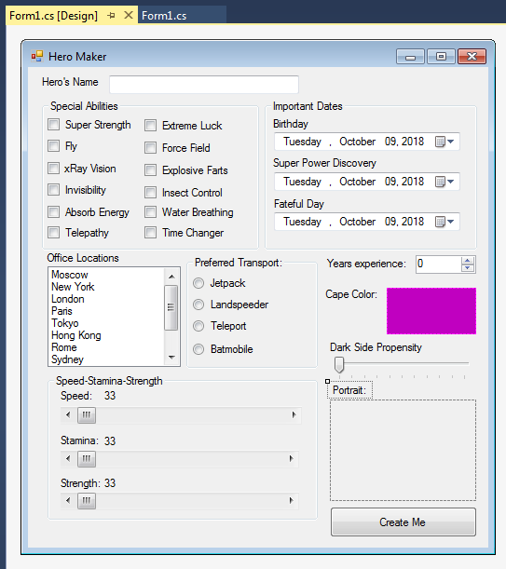

1. Design the form. Create a form with the following controls. You can use this picture as a guide but create your own version of a super hero creator.
   1. Text Edit
   2. GroupBoxes
   3. Checkbox
   4. List Box
   5. H-Scroll
   6. Radio button
   7. Date Pickers
   8. Number spinner
   9. Picture Box (optional)
   10. Track Bar

Add other controls if possible.

**Additional challenges**

1 – The speed, stamina, and strength should display their value in the lables immediately above them. Update the label’s text value whenever the slider moves.

2 – The speed, stamina, and strength should add up to a total of 100. If one of the values higher, then you must bring down the other two values. Display an error message if the user tries to make a sum greater than 100.

3 – The cape color should open a color chooser dialog box. When the user selects a color from the color wheel (or other color view), the picture box will show a background value of the new color. Save the resulting color in a string value.

4 – The Dark Side propensity should show a value between 1 and 10. Print the selected value on a label so the user can see what number has been selected.

5 – (optional) Allow the user to select an image for the picture box.

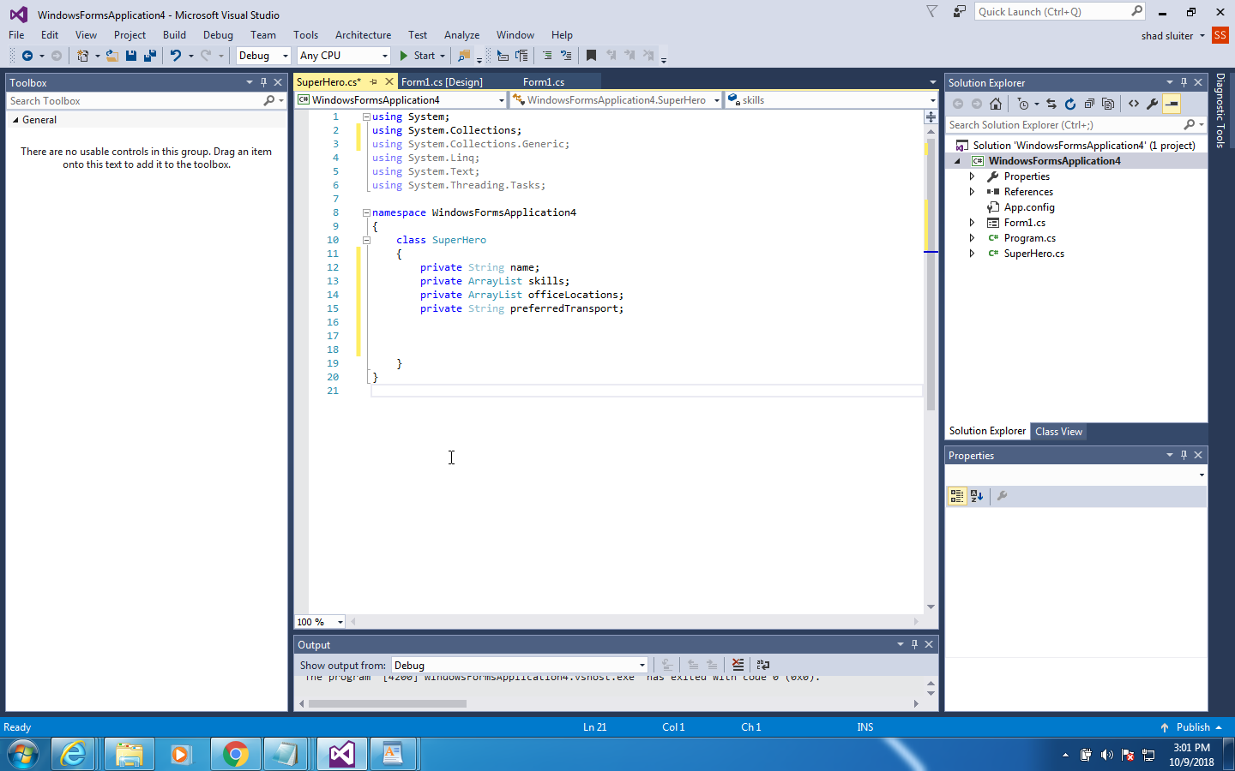

1. Design a class called SuperHero. It should contain properties that correspond to the items that appear on the form. You can see a partially-completed class pictured here. When the user clicks the “Create Me” button, a new SuperHero instance is created and saved in a list of SuperHeros.

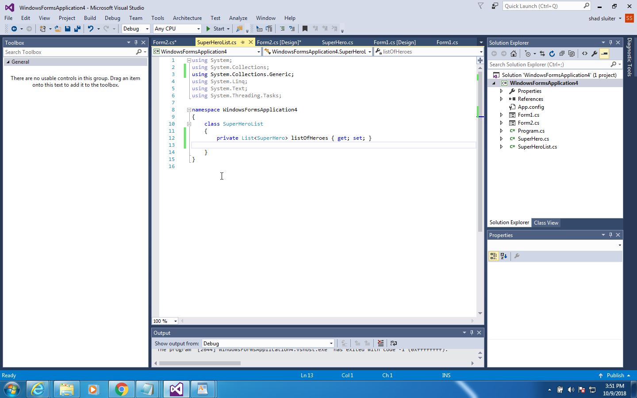

1. Create a second class called SuperHeroList. The class should contain an arraylist property of type Hero.
2. 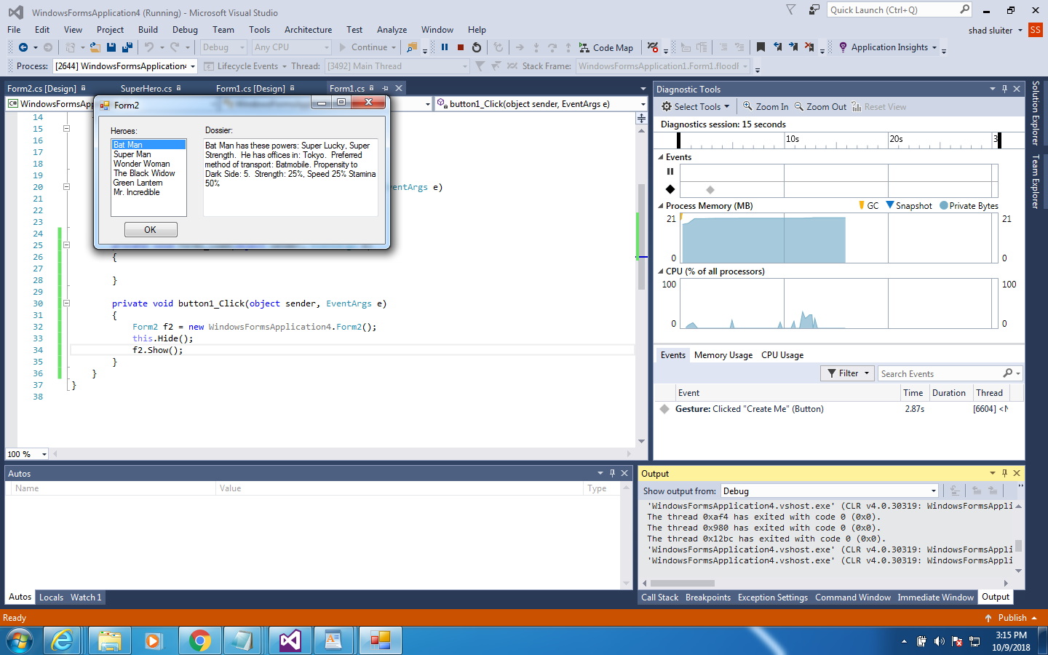Create a second form that displays all of the super heroes’ names in a list. When you click on a name in the list, the summary of the hero appears in the textbox (multiline) on the right.
3. On Form1, code the Button to create a new hero, hide Form 1 and show Form 2.

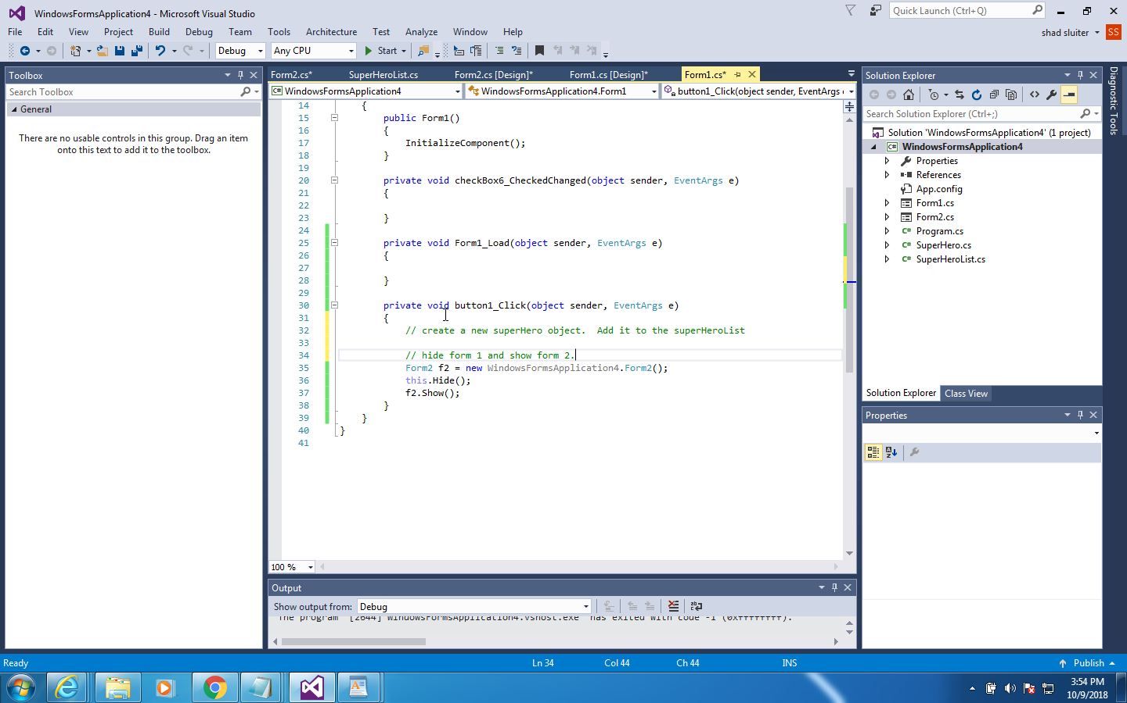

1. Create some events for the listBox1 and OnForm2 load events.

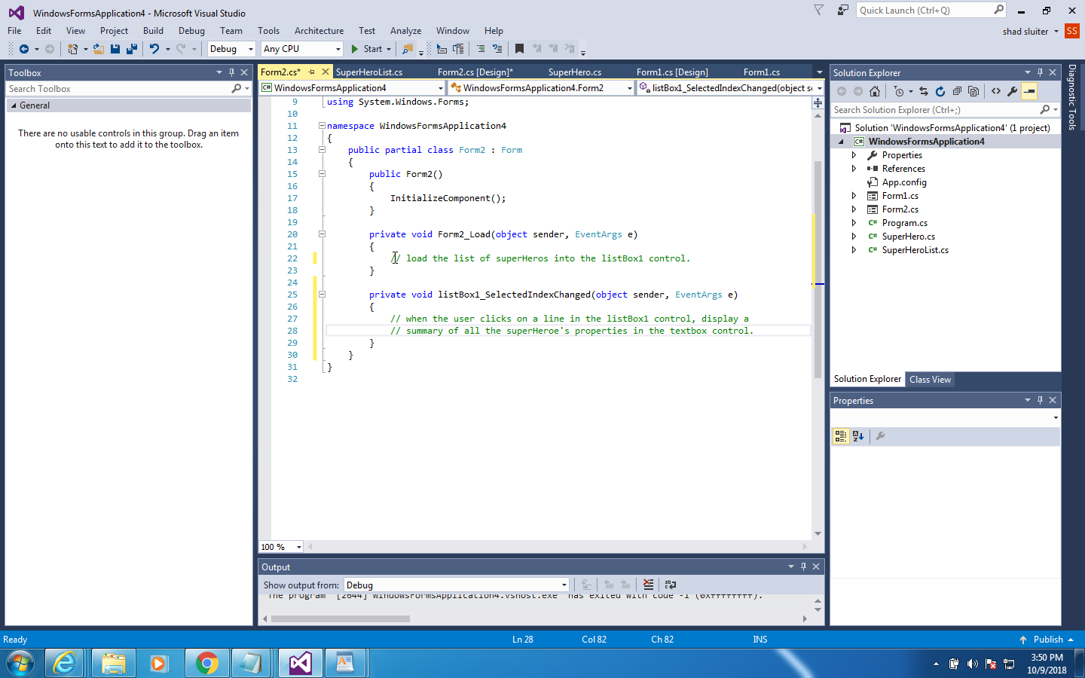

**Some additional help in passing values between forms**

# How to Pass Variables Between Forms in C#

This is simply a reference to help with the Super Hero Maker assignment.

Create two forms with some controls. Form 1 has a text field and button.

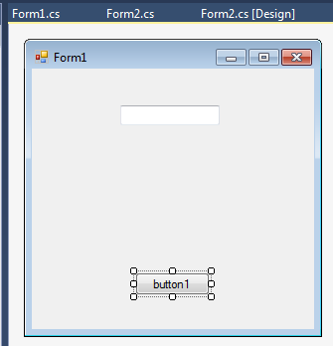

Form 2 has only a label.

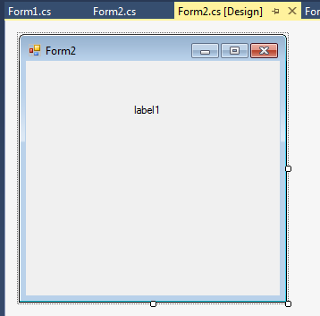

In Form1, create this code.

The key point is that when creating a new instance of Form2 we pass a variable as a parameter as shown on line 30. This will initially cause an error until we modify the constructor on Form2.

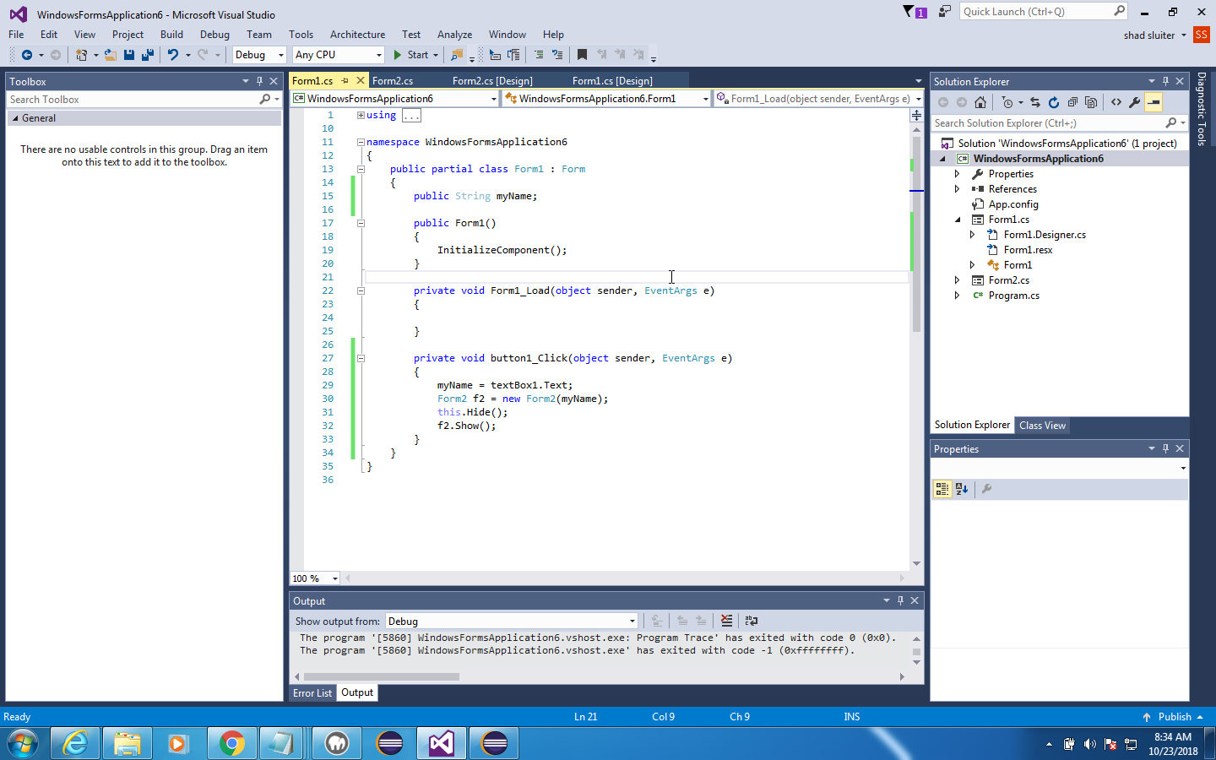

In the code for Form2, modify the constructor to receive the parameter, assign it to a variable in Form2 that all the other controls can see.

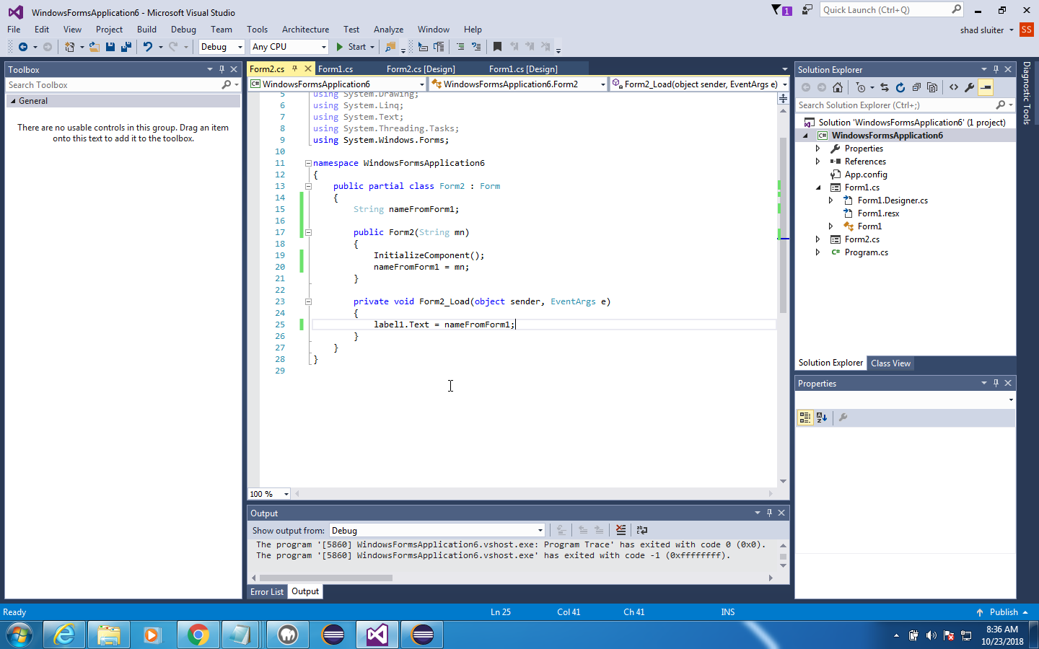

**Deliverables**:

1. Zip file containing all source code.
2. Word document containing screenshots of the application being run. Be sure to demonstrate all features that were created in the tutorial as well as the challenges.