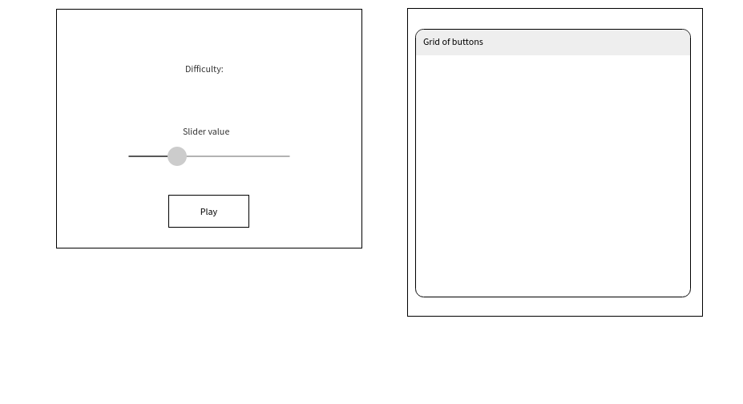

This is the Wireframe. Very simple. I wanted a slider instead of buttons for difficulty since that’s how I have it set up in my console game and the slider looks pretty nice compared to radio buttons in my opinion.

Here’s the actual first form. Not even my final form. The slider goes from 1 to 9 which will correlate to 10% of the board being bombs to 90%. You’re a masochist if you do anything above 6.

This is the grid. So far, all the buttons do is reveal their number when pressed which is generated in order from 1 to 100, left to right then down a row.